UNITED STATES
SECURITIES AND EXCHANGE COMMISSION
Washington, D.C. 20549

SCHEDULE 14A INFORMATION
Proxy Statement Pursuant to Section 14(a) of the
Securities Exchange Act of 1934
(Amendment No. 1)

Filed by the Registrant ☒
Filed by a Party other than the Registrant ☐

Check | the appropriate box:

☐ | Preliminary Proxy Statement

☐ | Confidential, for Use of the Commission Only (as permitted by Rule 14a-6(e)(2))

☒ | Definitive Proxy Statement

☐ | Definitive Additional Materials

☐ | Soliciting Material Pursuant to § 240.14a-12
SOTERA HEALTH COMPANY
(Name of Registrant as Specified In Its Charter)
Payment of Filing Fee (Check the appropriate box):

☒ | No fee required.

☐ | Fee paid previously with preliminary materials.

☐ | Fee computed on table required by Item 25(b) per Exchange Act Rules 14a-6(i)(1) and 0-11.

SUPPLEMENT TO PROXY STATEMENT DATED MAY 8, 2024,
FOR THE ANNUAL MEETING OF STOCKHOLDERS
TO BE HELD ON MAY 23, 2024
This supplement, dated May 8, 2024, supplements and amends the definitive proxy statement (the Proxy Statement) filed by Sotera Health Company (the Company) with the Securities and Exchange Commission (the SEC) on April 11, 2024 for the 2024 Annual Meeting of Shareholders to be held on May 23, 2024 (the Annual Meeting). This supplement is being filed (i) to correct an error in the graphic in the section entitled Board Composition, Nominations Process and Director Qualifications  Board Diversity and (ii) to correct errors in the table set forth on page 78 of the Proxy Statement and to clarify the voting standards for the proposals to be voted on at the Annual Meeting.
On page 8 of the Proxy Statement, the total number of directors in the diversity graphic was inadvertently presented incorrectly. This supplement amends and replaces the graphic set forth on page 8 of the Proxy Statement with the following corrected version of the graphic, which comports with the associated text of the Proxy Statement:

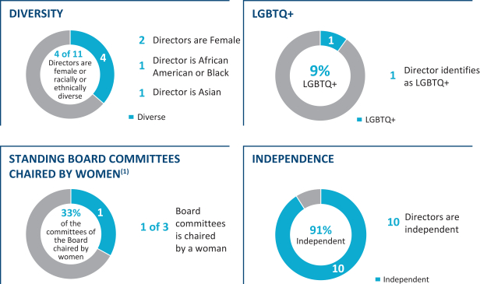

 | (1) | The EO Litigation Committee and Nordion Pricing Committee are not standing committees of the Board and do not have chairs. See Committees of the Board of Directors on page 20 for more information.
This supplement amends and replaces the table set forth on page 78 of the Proxy Statement with the following corrected version of the table:

Proposal |  | Voting Options |  | Required Vote |  | Effect of Abstentions  and Broker Non-Votes |  | Broker  Discretionary  Voting Allowed? |  | Advisory  Proposal?
1. Election of directors |  | FOR, AGAINST or ABSTAIN with respect to each of the director nominees |  | Majority of votes cast (1) |  | No effect  not counted as avote cast |  | No |  | No

Proposal |  | Voting Options |  | Required Vote |  | Effect of Abstentions  and Broker Non-Votes |  | Broker  Discretionary  Voting Allowed? |  | Advisory  Proposal?
2. Vote to approve named executive officer compensation (Say-on-Pay) |  | FOR, AGAINST or ABSTAIN |  | Majority of the shares present and entitled to vote on the subject matter |  | Broker non-votes will have no effect  not counted as avote cast  Abstentions will have the effect of a vote against |  | No |  | Yes
3. Ratification of appointment of independent auditors |  | FOR, AGAINST or ABSTAIN |  | Majority of the shares present and entitled to vote on the subject matter |  | Broker non-votes will have no effect  not counted as avote cast  Abstentions will have the effect of a vote against |  | Yes |  | Yes
4. Approval of an officer exculpation amendment to our amended and restated certificate of incorporation |  | FOR, AGAINST or ABSTAIN |  | Majority of the shares of outstanding common stock of the Company entitled to vote |  | Will count as a vote against |  | No |  | No

(1) | In accordance with our Corporate Governance Guidelines, because the election of directors will be uncontested, a director nominee must receive more votes cast FOR than AGAINST his election to be elected.
Except as specifically supplemented by the information contained herein, this supplement does not revise or update any of the other information set forth in the Proxy Statement. This supplement does not provide all of the information that is important to your voting decisions at the Annual Meeting, and the Proxy Statement contains other important additional information. This supplement should be read in conjunction with the Proxy Statement.
If you have already returned your proxy or voting instruction card or provided voting instructions, you do not need to take any action unless you wish to change your vote. If you have submitted a proxy and wish to change your vote, you may revoke your proxy and change your vote by following the instructions in the question Can I change my vote or revoke my proxy? of the section titled Questions And Answers About The Proxy Statement And Our 2024 Annual Meeting Of Shareholders of the Proxy Statement. This supplement does not change the proposals to be acted upon at the Annual Meeting, which are described in the Proxy Statement.

