

2024 Annual Report

Safeguarding Global Health®


Our Commitment
to Safeguarding

Global Health®

Sotera Health Company (Nasdaq: SHC) is a leading global provider

of mission-critical end-to-end sterilization solutions, lab testing and advisory services for the healthcare industry. The name Sotera Health was inspired by Soteria, the Greek goddess of safety, and reflects the Company’s unwavering commitment to its mission, Safeguarding Global Health®.

Company Highlights

 |  |  |  |  |  |  |  |  |  | Network of 62
 |  |  |  |  |  |  | Over 3,000 |  |  |  |  |  |  | ~5,000
 | 90+
 | years of sterilization |  |  |  |  |  | employees across |  |  |  | global facilities |  |  | customers in
 | and lab services |  |  |  |  |  |  | the globe |  |  |  |  |  | 50+ countries
 | Our Three Businesses
 |  |  |  | STERILIZATION SERVICES |  |  |  |  |  |  |  |  |  | LAB SERVICES
 |  |  |  | Leader in sterilization services |  |  |  |  |  |  |  |  |  | Leader in lab testing & advisory services

Comprehensive sterilization services |  | Gamma technologies |  | Expert lab testing and advisory services
Provider of mission-critical and |  | Global leader in supply of Cobalt-60, |  | Provider of mission-critical medical
often government-mandated |  | the key input for gamma sterilization |  | device and pharmaceutical lab testing
sterilization services |  |  |  | and advisory services
48 | 2,000+ | 2 | ~40 | 12 | ~3,000
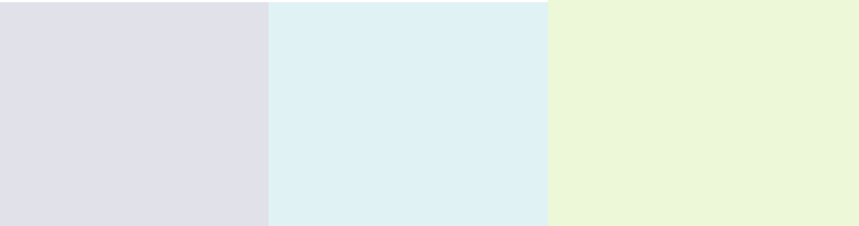

locations customers locations customers locations customers



Living Our Mission Every Day

At Sotera Health, we are steadfast in our commitment to our mission, Safeguarding Global Health®. Our work helps to ensure the safety of millions of patients and healthcare workers around the globe, as well as the communities in which we operate and our 3,000+ global team members. While our high-quality testing, safe and reliable sterilization services and Cobalt-60 supply expertise enable the safety of the global healthcare industry, it is our team’s commitment to living our mission every day that makes an extraordinary difference.

Our Values

SAFET Y

We are uncompromising in our commitment to health and well-being.

CUSTOMER FOCUS

We are driven to fulfill our customers’ needs with the highest quality and care.

PEOPLE

We value our people who are part of a global team that is diverse, respectful, passionate and collaborative.

INTEGRITY

We are honest, reliable and accountable in everything we do.

EXCELLENCE

We exceed the expectations of our stakeholders and continue to improve and innovate in everything we do.

Alignment with UN Sustainable Development Goals

 Good HEALTH
and well-being

Gender
EQUALITY

• 1

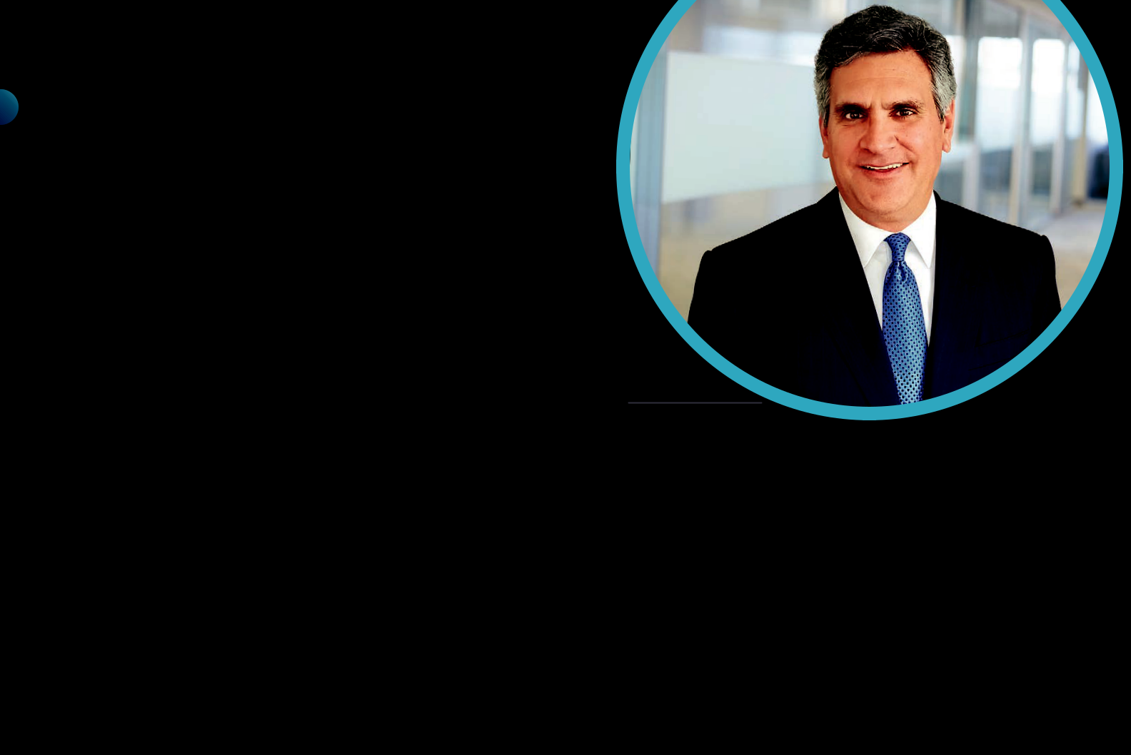
- Letter from Our CEO

Dear Shareholders,

Reflecting on 2024, I am proud to share that Sotera Health has continued to exemplify our unwavering commitment to our mission of Safeguarding Global Health®. Our focus on excellence has driven significant achievements across our businesses—Sterigenics, Nordion, and Nelson Labs—reinforcing our position as a trusted partner in the healthcare industry.

We continue to be presented with exciting opportunities as the global economy evolves rapidly. The rate of technological innovation offers new avenues for growth and partnership with our healthcare customers, while geopolitical and supply chain disruptions help to refine our strategies and enhance our agility. However, it is the resilience of our people that continues to make me most proud. Embracing these external factors, combined with an unrelenting focus on execution, led to another year of top- and bottom-line growth. This growth underscores the strength of our business model and our ability to deliver consistent results, all while being uncompromising in living our core values of Safety, Customer Focus, People, Integrity and Excellence.

Michael B. Petras, Jr.

Chairman and Chief Executive Officer

Key financial and operational highlights from 2024 include:

- Consistently delivering growth, with 2024 marking the 19th consecutive year of annual revenue growth for our Company;

- Ongoing focus on operational excellence and reorganizing within our businesses as needed to foster growth;

- Achieving 100% fulfillment of customer Cobalt-60 requests, the first time since 2018;

- Welcoming Danielle Menture, Senior Vice President, Global Environmental, Health, Safety and Sustainability to the executive team;
- Hosting our inaugural Investor Day in New York City, where we outlined our strategic position and future growth plans, while providing an opportunity for enhanced shareholder engagement;

- Successfully completing Term Loan and Senior Secured Note financings to enhance our capital structure and support our long-term growth initiatives;

- Strengthening our Board governance with the appointment of Christopher Simon as an independent director in August 2024;

• 2

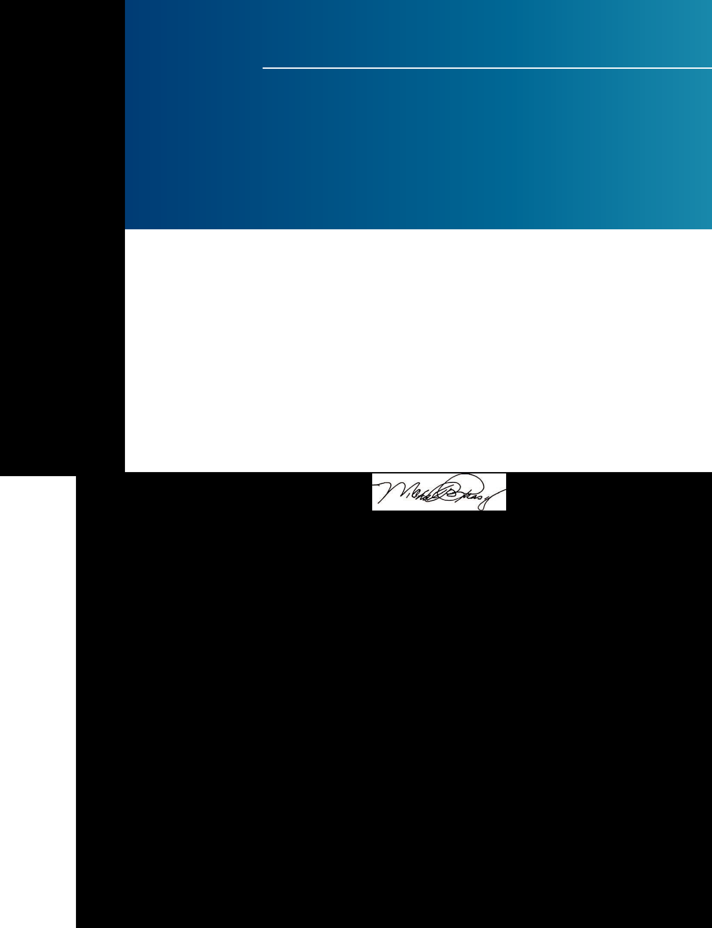
“Our focus on excellence has driven significant achievements across our businesses—Sterigenics, Nordion, and Nelson Labs—reinforcing our position as a trusted partner in the healthcare industry.

- Continuing our valuable dialogue with investors through our outreach and engagement efforts; and

- Further evolving our corporate responsibility principles and remaining steadfast in advancing our environmental sustainability programs, improving data collection processes and investing in state-of-the-art technologies to reduce emissions across our facilities.

Looking Ahead

As we progress through 2025, we believe our commitment to excellence and our strategic focus will prevail. Our resilience and dedication are the cornerstones of our success, and they will continue to guide us. We remain focused on our four key priorities as communicated during our Investor Day:

- Excellence in serving our customers with end-to-end solutions;

- Winning in growth markets;

- Driving operational excellence to enhance Free Cash Flow; and

- Disciplined capital deployment.

I want to take a moment to say thank you to our 3,000 dedicated employees across the globe, our valued customers, and you—our shareholders—for your continued trust and support. We take our responsibility seriously and we will continue to work together to make a meaningful impact in the healthcare industry and uphold our mission of Safeguarding Global Health®.

Michael B. Petras, Jr.

Chairman and Chief Executive Officer

• 3

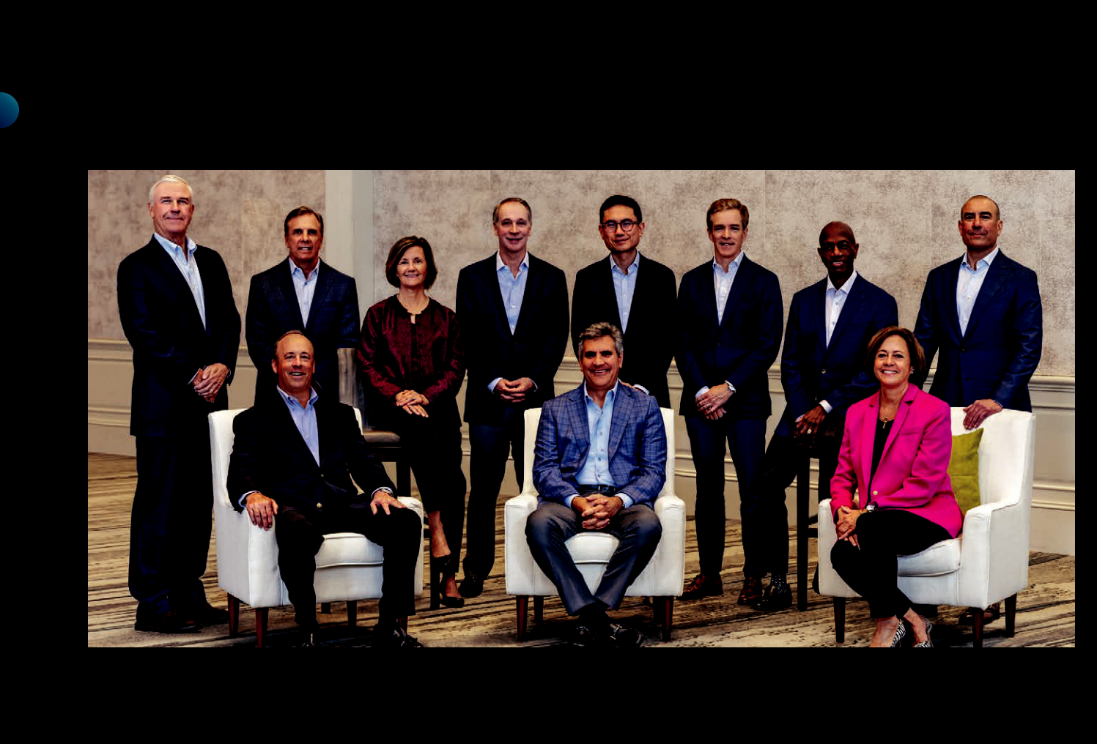
Board of Directors

Back row | Robert B. Knauss, Managing Director, Warburg Pincus; Christopher A. Simon, President and Chief Executive Officer, Haemonetics; Karen A. Flynn, Former
left to right: | Senior Vice President and Chief Commercial Officer, Catalent Pharma Solutions; James C. Neary, Managing Director, Warburg Pincus; Ruoxi Chen, Managing
 | Director, Warburg Pincus; Sean L. Cunningham, Managing Director, GTCR; David E. Wheadon, M.D., Former Senior Vice President, Global Regulatory Affairs,
 | Patient Safety and Quality Assurance, AstraZeneca PLC; Constantine S. Mihas, Managing Director, GTCR
Seated | Vincent K. Petrella, Lead Independent Director, Sotera Health; Former Executive Vice President, Chief Financial Officer and Treasurer, Lincoln Electric
left to right: | Holdings, Inc.; Michael B. Petras, Jr., Chairman and Chief Executive Officer, Sotera Health; Ann R. Klee, Former Executive Vice President of Business
 | Development & External Affairs, Suffolk Construction

Executive Management




Michael B. Petras, Jr. | Jonathan M. Lyons | Riaz Bandali
Chairman and Chief | Senior Vice President | President, Nordion
Executive Officer, | and Chief Financial Officer,
Sotera Health | Sotera Health

 | Michael P. Rutz |  | Joseph A. Shrawder |  | Alex Dimitrief
 | President, Sterigenics |  | President, Nelson Labs |  | Senior Vice President
 |  |  |  |  | and General Counsel,
 |  |  |  |  | Sotera Health


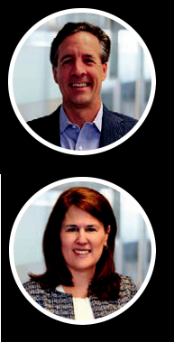

Kristin A. Gibbs | Robert G. Hauzie | William (BJ) O. Lehmann
Chief Marketing Officer, | Chief Information Officer, | Senior Vice President,
Sotera Health | Sotera Health | Corporate Development &
 |  | Strategy, Sotera Health

 | Danielle J. Menture | Erika Ostrowski | Sally R. Turner
 | Senior Vice President, | Vice President, | Chief Human Resources
 | Global Environmental, Health | Deputy General Counsel | Officer, Sotera Health
 | & Safety and Sustainability, | and Corporate Secretary,
 | Sotera Health | Sotera Health

• 4

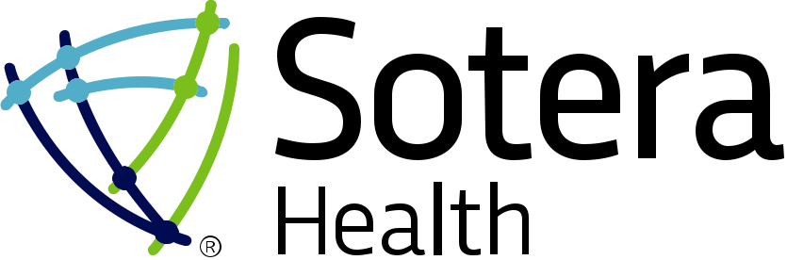

2024 Form 10-K

UNITED STATES

SECURITIES AND EXCHANGE COMMISSION

Washington, D.C. 20549

FORM 10-K

(Mark One)

- ANNUAL REPORT PURSUANT TO SECTION 13 OR 15(d) OF THE SECURITIES EXCHANGE ACT OF 1934

For the fiscal year ended December 31, 2024

or

- TRANSITION REPORT PURSUANT TO SECTION 13 OR 15(d) OF THE SECURITIES EXCHANGE ACT OF 1934 Commission file number 001-39729
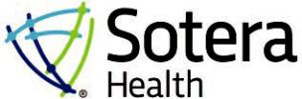

SOTERA HEALTH COMPANY

(Exact name of registrant as specified in its charter)

Delaware |  | 47-3531161
(State or other jurisdiction of incorporation or organization) |  | (I.R.S. Employer Identification No.)
9100 South Hills Blvd, Suite 300
Broadview Heights, Ohio |  | 44147
(Address of principal executive offices) |  | (Zip Code)
 | (440) 262-1410
(Registrant’s telephone number, including area code)
Securities registered pursuant to Section 12(b) of the Act:
Title of each class | Trading Symbol(s) | Name of each exchange on which registered
Common Stock, $0.01 par value per share | SHC | The Nasdaq Stock Market LLC

Securities registered pursuant to Section 12(g) of the Act: None

Indicate by check mark if the registrant is a well-known seasoned issuer, as defined in Rule 405 of the Securities Act. ☒ Yes ☐ No Indicate by check mark if the registrant is not required to file reports pursuant to Section 13 or Section 15(d) of the Act. ☐ Yes ☒ No

Indicate by check mark whether the registrant (1) has filed all reports required to be filed by Section 13 or 15(d) of the Securities Exchange Act of 1934 during the preceding 12 months (or for such shorter period that the registrant was required to file such reports), and (2) has been subject to such filing requirements for the past 90 days. ☒ Yes ☐ No

Indicate by check mark whether the registrant has submitted electronically, every Interactive Data File required to be submitted pursuant to Rule 405 of Regulation S-T (§232.405 of this chapter) during the preceding 12 months (or for such shorter period that the registrant was required to submit such files). ☒ Yes ☐ No

Indicate by check mark whether the registrant is a large accelerated filer, an accelerated filer, a non-accelerated filer, a smaller reporting company, or an emerging growth company. See the definitions of “large accelerated filer,” “accelerated filer,” “smaller reporting company” and “emerging growth company” in Rule 12b-2 of the Exchange Act.

Large accelerated filer | ☒ | Accelerated filer | ☐
Non-accelerated filer | ☐ | Smaller reporting company | ☐
 |  | Emerging growth company | ☐

If an emerging growth company, indicate by check mark if the registrant has elected not to use the extended transition period for complying with any new or revised financial accounting standards provided pursuant to Section 13(a) of the Exchange Act. ☐

Indicate by check mark whether the registrant has filed a report on and attestation to its management’s assessment of the effectiveness of its internal control over financial reporting under Section 404(b) of the Sarbanes-Oxley Act (15 U.S.C.7262(b)) by the registered public accounting firm that prepared or issued its audit report. ☒
If securities are registered pursuant to Section 12(b) of the Act, indicate by check mark whether the financial statements of the registrant included in the filing reflect the correction of an error to previously issued financial statements. ☐
Indicate by check mark whether any of those error corrections are restatements that required a recovery analysis of incentive-based compensation received by any of the registrant’s executive officers during the relevant recovery period pursuant to §240.10D-1(b). ☐
Indicate by check mark whether the registrant is a shell company (as defined in Rule 12b-2 of the Act). ☐ Yes ☒ No

The aggregate market value of the voting and non-voting common stock held by non-affiliates of the registrant as of June 28, 2024, based upon the last sale price of such voting and non-voting common stock on that date, was $1,524,907,421.

As of February 20, 2025, there were 283,473,342 shares of the registrant’s common stock, $0.01 par value per share, outstanding.

DOCUMENTS INCORPORATED BY REFERENCE

Portions of the Definitive Proxy Statement for the registrant’s 2025 Annual Meeting of Stockholders are incorporated by reference in Part III of this Annual Report on Form 10-K. Sotera Health Company intends to file the Definitive Proxy Statement with the Securities and Exchange Commission within 120 days after the end of the registrant’s fiscal year ended December 31, 2024.

Audit Firm PCAOB ID: 42 | Auditor Name: Ernst & Young LLP | Auditor Location: Cleveland, Ohio

 |  |  |  |  |  |  |  |  |  |  |  |  |  |  | SOTERA HEALTH COMPANY
 |  |  |  |  |  |  |  |  |  |  |  |  |  |  | - TABLE OF CONTENTS -
 |  |  |  |  |  |  |  |  |  |  |  |  |  |  |  |  |  |  |  |  |  |  |  |  |  |  | Page No.
PART I
Item | 1. | Business |  |  |  |  |  |  |  |  |  |  |  |  |  |  |  |  |  |  |  |  |  |  |  |  | 6
Item | 1A. | Risk Factors |  |  |  |  |  |  |  |  |  |  |  |  |  |  |  |  |  |  |  |  |  |  |  |  |  | 18
Item | 1B. | Unresolved Staff Comments |  |  |  |  |  |  |  |  |  |  |  |  |  |  |  |  |  |  |  |  |  |  |  |  |  | 44
Item | 1C. | Cybersecurity |  |  |  |  |  |  |  |  |  |  |  |  |  |  |  |  |  |  |  |  |  |  |  |  | 44
Item | 2. | Properties |  |  |  |  |  |  |  |  |  |  |  |  |  |  |  |  |  |  |  |  |  |  |  |  |  | 46
Item | 3. | Legal Proceedings |  |  |  |  |  |  |  |  |  |  |  |  |  |  |  |  |  |  |  |  |  |  |  |  |  | 46
Item | 4. | Mine Safety Disclosures |  |  |  |  |  |  |  |  |  |  |  |  |  |  |  |  |  |  |  |  |  |  |  |  | 47
PART II
Item | 5. | Market for Registrant’s Common Equity, Related Stockholder Matters and Issuer Purchases of |  |  |  |  |  |  |  |  |  |  |  |  |  |  |  |  |  |  |  |  |  |  |  |  |  | 48
 |  |  | Equity Securities
Item | 6. | Reserved |  |  |  |  |  |  |  |  |  |  |  |  |  |  |  |  |  |  |  |  |  |  |  |  |  | 49
Item | 7. | Management’s Discussion and Analysis of Financial Condition and Results of Operations |  |  |  |  |  |  |  |  |  |  |  |  |  |  |  |  |  |  |  |  |  |  |  |  | 49
Item | 7A. | Quantitative and Qualitative Disclosures About Market Risk |  |  |  |  |  |  |  |  |  |  |  |  |  |  |  |  |  |  |  |  |  |  |  |  |  | 66
Item | 8. | Financial Statements and Supplementary Data |  |  |  |  |  |  |  |  |  |  |  |  |  |  |  |  |  |  |  |  |  |  |  |  |  | 69
Item | 9. | Changes in and Disagreements with Accountants on Accounting and Financial Disclosure |  |  |  |  |  |  |  |  |  |  |  |  |  |  |  |  |  |  |  |  |  |  |  |  | 116
Item | 9A. | Controls and Procedures |  |  |  |  |  |  |  |  |  |  |  |  |  |  |  |  |  |  |  |  |  |  |  |  | 116
Item | 9B. | Other Information |  |  |  |  |  |  |  |  |  |  |  |  |  |  |  |  |  |  |  |  |  |  |  |  | 118
Item | 9C. | Disclosure Regarding Foreign Jurisdictions that Prevent Inspections |  |  |  |  |  |  |  |  |  |  |  |  |  |  |  |  |  |  |  |  |  |  |  |  | 118
PART III
Item | 10. | Directors, Executive Officers and Corporate Governance |  |  |  |  |  |  |  |  |  |  |  |  |  |  |  |  |  |  |  |  |  |  |  |  | 119
Item | 11. | Executive Compensation |  |  |  |  |  |  |  |  |  |  |  |  |  |  |  |  |  |  |  |  |  |  |  |  | 120
Item | 12. | Security Ownership of Certain Beneficial Owners and Management and Related Stockholder |  |  |  |  |  |  |  |  |  |  |  |  |  |  |  |  |  |  |  |  |  |  |  |  | 120
 |  |  | Matters
Item | 13. | Certain Relationships and Related Transactions, and Director Independence |  |  |  |  |  |  |  |  |  |  |  |  |  |  |  |  |  |  |  |  |  |  |  |  | 120
Item | 14. | Principal Accountant Fees and Services |  |  |  |  |  |  |  |  |  |  |  |  |  |  |  |  |  |  |  |  |  |  |  |  | 120
PART IV
Item | 15. | Exhibits and Financial Statement Schedules |  |  |  |  |  |  |  |  |  |  |  |  |  |  |  |  |  |  |  |  |  |  |  |  | 121
Item | 16. | Form 10-K Summary |  |  |  |  |  |  |  |  |  |  |  |  |  |  |  |  |  |  |  |  |  |  |  |  | 127
 |  | Signatures |  |  |  |  |  |  |  |  |  |  |  |  |  |  |  |  |  |  |  |  |  |  |  |  | 128
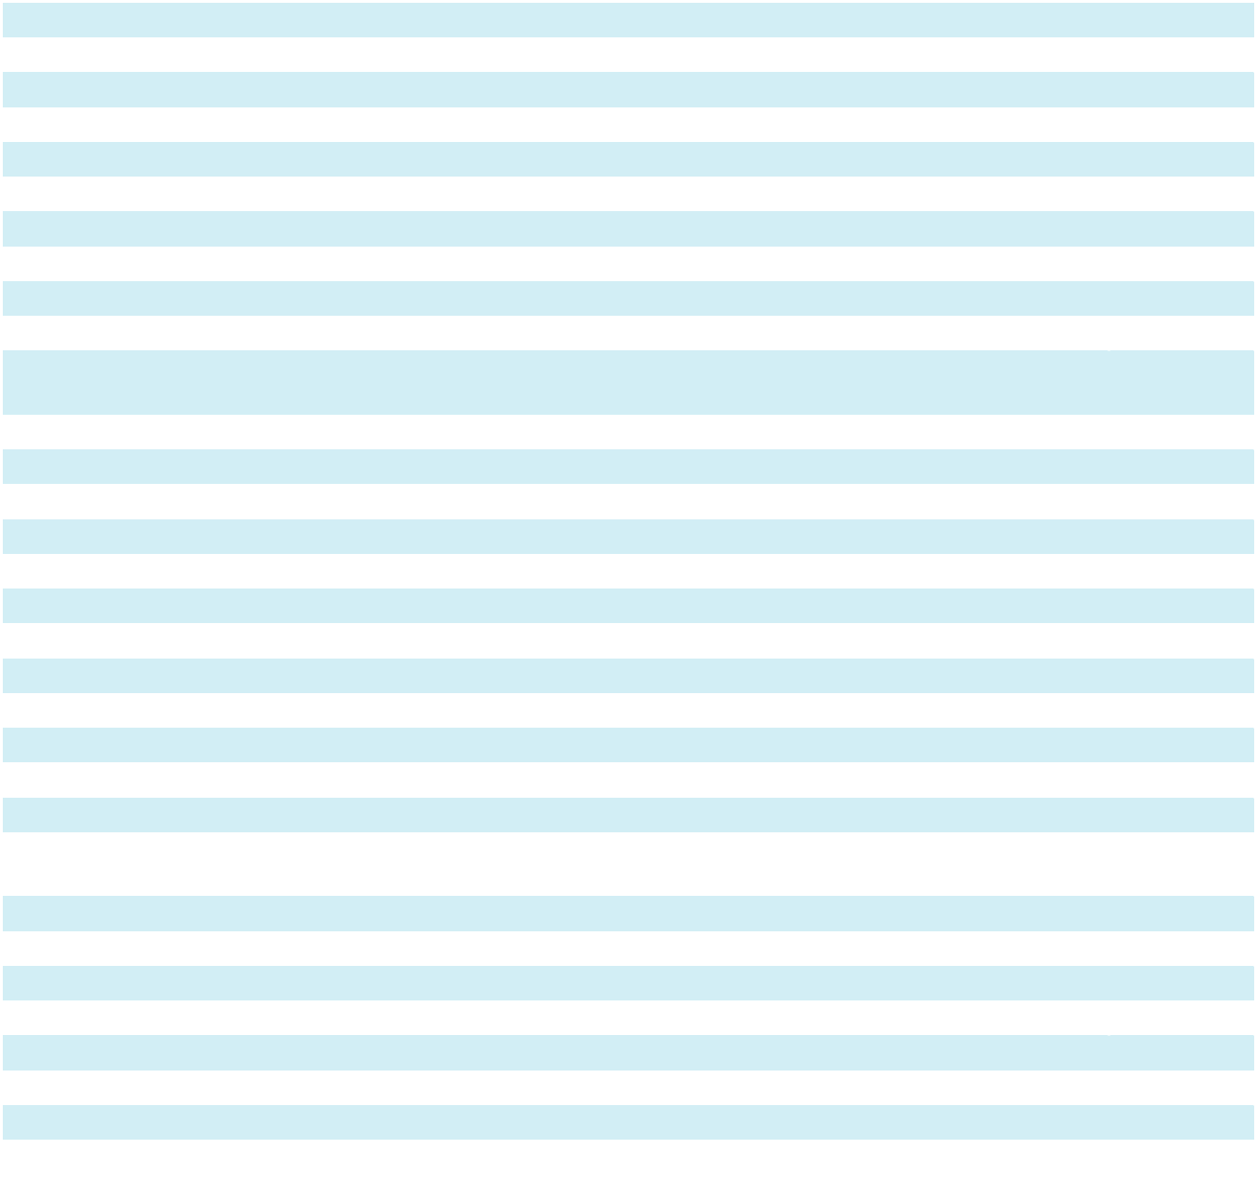

CAUTIONARY NOTE REGARDING FORWARD-LOOKING STATEMENTS

This Annual Report on Form 10-K includes “forward-looking statements” within the meaning of the Private Securities Litigation Reform Act of 1995. Forward-looking statements are often characterized by the use of words such as “believes,” “estimates,” “expects,” “projects,” “may,” “intends,” “plans” or “anticipates,” or by discussions of strategy, plans or intentions. Such forward-looking statements involve known and unknown risks, uncertainties and other important factors that could cause our actual results, performance or achievements, or industry results, to differ materially from historical results or any future results, performance or achievements expressed, suggested or implied by such forward-looking statements. Such risks and uncertainties include but are not limited to:

- a disruption in the availability or supply of, or increases in the price of, ethylene oxide (“EO”), Cobalt-60 (“Co-60”) or our other direct materials, services and supplies, including as a result of geopolitical instability and/ or sanctions against Russia by the United States, Canada, United Kingdom and/or the European Union;

- fluctuations in foreign currency exchange rates;

- evolving changes in environmental, health and safety regulations;

- health and safety risks associated with the use, storage, transportation and disposal of potentially hazardous materials such as EO and Co-60;
- the impact and outcome of current and future legal proceedings and liability claims, including litigation related to the use, emissions and releases of EO from our facilities in California, Georgia, Illinois and New Mexico and the possibility that other claims will be made in the future relating to these or other facilities;
- allegations of our failure to properly perform services and potential product liability claims, recalls, penalties and reputational harm;
- compliance with the extensive regulatory requirements to which we are subject, the related costs, and any failures to receive or maintain, or delays in receiving, required clearances or approvals;
- adverse changes in industry trends;

- competition we face;

- market conditions and changes, including inflationary trends, that impact our long-term supply contracts with variable price clauses and increase our cost of revenues;
- business continuity hazards, including supply chain disruptions and other risks associated with our operations;

- the risks of doing business internationally, including global and regional economic and political instability and compliance with various applicable laws and potentially inconsistent laws and regulations in multiple jurisdictions;

- our ability to increase capacity at existing facilities, build new facilities in a timely and cost-effective manner and renew leases for our leased facilities;
- our ability to attract and retain qualified employees;

- severe health events or environmental events;

- cybersecurity incidents, unauthorized data disclosures, and our dependence on information technology systems;

- an inability to pursue strategic transactions, find suitable acquisition targets, or integrate strategic acquisitions into our business successfully;
- our ability to maintain effective internal control over financial reporting;

- our reliance on intellectual property to maintain our competitive position and the risk of claims from third parties that we have infringed or misappropriated, or are infringing or misappropriating, their intellectual property rights;

- our ability to comply with rapidly evolving data privacy and security laws and regulations in various jurisdictions and any ineffective compliance efforts with such laws and regulations;
- our ability to generate profitability in future periods;

- impairment charges on our goodwill and other intangible assets with indefinite lives, as well as other long-lived assets and intangible assets with definite lives;
- the effects of unionization efforts and labor regulations in countries in which we operate;

- adverse changes to our tax positions in U.S. or non-U.S. jurisdictions or the interpretation and application of recent U.S. tax legislation or other changes in U.S. or non-U.S. taxation of our operations; and

- our significant leverage and how this significant leverage could adversely affect our ability to raise additional capital, limit our ability to react to challenges confronting our Company or broader changes in our industry or the economy, limit our flexibility in operating our business through restrictions contained in our debt agreements and/ or prevent us from meeting our obligations under our existing and future agreements governing our indebtedness.

4

These forward-looking statements are based on current plans, estimates and projections, and therefore you should not place undue reliance on them. Forward-looking statements speak only as of the date they are made, and we undertake no obligation to update them publicly in light of new information or future events, except as required by law. The inclusion of this forward-looking information should not be regarded as a representation by us or any other person that the future plans, estimates or expectations contemplated by us will be achieved.

You should carefully consider the above factors, as well as the factors discussed elsewhere in this Annual Report on Form 10-K, including under Part I, Item 1A, “Risk Factors” and elsewhere in this Annual Report on Form 10-K. If any of these trends, risks or uncertainties actually occur or continue, our business, financial condition or operating results could be materially adversely affected, the trading prices of our securities could decline and you could lose all or part of your investment. All forward-looking statements attributable to us or persons acting on our behalf are expressly qualified in their entirety by this cautionary statement.

Unless expressly indicated or the context requires otherwise, the terms “Sotera Health,” “Company,” “we,” “us,” and “our” in this Annual Report on Form 10-K refer to Sotera Health Company, a Delaware corporation, and, where appropriate, its subsidiaries on a consolidated basis.

5

Part I

Item 1. Business

General Information

We are a leading global provider of mission-critical end-to-end sterilization solutions, lab testing and advisory services for the healthcare industry. We are driven by our mission: Safeguarding Global Health®. We provide end-to-end sterilization as well as microbiological and analytical lab testing and advisory services to help ensure that medical, pharmaceutical and food products are safe for healthcare practitioners, patients and consumers in the United States and around the world. In 2024, our customers included over 40 of the top 50 medical device companies and nine of the top ten global pharmaceutical companies (based on revenue). Our services are an essential aspect of our customers’ manufacturing processes and supply chains, helping to ensure sterilized medical products reach healthcare practitioners and patients. Most of our services are necessary for our customers to satisfy applicable government requirements.

We are a trusted partner to approximately 5,000 customers in over 50 countries. We strive to give our customers confidence that their products meet regulatory, safety and effectiveness requirements. With our industry-recognized scientific and technological expertise, we help promote the safety of millions of patients and healthcare practitioners around the world. Across our 62 facilities worldwide, we have over 3,000 employees who are dedicated to safety and quality.

Sotera Health Company was incorporated in Delaware in November 2017 as the parent company for Sterigenics, Nordion and Nelson Labs. We completed our initial public offering and listed our shares of common stock on the Nasdaq Global Select Market (“Nasdaq”) in November 2020 under the ticker symbol “SHC.”

Our Businesses

Sterilization Services

Our sterilization services business is comprised of Sterigenics and Nordion.

Sterigenics

We are a leading global provider of outsourced terminal sterilization and irradiation services and have provided sterilization services for over 90 years. We offer a globally integrated platform for our customers in the medical device, pharmaceutical, food safety, and advanced applications markets, with facilities strategically located to be convenient to our customers’ manufacturing sites and distribution hubs or routes.

Terminal sterilization is the process of sterilizing a product in its final packaging; it is an essential, and often government-mandated, last step in the manufacturing process of healthcare products before they are shipped to end-users. The products that we sterilize include procedure kits and trays, implants, syringes, catheters, wound care products, medical protective barriers, including personal protective equipment (“PPE”), laboratory products and pharmaceuticals.

Sterilization Services

We offer our customers a complete range of terminal sterilization services, primarily using the three major commercial terminal sterilization technologies: gamma irradiation, EO processing and E-beam irradiation. We continue to invest in and develop our capabilities and our current methods of sterilization and we continue to explore new alternative modalities and technologies. Our primary terminal sterilization technologies include:

6

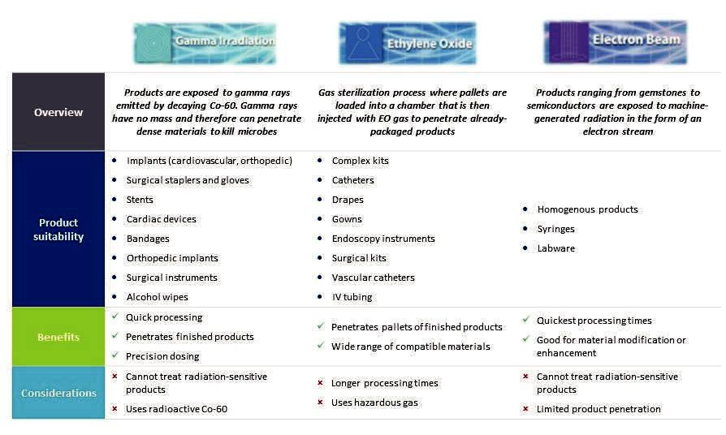

We provide gamma irradiation services at 23 of our facilities, EO processing services at 17 of our facilities and electron beam (“E-beam”) irradiation services at eight of our facilities.

We also invest in alternative modalities to serve our customers. X-ray irradiation is a process in which products such as medical devices and lab ware are exposed to machine-generated radiation in the form of X-rays for the purpose of sterilization and decontamination. X-rays are similar in performance to gamma rays and are useful for processing certain materials by virtue of the high penetration capabilities of X-ray. We utilize X-ray irradiation at one of our sterilization facilities for bio-hazard reduction for the United States Postal Service (“USPS”). We are also investing in NO2-based sterilization and other technologies, which have been effective in sterilizing of prefilled syringes, drug-device combination products and custom implants.

Sterilization Applications

Sterigenics primarily provides sterilization services for medical device manufacturers and the pharmaceutical industry. Sterigenics also provides decontamination services for the food industry. Additionally, Sterigenics provides various advanced applications for other organizations and companies, including the USPS and semiconductor manufacturers. Our customers select the sterilization method that meets the needs of their products and requirements of regulators and we deliver sterilization services according to their customer-specific protocols. In most cases, customers are serviced from more than one facility.

- Medical device sterilization. Medical device sterilization is a regulatory requirement in many jurisdictions and an important and last step in the manufacturing of healthcare products such as medical protective barriers, including PPE, procedure kits and trays, implants, syringes, catheters and wound care products. A broad range of single-use, prepackaged medical products, as well as certain consumer products, are required by government regulations to be sterile, or meet certain acceptable microbial levels when sold. These products are not manufactured in a “sterile” or “clean” environment and are therefore inhabited by potentially harmful microbes. Products must therefore be treated before shipment, either in-house by the manufacturer or by an outsourced sterilization provider such as Sterigenics.

We have developed a consultative approach with medical device manufacturers that expands our service offerings beyond core product sterilization, as we believe they want value-added solutions from their outsourced sterilization partners that reach beyond the traditional scope of sterilization. We offer customers a comprehensive selection of advisory services in design, testing, production and supply chain management for sterile healthcare products before, during and after the sterilization process to ensure and improve a product’s speed to market and compliance with regulatory requirements.

7

- Pharmaceuticals. We provide comprehensive outsourced terminal sterilization solutions to help our customers in the pharmaceutical industry meet regulatory requirements. Our sterilization expertise covers a variety of pharmaceutical drug products, such as active pharmaceutical ingredients, pre-filled syringes, drug components, excipients and primary packaging and components.

In addition, pharmaceutical companies are starting to market disposable delivery devices, such as auto-inject devices for epinephrine, which are combined medical device and pharmaceutical products. As these disposable delivery devices are subject to both medical device regulations and pharmaceutical regulations, we believe these companies are looking to leading outsourced sterilization providers like us for our expertise in sterilizing these complex devices. We believe that the complementary capabilities and expertise in our Nelson Labs business make Sterigenics an attractive sterilization partner to customers in the pharmaceutical industry. We can provide a full suite of services across the Company to help our customers throughout key stages in the lifecycle of these complex products.

- Food and agricultural products. We provide microbial reduction and microbial remediation services for food and agricultural products. Generally, in a microbial reduction process, products are exposed to lower levels of treatment than in a sterilization process. This process is not intended to render a product free of viable organisms but rather to reduce their number. In connection with our microbial reduction services, we treat a wide array of products such as spices, herbs, animal feed and food packaging materials to address safety concerns of customers and consumers or to extend shelf life. We currently irradiate a variety of food and food packaging products, ranging from orange juice to steaks, to guard against harmful bacteria, such as listeria, salmonella, E. coli and other pathogens. Microbial reduction and irradiation offer producers and processors a method to safeguard against bacteria from the time of the packaging of their products to the time they reach consumers. We also provide microbial remediation services that stop the progression of damage to products and help make the products safe for distribution.

- Commercial, advanced and specialty applications. We provide a wide range of advanced applications services for industrial materials to customers that use ionizing radiation to modify materials or products. The advanced applications sterilization industry is comprised of a large number of distinct segments that can be addressed using our services for radiation processing. Materials that undergo advanced application processes include products such as power semiconductors, polymers and gemstones. In addition, we utilize our ionizing radiation services to provide bio-security services to the USPS by treating and protecting the mail against unwanted pathogens and biohazards. We believe we are the only provider of this service to the USPS. We also treat commercial products, such as cosmetics, with our microbial reduction services. In Canada and Europe, where recreational cannabis, medical cannabis, or both, are legal, we provide commercial gamma and E-beam irradiation services for decontamination of cannabis.

Sterigenics Customers

In 2024, Sterigenics served more than 2,000 customers. We follow extensive validation procedures with our customers to determine the optimal sterilization method for each product and to validate that the chosen method will achieve the sterility requirement for that product. Once a sterilization process has been validated, we adhere to our customers’ process specifications to treat their product.

Although sterilization services are an essential element in our customers’ manufacturing processes, they generally represent a small fraction of the total end-product cost of medical devices. We believe this means that our customers choose our services based on quality, consistency of service and location rather than solely on the cost. These deep, tenured customer relationships are supported by multi-year contracts with cost pass-through provisions, which have resulted in recurring revenue streams.

For many products, our customers are required to include the specific chamber or chambers at which the product was validated to validate a product’s listing in the Food and Drug Administration (“FDA”) (or foreign equivalent) product registration and are typically required to re-register if they switch facilities, which makes switching locations for a particular product a difficult and expensive process for our customers. This dynamic contributes to low customer turnover and long-term relationships.

In addition, Sterigenics has achieved high historical customer retention and renewal rates—Sterigenics has 100% renewal rates of its top ten customers for more than five consecutive years, and an average tenure of over a decade with its top 25 customers over the last five years—and minimal customer concentration. We have also introduced innovative, advanced processing systems for outsourced sterilization that are designed to enhance operating efficiencies, improve turnaround times and provide for greater processing flexibility without sacrificing quality, consistency or reliability. More than 90% of Sterigenics’ revenues for the year ended December 31, 2024 were from customers under multi-year contracts.

8

Sterigenics Competition

We compete globally with Applied Sterilization Technologies, a segment of STERIS plc, as well as other smaller or regional outsourced sterilization companies. In addition, some manufacturers have invested or are investing in in-house sterilization capabilities. We also face competition from other technologies. Our services generally compete on the basis of the quality of technology and services offered, level of expertise in each of the major sterilization methods, level of expertise in the applicable regulatory requirements, proximity to customers and the cost of services.

Sterigenics Suppliers

Sterigenics primarily purchases its supply of Co-60 sources, the key input into the gamma sterilization process, from Nordion. Our supply of Co-60 sources is at times impacted by the global availability of Co-60. Our supply of EO is sourced from various suppliers around the world. There is more than one supplier of EO in most of the countries in which we operate; however, in the United States, there is a single supplier for EO to our industry. We have not historically experienced any supply disruptions, and our U.S. supplier has redundant production facilities to help ensure reliable EO supply. We also have a license in the United States to distribute EO to self-supply should the need arise and we determine the need to make the necessary investments.

Sterigenics Facilities

With 48 facilities in 13 countries, our global network of sterilization facilities represents a significant competitive advantage. We serve many of our sterilization customers at more than one facility, with approximately 80% of Sterigenics’ net revenues attributable to customers using more than one of our facilities and more than 50% of Sterigenics’ net revenues attributable to customers using five or more of our facilities in 2024. Extensive capital, technical expertise and regulatory knowledge are required to build and maintain our facilities. We estimate that building a new facility may cost over $50 million and the cost may vary depending on sterilization modality, in addition to requiring extensive and complex licensing approval and regulatory compliance processes. We estimate that the cost to replicate the facilities in our network alone could exceed $2.0 billion, in addition to investments required to meet associated technical and regulatory requirements.

Our global facility network, built and expanded over several decades, is strategically located convenient to customers’ manufacturing sites and distribution hubs or routes. For many of our customers, the location of our facilities is important because transportation and logistics costs can be meaningful. We also employ proprietary technology to provide customers with increased visibility into our processes. Sterigenics GPS™ enables customers to monitor the sterilization process in real-time and better manage their supply chain. These features improve the accuracy and visibility of customer order information and quality data, which in turn provide enhanced transparency to regulatory agencies around the world, further enhancing our reputation as a company with regulatory expertise. We are focused on continuing to leverage advanced technology and service offerings to better serve customers, and we believe our capital and resource commitment in this area drives customer loyalty and retention.

By leveraging a global operating system, we drive operational excellence across our network of facilities to achieve high levels of safety, quality, operating efficiency and customer satisfaction to provide a uniform customer experience. Most of our facilities are either International Organization for Standardization (“ISO”) 13485 certified, ISO 9001 certified, or both, as well as licensed and registered in all necessary jurisdictions to comply with government required regulations.

Nordion

Nordion is the leading global provider of Co-60 used in the sterilization and irradiation processes for the medical device, pharmaceutical, food safety, and high-performance materials industries, as well as in the treatment of cancer. Co-60 is a radioactive isotope that emits gamma radiation that sterilizes items by killing contaminating micro-organisms. In addition, Nordion is a leading global provider of gamma irradiation systems, which are the units that house the Co-60 sources within a gamma sterilization facility. We estimate that gamma sterilization, which is a critical component of the global infection control supply chain, accounts for approximately 30% of single-use medical device sterilization worldwide. Nordion’s customers include outsourced contract sterilizers, including Sterigenics, medical device manufacturers that sterilize their products in-house and other specialized medical device manufacturers. Approximately 90% of Nordion’s revenues for the year ended December 31, 2024 were from customers under multi-year contracts.

We provide our customers with high quality, reliable, safe and secure Co-60 source supply at each stage of the source’s life cycle. We support our customers with handling and processing of Co-60, recycling of depleted sources and global logistics enabled by our licensed container fleet. We also provide regulatory and technical service expertise to improve the risk profiles and enhance effectiveness of gamma processing operations. Without this radioactive material, gamma sterilization would not be

9

possible on the global scale at which it is used today. We are integral to our customers’ operations due to highly coordinated and complex installation processes.

Nordion has a long history in gamma technologies. Nordion designs, installs and maintains gamma irradiation systems. Nordion developed the first Co-60 based tele-therapy unit for cancer treatment in 1951 and the first panoramic irradiator in 1964. In addition to selling Co-60 sources for sterilization purposes, Nordion also sells high specific activity Co-60 (“HSA Co-60” or “medical Co-60”) used in stereotactic radiosurgery as a radiation source for oncology applications, specifically in Gamma Knife® and other similar applications. Today, Co-60 is a critical part of treatment for brain and other cancers because it is noninvasive, reliable, effective and safe to use.

Co-60 Production Process

Nordion’s primary product is Co-60 sources. Co-60 is a radioactive isotope used in radiation sterilization that decays naturally at a rate of approximately 12% annually. Co-60 is produced by placing cobalt-59 (“Co-59”), the most common form of cobalt, into a nuclear power reactor to be activated.

The Co-60 production process requires high purity Co-59. Co-59 is produced globally, primarily as a byproduct of nickel and copper mining, and used in a variety of industrial applications. The Co-59 used for sterilization accounts for a small portion of overall Co-59 demand. Co-59 is compressed into “targets,” which are pellets and slugs suitable to be activated into Co-60.

These targets are then encapsulated and delivered to be installed in nuclear reactors. Depending on the type of reactor and the location of the Co-59 in the reactor, the conversion process can take between 18 months to five years. Once the conversion to Co-60 is complete, the targets are extracted from the nuclear reactor while the reactor is shut down and shipped to Nordion to be processed into Co-60 sources to be sold to customers. See Item 1A, “Risk Factors”—Risks Related to the Company—Safety risks associated with the use, storage and disposal of potentially hazardous materials, such as EO and Co-60, may result in accidents or liabilities that materially affect our results of operations.”

Nordion Products

Co-60 is sold to customers by its level of radioactivity as measured in curies. Our customers typically buy low specific activity Co-60 (“LSA Co-60”) for industrial sterilization use and HSA Co-60 for medical use. At our Ottawa facility, we receive and process the targets to form the final Co-60 source product with the desired amount of radioactivity for each customer order. The Co-60 sources undergo stringent and sophisticated quality assurance testing at our Ottawa facility. The final product is then placed in specialized containers, which Nordion uses to transport Co-60 to our customers.

We transport the Co-60 sources via proprietary lead and steel containers that are licensed to meet all applicable international shipping requirements. We believe we have the most extensive expertise in Co-60 logistics. There is a significant regulatory burden in the production, management and transportation of fleets of containers of Co-60 sources. Our transportation routes and carriers are highly controlled, and we provide regular and comprehensive training for employees and carriers who are involved in moving the Co-60 globally.

We also design, install and maintain gamma irradiation systems, which include radiation shielding, a series of conveyors and control systems that are designed to expose products to the correct gamma radiation dosage in a safe and efficient manner. A gamma irradiation system is the infrastructure that houses the Co-60 sources and makes up a part of a sterilization and warehousing facility. We have designed and built over 100 of the estimated 290 large scale irradiation systems active globally. Our installation, physics and engineering teams are comprised of highly trained professionals who provide fast and ongoing technical support from source installation to emergency response.

We also offer our customers a for-fee spent Co-60 source return service for depleted Co-60 sources that have reached the end of their useful life, which is often 20 or more years. We also have a source recycling program that extends the useful life of individual slugs from the decayed product up to an additional 20 years, pairing them with new slugs to make new Co-60 sources.

Nuclear Reactor Operators

Given the timeline required to produce Co-60, forecasting supply and working closely with nuclear power reactor operators to manage the amount and timing of shipments represents an important business capability of Nordion.

10

The amount of Co-60 supply is ultimately determined by the number of nuclear reactors that are capable of producing Co-60 at a given point in time. Our access to Co-60 tends to vary on a quarterly basis, due primarily to nuclear reactor maintenance schedules, the length of time required to convert Co-59 into Co-60, the limited number of facilities that can generate Co-60 in an economically efficient manner, and the timing of the removal of Co-60 from reactors. While short-term variability in Co-60 supplier delivery timing can sometimes result in variability in our financial performance across fiscal quarters, we work with multiple reactor sites that operate on consistent and predictable discharge and harvest schedules over the long-term.

Nordion currently has access to Co-60 supply at multiple nuclear reactors pursuant to multi-year contracts with three operators that cover 13 reactors at five generating stations, that extend to dates between 2026 and 2064, with our largest supplier under contract until 2064. See Item 1A, “Risk Factors”—Risks Related to the Company—We depend on a limited number of counterparties to provide the materials and resources we need to operate our business. Any disruption in the availability of, or increases in the price of, EO, Co-60 or our other direct materials, services and supplies, including as a result of geopolitical instability and sanctions against Russia by the United States, Canada, United Kingdom and European Union, may have a material adverse effect on our operating results.” The substantial majority of our Co-60 material has historically been produced under multi-year contracts with nuclear reactor operators in Canada and Russia. Nordion provides Co-59 targets to its Canadian and Russian reactor suppliers, manufactured to proprietary specifications customized for each supplier. We also acquire a portion of our Co-60 supply from reactors that produce Co-60 in Argentina, China and India.

The vertical integration of Nordion and Sterigenics has allowed us to more confidently make meaningful long-term investments to expand Co-60 supply for the medical products sterilization industry. See Item 7, “Management’s Discussion and Analysis of Financial Condition and Results of Operations—Trends and Key Factors Affecting Our Results of Operations.” Currently, approximately 9% of nuclear reactors worldwide are the type of reactors that have been capable of producing commercial quantities of Co-60. In December 2018, we acquired patents that may allow us to significantly increase our sourcing options for Co-60 and further expand the market for gamma sterilization. Additionally, in February 2020, we announced a collaboration with Westinghouse Electric Company to further develop the technology to produce Co-60 in Pressurized Water Reactors. We believe this collaboration could further diversify our supply with reliable U.S. domestic partners and encourage the implementation of this patented technology at other reactors around the world.

We continue to evaluate opportunities to increase Co-60 production, including through partnerships with CANDU reactor operators in Canada and Romania that would involve investing in their reactor infrastructure to enable long-term production of Co-60.

Nordion Customers

In 2024, Nordion supplied products and services to approximately 40 customers, including medical device manufacturers and gamma sterilization service providers. Co-60’s consumable nature results in annual natural decay at an approximately 12% annual rate, which creates stable, recurring demand as customers must purchase incremental supply in order to satisfy ongoing needs. We are integral to our customers’ operations due to highly coordinated and complex installation and service processes that require expertise in handling and shipping radioactive material as well as our deep knowledge of the relevant regulatory and compliance requirements. Customer relationships are typically governed by multi-year supply agreements.

One of Nordion’s customers is Sterigenics, which competes with several of Nordion’s other gamma sterilization service customers. When we acquired Nordion in 2014, we established information barriers between Nordion and Sterigenics with regard to certain customer information, which remain in place today, and certain of our agreements with Nordion’s customers require that we maintain these barriers. These barriers prohibit us from managing a customer pricing strategy across our Sterigenics and Nordion segments.

We are a leading global supplier of HSA Co-60 used in oncology-related stereotactic radiosurgery devices, including the Gamma Knife®, which use directed gamma rays for certain oncology applications. We also supply other medical equipment manufacturers and sub-contractors in the industry who require the concentrated radiation dose capabilities of HSA Co-60.

Nordion Competition

Nordion’s two main competitors in the industrial LSA Co-60 sources supply market are a Russian Co-60 sources producer, which historically has supplied certain regions in Europe and Asia, and a China-based producer, which supplies the domestic Chinese market. In addition, certain regional competitors have the capability to produce Co-60. For example, a producer in Argentina supplies certain regions in Central and South America and an Indian producer supplies India and certain parts of Southeast Asia. These competitors could potentially increase their global competition capabilities in the future. Nordion also

11

competes indirectly with other developing modalities of sterilization, such as X-ray technology, that use electricity to generate radiation and therefore do not require Co-60 sources.

Nordion’s main competitors in the HSA Co-60 industry include suppliers in China, Sweden and North America that have the capability to produce medical Co-60.

Nordion Facilities

Nordion’s operations are supported by a facility in Kanata, Canada dedicated to processing and shipping cobalt, and a European distribution facility in Milton, United Kingdom.

Lab Testing and Advisory Services

Nelson Labs

Lab testing and advisory services are necessary across the medical device and pharmaceutical product lifecycles to evaluate and ensure the safety and effectiveness of healthcare products. We are a global leader in outsourced microbiological and analytical chemistry testing services for the medical device and pharmaceutical industries. In addition to our testing services, our customers often call upon our experts for technical assistance, regulatory consulting and our advisory services. We go to market leveraging our global footprint and an extensive range of services under our Nelson Labs brand.

We have established ourselves as a critical partner for our customers through our delivery of high-quality services, quick testing turnaround times, responsiveness, high-touch support and easy accessibility to our science and service teams. We have an industry-leading brand recognized for the quality and comprehensiveness of our services, both of which can take many years to build. Further, we believe that our testing and advisory services offerings and experience across a broad array of products differentiate us from smaller laboratories, as we are able to provide testing and advisory services across the entire lifecycle of our customers’ multitude of products. Our scale combined with our global network enable us to undertake significant and time-sensitive projects for our customers that might typically require them to interface with multiple labs. This allows us to simplify complex issues for our customers and streamline communication and execution. Moreover, the integration across our services and facilities enables us to assist our customers in minimizing their business continuity risk by reducing capacity shortages, turnaround time delays and throughput issues.

Our microbiology and analytical chemistry services include over 900 tests. We also provide for-fee advisory services that position us as thought leaders in the industry and increase the demand for our testing offerings. These can be categorized into three broad categories that address different stages of customers’ product lifecycle:

- Product Development and Validation. Prior to a new medical product or alteration to an existing product being submitted for regulatory approval, Nelson Labs provides a variety of tests to customers during the research and development stage. These include tests that assist the client in:

◦ | Product design | ◦ Cleaning and disinfection validation (for reusable devices)
◦ | Material selection | ◦ | Package barrier properties
◦ | Biological safety evaluation | ◦ | Distribution simulation
◦ | Toxicological risk assessment | ◦ Filtration efficiency and physical functionality of PPE
◦ Sterilization modality selection and |  |  | (including surgical facemasks, N95 respirators, gowns, drapes
 | sterilization validation |  | and other PPE)

We provide sterilization modality selection and sterilization validation services for a variety of sterilization modalities, including the three major modalities offered by Sterigenics—gamma irradiation, EO processing and E-beam— allowing us to serve our customers in multiple areas.

12

- Expert Advisory. Bringing a medical product or drug to market can be a long and complex process, especially in the context of constantly evolving standards in a changing regulatory environment. Nelson Labs provides expert advisory services to aid customers in navigating the appropriate standards and regulatory environments. These services include:

◦ | Study design | ◦ | Technical troubleshooting and scientific problem solving
◦ | Development and justification of | ◦ | Regulatory compliance related services, including supporting
 | acceptance criteria |  | clients through the regulatory submission process
- Onsite facility evaluation and validations

Our expert advisory services provide additional value and expertise at any stage of the product development life cycle. Nelson Labs offers these services on a standalone basis or as a combined offering with our lab testing services, which creates opportunities for cross-selling with our existing customers for both services. Our expert advisory services are also complemented by our ongoing education offerings conducted through webinars, seminars, tailored onsite education sessions and our website.

- Routine Sterility and Quality Control Testing. Once a product has received regulatory approval and is in production, Nelson Labs provides ongoing quality control testing, including production batch verification testing and environmental testing of the client’s production systems and facilities, the requirements for which vary based on applicable standards. Nelson Labs performs bacterial endotoxin testing or quarterly dose audits for devices sterilized using irradiation, and biological indicator testing for devices sterilized with EO. Nelson Labs also provides testing for producers of non-sterile products to ensure they are free of objectionable organisms. Often, Nelson Labs provides this ongoing routine quality control testing (based on production lot sizes) for the products for which it performed initial validation testing. These products are often sterilized by Sterigenics.
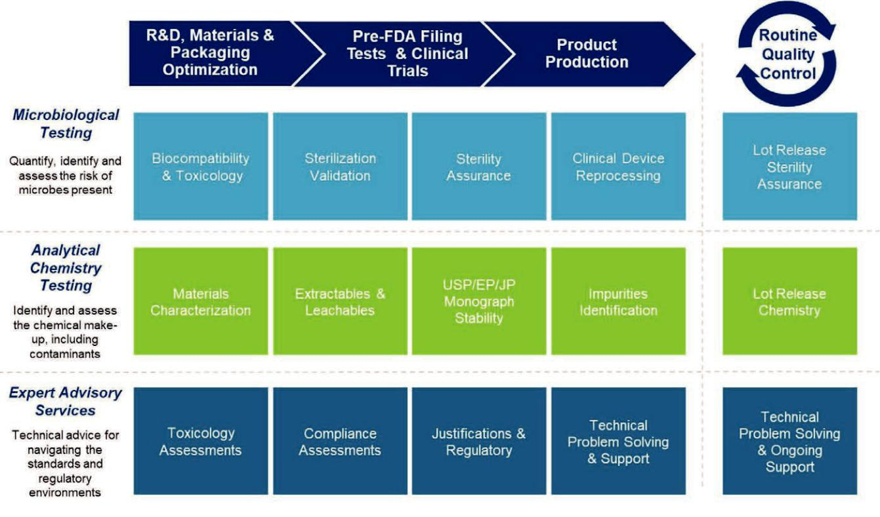

The testing process commences when Nelson Labs receives samples and a testing request from the customer. Samples are triaged and assigned to specific lab departments, where laboratory analysts and study directors verify orders and interface with customers directly to clarify, adjust or enhance testing as needed to ensure compliance with regulatory standards. Once the sample has been tested, the order is closed out and results are verified by the study director and a technical reviewer prior to electronic delivery of the final customer report via a secure online customer portal.

We operate in an industry that requires significant regulatory and specialized scientific expertise. At a minimum, providers must maintain the proper certifications and accreditations from key regulatory and accreditation bodies, as well as obtain qualification by each customer as a “qualified supplier,” which is often required at the corporate level and at each of the customer’s operating sites. We employ approximately 600 scientists, technicians and service specialists, creating a substantial

13

competitive advantage in terms of expertise. Our experts serve in predominant roles on a number of standards writing organizations, including the United States Pharmacopeia, AAMI, American Society of Testing and Materials and the ISO. We have established credibility and trust with regulators and standards writing organizations which helps us educate customers about the continually changing testing requirements in a complex and evolving regulatory landscape. Our regulatory and scientific expertise in laboratory testing allows us to serve as a thought leader within the industry and provide high-quality service to our customers. We focus on providing highly differentiated services that our customers can rely upon to ensure compliance of and enhance their products. For example, over the course of 15 years, we have developed a proprietary, world-class compound database with over 8,000 known elements which enables our extractables and leachables testing. This database allows us to provide analytical data that differentiates our capabilities from our competitors.

We provide microbiological and analytical chemistry laboratory tests across the medical device and pharmaceutical industries. Specifically, our medical device lab testing services include microbiology, biocompatibility and toxicology assessments, material characterization, sterilization validation, sterility assurance, packaging validation and distribution simulation, reprocessing validations, facility and process validation and performance validation and verification of PPE barriers and material. Our pharmaceutical lab testing services include microbiology, biocompatibility and toxicology assessments, extractables and leachables evaluations of pharmaceutical containers, sterilization validation, sterility assurance, packaging validation and distribution simulation and facility and process validation.

Nelson Labs benefits from many of the same underlying growth drivers as our sterilization business, including the global utilization of medical devices and pharmaceutical products and the importance of compliance with continuously evolving global regulatory requirements. In particular, recent global regulatory changes, such as the enactment of the European Union Medical Device Regulation 2017/745 and the FDA’s modernization of the premarket notification process under Section 510(k) of the Federal Food, Drug and Cosmetic Act, have increased the requirements for the testing and sterilization of medical devices. The COVID-19 pandemic also increased testing demand due to new FDA Emergency Use Authorizations, which define testing criteria necessary for the direct release of masks and respirators to hospitals and clinics without FDA submission. Because we provide product development and validation testing services to clients launching new products or altering existing products, this business benefits from the ongoing technological advances and increasing complexity of medical and pharmaceutical products.

Nelson Labs Customers

In 2024, Nelson Labs served approximately 3,000 customers, including many leading medical device manufacturers and pharmaceutical companies. We have recurring and stable customer relationships and benefit from minimal customer concentration. Our services are an essential component in our customers’ research and development and ongoing quality control processes but represent a small portion of end-product cost, which allows us to maintain long-term customer relationships and provide services that are integral to the supply chains of our global customers. We support customers through solutions-focused relationship managers, dedicated service centers and a team-wide service ethic. Nelson Labs has developed a proprietary customer portal that provides our customers quick and convenient access to important product information and customer service. The portal allows our customers to see their tests, status of the tests, estimated completion date and final reports and includes a live chat system connected to our customer service team.

Nelson Labs Competition

We primarily compete in the global lab testing services market with a range of providers, from national or international players to other smaller regional or niche laboratories. Our products and services compete on the basis of the quality of services offered, breadth of services, level of expertise in each testing method, delivery time, level of expertise in the applicable regulatory requirements, our reputation with customers and regulators and the cost of services.

Nelson Labs Suppliers

We purchase our lab testing supplies from a number of vendors mainly in the United States and occasionally throughout the world. In many cases we have redundant sources of supplies that minimize our risk of concentration. In addition, some crucial supplies are placed on reserve at specific vendors for our exclusive use.

Nelson Labs Facilities

We operate from a five-building campus in Salt Lake City, Utah, with 85 laboratories including metrology, training, media prep labs, five ISO Class V certified clean rooms and customizable lab spaces. We also have facilities in Itasca, Illinois; Leuven,

14

Belgium; Pleasant Prairie, Wisconsin; Wiesbaden, Germany, and seven other laboratories embedded in our Sterigenics sterilization facilities in North America, Europe and Asia.

Intellectual Property

Our businesses rely on certain proprietary technologies. Most of the proprietary technologies used in our businesses are unpatented. Some of our technologies, including certain processes, methods, algorithms and proprietary databases, are maintained by the business as trade secrets, which we seek to protect through a combination of physical and technological security measures and contractual measures, such as nondisclosure and confidentiality agreements. We also have limited proprietary technologies that are covered by issued patents or patent applications, in particular related to potential new Co-60 supply opportunities for our Nordion business.

The name recognition of our businesses is a valuable asset. Many of our business names are the subject of trademark registrations or applications in the United States or certain other jurisdictions, or part of registered domain names.

Human Capital Resources

One of our values is People. We value a global team that is talented, experienced, inclusive, respectful, passionate and collaborative. Our human capital strategy is aligned with our business strategy and priorities and focuses on developing and delivering global solutions to attract, develop, engage and retain top talent. On an annual basis, we review our employees to assess performance and leadership potential. We also create succession plans and individual development plans to ensure we have the team needed for the future. As of December 31, 2024, we employed over 3,000 employees worldwide. Certain of our employees, primarily outside of the United States, are represented by labor unions or work councils and are negotiating or working under collective bargaining or similar agreements, some of which are subject to periodic renegotiation. One labor union within the U.S., representing approximately 40 employees, is covered under a collective bargaining agreement.

We are committed to providing a safe work environment for our employees and contractors. We have implemented a health and safety program to manage workplace safety hazards and to protect employees. The program includes periodic reviews of our work practices by external third parties as inputs for continuous improvement. Additionally, as part of our corporate governance practices, we review the outcomes of our safety program at the highest levels of the Company, including our board of directors.

We are committed to creating a positive employee experience for our teams. We work to achieve this through our focus on the inclusion, well-being and development of all of our team members.

Governmental Regulation and Environmental Matters

We are subject to environmental, health and safety laws and regulations in the jurisdictions in which we operate, including laws, regulations and permit requirements with respect to our use of Co-60, EO and E-beam. These requirements limit emissions of, and the exposure of workers to, gamma radiation and EO. Nordion’s Kanata facility is licensed as a Class 1B nuclear facility in Canada, regulated by the Canadian Nuclear Safety Commission (“CNSC”), and is audited across various dimensions of this license on an annual basis. Our Nuclear Substance Processing Facility Operating license, CNSC Export license and CNSC Device servicing licenses for our Kanata facility were renewed in October 2015 for a 10-year period, and Nordion is currently engaged in the renewal process for these licenses set to expire in 2025. In addition to the nuclear aspect of our products, many of the products that we process are medical devices directed for human use or products used in the manufacture of medical devices that are directed for human use. Our facilities hold various ISO certifications including ISO 9002, 9001, 13485, 14001, 45001 and 17025. We have device, facility, and specific product registrations with North American (Health Canada and the FDA) and European Drug and Device health regulators. These regulators exert oversight through requirements for a product registration and direct audit of our operations.

Additionally, our operations in the United States and the majority of our facilities outside the United States (to the extent we are processing or testing a product that will end up in the U.S. market) are regulated by the FDA. We are also regulated by other health regulatory authorities in other countries. Specifically, these operations include some of our sterilization and product testing activities that may constitute “manufacturing” activities and are subject to FDA requirements. These requirements include site, contract drug manufacturer and supplier of active pharmaceutical ingredients registration and listing and manufacturing requirements. Regulations issued by the Occupational Safety and Health Administration (“OSHA”), the U.S. Nuclear Regulatory Commission (“NRC”) and other agencies also require that equipment used at our facilities be designed and operated in a manner that is safe and with proper safety precautions and practices when handling, monitoring and storing EO and Co-60.

15

We strive to comply with these regulatory requirements and could be subject to significant civil and criminal fines and penalties for non-compliance. To reduce the risk of noncompliance, we employ engineering and procedural controls and pollution control equipment and undertake internal and external regulatory compliance audits at our facilities. We have a proactive environmental health and safety (“EH&S”) program and a culture of safety and quality across all business units, and we employ a Senior Vice President of Environmental, Health and Safety who reports directly to the Chief Executive Officer and has a team of approximately 50 employees.

For additional information, please see Item 1A, “Risk Factors”—Risks Related to the Company. We are subject to extensive regulatory requirements and routine regulatory audits in our operations. We must receive certain permits, licenses and/or regulatory clearance or approval for our operations. Compliance with these regulations is costly, and failure to comply with all laws and regulations or to receive or maintain permits, licenses, clearances or approvals may impact our revenues, profitability, financial condition or value. We may face liability and reputational risks even if we comply with all laws and regulations.”

EO Regulatory Overview

In addition to general environmental laws and regulations, EO facilities and the EO sterilization process are subject to specific regulatory requirements under federal laws in the United States and the laws of the countries in which we operate, including European Union regulations. These additional regulations include specific requirements for permissible employee exposure limits, process safety programs, approved EO containers and their transportation, facility security, quality system programs, emission control systems and emission limits and products allowed to be treated with EO. Some state and local governments have additional environmental laws, stricter regulations or other requirements, including permitting programs that set forth operational parameters for EO sterilization facilities. In the United States, OSHA regulations limit worker exposure to EO. The use of EO for the reduction of bioburden on or sterilization of an approved list of products, including medical devices, pharmaceutical products, spices, and cosmetics is regulated by the U.S. Environmental Protection Agency (“US EPA”) under the Clean Air Act (“CAA”) and the Federal Insecticide, Fungicide and Rodenticide Act (“FIFRA”). In addition, FDA regulations dictate the acceptable amount of EO residue on different types of EO-processed products. Most other countries in which we operate have similar EH&S and worker exposure regulations.

Our EO sterilization facilities evacuate EO from the sterilization chambers and aeration rooms. Most countries in which we operate have varying emission control requirements for EO emissions from our facilities. We are investing in additional controls on EO emissions at our facilities to meet or exceed current and expected future regulatory requirements and further reduce facility emissions. In the United States, our supplier maintains FIFRA registrations for EO as a medical device sterilant for users of EO across the United States. On March 14, 2024, the US EPA announced final rules under the National Emission Standards for Hazardous Air Pollutants (“NESHAP”) to govern EO sterilization facilities in the United States. The final regulation requires EO sterilization facilities to implement additional air pollution technologies, practices and procedures designed to further reduce EO emissions. For facilities like ours, the final NESHAP regulation imposes new requirements such as higher efficiencies for EO emission controls, implementation of permanent total enclosure capture technology, and use of continuous emissions monitoring systems (“CEMS”). Our operations are required to comply with the final NESHAP EO sterilizer regulation by April 6, 2026 and to conduct a compliance test and demonstrate compliance within 180 days after that date.

In January 2025, the US EPA announced its final Interim Decision (“ID”) under FIFRA relating to the registration of EO for medical device sterilization. Over the next one to ten years, the FIFRA ID requires users of EO, including EO sterilization facilities like ours in the United States, to reach and maintain reduced employee exposure levels of EO; implement heightened worker protection practices, particularly in those areas of sterilization facilities where workers do not regularly wear respiratory protective equipment; and implement further facility design, increased employee exposure monitoring, additional indoor EO monitoring practices, sterilization cycle concentration limits, and other worker protection and training practices.

Additional regulatory requirements and obligations exist in certain other states, including requirements for the provision of notices regarding the release of or exposure to EO. Some states are considering changes that would impose new requirements for EO commercial sterilization facilities. For example, in December 2023, regulators in California imposed a number of new requirements with which our EO sterilization facilities will need to comply. Bills have been introduced in the U.S. Congress to further regulate EO sterilization activity.

Each of our EO sterilization facilities utilizes a variety of control technologies (including wet scrubbers, catalytic oxidizers and dry bed scrubbers) to control emissions, and we are investing in additional control features to further reduce emissions. For 2025, we expect capital expenditures of approximately $46 million related to environmental facility enhancements across all facilities within our business, and we anticipate continuing to invest in environmental facility enhancements in the future. We

16

consistently meet or exceed regulatory emissions control requirements, although we have periodically experienced isolated instances of emissions exceeding applicable standards or other non-compliance, none of which we believe were material. We expect to be able to satisfy any changes to applicable regulatory requirements as they evolve and are committed to doing so, although there can be no assurance that we will always be able to meet new regulatory requirements. See related Risk Factor “—We are subject to extensive regulatory requirements and routine regulatory audits in our operations. We must receive certain permits, licenses and/or regulatory clearance or approval for our operations. Compliance with these regulations is costly, and failure to comply with all laws and regulations or to receive or maintain permits, licenses, clearances or approvals may impact our revenues, profitability, financial condition or value. We may face liability and reputational risks even if we comply with all laws and regulations.”

In addition to government regulation, there are standards, guidelines and requirements established by industry organizations and other non-governmental bodies that may impact our operations, such as the ISO’s limit on the permissible levels of residual EO on sterilized medical devices.

Gamma Irradiation Regulatory Overview

In the United States, Sterigenics is subject to NRC and state regulations that govern operations involving radioactive materials at gamma irradiation plants. These NRC and state regulations specify the requirements for, among other things, maximum radiation doses, system designs, safety features, alarms, employee and area monitoring, testing and reporting. Each of our U.S. gamma plants has a radioactive materials license from the NRC or the state in which it operates. Nordion also has NRC licenses to distribute radioactive material within the United States, which permit Nordion to install and remove Co-60 sources and provide other services to its customers, as well as a license to export radioactive material from the United States to Canada. The NRC periodically updates and issues new security requirements for our U.S. gamma facilities.

Our Nordion segment operates through our subsidiary Nordion (Canada) Inc. in Canada and REVISS Services in the United Kingdom. Through Nordion, we are subject to additional Canadian regulations, including Transport Canada regulations for the Transportation of Dangerous Goods, CNSC regulations for the General Nuclear Safety and Controls, Health Canada requirements for drugs and devices and CNSC and Canadian Department of Foreign Affairs and International Trade requirements for import and export.

Outside North America, the European Union and other national authorities have developed regulations pertinent to the operation of gamma irradiators that are similar to those of the NRC. While some specific requirements are different in the various other nations as compared to the United States, the fundamental concepts are consistent among the countries, since all are signatories to the International Atomic Energy Agency (“IAEA”) conventions and have adopted safety standards from the IAEA and recommendations from the International Commission on Radiological Protection (“ICRP”).

E-beam and X-ray Irradiation Regulatory Overview

In the United States, irradiators that use accelerators are regulated by the individual state in which a facility is located. While there is some variability in the content of regulations among states, all are patterned after the general regulations of the NRC. These regulations typically specify the requirements for radiation shielding, system designs, safety features, alarms, employee and area monitoring, testing and reporting. Some E-beam and X-ray facilities require environmental permits too.

Outside of the United States, accelerator regulations are similar among various nations. These regulations are based on the IAEA standards and ICRP recommendations, much like those for gamma irradiators.

Available Information

Our Annual Report on Form 10-K, Quarterly Reports on Form 10-Q, Current Reports on Form 8-K and amendments to those reports filed or furnished pursuant to Section 13(a) or 15(d) of the Securities Exchange Act of 1934, as amended (the “Exchange Act”), are made available free of charge through the Investor Relations page of our internet website at https:// investors.soterahealth.com, as soon as reasonably practicable after such documents are electronically filed with, or furnished to, the Securities and Exchange Commission (“SEC”). The SEC maintains an internet website, https://www.sec.gov, that contains reports, proxy and information statements, and other information regarding issuers that file electronically with the SEC.

17

Item 1A. Risk Factors

We describe below certain risks that could adversely affect our business, prospects, financial condition or results of operations. While we believe we have identified and discussed below the key risks affecting our business, there may be additional risks and uncertainties that are not presently known or that are not currently believed to be significant that may adversely affect our business, results of operations, cash flow, liquidity or financial condition in the future. These risk factors may change from time to time and may be amended, supplemented or superseded by updates to the risk factors contained in our future periodic reports, Quarterly Reports on Form 10-Q and reports on other forms we file with the SEC. All forward-looking statements about our future results of operations or other matters made by us in this Annual Report on Form 10-K as well as our consolidated financial statements and notes, and in our subsequently filed reports to the SEC, as well as in our press releases and other public communications, are qualified by the risks described below.

Risk Factor Summary

Our business operations are subject to numerous risks, factors and uncertainties, including those outside of our control, that could cause our actual results to be harmed, including risks regarding the following:

- a disruption in the availability or supply of, or increases in the price of, EO, Co-60 or our other direct materials, services and supplies, including as a result of geopolitical instability and/or sanctions against Russia by the United States, Canada, United Kingdom and European Union;

- fluctuations in foreign currency exchange rates;

- evolving changes in environmental, health and safety regulations, which may negatively impact our business;

- health and safety risks associated with the use, storage, transportation and disposal of potentially hazardous materials such as EO and Co-60;

- the impact and outcome of current and future legal proceedings and liability claims, including litigation related to the use, emissions and releases of EO from our facilities in California, Georgia, Illinois and New Mexico and the possibility that other claims will be made in the future relating to these or other facilities;

- allegations of our failure to properly perform services and potential product liability claims, recalls, penalties and reputational harm;

- compliance with the extensive regulatory requirements to which we are subject, the related costs, and any failures to receive or maintain, or delays in receiving, required clearances or approvals;

- adverse changes in industry trends;

- competition we face;

- market changes, including inflationary trends, that impact our long-term supply contracts with variable price clauses and increase our cost of revenues;

- business continuity hazards, including supply chain disruptions and other risks associated with our operations;

- the risks of doing business internationally, including global and regional economic and political instability and compliance with numerous and sometimes inconsistent laws and regulations in multiple jurisdictions;

- our ability to increase capacity at existing facilities, build new facilities in a timely and cost-effective manner and renew leases for our leased facilities;

- our ability to attract and retain qualified employees;

- severe health events or environmental events;

- cybersecurity incidents, unauthorized data disclosures, and our dependence on information technology systems;

- an inability to pursue strategic transactions, find suitable acquisition targets, or integrate strategic acquisitions into our business successfully;

- our ability to maintain effective internal controls over financial reporting;

- our reliance on intellectual property to maintain our competitive position and the risk of current and potential claims from third parties that we have infringed or misappropriated or are infringing or misappropriating their intellectual property rights;

18

- our ability to comply with rapidly evolving data privacy and security laws and regulations in various jurisdictions (including California and the European Union) and any ineffective compliance efforts with such laws and regulations;

- our ability to maintain profitability in the future;

- impairment charges on our goodwill and other intangible assets with indefinite lives, as well as other long-lived assets and intangible assets with definite lives;

- the effects of unionization efforts and labor regulations in countries in which we operate;

- adverse changes to our tax positions in U.S. or non-U.S. jurisdictions or the interpretation and application of recent U.S. tax legislation or other changes in U.S. or non-U.S. taxation of our operations;

- our significant leverage and how this significant leverage could adversely affect our ability to raise additional capital, limit our ability to react to challenges confronting our Company or broader changes in our industry or the economy, limit our flexibility in operating our business through restrictions contained in our debt agreements and prevent us from meeting our obligations under our existing and future indebtedness; and

- the substantial control that certain investment funds and entities affiliated with Warburg Pincus and GTCR, which we refer to collectively as the “Sponsors,” continue to have over us, which could limit stockholders’ ability to influence the outcome of key transactions, including a change of control.

Risks Related to the Company

We depend on a limited number of counterparties to provide the materials and resources we need to operate our business. Any disruption in the availability of, or increases in the price of, EO, Co-60 or our other direct materials, services and supplies, including as a result of geopolitical instability or sanctions against Russia by the United States, Canada, the United Kingdom and the European Union, may have a material adverse effect on our operating results.

We purchase certain direct materials, equipment and services necessary for our specialized products and services from a limited number of suppliers and subcontractors, and, in certain cases, we purchase large quantities of product from a sole supplier. If our significant suppliers or service providers were unable to meet their obligations under present arrangements, direct materials or equipment were to become unavailable within the geographic area from which they are now sourced, or supplies were otherwise constrained or disrupted for any reason (including as a result of a natural disaster, the unavailability or short-supply of raw materials or services, labor disruptions, changes in regulatory requirements, delays in securing required regulatory approvals, geopolitical instability, sanctions or other adverse occurrences), we may incur increased costs for our direct materials or equipment and may be unable to accommodate new business or meet our current customer commitments. For example, although there is more than one supplier of EO in most of the countries in which we operate, in the United States there is a single supplier for EO for our sterilization business. Further, our reliance on a single or limited number of suppliers may limit our negotiating power, particularly during times of rising direct material costs. Any interruptions that we experience in our supply of EO or Co-60 may disrupt, interrupt or shut down portions of our operations, materially increase our costs or have other adverse effects on our business, prospects, financial condition or results of operations.

We source a substantial portion of our Co-60 supply from three nuclear reactor operators and six reactor sites in Canada and Russia under contracts that extend to between 2026 and 2064. See Item 1, “Business—Our Businesses—Sterilization Services —Nordion—Nuclear Reactor Operators.” If there is a decrease in output from any of these reactors (including as a result of a natural disaster or other adverse occurrence), the counterparties fail to perform under their agreements with us or decline to enter into renewal contracts with us for our future supply needs and we are unable to obtain supply from other sources, or if such sources begin to compete with us in one or more geographies, this could have a material adverse effect on our business. In addition, a number of reactors that have the capacity to generate Co-60 are government owned. Priorities of governments can change. Shutdowns in the past of a government-owned reactors have decreased the availability of Co-60 and potential shutdowns in the future could decrease the availability of Co-60, which could have a material adverse effect on our business, prospects, financial condition or results of operations.

We estimate approximately 20% of our long-term supply of Co-60 will be generated by Russian nuclear reactors. Further, over the next few years, we expect that there will be periods when, owing to planned or unplanned outages and variability in supply from reactors located in other countries, the proportion of our supply from Russian reactors may increase to as much as approximately 50% in a given year. The United States, Canada, United Kingdom and European Union have imposed and are expected to continue imposing sanctions against Russian industries, Russian officials and certain Russian companies, banks, logistics providers and individuals. Russia has responded and is expected to continue to respond with countermeasures,

19

including prohibiting imports of certain goods from certain other countries and exports of certain goods from Russia to certain other countries.

Expanded sanctions could target additional government- and privately-owned operations in Russia, including nuclear reactor operators, banks and logistics providers, and these expanded sanctions could prevent us from doing business with them. For example, certain banks through which our suppliers have been paid in the past have been sanctioned and there is no assurance the suppliers will continue to be able to find new, unsanctioned banking relationships in the future. Moreover, although Co-60 has not been sanctioned directly, sanctions on other products and materials imported from and exported to Russia have disrupted the logistics required to import Co-60 from Russia, requiring us, our logistics providers (including the single ocean carrier that is presently licensed to carry radioactive goods from Russia to North America) and insurers to seek licenses that will come up for renewal in 2026 and 2027. There are also various Canadian CNSC and Global Affairs Canada licenses for export and import of Canadian Co-59 “targets,” such as cobalt pellets and slugs, that require renewal on a routine basis. Although these other licenses were historically required as part of control of the nuclear industry and are not related to the increased sanction frameworks, an inability to obtain these licenses would impact future supply. CNSC licenses for the imports and exports related to the targets expire in 2028. If present or future sanctions against Russia directly or indirectly impede the shipment of Co-60 from Russia to North America or targets from North America to Russia, if we or our logistics providers are unable to secure or renew licenses under existing or future sanctions, if we are unable to identify international logistics providers needed for the supply of Co-60 or if Russia responds with further countersanctions, it may generally become more difficult to do business with Russian entities, which could have a material adverse effect on our business, prospects, financial condition or results of operations.

We may be subject to evolving changes in environmental, health and safety regulations, which may negatively impact our business.

Federal, state, local and international authorities regulate operations within our three business units, including the operation of our gamma irradiation and EO processing plants, as well as the operations of our customers. If the regulators that govern our operations or the operations of our customers were to institute restrictive or onerous policies or regulations that increase our costs or change the preferences or requirements of our customers or suppliers, demand for and the timely and cost-effective availability of our products and services may be materially affected.

Additionally, certain regulators, including the FDA, have started initiatives to encourage development of sterilization alternatives to EO processing. For example, the FDA approved vaporized hydrogen peroxide as a Category-A sterilization methodology in 2024. We have taken part in some of these initiatives. We have also made proactive, voluntary investments to enhance the emissions controls and employee protections within our EO facilities. Still, new regulations or changes to existing or expected regulations may require additional investments in new emissions control or employee protection technology or otherwise increase the cost of our gamma irradiation or EO processing. See related Risk Factor “—We are subject to extensive regulatory requirements and routine regulatory audits in our operations. We must receive certain permits, licenses and/or regulatory clearance or approval for our operations. Compliance with these regulations is costly, and failure to comply with all laws and regulations or to receive or maintain permits, licenses, clearances or approvals may impact our revenues, profitability, financial condition or value. We may face liability and reputational risks even if we comply with all laws and regulations.” Reconfiguring a gamma irradiation or EO processing plant so that it is suitable for a different sterilization technology, in response to changes in demand, regulations or other factors, would require significant capital investment and require us to suspend operations at the affected facility during the conversion. Any of the foregoing could have a material adverse effect on our business, prospects, financial condition or results of operations.

Safety risks associated with the use, storage and disposal of potentially hazardous materials, such as EO and Co-60, may result in accidents or liabilities that materially affect our results of operations.

EO is flammable and potentially explosive. Despite our extensive safety measures, a fire or explosion could occur at a sterilization facility where we use EO, which could interrupt our normal operations and result in facility closures, workplace injuries, property damage, or otherwise adversely affect our business.

Because Co-60 is radioactive, its containment and proper shielding is important in preventing contamination or improper exposure. If the double-encapsulated Co-60 pencils were to become damaged or corroded, Co-60 sources could develop a source leak, leading to radioactive contamination requiring comprehensive clean-up of the storage pool. Similarly, physical damage to the protective stainless-steel covering during the process of adding or removing Co-60 rods from an irradiator could also result in a source leak and contamination incident. Clean-up and disposal costs for damaged Co-60 rods and radioactive contamination could be significant. If any liability claims are made against us in the future, we could be liable for damages that are alleged to have resulted from such exposure or contamination.

20

Potentially hazardous materials must be handled and disposed of properly. Accidents involving disposal or handling of these substances, including accidents resulting from employees failing to follow safety protocols, could result in injury to people, property or the environment, as well as possible disruptions, restrictions or delays in production, and have in the past and could in the future result in claims relating to such events. For example, members of our workforce have been injured in our facilities and we have experienced property damage, production disruptions and temporary facility closures. Any injuries or damage to people, equipment or property or other disruptions in the disposal, production, processing or distribution of products could result in a significant decrease in operating revenue, a significant increase in costs to replace or repair and insure our assets and substantial reputational harm, which could materially adversely affect our business, prospects, financial condition or results of operations, and could have legal consequences that affect our ability to continue to operate the affected facility. Our customers served by an affected facility could choose to switch to an alternative sterilization service provider.

Any incident at or emission from any of our EO, gamma or lab facilities that causes harm to workers or people who live, work, attend school or otherwise spend significant amounts of time near our facilities, or the interruption of normal operations at our facilities, could result in claims against us and, if those claims are successful, substantial liability to us. We are currently the subject of lawsuits alleging that purported EO emissions from certain of our current and former facilities have resulted in toxicological or health-related impacts on the environment and the communities that surround these facilities. We deny these allegations. We have also from time to time been involved with workers’ compensation claims relating to potentially hazardous materials. We may be subject to similar claims in the future, and one or more adverse judgments could result in significant liability for us and have a material adverse effect on our business, financial condition and results of operations. See related Risk Factors “—We are currently defending certain litigation, and we are likely to be subject to additional litigation in the future” and “—Potential health risks associated with the use of EO may subject us to future liability claims and associated adverse effects.”

Nordion contracts for the activation of Co-59 “targets,” such as cobalt pellets and slugs, into Co-60 in certain nuclear reactors in Canada and Russia. Our Co-59 targets (and in Canada, our adjuster rods provided to us by a supplier) function as part of the reactors’ reactivity control systems. While national laws or international conventions generally channel liability for nuclear incidents exclusively to reactor operators, equipment suppliers nevertheless could be subject to lawsuits for damage to the nuclear installation or damages from a nuclear incident that were allegedly intentionally caused. While we make efforts to protect our interests through contractual provisions, quality assurance programs and the nature of our commercial relationships, there is no assurance that any of these measures or liability channeling laws or conventions will always prove effective in shielding us from liability, and any such liability or consequences could have a material adverse impact on our business, results of operation and financial condition.

We currently carry pollution liability insurance for all our facilities and related operations and liability insurance, including from third party bodily injury or property damage allegedly arising from the storage, use, transportation or accident involving Co-60 sources throughout our operations. But this insurance may not cover all risks associated with the potential hazards of our business and is subject to limitations, including deductibles and maximum liabilities covered. We may incur losses beyond the limits, or outside the coverage, of our insurance policies. Additionally, our insurance for future alleged environmental liabilities excludes coverage for EO claims. Our ability to increase pollution liability insurance limits or replace any policies upon their expiration without exclusions for claims related to alleged EO exposure has been adversely impacted by claims against us, including pending claims alleging that purported EO emissions from certain of our facilities have resulted in toxicological or health-related impacts on the environment and the communities that surround these facilities. To the extent any pollution liability is not covered by our insurance or able to be recovered from other parties, our business, financial condition or results of operations could be materially adversely affected.

Potential health risks associated with the use of EO may subject us to future liability claims and associated adverse effects.

Potential health risks associated with exposure to EO subject us to the risk of liability claims being made against us by workers, contractors, employees of our customers and individuals who have resided, worked, attended school or otherwise spent time within miles of our EO sterilization facilities. Assessments of the potential health risks of exposure to EO have evolved over time. For example, although EO is present in the environment from a variety of sources and naturally produced by the human body, the US EPA has identified a potential for increased risk of certain cancers from exposure to EO emitted from sterilization facilities. In 2016, the US EPA published its Integrated Risk Information System toxicity assessment of EO (the “2016 IRIS Assessment”), and, since 2018, the US EPA has published National Air Toxics Assessments, which have been succeeded by Air Toxics Screening Assessments. These assessments have used the 2016 IRIS Assessment and other data to identify EO as a potential cancer concern in several areas across the country, including areas surrounding our former facility in Willowbrook, Illinois and our facilities in Atlanta, Georgia and Santa Teresa, New Mexico. Although we and other organizations disagree with the US EPA’s assessments of the carcinogenic potency of EO, Sterigenics’ facilities and other EO facilities could continue

21

to be the subject of unfavorable air quality assessments, regulations and other initiatives as risk assessments of EO continue to evolve and we can give no assurance as to the impact of such EO risk or air quality assessments on our business, prospects, financial condition, litigation and regulatory risks or results of operations. See related Risk Factor “—We are subject to extensive regulatory requirements and routine regulatory audits in our operations. We must receive certain permits, licenses and/or regulatory clearance or approval for our operations. Compliance with these regulations is costly, and failure to comply with all laws and regulations or to receive or maintain permits, licenses, clearances or approvals may impact our revenues, profitability, financial condition or value. We may face liability and reputational risks even if we comply with all laws and regulations.”

We are currently subject to lawsuits in California, Georgia, Illinois and New Mexico alleging personal injury, property devaluation and other claims related to our use of EO at, or emissions and releases of EO from our facilities. Additional EO lawsuits have been threatened relating to Sterigenics’ former facility in Willowbrook and existing facilities in Atlanta, Georgia; Charlotte, North Carolina; Grand Prairie, Texas; and Vernon, California and may be filed in the future relating to these or Sterigenics’ other EO facilities; these threats of additional EO lawsuits are comparable to threats that have similarly been made against other companies within our industry. We deny these allegations against us and our subsidiaries. See related Risk Factor “—We are currently defending certain litigation, and we are likely to be subject to additional litigation in the future,” Item 3, “Legal Proceedings” and Note 19, “Commitments and Contingencies,” to our consolidated financial statements. We may be subject to other claims by private plaintiffs and/or state or local governments and/or agencies in the future relating to our current or former facilities. In addition, we have encountered and may continue to encounter resistance, protests or other actions in communities where our existing facilities are located or where we seek to establish or expand facilities based on perceptions within these communities of the risks associated with exposure to EO. Publicity regarding community resistance to EO facilities may also have other adverse impacts, including damage to our reputation and public pressure against our facilities that may affect our ability to conduct our business.

If we are the subject of other lawsuits related to use, emissions and releases of EO, that litigation, regardless of the merits of the claims at issue or the ultimate outcome of the case, could result in a substantial cost to us and could have a material adverse effect on our business, prospects, financial condition or results of operations.

We are currently defending certain litigation, and we are likely to be subject to additional litigation in the future.

Our business exposes us to significant potential risk from lawsuits, investigations and other legal proceedings. We are currently pursuing and defending various proceedings and will likely be subject to additional proceedings in the future, including potential litigation regarding the products and services we provide or which we or our predecessors have provided. As detailed in Note 19, “Commitments and Contingencies,” to our consolidated financial statements under the heading “Ethylene Oxide Tort Litigation,” we are currently subject to lawsuits in California, Georgia and Illinois brought by private plaintiffs and, in New Mexico, a government entity, alleging personal injury, property devaluation and other claims related to our use, emissions and releases of EO. Additional EO lawsuits have been threatened relating to Sterigenics’ former facility in Willowbrook and existing facilities in Atlanta, Georgia; Charlotte, North Carolina; Grand Prairie, Texas; and Vernon, California and may be filed in the future relating to these or Sterigenics’ other EO facilities; these threats of additional EO lawsuits are comparable to threats that have similarly been made against other companies within our industry.

In such litigation, plaintiffs typically seek various remedies, including injunctive relief and compensatory and punitive damages. Settlement demands may seek significant payments and other remedies, or otherwise be on terms that we do not consider reasonable under the circumstances. Settlement negotiations may result in agreements to settle claims on various terms and conditions adverse to the Company, including significant payments to settle claims that we believe are without merit. In some instances, despite our compliance with applicable laws and regulations, including those relating to emission standards, an adverse judgment or outcome may occur based on other applicable laws or principles of common law, including negligence and strict liability, and result in significant liability and reputational damage for us. Defense of litigation may result in diversion of management attention from other priorities. We may be subject to future claims in addition to those described above by or on behalf of similar groups of plaintiffs, including potentially our employees or former employees, relating to any of our current or former facilities or activities. In addition, awards against and settlements by us or our competitors or publicity associated with EO-related litigation or regulator activity could incentivize parties to bring additional claims against us.

The financial impact of litigation, particularly mass action lawsuits, is difficult to assess or quantify. The outcomes of jury trials are unpredictable and a judgment entered or settlement reached in one case is not representative of the outcome of other seemingly comparable cases. If we are the subject of future lawsuits, regardless of the merits of the claims at issue or the ultimate outcome of a case, any litigation could be costly to defend, result in an increase of our insurance premiums, and exhaust any available insurance coverage. Claims against us that result in entry of a judgment or that we settle that are not

22

covered or not sufficiently covered by insurance policies, or which fall within retained liability under our policies, could have a material adverse impact on our business, prospects, financial condition or results of operations. Our current environmental liability insurance does not cover claims related to EO. Even where we have coverage under prior or existing policies for claims brought against us, our insurance may not be adequate to cover all potential liabilities and losses arising from those claims, and we have significant self-insured retention amounts, which we would have to pay in full before obtaining any insurance proceeds. Additionally, even where a claim should be covered by insurance, an insurer might refuse coverage. To the extent our insurance coverage is inadequate and we are not successful in identifying additional coverage for such claims, we would have to pay any costs or losses in excess of policy limits, including costs to defend such claims, and the amount of any settlement or judgment. Any settlement or judgment against us arising out of pending or future claims related to EO would likely exceed any insurance recoveries available to us and could have a material adverse effect on our business, prospects, financial condition or results of operations. See Note 19, “Commitments and Contingencies,” to our consolidated financial statements for more detail on our pending litigation.

We have received an adverse judgment and may in the future receive other adverse judgments in litigation relating to our use, emissions and releases of EO. Despite our belief that these claims are not supported by the science and are otherwise without merit, we have entered and may in the future enter into agreements to settle claims relating to our use, emissions and releases of EO. The resolution of these matters by litigation or settlement may have a negative impact on our financial condition and liquidity in the near and long term.

As described elsewhere in Note 19, “Commitments and Contingencies,” to our consolidated financial statements under the heading “Ethylene Oxide Tort Litigation,” we are subject to tort lawsuits alleging injuries caused by our use of EO and low-level environmental exposure to EO emissions and releases from certain of our sterilization facilities. Trials were conducted in the Circuit Court of Cook County, Illinois in late 2022 in two individual cases related to the Willowbrook, Illinois facility. The first trial resulted in a verdict for the plaintiff and a judgment of $358.7 million (including $320 million in punitive damages) against Sterigenics U.S., LLC and Sotera Health LLC (the “Defendant Subsidiaries”). Two months later, the second trial resulted in a verdict for the Defendant Subsidiaries.

In January 2023, the Defendant Subsidiaries entered into binding term sheets that provided an agreed path to pay $408.0 million to settle over 880 claims related to our former facility in Willowbrook, Illinois, including the claim of the plaintiff in the first trial. The settlement was finalized in June 2023. Two plaintiffs opted out of the settlement and approximately 100 more cases have since been brought relating to the Willowbrook facility, mostly in connection with illnesses diagnosed subsequent to June 2023.

In October 2023, the Defendant Subsidiaries entered into binding term sheets to pay $35 million to resolve 79 claims related to the Atlanta, Georgia facility. The settlement was finalized with 100 percent participation by the 79 eligible claimants in January 2024. Approximately 315 personal injury claims and 345 property devaluation claims related to the Atlanta facility, and a lawsuit in which employees of a sterilization customer of Sterigenics allege they were injured while working at the customer’s distribution facility by exposure to residual EO allegedly emanating from products of the customer that had been sterilized by Sterigenics remain pending in the State Court of Cobb County, Georgia.

We continue to believe that the EO-related claims are without merit and intend to vigorously defend the remaining EO cases and any future EO cases. We do not believe the damages award in the first trial in Illinois is predictive of potential future damage awards in the other EO tort cases, or that the settlement amounts reflected in the Willowbrook or Atlanta settlements described above are predictive of potential future settlements, but there can be no assurance that any cases proceeding to trial will not result in significant judgments adverse to us, the Defendant Subsidiaries or other subsidiaries and future settlements of EO cases are reasonably possible. In the event we or our subsidiaries receive one or more additional adverse judgments in any EO tort case(s), we or our subsidiaries may be required to post security of a significant amount to stay those judgments through the appeals process.

Actions required to secure appellate bonds may create a substantial strain on our and our subsidiaries’ liquidity and financial condition. There is no assurance that our subsidiaries or the Company will meet the requirements to provide an appellate bond(s) for appeals of any future adverse judgments. If we or our subsidiaries are unable to meet those requirements and are not able to secure an appellate bond when and in the form and amount required by the courts for the appeal to proceed, the judgment(s) will become enforceable and may exceed our or our subsidiaries’ ability to pay in cash. If we or our subsidiaries are unable to pay in cash, the Company or our subsidiaries may be required to seek financing, sell assets or take other measures to address the judgments. There can be no assurance that our subsidiaries or the Company will be able to secure such financing, and any sales of assets or other such actions taken to attempt to satisfy judgments may significantly limit our liquidity, harm our financial condition and increase our leverage.

23

In addition, an event of default under the Senior Secured Credit Facilities (as defined below) and the Indenture (as defined below) would occur if the Company or certain of its subsidiaries received one or more enforceable judgments for payment in an aggregate amount in excess of the greater of (i) $162.6 million or (ii) 30.0% of consolidated EBITDA or LTM EBITDA (as defined in the Credit Agreement and the Indenture, respectively) and the judgments were not stayed or remained undischarged for a period of 60 consecutive days. Thus, if we or our subsidiaries are unable to meet collateral requirements to post an appellate bond to stay the enforceability of a judgment, absent judicial relief, we may be required to negotiate with our current lenders to avert a default under our senior secured credit facilities and the success of such negotiations cannot be assured.

Allegations of our failure to properly perform our services may expose us to potential product liability claims, recalls, penalties and reputational harm or could otherwise cause a material adverse effect on our business.

We face the risk of financial exposure to product and other liability claims alleging that our failure to adequately perform our services resulted in adverse effects, including product recalls or seizures, adverse publicity and safety alerts. In our Sterigenics business, for example, while our customers are generally responsible for determining the cycle parameters (the levels of temperature, humidity and EO concentration to which products are exposed during the sterilization process and the duration of such exposure) or dosage specifications (the amount of gamma or E-beam irradiation to which products are exposed) for their products, we are required to certify that such cycle or dosage parameters were achieved. If we fail to process a customer’s product in accordance with the cycle parameters, dosage specifications or testing requirements prescribed by the customer, our standard contract requires us to inform our customer of the nonconformance, to reprocess or retest the product if that is a feasible alternative and to reimburse the customer (subject to a maximum) for the cost of any products that are damaged as a result of the nonconformance. We could be held liable for personal injury, contractual or other damages that are alleged to result from improper or incorrect processing, cycle parameters or dosage specifications, testing or product damage. Even where processing occurred within cycle parameters, we have faced and may face future claims resulting from processing. In our Nelson Labs business, if we fail to perform our services in accordance with regulatory requirements for medical products, regulatory authorities may take action against us or our customers. Regulatory authorities may disqualify certain analyses from consideration in connection with marketing authorizations, which could result in our customers not being able to rely on our services in connection with their submissions, may subject our customers to additional studies or testing and delays in the development or authorization process, and may lead our customers to take actions such as terminating their contracts with us. We could also face claims that we performed erroneous or out-of-specification testing or data integrity complaints, any of which could require retesting and result in claims of economic or other loss or personal injury.

We derive limited revenue from government customers. Our government contracts may contain additional requirements that may increase our costs of doing business, subject us to additional government scrutiny and expose us to liability for failure to comply with additional government requirements. In our Nordion business, our processing and sale of medical-grade Co-60 used for radiation therapy involves an inherent risk of exposure to product liability claims, product recalls and product seizures. In addition, our installation of irradiators for our customers could expose us to design defect product liability claims, whether or not such claims are valid. A product liability judgment against us could also result in substantial and unexpected costs, affect customer confidence in our products, damage our reputation and divert management’s attention from other responsibilities.

Although we maintain product and professional liability insurance coverage in amounts we believe are customary for a company of our size, there can be no assurance that this level of coverage is adequate or that we will be able to continue to maintain our existing insurance or obtain comparable insurance at a reasonable cost, if at all. In addition, insurance coverage is subject to exclusions, which change from time to time based on industry developments. Our current product and professional liability insurance does not cover matters related to EO emissions, for example. A product recall or seizure or a partially or completely uninsured judgment against us could have a material adverse effect on our business, prospects, financial condition or results of operations.

We are subject to extensive regulatory requirements and routine regulatory audits in our operations. We must receive certain permits, licenses and/or regulatory clearance or approval for our operations. Compliance with these regulations is costly, and failure to comply with all laws and regulations or to receive or maintain permits, licenses, clearances

or approvals may impact our revenues, profitability, financial condition or value. We may face liability and reputational risks even if we comply with all laws and regulations.

Our industry is characterized by evolving regulations, and our operations are subject to extensive regulation in the United States and other countries where we do business. We are regulated by national and local agencies with jurisdiction over a number of areas directly or indirectly related to our businesses, including environmental, nuclear safety, homeland or national security, worker safety and health, food, drug and device manufacturing, fire protection, research, marketing, transportation, drug enforcement (governing the handling of controlled substances), protection against infectious diseases and pathogens and

24

agriculture, fish and wildlife. These laws and regulations regulate our use of potentially hazardous materials, such as EO, Co-60 and E-beam, and can require us to carefully manage, control emissions of and/or limit human exposure to, these materials. For example, OSHA and U.S. EPA regulations and similar laws in other jurisdictions limit worker exposure to EO. In addition, FDA and comparable foreign regulations dictate the acceptable amount of EO residue on different types of sterilized products. In most jurisdictions, we are required to maintain and operate pollution control equipment to minimize emissions and releases of EO. Regulations issued by OSHA, the NRC and other agencies also require that equipment used at our facilities be designed and operated in a manner that is safe.

In the United States, the use of EO for medical device sterilization is regulated by the US EPA under the CAA and FIFRA. Our supplier maintains a FIFRA registration for the EO they sell in the United States that is used to sterilize or reduce the viable microorganisms on a listed group of products, including medical devices, pharmaceutical products, cosmetics and spice products.

In March 2024, the US EPA announced final rules under NESHAP to govern EO sterilization facilities in the United States. The final regulation requires EO sterilization facilities to implement additional air pollution technologies, practices and procedures designed to further reduce EO emissions. For facilities like ours, the final NESHAP regulation imposes new requirements such as higher efficiencies for EO emission controls, implementation of permanent total enclosure capture technology, and use of CEMS. Our operations are required to comply with the final NESHAP EO sterilizer regulation by April 6, 2026 and to conduct a compliance test and demonstrate compliance within 180 days after that date.

Over the next one to ten years, the FIFRA ID requires users of EO, including EO sterilization facilities like ours in the United States, to reach and maintain reduced employee exposure levels of EO; implement heightened worker protection practices, particularly in those areas of sterilization facilities where workers do not regularly wear respiratory protective equipment; and implement further facility design, increased employee exposure monitoring, additional indoor EO monitoring practices, sterilization cycle concentration limits, and other worker protection and training practices.

We believe that our investments in emission control enhancements and employee protection at our EO facilities have positioned us to be able to comply with the updated NESHAP and FIFRA ID requirements within the timeframes specified by the final rules, but the requirements of the final rules represent significant changes from historical requirements and are challenging for existing EO sterilization facilities like ours, and therefore we cannot provide certainty that we will be able to comply with the requirements of the final rules at our EO facilities within the time required. Compliance with the final NESHAP and ID may ultimately require additional facility modifications, capital expenditures and operational costs beyond what the Company is presently anticipating.

The US EPA has engaged in additional regulatory activities relating to EO emissions that could trigger additional community concerns and litigation regarding EO that could cause us to incur material defense costs, could result in diversion of management resources, and potentially could cause us to incur material liability or settlement costs or have other adverse effects on our business, financial condition, or operations. For example, in recent years, the US EPA has conducted outreach sessions in communities located near commercial EO sterilization facilities. Such community outreach sessions have in the past, and may in the future, create community concerns and increase the risk of litigation near commercial EO sterilization facilities, including ours, notwithstanding facility compliance with applicable rules and control of emissions beyond the requirements of applicable rules.

State and local authorities, including California and the South Coast Air Quality Management District (“SCAQMD”) in Southern California, are also conducting community outreach sessions relating to EO commercial sterilization facilities. SCAQMD also adopted new regulations for EO sterilization facilities in December 2023, which require new compliance actions by September 2025. In 2024, SCAQMD published a new health risk assessment and conducted community meetings about risks related to EO emissions from Sterigenics facilities in Vernon, California, and is expected in 2025 to do the same related to the Sterigenics facility in Ontario, California. The European Union has also been reviewing current regulations for the use of EO in EO sterilization facilities and has decided that EO as a sterilizing agent for medical devices will fall under the scope of the European Union Medical Devices Regulation, which may impose new and different regulatory requirements for the use of EO in the European Union. We expect to incur capital costs for enhancements to our equipment and to implement process automation and emission control enhancements to comply with these and other evolving requirements, and we cannot provide assurance that we will be able to timely meet all requirements. If future regulations differ from our current expectations, they may require additional modifications and capital costs beyond what we have budgeted for, which could be material. New standards for commercial EO sterilization, such as the new US EPA standards based on the 2016 IRIS Assessment, could also make it more difficult and expensive to raise capital for future investments in EO sterilization facilities.

25

In the United States, our gamma irradiation facilities are heavily regulated, including by the NRC and state regulations. These laws and regulations specify the requirements for, among other things, maximum radiation doses, system designs, safety features and alarms and employee monitoring, testing and reporting. While some specific requirements are different in the various jurisdictions other than the United States, the fundamental concepts are consistent inasmuch as all are signatories to the IAEA conventions and have adopted safety standards from the IAEA and recommendations from the ICRP. The design, construction and operation of sterilization and lab testing facilities are highly regulated and require government licenses, including environmental approvals and permits, and may be subject to the imposition of related conditions that vary by jurisdiction. In some cases, these approvals and permits entail periodic review. We cannot predict whether all licenses required for a new facility will be granted or whether the conditions associated with such licenses will be achievable. Changes in these laws and regulations have the potential to increase our costs.

Additionally, our operations in the United States and the majority of our facilities outside the United States (to the extent we are processing a product in that facility that will end up in the U.S. market) are regulated by the FDA. We are also regulated by other health regulatory authorities in other countries. Specifically, these operations include some of our sterilization and product testing activities that may constitute “manufacturing” activities and are subject to FDA requirements. From time to time, the FDA issues Form 483 findings related to our operations and may issue warning letters or take other administrative or enforcement actions for noncompliance with FDA laws and regulations. The issues raised by such warning letters and related administrative actions require significant resources and time to correct. Failure to comply with regulatory requirements could have a material adverse effect on our business.

To the extent Nordion ceases to operate its facility in Kanata, Canada in the future, Nordion will be responsible for the radiological decommissioning of such facility, including in respect of the portion leased by BWX Technologies, Inc. in connection with its 2018 acquisition of the Medical Isotopes business to the extent any contamination precedes such transaction. In addition, if Sterigenics in the future ceases to operate any of its irradiation facilities, it will be responsible for decommissioning costs in respect of such facilities. We currently provide financial assurance for approximately $49.1 million of such decommissioning liabilities in the aggregate in the form of letters of credit, surety bonds or other surety. Such potential decommissioning liabilities may be greater than currently estimated if additional irradiation facilities are licensed, unexpected radioactive contamination of those facilities occur, regulatory requirements change, waste volume increases, or decommissioning cost factors such as waste disposal costs increase.

See Item 1, “Business—Governmental Regulation and Environmental Matters” for more information on the regulatory requirements of our businesses. Compliance with these regulations, our own voluntary programs that relate to maintaining the safety of our employees and facilities as well as the environment, and the safety and competitiveness of our equipment, systems and facilities, may be difficult, burdensome or expensive. Any changes in these regulations, the interpretation of such regulations or our customers’ perception of such changes could require us to make adaptations that may subject us to additional costs, and ultimate costs and the timing of such costs may be difficult to accurately predict and could be material. Regulatory agencies may refuse to grant approval or clearance or may require the provision of additional data, and regulatory processes may be time consuming and costly, and their outcome may be uncertain in some of the countries in which we operate. Failure to secure renewal of permits or tightening of restrictions within our existing permits could have a material adverse effect on our business or cause us to incur material expenses. Regulatory agencies may also change policies, adopt additional regulations or revise existing regulations, each of which could impact our ability to provide our services or increase our costs. Additionally, local regulatory authorities may change the way in which they interpret and apply local regulations. For example, officials stopped operations at one of our facilities purportedly to review our fire and building code status and certificate of occupancy and we were required to initiate and prevail in litigation to establish that we were entitled to continue to operate our facility.

Our failure to comply with the regulatory requirements of these agencies and officials may subject us to administratively or judicially imposed sanctions. These sanctions include, among others, warning letters, notices of violation, fines, civil penalties, criminal penalties, injunctions, debarment, product seizure or detention and total or partial suspension of operations, sale and/or promotion. While we strive to comply with these regulatory requirements, we have not always been and may not always be in compliance and, as a result, can be subject to significant civil and criminal fines and penalties, including the shutdown of our operations or the suspension of our licenses, permits or registrations. See Item 3, Legal Proceedings and Note 19, “Commitments and Contingencies,” to our consolidated financial statements and related Risk Factor “—Potential health risks associated with the use of EO may subject us to future liability claims and associated adverse effects.” The failure to receive or maintain, or delays in the receipt of, relevant U.S. or international regulatory qualifications could have a material adverse effect on our business, prospects, financial condition or results of operations.

26

Safety risks associated with the transportation of potentially hazardous materials, such as EO and Co-60, may result in accidents or liabilities that materially affect our results of operations.

Our products, supplies and by-products are transported through a combination of ground, sea and air transport. Co-60 and EO are radioactive and potentially combustible, respectively, and must be handled carefully and in accordance with applicable laws and regulations. An incident in the transportation of our raw materials, products and by-products or our failure to comply with laws and regulations applicable to the transfer of such products could lead to injuries or significant property damage, regulatory repercussions or difficulties fulfilling our obligations to our customers, any of which could have a material adverse effect on our business, prospects, financial condition or results of operations.

Our EO and Co-60 raw materials are potentially hazardous and we are therefore subject to stringent requirements to secure these materials from theft or other unauthorized uses. If our failure to adequately secure these materials leads to them being stolen or materially damaged, our licenses to operate could be suspended, resulting in a material adverse effect to our business, prospects, financial condition or results of operations. Any such incident could also have legal consequences, such as fines and penalties for violations of regulatory requirements and/or lawsuits for personal injuries, property damage or diminution or other claims that could result in substantial liability to us. Additionally, loss of control of Co-60 sources by a customer could result in contamination and significant public health consequences.

Industry trends could impact the demand for our products and services and could have a material adverse effect on our business.

Industry trends that affect medical device, pharmaceutical or biotechnology companies could affect our business. The medical device industry is characterized by frequent product development and technological advances, which may reduce demand for our sterilizing and testing services if our existing services no longer meet our customers’ requirements. Any significant decrease in life science research and development expenditures by medical device, pharmaceutical and biotechnology companies, including as a result of a general economic slowdown, could in turn impact the volumes of medical products that require sterilization or lab testing services. Future demand for Co-60 or our sterilization services could also be adversely impacted by changes to preferred sterilization modalities. For example, while X-ray has yet to be widely adopted as a method of sterilization, X-ray could be adopted as an alternative to Co-60 gamma irradiation in the future because of potential concerns about the cost or availability of Co-60 or the perceived benefits of X-ray. In addition, government agencies may encourage the development of X-ray to mitigate potential risks to the supply of Co-60 or to try to reduce access to radioactive material in particular areas, which could have an adverse impact on our business.

Our ability to adapt our business to meet evolving customer needs depends upon the development and successful commercialization of new services, new or improved technologies and additional applications of our technology for our customers’ new products. We can give no assurance that any such new services will be successful or that they will be accepted in the marketplace. Any failure to develop or commercialize new services and technologies and any decrease in demand for our products or services could have a material adverse effect on our business, prospects, financial condition or results of operations.

If changes in healthcare regulations or other developments in the healthcare industry, including concerns around single-use medical devices or the impact of the COVID-19 pandemic, were to lead to a material reduction in medical procedures or use of medical devices, demand for our services could be adversely affected. For more information, see Risk Factor “— Severe health events or environmental events, including impacts from climate change, and natural disasters, could have material adverse effects on our business, financial condition and results of operations.” Demand for our products and services may also be affected by changes from time to time in the laws and regulations that govern our operations and industry, including the Patient Protection and Affordable Care Act, as amended by the Health Care and Education Reconciliation Act, which in turn may impact industry trends. New regulatory requirements could lead to changes in the medical device industry and the behavior of our customers that are difficult to predict but could have a material adverse effect on our business, prospects, financial condition or results of operations. Further, if any significant disposal restrictions or requirements are imposed that materially increase the cost or administrative burden of the disposal process for single-use medical devices, hospitals and other end-users of such devices might decrease their use of such devices in favor of reusable medical products, which would decrease the demand for our services, which could in turn have a material adverse effect on our business, prospects, financial condition or results of operations.

27

Our business is highly competitive, and if we fail to compete successfully, our business, prospects, financial condition or results of operations may be adversely affected.

We face competition from other providers of outsourced sterilization and lab services. In addition, some manufacturers have developed or are developing in-house sterilization and lab testing and related capabilities, and further consolidation within our industry and within our customers’ industries could impact our ability to compete. Further, our competitors and potential competitors are attempting to develop alternate technologies, in particular improved X-ray sterilization technologies, which would not rely on the availability of Co-60. If our competitors or manufacturers significantly expand their sterilization or lab testing capacities, including as a result of these alternative technologies, this could lead to price fluctuations and competitive pricing pressure, diminish our profitability or result in changes in our customer relationships across our business segments. We generally compete on the basis of quality, reputation, the cost of sterilization services, the cost of transportation to and from the sterilization facility and processing turnaround time. If our services, supply, support, distribution or cost structure do not enable us to compete successfully, including against alternative technologies, or we are unable to successfully develop and adopt alternative technologies ourselves, our business, prospects, financial condition or results of operations could be materially adversely affected. The expansion of alternative sterilization technologies may require us to build new facilities, which can be time-consuming and costly.

If Co-60 source suppliers in other countries, including China, India, Argentina or Russia, significantly increase their involvement in the global Co-60 sources market, this could have a material adverse effect over the long-term on our business, prospects, financial condition or results of operations. Several customers of our Nordion business are themselves providers of sterilization services and therefore are competitors of our Sterigenics business. If these customers were to shift to a different supplier of Co-60 because they prefer to use a supplier not affiliated with us or for any other reason, this could materially adversely affect our business, prospects, financial condition or results of operations. Further, if a Nordion customer were to lose market share to a competitor using an alternative sterilization provider, we would similarly lose sales volumes, which may have a material adverse effect on our business, prospects, financial condition or results of operations.

Additionally, Nelson Labs faces a wide variety of competitors, including small, specialized niche players, large, broad multinational corporations and internal laboratories that can perform the services that we provide. Shifts in the market that diminish our customers’ preference for outsourcing their testing and large, well-funded competitors entering more directly into the specialized lab services that we provide may adversely affect our business.

The price of our input costs, including labor, raw materials and energy, are subject to inflation and other market risks and our ability to pass through increases in our input costs is highly dependent on market conditions.

Our aggregate direct input costs, including labor, raw materials and energy, represent a significant portion of our cost of revenues. We have experienced and may continue to experience, volatility and increases in the price of certain of these costs as a result of global market and supply chain disruptions and the broader inflationary environment. Additionally, the cost of energy for some of our facilities is regulated, and we are required to work with the local utility provider, which prevents us from contracting for a lower rate or seeking an alternate supplier. Although we have attempted, and will continue to attempt, to match increases in the prices of direct materials or energy with corresponding increases in prices for our products and services, our ability to pass through increases in our input costs is highly dependent upon market conditions and we may not be able to immediately raise our prices, if at all. Most of our customer contracts for sterilization services allow us to pass through our direct material costs, but we may not be able to immediately or completely implement increases in the prices of our products and services. Specifically, there is a risk that raising prices charged to our customers could result in a loss of sales volume. Reactions or anticipated reactions by our customers and competitors to our price increases could cause us to reevaluate and possibly reverse or reduce such price increases. We also may not be able to accurately predict the volume impact of price increases, especially if our competitors are able to adjust to such input cost volatility more successfully. Material increases in the price of labor, raw materials, or energy could have a material adverse effect on our business, prospects, financial condition or results of operations, particularly if we are unable to increase the prices to our customers of our products or services to offset inflationary cost trends or if we are unable to achieve cost savings to offset such cost increases, our profits and operating results could be adversely affected.

Our operations are subject to a variety of business continuity hazards and risks, including supply chain disruptions due to geopolitical uncertainty, and our reliance on the use and sale of products and services from single locations, any of which could interrupt production or operations or otherwise adversely affect our performance, results or value.

Our operations and our supplier and customers’ operations are subject to business continuity hazards and risks that include explosions, fires, earthquakes, inclement weather and other natural disasters; utility, equipment or other mechanical failures;

28

unscheduled downtime; labor difficulties; disruption of communications; security breaches or other workplace violence events; changes in regulations, including sanctions, export and import controls and other trade restrictions; changes in the use of government-owned reactors, including repurposing nuclear facilities; other governmental action; and pandemics or other public health crises.

It can be costly to ship products long distances for the purpose of sterilization; therefore, our ability to offer a full range of sterilization services close to our customers’ manufacturing and distribution centers worldwide is critical for our business. An adverse occurrence at one of our facilities or the facilities of a supplier or customer could damage our business. While other facilities in our network may have the capacity to service our customers that had been served by an affected facility, we may not be able to transfer all interrupted services. The stringent regulations and requirements to which we are subject regarding the manufacture of our products and provision of services and the complexities involved with processing Co-60 may prevent or delay us from establishing additional or replacement sources for our production facilities. Any event, including those listed above, that results in a prolonged business disruption or shutdown to one or more of our facilities, or the facilities of a supplier or customer, could create conditions that prevent, or significantly and adversely affect, our receiving, processing, manufacturing or shipping products at existing levels, or at all. Such events could adversely affect our sales, increase our expenses, create potential liabilities and/or damage our reputation, any of which could have a material adverse effect on our business, prospects, financial condition or results of operations.

Supply chain disruptions, such as the ones related to geopolitical uncertainty and conflicts, severe health events or a natural disaster, may impair or delay our ability to obtain sufficient quantities of certain materials through our ordinary supply channels and cause us to incur higher costs by procuring raw materials from other sources in order to compensate for such delays or lack of availability. Supply chain disruptions such as these may impair or delay our customers’ ability to provide us work or products for processing or affect the availability, quality and pricing of materials used in the operation of our business or our customers’ businesses. If we are not able to successfully mitigate such supply chain related risks, we could experience disruptions in production or increased costs, which may result in decrease in our gross margin or reduced sales, and have a material adverse effect on our business, results of operations and financial condition.

Governmental action may disrupt the operations of our facilities that process potentially hazardous materials. For example, in June 2021, in a lawsuit related to Sterigenics’ facility in Santa Teresa, New Mexico, the court granted a motion by New Mexico’s Attorney General for a preliminary injunction prohibiting Sterigenics from allowing any uncontrolled emission or release of EO from that facility. In December 2021, the court further established protocols to monitor Sterigenics’ compliance with the preliminary injunction. Although operations at the Santa Teresa facility comply with these orders, operations at the facility may be negatively impacted if Sterigenics is unable to continue to comply. Similar actions in the future by local, state or federal officials might disrupt or shut down operations or otherwise adversely impact the production or profitability of our facilities or its operations as a whole.

We obtain Co-60 from a limited number of suppliers. If any of the facilities or reactors from which we obtain Co-60 were to be seriously damaged or have their production materially decrease due to a natural disaster or other adverse occurrence, or if we become unable to transact with one of our suppliers of Co-60 due to expanded sanctions, our access to Co-60 would be materially affected and we may be unable to meet all the needs of our customers. See related Risk Factor “—We depend on a limited number of counterparties to provide the materials and resources we need to operate our business. Any disruption in the availability of, or increases in the price of, EO, Co-60 or our other direct materials, services and supplies, including as a result of geopolitical instability and sanctions against Russia by the United States, Canada, United Kingdom and European Union, may have a material adverse effect on our operating results.”

While we maintain insurance policies covering, among other things, physical damage, premises liability, business interruptions and liability resulting from our services in amounts that we believe are customary for our industries, our insurance coverage may be inadequate or unavailable and we could incur uninsured losses and liabilities arising from such events.

We may be adversely affected by global and regional economic and political instability.

We may be adversely affected by global and regional economic and political conditions. The uncertainty or deterioration of the global economic and political environment could adversely affect us. Russia’s invasion of Ukraine has significantly elevated global geopolitical tensions and continues to cause instability and volatility in global markets. The United States, Canada, the United Kingdom and European Union have implemented broad sanctions targeting Russia, which have the potential to disrupt our supply of Co-60 from Russia. The conflict between Israel and Hamas and Hamas’ allies, including Iran and factions in Lebanon, and its potential ramifications for the Middle East have caused and may continue to cause instability and volatility in global markets and adversely impact global supply chains, including potentially disrupting shipping channels. Any such

29

disruptions could have a material adverse effect on our business, prospects, financial condition or results of operations. See related Risk Factor “—We depend on a limited number of counterparties to provide the materials and resources we need to operate our business. Any disruption in the availability of, or increases in the price of, EO, Co-60 or our other direct materials, services and supplies, including as a result of current geopolitical instability against Russia by the United States, Canada, United Kingdom, and European Union, may have a material adverse effect on our operating results.”

The potential worsening of macro-economic conditions, including slower growth or recession, the inflationary environment, tighter credit, higher interest rates and currency fluctuations, may cause customers to modify, delay or cancel plans to purchase our products and services and suppliers may significantly and rapidly increase their prices or reduce their output because of cash flow problems. Any inability of current or potential customers to purchase or pay for our products because of such declining economic conditions or changes in spending patterns at medical device, pharmaceutical and biotechnology companies may have a negative impact on our business, prospects, financial condition or results of operations. Overall demand for our products could be reduced as a result of a global economic recession or political unrest, especially in such areas as the medical device, pharmaceutical, food safety and other end markets that we serve.

If we are unable to increase capacity at existing facilities and build new facilities in a timely and cost-effective manner, we may not achieve our expected revenue growth or profitability or such revenue growth and profitability, if any, could be delayed.

Our growth strategy depends on expanding capacity in Europe, the Americas and Asia, which includes building new facilities and maintaining and expanding existing facilities. The construction or expansion of modern and safe sterilization facilities requires significant expenditures. Delay in the review and licensing process for a new facility could impair or delay our ability to develop that facility or increase the cost so substantially that the facility becomes unattractive to us. Any failure to procure and maintain the necessary licenses and equipment would adversely affect ongoing development, construction and continuing operation of our facilities. Additionally, even when we maintain the necessary licenses and equipment and comply with applicable regulations, we still may be unable to maintain or expand our operations at existing facilities, or otherwise execute on our growth strategy, because of negative publicity or community resistance. Suspensions and closures of our facilities have impacted and may continue to impact our results of operations, and the effects could be material. New facilities may not meet our return expectations due to schedule delays, diversion of management’s attention, cost overruns or revenue shortfalls, or they may not generate the capacity that we anticipate or result in the receipt of revenue in the originally anticipated time period or at all. We may not maintain revenue growth or profitability, or such growth, if any, could be delayed if we are not successful in continuing to expand capacity. Additionally, if future demand trends warrant capacity in geographic areas that we have not targeted for new growth, we may be unable to capitalize on opportunities in a timely manner.

We depend upon our ability to attract and retain highly skilled employees. If we fail to attract and retain the talent required for our business, our operations could be adversely affected and our business could be materially harmed.

We depend to a significant degree on our ability to hire and retain highly qualified personnel with expertise in our industries. The market for qualified employees in the industries in which we operate is competitive and our ability to operate, compete and grow our business depends on our ability to hire and retain qualified personnel in all areas of our organization. If our recruiting efforts are less successful, or if we cannot retain our key personnel, performance of our operations may suffer and we may be delayed or prevented from achieving our business objectives. If we are unable to attract and retain highly skilled employees, our inability to do so could have a material adverse effect on our business, prospects, financial condition or results of operations.

We occupy many of our facilities under long-term leases, and we may be unable to renew our leases at the end of their terms.

Many of our facilities are located on leased premises. These leases vary in length up through 2044, most with options to renew for specified periods of time. At the end of the lease term and any renewal period for a facility, we may be unable to renew the lease without substantial additional cost, if at all. If we are unable to renew our facility leases, we may be required to relocate or close a facility. Relocating a facility involves significant expense in connection with the movement and installation of specialized equipment and any necessary recertification or licensing with regulatory authorities. Even briefly closing a facility to relocate would reduce the sales that the facility would have contributed to our revenues and could negatively impact our customer relations. Any such relocation or closure could have a material adverse effect on our business, prospects, financial condition or results of operations.

30

We conduct sales and distribution operations on a worldwide basis and are subject to a variety of risks associated with doing business outside the United States.

We maintain significant international operations, including operations in China, Brazil, Canada, Mexico, Costa Rica and other countries in Europe and Asia. As a result, we are subject to a number of risks and complications associated with international sales, services and other operations, as well as risks associated with U.S. foreign policy. These include:

- the imposition of or increases in duties and tariffs on foreign imports into the United States, particularly from Canada, China and Mexico, by the current U.S. federal administration, as well as duties and tariffs and any retaliatory measures imposed by Canada or other countries, and the Company’s ability or inability to pass through such price increases to customers;

- difficulties associated with compliance with numerous, potentially conflicting and frequently complex and changing laws in multiple jurisdictions relating to environmental matters, intellectual property, privacy and data protection, corrupt practices, embargoes, trade sanctions, competition, employment and licensing, among other things;

- general economic, social and political conditions in countries where we operate, including international and U.S. trade and sanctions policies and currency exchange rate fluctuations;

- tax and other laws that restrict our ability to use tax credits, offset gains or repatriate funds;

- currency restrictions, transfer pricing regulations and adverse tax consequences, which may affect our ability to transfer capital and profits;

- inflation, deflation and stagflation in any country in which we have a manufacturing facility; and

- foreign customers with longer payment cycles than customers in the United States.

We operate in a number of countries whose governments and companies do not always share the depth or breadth of the commitment to anti-corruption and ethical behavior that is required by U.S. laws and our Code of Conduct and other corporate policies. Based on the nature of our products, our business activities involve interaction with government agencies, public officials and state-owned enterprises. We are subject to the risk that we, our U.S. employees, our employees located in other jurisdictions, or third parties we engage to do work on our behalf may take actions determined to be in violation of anti-corruption laws in the United States or the jurisdictions in which we conduct business. The U.S. Foreign Corrupt Practices Act (the “FCPA”) and the Canadian Corruption of Foreign Public Officials Act (the “CFPOA”) prohibit corruptly providing anything of value to foreign officials (including employees of state-owned enterprises) for the purposes of obtaining or retaining business or securing any improper business advantage. The provisions of the U.K. Bribery Act of 2010 (the “Bribery Act”) extend beyond bribery of foreign public officials and are more onerous than the FCPA in a number of other respects. Any violation of the FCPA, the CFPOA, the Bribery Act or any similar anti-corruption law or regulation could result in substantial fines, sanctions or civil and/or criminal penalties, debarment from business dealings with certain governments or government agencies or restrictions on the marketing of our products in certain countries, which could harm our business, financial condition or results of operations. Violations of anti-corruption laws or our related internal policies could also substantially harm our reputation and operations. Further, detecting, investigating and resolving actual or alleged violations is expensive and can consume significant time and attention of our senior management.

Compliance with multiple, and potentially conflicting, international laws and regulations, including anti-corruption laws and exchange controls, at times may be difficult, burdensome or expensive. While our employees and agents are required to comply with these laws, our internal policies and procedures may not always prevent violations. Further, in connection with past and future acquisitions by us, there is a risk of successor liability relating to such laws in connection with prior actions of an acquired company. Such matters or allegations related to such matters could adversely affect our reputation and the burden and cost associated with defending or resolving such matters could adversely affect our business, prospects, financial condition or results of operations.

Further, as a result of our global operations, we generate a significant portion of our revenue and incur a significant portion of our expenses in currencies other than the U.S. dollar, including the euro, the Brazilian real, the British pound sterling, the Chinese yuan, the Thai baht, the Mexican peso, the Danish krone, the Costa Rica colon and the Canadian dollar. Our results of operations are impacted by currency exchange rate fluctuations to the extent that we are unable to match net revenues received in foreign currencies with expenses incurred in the same currency. For example, where we have significantly more expenses than net revenues generated in a foreign currency, our profit from operations in that location would be adversely affected in the event that the U.S. dollar depreciates against that foreign currency.

31

We are subject to significant regulatory oversight of our import and export operations due to the nature of some of our product offerings.

Our products and materials needed to make our products are subject to U.S. and Canadian laws and regulations that may limit, restrict or require a license to import or export (or re-export from other countries). We are also subject to the export and import laws of other foreign jurisdictions in which we operate, into which we sell our products and from which we source our materials, including Co-60. In addition, if we introduce new products or would like to participate in new capital investment projects, we may need to obtain licenses or approvals from the United States, Canada and other governments to ship products to or share technology or intellectual property with third parties located in foreign countries. Because of increasing security controls and regulations regarding the shipment of materials including Co-60, we are likely to encounter additional regulations affecting the transportation, storage, sale and import/export of radioactive materials. Further, any delay or inability to obtain these permits and licenses could delay or prevent us from fulfilling our obligations to our customers or suppliers, which could harm our business, financial condition or results of operations.

Additionally, the U.S. Department of the Treasury’s Office of Foreign Assets Control and other relevant agencies of the U.S. government administer laws and regulations that restrict U.S. persons and, in some instances, non-U.S. persons, from conducting activities, transacting business with or making investments in certain countries, or with governments, entities and individuals subject to U.S. economic sanctions. Our international operations subject us to these laws and regulations, which are complex, restrict our business dealings with certain countries, governments, entities and individuals and are constantly changing. Penalties for non-compliance with these complex laws and regulations can be significant and include substantial fines, sanctions or civil and/or criminal penalties and violations can result in adverse publicity, which could harm our business, financial condition or results of operations.

Severe health events or environmental events, including impacts from climate change, and natural disasters, could have material adverse effects on our business, financial condition and results of operations.

The COVID-19 pandemic affected our business operations, including secondary effects such as increased raw material prices, labor shortages, and supply chain disruptions. If similarly severe global health crises occur in the future, the impact and effects on our business, operations and results of operations also could be material.

Extreme environmental events, including impacts from climate change, could adversely affect our operating results and financial condition. We have operations located in regions that have been, and may in the future be, exposed to extreme weather events and other natural disasters, including California, Florida, and Texas. A catastrophic earthquake, fire, flood, tsunami or other weather event, widespread power loss or telecommunications failure, war or other significant event could adversely affect our operations, particularly if such event were to destroy or disrupt any of our facilities. Any significant impact on our ability to conduct normal operations at our facilities could cause significant capacity constraints and, as a result, have a material adverse effect on our business, results of operations and financial condition.

Any severe health or environmental event including as described above may also affect our suppliers or customers, which could disrupt our access to raw materials and customer product processing and exacerbate supply-chain related risks. See related Risk Factor “—Our operations are subject to a variety of business continuity hazards and risks, including supply chain disruptions due to geopolitical uncertainty and our reliance on the use and sale of products and services from single locations, any of which could interrupt production or operations or otherwise adversely affect our performance, results or value.”

Our business may be subject to system interruptions, cybersecurity incidents and unauthorized data disclosures.

Like other companies, we increasingly rely on information technology (“IT”) systems and networks and related services to conduct business, some of which are managed, hosted and/or provided by our third-party business partners. Our IT systems and infrastructure, and those of our third-party business partners, are potentially vulnerable to breakdowns or other interruptions by fire, power loss, system malfunctions and other events. Our IT systems and infrastructure are also subject to cybersecurity threats. Cybersecurity incidents and similar attacks vary in their form and can include the deployment of harmful malware, viruses, or ransomware, denial-of-service attacks, and other attacks, which may affect business continuity and threaten the availability, confidentiality and integrity of our systems and information. Cybersecurity incidents can also include employee or personnel failures, fraud, phishing or other social engineering attempts or other methods to cause confidential information, payments, account access or access credentials, or other data to be transmitted to an unintended recipient. Like other companies with international operations, we have been subjected to targeted and non-targeted attacks and other cybersecurity incidents and continue to face numerous cybersecurity threats on a regular basis, including regular attempts to penetrate our information technology infrastructure and breaches of our security systems by our employees, both accidental and intentional. Our

32

suppliers, contractors, service providers, and other third parties with whom we do business also experience cybersecurity threats and attacks that are similar in frequency and sophistication. Cybersecurity threat actors also may attempt to exploit vulnerabilities in software that is commonly used by companies in cloud-based services and bundled software. Our suppliers, contractors, service providers, and other third-party business partners also experience cybersecurity threats and cybersecurity incidents that are similar in frequency and sophistication. In many cases, the Company relies on controls put in place by our suppliers, contractors, service providers and other third-party business partners to defend against and otherwise respond to cybersecurity threats and cybersecurity incidents, which may prove insufficient.

Despite the Company’s security measures, cybersecurity threats, cybersecurity incidents, outages, malfunctions, or disruptions involving our systems or those of our third party business partners, or any failure by us or our third-party business partners to effectively address, enforce or maintain our information systems may adversely affect our business strategy, results of operations or financial condition, including the release of sensitive data to unauthorized persons or to the public or the alteration or corruption of data or systems. We could also experience a business interruption, information theft or reputational damage from industrial espionage attacks, ransomware, other malware or other cybersecurity incidents or data breaches, which may compromise our, or our third-party business partners’, system infrastructure or lead to outages, data loss (whether temporary or permanent), data breaches, either internally or at our third-party providers or other business partners. Such cybersecurity incidents could compromise our trade secrets or other confidential information and result in such information being disclosed to third parties and becoming less valuable. Breaches in security, system interruptions, unauthorized disclosures of data and other cybersecurity incidents, whether perceived or actual, could adversely affect our businesses, assets, revenues, brands and reputation and result in sanctions or fines, litigation, including individual claims or consumer class actions, commercial litigation, regulatory proceedings and administrative, civil or criminal investigations, increased insurance premiums, remediation efforts, indemnification expenditures, lost revenues, payment of ransom and other potential liabilities. As detailed in Item 1C, “Cybersecurity,” we have taken steps to protect the security and integrity of the information we collect and have policies and procedures in place dealing with data privacy and security and have yet to experience any material cybersecurity incidents that have caused us to incur any material expenses or materially affected our business strategy, results of operations or financial conditions. But there can be no assurance that our efforts will prevent material breakdowns, system failures, breaches in our systems or other cybersecurity incidents or otherwise be fully effective. Any such breakdown, breach or cybersecurity incident could adversely affect our business, prospects, financial condition or results of operations, and our cyber insurance may not cover such risks or may be insufficient to compensate us for losses that may occur.

Part of our growth strategy is to pursue strategic transactions, including acquisitions, which subjects us to risks that could harm our business and we may not be able to find suitable acquisition targets or integrate strategic acquisitions successfully into our existing business.

As part of our strategy, we have in the past grown, and may in the future seek to grow our business through acquisitions, and any such acquisition may be significant. Any future growth through acquisitions will depend in part upon the continued availability of suitable acquisition candidates at favorable prices and upon advantageous terms and conditions, which may not be available to us, as well as sufficient funds to complete these acquisitions from our cash on hand, cash flow from operations, existing debt facilities and additional indebtedness.

Not only is the identification of such suitable acquisition candidates difficult and competitive, but these transactions, including the acquisitions completed in recent years also involve numerous risks, including the diversion of management’s attention and their ability to:

- successfully integrate acquired facilities, companies, products, systems and personnel into our existing business, especially with respect to businesses or operations that are outside of the United States;

- minimize any potential interruption to our ongoing business;

- successfully enter categories and markets in which we may have limited or no prior experience, and ensure compliance with the regulatory requirements for such categories and markets;

- achieve expected synergies and obtain the desired financial or strategic benefits;

- detect and address any financial or control deficiencies of the acquired company;

- retain key relationships with employees, customers, partners and suppliers of acquired companies as well as our own employees, customers, partners and suppliers; and

- maintain uniform compliance standards, controls, procedures and policies throughout acquired companies.

33

Companies, businesses or operations acquired or joint ventures created may not be profitable or may not achieve revenue and profitability levels sufficient to justify the investments made. Recent and future acquisitions could also result in the incurrence of additional indebtedness subject to the restrictions contained in the documents governing our then-existing indebtedness. See related Risk Factor “—Our significant leverage could adversely affect our ability to raise additional capital to fund our operations, limit our ability to react to challenges facing our Company or broader changes in our industry or the economy, expose us to interest rate risk and prevent us from meeting our obligations under our existing and future indebtedness.”

Recent and future acquisitions could also result in the assumption of contingent liabilities, material expenses related to certain intangible assets, increased operating expenses and compliance issues under international laws and regulations, including antitrust laws, anti-corruption laws, the FCPA and similar anti-bribery laws, which could adversely affect our business, prospects, financial condition or results of operations. In addition, to the extent that the economic benefits associated with any of our acquisitions diminish in the future, we may be required to record additional write-downs of goodwill, intangible assets or other assets associated with such acquisitions, which could adversely affect our business, prospects, financial condition or results of operations.

Certain of the acquisition agreements by which we have acquired companies require the former owners to indemnify us against certain liabilities related to the operation of the companies before we acquired them. In most of these agreements, however, the liability of the former owners is limited, and certain former owners may be unable to meet their indemnification responsibilities. There is no assurance that these indemnification provisions will protect us fully or at all, and as a result we may face unexpected liabilities that adversely affect our business, prospects, financial condition or results of operations. Our ability to realize the benefits we anticipate from our strategic transactions, including acquisition activities, anticipated cost savings and additional sales opportunities, will depend in large part upon whether we are able to integrate such businesses efficiently and effectively. If we are unable to successfully integrate the operations of acquired businesses into our business or on the timeline we expect, we may be unable to realize the sales growth, cost synergies and other anticipated benefits we expect to achieve as a result of such transactions and our business, prospects, financial condition or results of operations could be adversely affected.

Our internal control over financial reporting may not be effective and our independent registered public accounting firm may not be able to certify as to their effectiveness, which could have a significant and adverse effect on our business and reputation.

Pursuant to the Sarbanes-Oxley Act of 2002, we furnished a report by our management on the effectiveness of our internal control over financial reporting as of December 31, 2024. This assessment is required to include disclosure of any material weaknesses identified by our management in our internal control over financial reporting. Our independent registered public accounting firm attested to the effectiveness of our internal controls as of December 31, 2024.

In future periods, if we identify a material weakness in connection with our ongoing assessment and we fail to remediate the identified material weakness within the prescribed period, we will be unable to assert that our internal control over financial reporting is effective. We cannot be certain that there will not be material weaknesses or significant deficiencies in our internal control over financial reporting in the future. Any failure to maintain internal control over financial reporting could severely inhibit our ability to accurately report our financial condition or results of operations. In addition, we may be required to incur costs in improving our internal control system and hiring additional personnel. If we are unable to conclude that our internal control over financial reporting is effective, or if our independent registered public accounting firm determines we have a material weakness in our internal control over financial reporting, we could lose investor confidence in the accuracy and completeness of our financial reports, the market price of shares of our common stock could decline and we could be subject to sanctions or investigations by the Nasdaq, the SEC or other regulatory authorities. Failure to remedy any material weakness in our internal control over financial reporting, or to implement or maintain other effective control systems required of public companies, could also restrict our future access to the capital markets.

We rely on intellectual property rights to maintain our competitive position and third parties have claimed in the past, and may claim in the future, that we infringe or misappropriate their intellectual property rights.

We rely on proprietary technology and are dependent on our ability to protect such technology. We rely primarily on trade secrets and non-disclosure and confidentiality arrangements to protect our intellectual property rights, including such rights as related to our Nelson Labs business and its lab testing services. The efforts we have taken to protect our intellectual property and proprietary technology may not be sufficient or effective. Third parties, including current or former employees, consultants, contractors, customers or partners, who have access to our confidential information (including our trade secrets), may unintentionally or willfully disclose our confidential information to others, and there can be no assurance that our trade secret rights and non-disclosure and confidentiality arrangements will provide meaningful protection of our proprietary technology.

34

There can also be no assurance that others will not independently develop similar or superior technologies or duplicate any technology developed by us. Effective protection of intellectual property rights may not be available in every jurisdiction in which our products and services are made available and monitoring unauthorized use and disclosures of our proprietary technology or confidential information can be difficult and expensive. Actions to enforce our intellectual property rights could lead to disputes with third parties, including our customers, and could impact our future ability to gain business. Furthermore, legal proceedings to protect or enforce our intellectual property rights could result in narrowing the scope of our intellectual property rights or substantial cost to us, and they may be time consuming and divert resources and the attention of management and key personnel, and the outcomes of such actions may be unpredictable.

Additionally, we cannot be certain that the conduct of our business does not and will not infringe or misappropriate intellectual property rights of others. From time to time, we may become subject to claims, allegations and legal proceedings, including by means of counterclaims, that we infringe or misappropriate intellectual property or other proprietary rights of third parties. For example, in December 2024, Sterigenics Petit Rechain (“Sterigenics PR”) was served with Writs of Summons in actions filed in Brussels, Belgium, in which the complainant alleges that the plaintiff’s intellectual property rights in certain products are being infringed by Sterigenics PR and by products of two Sterigenics PR customers. Such legal proceedings involving intellectual property rights are highly uncertain, can involve complex legal and scientific questions and may divert resources and the attention of management and key personnel. Our failure to prevail against infringement or misappropriation claims brought against us could also result in judgments awarding substantial damages against us, including possible treble damages and attorneys’ fees, and could result in reputational harm. Judgments that result in equitable or injunctive relief could cause us to delay or cease selling or providing certain products or services or otherwise harm our operations. We also may have to seek third party licenses to intellectual property, which may be unavailable, require payment of significant royalties or be available only at commercially unreasonable, unfavorable or otherwise unacceptable terms.

If we are unable to adequately protect, establish, maintain or enforce our intellectual property rights or if we are subject to any infringement or misappropriation claims, our business, prospects, financial condition or results of operations may be adversely affected.

We are subject to complex and rapidly evolving data privacy and security laws and regulations and any ineffective compliance efforts with such laws and regulations may adversely impact our business.

We must comply with laws and regulations of federal and state governments in multiple jurisdictions governing the collection, dissemination, retention, access, use, protection, security and disposal of personal data, which mostly consists of our employees’ data. The interpretation and application of many existing or recently enacted privacy and data protection laws and regulations in the United States, the European Union and elsewhere are uncertain and fluid, and it is possible that such laws and regulations may be interpreted or applied in a manner that is inconsistent with our existing practices. Companies are under increased regulatory scrutiny relating to data privacy and security. Any actual or perceived breach of such laws or regulations may subject us to claims and may lead to administrative, civil or criminal liability, as well as reputational harm. Moreover, these laws are evolving and are generally becoming stricter. For example, activities conducted from our EU facilities or related to products and services that we may offer to EU users or customers are subject to the General Data Protection Regulation (Regulation (EU) 2016/679) (“GDPR”), which provides for enhanced data privacy obligations and fines of up to the higher of 4% of annual worldwide revenues or €20 million. The GDPR was transposed into United Kingdom domestic law following the United Kingdom’s exit from the EU, and the UK GDPR supplements the United Kingdom’s Data Protection Act of 2018. The UK GDPR mirrors the compliance requirements and fine structure of the GDPR. Outside of the United States, United Kingdom and the European Union, many jurisdictions have adopted or are adopting new data privacy laws that impose further onerous compliance requirements, such as data localization, which prohibit companies from storing outside the jurisdiction data relating to resident individuals. The proliferation of such laws may result in conflicting and contradictory requirements and there can be no assurance that the measures we have taken will be sufficient for compliance with such various laws and regulations. Complying with these various laws is an ongoing commitment and could cause us to incur substantial costs or require us to change our business practices in a manner adverse to our business. Privacy-related claims or lawsuits initiated by governmental bodies, employees, customers or third parties, whether meritorious or not, could adversely affect our businesses, assets, revenues, brands and reputation and result in fines, litigation, regulatory proceedings, regulatory investigations, increased insurance premiums, remediation efforts, indemnification expenditures, lost revenues and other potential liabilities. We take steps to comply with applicable data privacy and security laws, regulations and standards and applicable privacy policies, but there can be no assurance that our compliance efforts will be effective. Any such failure to comply could adversely affect our business, prospects, financial condition or results of operations.

35

We have a history of net losses and may not maintain profitability in the future.

We have a history of net operating losses, including a net loss attributable to Sotera Health Company of $233.6 million for the year ended December 31, 2022. Although we reported net income attributable to Sotera Health Company of $44.4 million for the year ended December 31, 2024, we may not be able to maintain profitability in future fiscal years. Our ability to maintain profitability depends on a number of factors, including the growth rate of the sterilization and lab services industries, the prices of our products and services, the costs to provide our products and services and the competitiveness of our products and services. We may incur significant losses in the future for a number of reasons, including principal and interest expense related to our indebtedness and the other risks described herein, and we may encounter unforeseen expenses, difficulties, complications and delays and other unknown events. As a result, our operations may not maintain or increase profitability in the future.

We may incur impairment charges on our goodwill and other intangible assets with indefinite lives as well as other long-lived assets and intangible assets with definite lives, which could negatively impact our business, financial condition or results of operations.

We are subject to Accounting Standards Codification (“ASC”) Topic 350, Intangibles—Goodwill and Other, which requires that goodwill and other intangible assets that have an indefinite useful life be evaluated at least annually for impairment. Goodwill and other intangible assets with indefinite lives must also be evaluated for impairment between the annual tests if an event or change in circumstance occurs that would more likely than not reduce the fair value of the asset below its carrying amount. We have substantial goodwill and other intangible assets. If we were to determine in the future that there has been an impairment, our financial results for the relevant period would be reduced by the amount of the non-cash impairment charge, net of any income tax effects, which could have an adverse effect on our financial condition or results of operations.

Similarly, pursuant to ASC Topic 360—Property, Plant, and Equipment, long-lived assets, such as property, plant and equipment and intangible assets subject to amortization, must be reviewed for impairment whenever events or changes in circumstances indicate that the carrying amount of an asset or asset group may not be recoverable. If we were to determine in the future that there has been an impairment of long-lived assets or intangible assets subject to amortization, our financial results for the relevant period would be reduced by the amount of the non-cash impairment charge, net of any income tax effects, which could have an adverse effect on our financial condition or results of operations.

Unionization efforts and labor regulations could materially increase our costs or limit our flexibility.

Efforts have been made from time to time to unionize portions of our workforce and we are likely to experience similar efforts in the future. Certain of our employees are represented by labor unions or works councils and are negotiating or working under collective bargaining or similar agreements, some of which are subject to periodic renegotiation. For example, employees at a gamma irradiation facility in the United States voted to unionize in November 2023 and we may experience similar efforts to unionize portions of our workforce in the future. Unionization efforts, new collective bargaining agreements or work stoppages could materially increase our costs, reduce our net revenues or limit our flexibility. The collective bargaining agreements applicable to our employees in Brazil and Mexico expire annually. The collective bargaining agreement applicable to Nordion’s employees in Kanata, Canada expired on March 31, 2024. Although the Company is currently in contract negotiations and follows a clearly defined process, there is a risk that the parties do not reach a negotiated agreement, which could result in a labor dispute (strike) that would have an adverse effect on business operations. The process of negotiating or renegotiating these collective bargaining agreements could increase our labor costs or lead to labor disruptions, which could negatively affect our business and operations.

Other legal obligations in the markets where we conduct business require us to contribute amounts to retirement funds and pension plans and restrict our ability to dismiss employees. Future regulations or court interpretations established in the countries in which we conduct our operations could increase our costs and materially adversely affect our business, financial condition or results of operations.

Our business is subject to a variety of laws involving the cannabis industry, many of which are unsettled and still developing and which could subject us to claims or otherwise harm our business.

We provide bioburden reduction irradiation services for the processing of cannabis, primarily in Canada and certain European countries. The commercial recreational cannabis industry is a relatively new industry in Canada and Canada’s Cannabis Regulations have been in effect in their current form only in recent years. Likewise, laws and regulations governing cannabis in European countries have evolved rapidly over recent years. In the United States, marijuana (all parts of the cannabis plant other than those parts that are exempt) presently remains a Schedule I controlled substance under federal law. In other countries in

36

which the cultivation and use of marijuana is legalized, most notably in Canada, our operations include irradiation services for recreational and medical marijuana. As laws in the United States, Canada, Europe and other jurisdictions evolve, our activities in these spaces may face additional regulations, and it may be costly or burdensome to comply.

Government or private civil antitrust actions could harm our business, prospects, financial condition or results of operations.

The antitrust laws prohibit a wide variety of conduct that unlawfully suppresses competition, such as conspiracies among competitors not to reduce (or to “fix”) prices. Although our Global Code of Conduct requires our employees to comply with the antitrust laws and we believe that we are doing so, a governmental or private civil action alleging the improper exchange of information, unlawful participation in price maintenance or other unlawful or anticompetitive activity, even if unfounded, could be costly to defend and could harm our business, prospects, financial condition or results of operations.

We may have greater than anticipated tax liabilities, which could harm our business, revenue and financial results.

We operate in a number of tax jurisdictions globally, including in the United States at the federal, state and local levels, and in many other countries, and we are therefore subject to review and potential audit by tax authorities in these various jurisdictions. Significant judgment is required in determining our worldwide provision for income taxes and other tax liabilities, and tax authorities may disagree with tax positions we take and challenge our tax positions. Successful unilateral or multi-jurisdictional actions by various tax authorities, including in the context of our current or future corporate operating structure and third-party and intercompany arrangements, may increase our worldwide effective tax rate, result in additional taxes or other costs or have other material consequences, which could harm our business, revenue and financial results.

Our effective tax rate may also change from year to year or vary materially from our expectations based on changes or uncertainties in the mix of activities and income allocated or earned among various jurisdictions, changes in tax laws and the applicable tax rates in these jurisdictions (including future tax laws that may become material), tax treaties between countries, our eligibility for benefits under those tax treaties and the valuation of deferred tax assets and liabilities. Such changes could result in an increase in the effective tax rate applicable to all or a portion of our income, impose new limitations on deductions, credits or other tax benefits or make other changes that may adversely affect our business, cash flows or financial performance. For example, we have been unable to fully realize the benefit of interest expense as a result of recent tax law changes, and we recognized a valuation allowance on related deferred tax assets, which impacted our annual effective income tax rate.

Any changes in tax law may create uncertainty and our business and financial condition could be adversely affected.

Risks Related to Our Indebtedness and Liquidity

Our significant leverage could adversely affect our ability to raise additional capital to fund our operations, limit our ability to react to challenges facing our Company or broader changes in our industry or the economy, expose us to interest rate risk and prevent us from meeting our obligations under our existing and future indebtedness.

As of December 31, 2024, our total indebtedness was approximately $2,255.6 million, all of which is indebtedness of Sotera Health Holdings, LLC (“SHH”) that is guaranteed by the Company and certain of our other subsidiaries. We also had an additional $409.8 million of unutilized capacity under our Revolving Credit Facility (as defined herein) at that date (without giving effect to $14.0 million of letters of credit that were outstanding). On May 30, 2024, the Company and SHH entered into Amendment No. 4 (“Amendment No. 4”) to the Senior Secured Credit Facilities. Among other changes, Amendment No. 4 provides for term loans (the “Refinancing Term Loans”) to SHH in an aggregate principal amount of $1,509.4 million. On May 30, 2024, SHH, the Company and certain subsidiaries of the Company (the “Guarantors”), and Wilmington Trust, National Association, as trustee, paying agent, registrar, transfer agent and notes collateral agent, entered into an indenture (the “Indenture”) governing SHH’s $750.0 million aggregate principal amount of 7.375% Senior Secured Notes due 2031 (the “Secured Notes”) issued in 2024. The Secured Notes pay interest semiannually in arrears on June 1 and December 1 of each year, beginning on December 1, 2024, at a rate of 7.375% per year, and will mature on June 1, 2031. Please refer to Note 9, “Long-Term Debt” and “Item 7. Management’s Discussion and Analysis of Financial Condition and Results of Operations - Liquidity and Capital Resources” for further information.

$1,505.6 million of our $2,255.6 million outstanding principal amount of indebtedness is variable interest rate debt. Our estimated debt service obligations for the next 12 months, which are comprised of principal and interest payments, are $183.7 million, a portion of which are based on Term SOFR benchmark interest rate as of December 31, 2024. For the year ended

37

December 31, 2024, our cash flow used for debt service totaled $184.9 million, which was comprised of $5.0 million of principal payments on the Term Loan (as defined herein) and interest payments of $179.9 million on all of our outstanding debt.

Our high degree of leverage could have important consequences, including:

- making it more difficult for us to satisfy our obligations;

- increasing our vulnerability to general economic and industry conditions;

- requiring a substantial portion of cash flow from operations to be used to pay off principal and interest on our indebtedness, thereby reducing our ability to use our cash flow to fund our operations, capital expenditures and future business opportunities;

- exposing us to the risk of increased interest rates as our indebtedness is at variable interest rates;

- restricting us from making strategic acquisitions or causing us to make non-strategic divestitures;

- limiting our ability to obtain additional financing for working capital, capital expenditures, product development, debt service requirements, acquisitions, appellate litigation bonding expenses and general corporate or other purposes;

- limiting our ability to adjust to changing market conditions and placing us at a disadvantage compared to our competitors that are less highly leveraged; and

- causing us to pay higher rates if we need to refinance our indebtedness at a time when prevailing market interest rates are unfavorable.

We and our subsidiaries may obtain substantial additional indebtedness in the future, subject to the restrictions contained in the Credit Agreement governing our Senior Secured Credit Facilities and the Indenture that governs the Secured Notes (together the “Combined Senior Secured Credit Facilities”). If new indebtedness is added to our current debt levels, the related risks that we now face could intensify.

Because we are exposed to interest rate risk through our variable-rate borrowings, we have entered into and may, in the future, enter into additional interest rate swaps that involve the exchange of floating for fixed rate interest payments to reduce interest rate volatility and interest rate cap agreements. We may not maintain interest rate swaps with respect to any of our variable rate indebtedness, and any swaps we enter into may not fully mitigate our interest rate risk. If interest rates increase, our debt service obligations on any variable rate indebtedness will increase even if the amount borrowed remains the same, and our earnings and cash flows, including cash available for servicing our indebtedness, will correspondingly decrease. Based on our indebtedness outstanding as of December 31, 2024 and the interest rate under our Term Loans that was in effect on December 31, 2024, a 1% increase in the Term SOFR benchmark interest rates would result in an increase of approximately $11.1 million in total annual interest expense under our outstanding debt obligations. Refer to Note 9, “Long-Term Debt” to our consolidated financial statements.

The agreements governing our debt, including the Secured Notes, contain various covenants that impose restrictions on us and limit our flexibility in operating our business.

The Credit Agreement that governs the Senior Secured Credit Facilities and the Indenture that governs the Secured Notes, contain various covenants that limit our ability to engage in specified types of transactions. These covenants limit our ability and our restricted subsidiaries’ ability to, among other things:

- incur additional indebtedness or issue certain shares of preferred stock;

- pay dividends on, repurchase or make distributions in respect of our capital stock or make other restricted payments;

- make certain investments and acquisitions;

- sell or transfer assets;

- grant liens on our assets;

- consolidate, merge, sell or otherwise dispose of all or substantially all of our assets; and

- enter into certain transactions with our affiliates.

In addition, under certain circumstances we are required to satisfy and maintain specified financial ratios and other financial condition tests under certain covenants in our Combined Senior Secured Credit Facilities. See Item 7, “Management’s Discussion and Analysis of Financial Condition and Results of Operations—Liquidity and Capital Resources.” Our ability to

38

meet those financial ratios and tests can be affected by events beyond our control, including prevailing economic, financial market and industry conditions, and we cannot give assurance that we will be able to satisfy such ratios and tests when required.

Further, various risks, uncertainties and events beyond our control could affect our ability to comply with these covenants. Failure to comply with any of the covenants in our existing or future financing agreements could result in a default under those agreements and under other agreements containing cross-default or cross-acceleration provisions (including under each of our Combined Senior Secured Credit Facilities). Upon the occurrence of an event of default, all amounts outstanding under the Combined Senior Secured Credit Facilities could be declared immediately due and payable and all commitments to extend further credit could be terminated. If we were unable to repay those amounts, the collateral granted under the Combined Senior Secured Credit Facilities to secure each such indebtedness could be foreclosed on. We have pledged substantially all of our assets as collateral under the Combined Senior Secured Credit Facilities.

Our cash flows may not be sufficient to service our indebtedness, and if we are unable to satisfy our obligations under our indebtedness, we may be required to seek other financing alternatives, which may not be successful.

Our ability to make timely payments of principal and interest on our debt obligations, including our obligations under the Combined Senior Secured Credit Facilities, depends on our ability to generate positive cash flows from operations, which is subject to general economic conditions, competitive pressures and certain financial, business and other factors beyond our control. If our cash flows and capital resources are insufficient to make these payments, we may be required to seek additional financing sources, reduce or delay capital expenditures, sell assets or operations or refinance our indebtedness. These actions could have a material adverse effect on our business, financial conditions and results of operations. In addition, we may not be able to take any of these actions, and even if successful, these actions may not permit us to meet our scheduled debt service obligations. Our ability to restructure or refinance our existing indebtedness will depend on, among other things, the condition of the capital markets and our financial condition at the time. We may not be able to restructure or refinance any of our indebtedness on commercially reasonable terms or at all. If we cannot make scheduled payments on our debt, we will be in default and the outstanding principal and interest on our debt could be declared to be due and payable, in which case we could be forced into bankruptcy or liquidation or required to substantially restructure or alter our business operations or debt obligations.

A lowering or withdrawal of the ratings assigned to our debt by rating agencies may increase our future borrowing costs and reduce our access to capital.

Any rating assigned to our debt by a rating agency could be lowered or withdrawn entirely if, in that rating agency’s judgment, future circumstances relating to the basis of the rating, such as adverse changes to our ability to service our debt obligations or our general financial condition, so warrant. Any future lowering of our ratings would likely make it more difficult or more expensive for us to obtain additional debt financing. Additionally, we enter into various forms of hedging arrangements against currency, interest rates or commodity price fluctuations. Financial strength and credit ratings are also important to the availability and pricing of any hedging activities we decide to undertake, and a downgrade of our credit ratings may make it more costly for us to engage in these activities.

Term SOFR and certain other interest “benchmarks” are subject to regulatory guidance and reform that we expect will cause interest rates under our current or future debt agreements to perform differently than in the past or could cause other unanticipated consequences.

Because our Senior Secured Credit Facilities bear interest at variable interest rates, based on the Term SOFR and certain other interest “benchmarks,” fluctuations in interest rates could have a material effect on our business. We currently utilize, and may in the future utilize, derivative financial instruments such as interest rate swaps or interest rate caps to hedge some of our exposure to interest rate fluctuations, but such instruments may not be effective in reducing our exposure to interest fluctuations, and we may discontinue utilizing them at any time. As a result, we may incur higher interest costs if interest rates increase. These higher interest costs could have a material adverse impact on our financial condition and the levels of cash we maintain for working capital.

SHH is a holding company, and therefore its ability to make any required payment on our credit agreements depends upon the ability of its subsidiaries to pay it dividends or to advance it funds.

SHH, the issuer under our Secured Notes and the borrower under our Senior Secured Credit Facilities, has no direct operations and no significant assets other than the equity interests of its subsidiaries. Because it conducts its operations through its operating subsidiaries, SHH depends on those entities to generate the funds necessary to meet its financial obligations,

39

including its required obligations under our Combined Senior Secured Credit Facilities. The ability of our subsidiaries to make transfers and other distributions to SHH will be subject to, among other things, the terms of any debt instruments of such subsidiaries then in effect and applicable law. If transfers or other distributions from our subsidiaries to SHH were eliminated, delayed, reduced or otherwise impaired, our ability to make payments on the obligations under our credit agreements could be substantially impaired.

Risks Related to Ownership of Our Common Stock

The market and trading volume of our common stock may be volatile, and you could lose all or part of your investment.

The market price of our common stock may fluctuate or decline significantly in the future. Some of the factors that could negatively affect our share price or result in fluctuations in the price or trading volume of our common stock include those listed in the related Risk Factor “—Risks Related to the Company,” “—Risks Related to Our Indebtedness and Liquidity” and the following, some of which are beyond our control:

- developments in our litigation matters and governmental investigations or additional significant lawsuits or governmental investigations relating to our services or facilities, including our susceptibility as a publicly-traded company to enforcement proceedings and civil litigation alleging that our disclosures have not complied with federal and state securities laws and regulations;

- regulatory or legal developments in the jurisdictions in which we operate;

- adverse publicity about us or the industries in which we participate;

- variations in our quarterly or annual results of operations, or in those of our competitors or of companies in the medical device and pharmaceutical industries;

- the financial projections we may provide to the public, any changes in these projections or our failure to meet these projections;

- sales of our common stock by us or our stockholders in the future or the perception that such sales may occur;

- publication of research reports about the industries in which we participate;

- changes in analysts’ estimates, investors’ perceptions, recommendations by securities analysts, our failure to achieve analysts’ estimates or failure of analysts to maintain coverage of us;

- volatility in the trading prices and trading volumes of companies similar to us;

- changes in operating performance and stock market valuations of companies in our industry;

- changes in accounting principles, policies, guidance, interpretations or standards;

- volatility or economic downturns in the markets in which we, our suppliers or our customers are located caused by pandemics, such as the COVID-19 pandemic, and related policies and restrictions undertaken to contain the spread of such pandemics or potential pandemics;

- time and costs associated with potential shareholder activism campaigns and outreach efforts; and

- general market conditions and other factors unrelated to our operating performance or the operating performance of our competitors.

Certain broad market and industry factors may decrease the market price of our common stock, regardless of our actual operating performance. The stock market in general has from time to time experienced extreme price and volume fluctuations. In addition, in the past, following periods of volatility in the overall market and the market price of companies’ securities, securities class action litigation has often been instituted against these companies, and a putative class action of this kind is currently pending against us. See Note 19, “Commitments and Contingencies” to our consolidated financial statements under the heading “Sotera Health Company Securities Litigation and Related Matters.” Such litigation could result in substantial costs and a diversion of our management’s attention and resources.

The future issuance of additional common stock in connection with our incentive plans, acquisitions or otherwise will dilute all other stockholdings.

As of February 20, 2025, we had an aggregate of 886,109,800 shares of common stock that are not currently reserved for issuance under our 2020 Omnibus Incentive Plan (“2020 Plan”), as well as 2,563,810 treasury shares. We may issue all of these

40

shares of common stock without any action or approval by our stockholders, subject to certain exceptions. We also intend to continue to evaluate acquisition opportunities and may issue common stock in connection with these acquisitions. Any common stock issued in connection with our incentive plans, acquisitions or otherwise would dilute the percentage ownership held by the investors who own our common stock.

Future offerings of debt or equity securities by us may adversely affect the market price of our common stock.

In the future, we may attempt to obtain financing or to further increase our capital resources by issuing additional shares of our common stock or offering debt or other equity securities. Future acquisitions could require substantial additional capital in excess of cash from operations. We would expect to finance any future acquisitions requiring substantial additional capital through a combination of additional issuances of equity, corporate indebtedness, asset-backed acquisition financing and/or cash from operations.

Issuing additional shares of our common stock or other equity securities or securities convertible into equity may dilute the economic and voting rights of our existing stockholders or reduce the market price of our common stock or both. Upon liquidation, holders of such debt securities and preferred shares, if issued, and lenders with respect to other borrowings would receive a distribution of our available assets prior to the holders of our common stock. Debt securities convertible into equity could be subject to adjustments in the conversion ratio pursuant to which certain events may increase the number of equity securities issuable upon conversion. Preferred shares, if issued, could have a preference with respect to liquidating distributions or a preference with respect to dividend payments that could limit our ability to pay dividends to the holders of our common stock. Our decision to issue securities in any future offering will depend on market conditions and other factors beyond our control, which may adversely affect the amount, timing or nature of our future offerings. Thus, holders of our common stock bear the risk that our future offerings may reduce the market price of our common stock and dilute their stockholdings in us.

A sale of a substantial number of shares of our common stock, or the perception that such sales might occur, may cause the price of our common stock to decline.

Future sales of substantial amounts of our common stock in the public market, or the perception that such sales might occur, could cause the trading price of our common stock to decline. These sales, or the possibility that these sales may occur, also might make it more difficult for us to sell equity securities in the future at a time and at a price that we deem appropriate.

In connection with our initial public offering (“IPO”), we entered into a stockholders’ agreement with certain holders of our common stock, including investment funds and entities affiliated with either Warburg Pincus or GTCR and members of our management team, which we refer to as the “Stockholders Agreement.” Under the Stockholders Agreement, individual stockholders who were members of our management before the IPO, and other persons related to these individuals, are subject to contractual restrictions on transfer of shares of our common stock until November 19, 2026. These restrictions apply to approximately 19,042,394 shares as of February 20, 2025, but may be waived at any time by a majority of the members of the leadership development and compensation committee of the board of directors.

As of February 20, 2025, Warburg Pincus and GTCR together own approximately 43.4% of our outstanding common stock and have rights to require us to file registration statements covering their shares. The Sponsors and certain other stockholders could also require us to include their shares in registration statements that we may file for ourselves or our stockholders. Additionally, the Sponsors and our officers and directors may sell shares into the public markets in accordance with the requirements of Rule 144 under the Securities Act.

Any sales of securities by any of our stockholders described above could have a material adverse effect on the market price of our common stock.

In the future, we may also issue securities in connection with investments or acquisitions. In particular, the number of shares of our common stock issued in connection with an investment or acquisition could constitute a material portion of our then-outstanding shares of our common stock. Any such issuance of additional securities in the future may result in additional dilution to you or may adversely impact the price of our common stock.

The interests of our Sponsors may differ from the interests of other stockholders of the Company.

As of February 20, 2025, the Sponsors own approximately 43.4% of our outstanding common stock and retain the right to designate over a majority of our directors. The Stockholders Agreement contains agreements with respect to certain other matters, including the election of directors; mergers, consolidations and acquisitions; the sale of all or substantially all of our

41

assets and other decisions affecting our capital structure; the amendment of our Amended and Restated Certificate of Incorporation and our Amended and Restated Bylaws; the termination of our chief executive officer or designation of a new chief executive officer; changes in the composition of committees of our board of directors; entry into or changes to certain compensation agreements; and the issuance of additional shares of our common stock. This concentration of ownership, together with the Sponsors’ rights under the Stockholders Agreement, may delay, deter or prevent acts that would be favored by our other stockholders. The interests of the Sponsors may not always coincide with our interests or the interests of our other stockholders. For example, because the Sponsors purchased their shares at prices substantially below the price at which shares were sold to the public in our IPO and have held their shares for a longer period, they may be more interested in selling our Company to an acquirer than other investors or may want us to pursue strategies that deviate from the interests of other stockholders. In addition, under the Stockholders Agreement, we have agreed, subject to certain exceptions, to indemnify the Sponsors, and various affiliated persons and indirect equity holders of the Sponsors, from losses arising out of any threatened or actual litigation by reason of the fact that the indemnified person is or was a holder of our common stock or of equity interests in Sotera Health Company. Public stockholders will not benefit from this indemnification provision.

This concentration of ownership, together with the Sponsors’ rights under the Stockholders Agreement, may also have the effect of delaying, preventing or deterring a change in control. As a result, the market price of our common stock could decline or stockholders might not receive a premium over the then-current market price of our common stock upon a change in control. In addition, this concentration of ownership, together with the Sponsors’ rights under the Stockholders Agreement, may adversely affect the trading price of our common stock because investors may perceive disadvantages in owning shares in a company with significant stockholders with correspondingly significant voting rights.

Certain of our stockholders have the right to engage or invest in the same or similar businesses as us.

The Sponsors have other investments and business activities in addition to their ownership of us. The Sponsors have the right, and have no duty to abstain from exercising such right, to engage or invest in the same or similar businesses as us, do business with any of our customers or suppliers or employ or otherwise engage any of our officers, directors or employees. If the Sponsors or any of their officers, directors or employees acquire knowledge of a potential transaction that could be a corporate opportunity, they have no duty, to the fullest extent permitted by law, to offer such corporate opportunity to us, our stockholders or our affiliates. This right could adversely impact our business, prospects, financial condition or results of operations if attractive business opportunities are procured by the Sponsors or another party for their own benefit rather than for ours.

In the event that any of our directors who is also a director, officer or employee of any Sponsor acquires knowledge of a corporate opportunity or is offered a corporate opportunity, such person is deemed to have fully satisfied such person’s fiduciary duties owed to us and is not liable to us, to the fullest extent permitted by law, if such Sponsor pursues or acquires the corporate opportunity or does not present the corporate opportunity to us, provided that this knowledge was not acquired solely in such person’s capacity as our director and such person acts in good faith.

Anti-takeover provisions in our Amended and Restated Certificate of Incorporation, Amended and Restated Bylaws and the Stockholders Agreement, as well as Delaware law, could discourage a change in control of our company or a change in our management.

Our Amended and Restated Certificate of Incorporation, Amended and Restated Bylaws, the Stockholders Agreement and Delaware law contain provisions that might discourage, delay or prevent a merger, acquisition, or other change in control that stockholders may consider favorable, including transactions in which our stockholders might otherwise receive a premium for shares of our common stock. These provisions may also prevent or frustrate attempts by our stockholders to replace or remove our management. These provisions include:

- limiting the liability of, and providing indemnification to, our directors and officers;

- establishing a classified board of directors with three-year staggered terms, which could delay the ability of stockholders to change the membership of a majority of our board of directors;

- providing that directors may be removed only for cause by the affirmative vote of the holders of at least 75% of the voting power of our outstanding common stock;

- limiting the determination of the number of directors on our board of directors and the filling of vacancies or newly created seats on the board to our board of directors then in office; provided that for so long as investment funds and entities affiliated with either Warburg Pincus or GTCR have the right to designate at least one director for election to our board of directors, (i) any vacancies will be filled in accordance with the designation provisions set forth in the

42

Stockholders Agreement and (ii) the number of directors shall not exceed eleven without the consent of Warburg Pincus or GTCR;

- advance notice requirements applicable to stockholders for matters to be brought before a meeting of stockholders and requirements as to the form and content of a stockholders’ notice; provided that no advance notice shall be required for nominations of candidates for election to our board of directors pursuant to the Stockholders Agreement;

- requiring the affirmative vote of at least 66 2/3% of the voting power of our outstanding common stock to amend certain provisions of our Amended and Restated Certificate of Incorporation and Amended and Restated Bylaws;

- providing that for so long as investment funds and entities affiliated with either Warburg Pincus or GTCR have the right (individually) to designate at least three directors for election to our board of directors, certain board approvals, including amendments to our Amended and Restated Certificate of Incorporation or Amended and Restated Bylaws and certain specified corporate transactions, including certain acquisitions, mergers, other business combination transactions and dispositions, may be effected only with the affirmative vote of 75% of our board of directors, in addition to any other vote required by applicable law;

- providing that for so long as investment funds and entities affiliated with Warburg Pincus have the right to designate at least one director for election to our board of directors and for so long as investment funds and entities affiliated with GTCR have the right to designate one director for election to our board of directors, in each case, a quorum of our board of directors (and committees of the board of directors on which a director designated by Warburg Pincus or GTCR will serve) will not exist without at least one director designee of each of Warburg Pincus and GTCR present at such meeting; provided that if a meeting of our board of directors (or a committee of the board of directors) fails to achieve a quorum due to the absence of a director designee of Warburg Pincus or GTCR, as applicable, the presence of a director designee of Warburg Pincus or GTCR, as applicable, will not be required in order for a quorum to exist at the next duly noticed meeting of our board of directors (or a committee thereof);

- the right to issue blank check preferred stock without stockholder approval, which could be used to dilute the stock ownership of a potential hostile acquirer or adopt a stockholder rights plan;

- a requirement that our stockholders may only take action at annual or special meetings of our stockholders and may not act by written consent;

- limiting the ability of stockholders to call and bring business before special meetings; and

- limiting the forum to the Court of Chancery of the State of Delaware or federal court located within the State of Delaware for certain types of actions and proceedings that may be initiated against us by stockholders.

In addition, our Amended and Restated Certificate of Incorporation contains a provision that provides us with protections similar to Section 203 of the Delaware General Corporation Law (“DGCL”), and prevents us from engaging in a business combination with a person (excluding the Sponsors and any of their respective direct or indirect transferees and any group as to which such persons are a party) who acquires at least 15% of our common stock for a period of three years from the date such person acquired such common stock, unless board or stockholder approval is obtained prior to the acquisition.

These provisions might discourage, delay or prevent a change in control of our Company or a change in our management. For example, because investment funds and entities affiliated with either Warburg Pincus or GTCR together will continue to own a substantial portion of the voting power of our common stock, they could prevent or make more difficult a third party acquisition of us, even if the third party’s offer may be considered beneficial by many of our stockholders. The existence of these provisions could adversely affect the voting power of holders of common stock and limit the price that investors might be willing to pay in the future for shares of our common stock.

Our Amended and Restated Certificate of Incorporation designates specific courts as the exclusive forum for certain litigation that may be initiated by our stockholders, which could limit our stockholders’ abilities to obtain a favorable judicial forum for disputes with us or our directors, officers or employees.

Our Amended and Restated Certificate of Incorporation provides that, unless we consent in writing to the selection of an alternative forum, the sole and exclusive forum, to the fullest extent permitted by law, for (1) any derivative action or proceeding brought on our behalf, (2) any action asserting a claim of breach of a fiduciary duty owed by any of our current or former directors, officers or other employees or stockholders to us or our stockholders, (3) any action asserting a claim against us or any of our directors or officers or other employees or stockholders arising pursuant to, any action to interpret, apply, enforce any right, obligation or remedy under, any provision of the DGCL our amended and restated certificate of incorporation or amended and restated bylaws, (4) any action asserting a claim that is governed by the internal affairs doctrine, or (5) any

43

other action asserting an “internal corporate claim” under the DGCL shall be the Court of Chancery of the State of Delaware (or any state or federal court located within the State of Delaware if the Court of Chancery does not have jurisdiction) (the “Delaware Forum Provision”). Notwithstanding the foregoing, our Amended and Restated Certificate of Incorporation provides that the Delaware Forum Provision will not apply to suits brought to enforce a duty or liability created by the Exchange Act. Section 27 of the Exchange Act creates exclusive federal jurisdiction over all suits brought to enforce any duty or liability created by the Exchange Act or the rules and regulations thereunder. Our amended and restated certificate of incorporation further provides that unless we consent in writing to the selection of an alternative forum, the federal district courts of the United States shall, to the fullest extent permitted by law, be the sole and exclusive forum for resolving any complaint asserting a cause of action arising under the Securities Act (the “Federal Forum Provision”).

The Delaware Forum Provision and the Federal Forum Provision may limit a stockholder’s ability to bring a claim in a judicial forum that the stockholder believes might be favorable for disputes with us or our directors, officers or other employees, which may discourage lawsuits against us and our directors, officers and other employees. Alternatively, if a court were to find the Delaware Forum Provision or the Federal Forum Provision to be inapplicable or unenforceable in an action, we may incur additional costs associated with resolving such action in other jurisdictions, which could harm our business, financial condition or results of operations. Any person or entity purchasing or otherwise acquiring any interest in our shares of capital stock shall be deemed to have notice of and consented to the Delaware Forum Provision and the Federal Forum Provision, but will not be deemed to have waived our compliance with the federal securities laws and the rules and regulations thereunder.

We do not anticipate paying any dividends on our common stock in the foreseeable future, and, consequently, our stockholders’ ability to achieve a return on their investment depends on appreciation in the price of our common stock.

We do not expect to declare or pay dividends on our common stock in the foreseeable future. We currently expect to use any cash flow generated by operations to pay for our operations, grow our business and repay existing indebtedness. Any decisions to declare and pay dividends in the future will be made at the discretion of our board of directors and will depend on, among other things, our results of operations, financial condition, cash requirements, contractual restrictions, restrictions imposed by applicable law and other factors that our board of directors may deem relevant. Our ability to pay dividends on our common stock is limited by the terms of the Combined Senior Secured Credit Facilities. As a result, capital appreciation, if any, of our common stock will be the sole source of potential gain for the foreseeable future, and our stockholders will have to sell some or all of their common stock holdings to generate cash flow from their investment.

Item 1B. Unresolved Staff Comments

Not applicable.

Item 1C. Cybersecurity

We rely on IT systems to conduct business, including but not limited to, interacting with customers and suppliers, fulfilling orders, generating invoices, collecting and making payments, fulfilling contractual obligations, communicating with internal and external stakeholders, and maintaining our business and financial records. In addition, we rely on networks and services, including internet sites, cloud and software-as-a-service solutions, data hosting and processing facilities and tools and other hardware, software and technical applications and platforms, some of which are managed, hosted, provided and/or used by third-parties or their vendors. As a result, the Company is subject to various risks related to vulnerabilities, threats and attacks on these IT systems. See Item 1A, “Risks Related to the Company–“Our business may be subject to system interruptions, cybersecurity incidents and unauthorized data disclosures.” under Item 1A. Risk Factors for additional discussion of these risks.

Cybersecurity Risk Management and Strategy

The Company has an enterprise risk management (“ERM”) program that includes the processes used to identify assess, and manage our most significant enterprise risks and uncertainties that could materially impact the long-term health of the Company or prevent the achievement of strategic objectives. These risks are identified, measured, monitored, and managed across key risk categories, which include the consideration of cybersecurity risks. The Company develops and maintains cybersecurity processes that protect the confidentiality, integrity and availability of Company, employee, customer and partner information against a growing number of cybersecurity threats and threat actors. Our cybersecurity program is designed to protect our infrastructure from potential threats, including threats associated with our third party business partners, to allow us to assess, identify and manage material risks from cybersecurity threats and to endeavor to secure the integrity of our data and IT systems using techniques, hardware, and software typical of companies of our size and scope, which are described further below. For example, we leverage the National Institute of Standards and Technology Cybersecurity Framework’s (“NIST CSF”) principles in developing our cybersecurity program to monitor our security environment and manage risk. However, this does not mean

44

that we meet any particular technical standards, specifications, or requirements, but rather that we use the NIST CSF as a guide to help us identify, assess, and manage cybersecurity risks and threats relevant to our business.

The Company has adopted a risk-based strategy designed to achieve a targeted and cost-effective approach to managing cybersecurity risks that strengthens our abilities to prevent, detect, and respond to cybersecurity incidents. The Company has configured its IT environment, where possible, to restrict access using a least privileged methodology. We use various technologies and monitoring capabilities to detect anomalies and track information and assets. We have implemented a cybersecurity awareness program consisting of frequent training, phishing exercises, and bulletins regarding pertinent cybersecurity developments. We maintain and regularly update incident response, disaster recovery and business continuity plans and procedures. Our IT specialists subscribe to threat intelligence feeds and are members of cybersecurity-related associations such as the Information Systems Audit and Control Association, the Computing Technology Industry Association and the Cloud Security Alliance. We also maintain insurance coverage for cyber and data security risks of an amount and subject to conditions and exceptions that we believe are customary for companies like ours, but there can be no assurance that our levels of coverage are adequate or that we will be able to continue to maintain our existing insurance or obtain comparable insurance at a reasonable cost or at all.

As of the date of this filing, we do not believe that any risks from cybersecurity threats, including as a result of past cybersecurity incidents have had, or are reasonably likely to have, a material effect on our business strategy, results of operations or financial condition, but we cannot assure that our business strategy, results of operations and financial condition will not be materially affected in the future by cybersecurity risks or future cybersecurity incidents. Although we have taken and will continue to take significant steps to protect the security and integrity of our information and although we have implemented policies and procedures to enhance data privacy and security, there can be no assurance that our efforts will prevent breakdowns, system failures, breaches of our systems or other cybersecurity incidents or otherwise be fully effective. Any such breakdown, breach or cybersecurity incident could adversely affect our business strategy, prospects, financial condition or results of operations, and any insurance that we may have for cybersecurity incidents may not cover such risks or be sufficient to compensate us for losses that may occur.

Cybersecurity Governance

Our Chief Information Officer (“CIO”) is responsible for assessing and managing cybersecurity risks. The CIO is supported by the Senior Director of IT Governance, Security, and Service Delivery and the Senior Director of Global Infrastructure, and Senior Information Security Architect, who manage our day-to-day cybersecurity-related matters and keep abreast of cybersecurity news, events and incidents through regular course monitoring and updates. Our CIO has over 12 years of professional experience in various roles involving managing information security, developing cybersecurity strategy, implementing cybersecurity programs, and managing multiple industry and regulatory compliance environments. Our CIO also holds a certificate in Cyber-Risk Oversight issued by the National Association of Corporate Directors. Our Senior Director of IT Governance, Security, and Service Delivery has over 15 years of professional experience in various roles involving managing information security, developing cybersecurity strategy, implementing cybersecurity programs, and managing industry and regulatory compliance environments. Our Senior Information Security Architect has over 20 years of professional experience designing secure architecture, conducting threat and risk assessments, incident response, cyber forensics, and teaching college and university level cybersecurity program courses. Our Senior Information Security Architect also holds a diverse set of certifications, including CISSP, CISCO Security +, CISA, CEH, CompTIA Sec +, and others.

When detected, suspected cybersecurity threats are escalated to the CIO and incident response team. The CIO then creates a Cybersecurity Incident Response Team (“CSIRT”) which, depending on the incident, comprises the incident coordinator, cybersecurity staff, legal counsel and other stakeholders as appropriate. The CSIRT investigates and manages the impact of cybersecurity incidents in accordance with our security incident response procedures.

Our board of directors and its audit committee oversee the Company’s ERM program, and the steps management has taken to monitor and mitigate such risks, including the Company’s procedures and any related policies with respect to enterprise risk assessment and risk management. The board of directors bears principal responsibility for overseeing the Company’s principal current and future risk exposures, and, on an annual basis, the board of directors reviews them, including cybersecurity risks and exposures. The board of directors’ review includes an annual session with our CIO on the Company’s procedures and policies for assessing and managing cybersecurity risks and disclosing any material cybersecurity incidents. In performing these oversight functions, the board of directors relies on advice, reports and opinions of management, counsel and our internal and external auditors, including mid-year and year-end cybersecurity inquiries by our external auditors on various aspects of the Company’s cybersecurity program, processes and training.

45

Use of Independent Experts

The Company engages external resources in connection with our processes for assessing, identifying and managing material risks from cybersecurity threats. These resources include, but are not limited to, regular internal and external penetration tests and assessments of our cybersecurity program by third-party experts. We plan to continue to engage independent experts to periodically test our cybersecurity policies for their effectiveness.

Item 2. Properties

Our corporate headquarters is in Broadview Heights, Ohio, our Sterigenics headquarters is in Oakbrook, Illinois, our Nelson Labs headquarters is in Taylorsville, Utah and our Nordion headquarters is in Kanata, Ontario. As of December 31, 2024, we operated 62 facilities in North America, South America, Europe and Asia. The following table identified the number of owned and leased facilities, other than our headquarters listed above. We believe that our facilities are adequate for our current needs and that suitable additional or substitute space will be available as needed to accommodate our operations.

 |  |  |  | Owned/Leased
Segment⁽¹⁾ |  | Owned Facilities |  | Facilities⁽²⁾ |  | Leased Facilities
Sterigenics
 |  | 30 | 3 |  | 15
Nelson Labs |  | 5 | 1 |  | 6
Nordion |  | 1 |  | — | 1

- Seven of our Sterigenics and Nelson Labs facilities are located at the same address but are considered separate facilities because they require separate infrastructure. Two of our Sterigenics facilities are located at the same address but are considered separate facilities because they provide different sterilization modalities and require separate infrastructure.

- Owned/leased facilities are comprised of multiple buildings, with some leased and some owned.

Item 3. Legal Proceedings

From time to time, we may be subject to various legal proceedings arising in the ordinary course of our business, including claims relating to personal injury, property damage, workers’ compensation, employee safety and our disclosures as a Nasdaq-listed, publicly-traded company. In addition, from time to time, we receive communications from government or regulatory agencies concerning investigations or allegations of noncompliance with laws or regulations in jurisdictions in which we operate. At this time, and except as disclosed herein, we are unable to predict the outcome of, and cannot reasonably estimate the impact of, any pending litigation matters, matters concerning allegations of non-compliance with laws or regulations and matters concerning other allegations of other improprieties, or the incidence of any such matters in the future. Information regarding our legal proceedings is included below.

Legal Proceedings Described in Note 19, “Commitments and Contingencies,” of Our Consolidated Financial Statements

Note 19, “Commitments and Contingencies,” to our consolidated financial statements for the year ended December 31, 2024 contained in this Annual Report on Form 10-K includes information on legal proceedings that constitute material contingencies for financial reporting purposes that could have a material effect on our financial condition or results of operations. This Item should be read in conjunction with Note 19, “Commitments and Contingencies,” for information regarding the following legal proceedings, which information is incorporated into this Item 3 by reference:

- Ethylene Oxide Tort Litigation – California, Georgia, Illinois and New Mexico;

- Insurance Coverage for Environmental Liabilities; and

- Sotera Health Company Securities Litigation and Related Matters.

Legal Proceedings Not Described in Note 19, “Commitments and Contingencies,” to Our Consolidated Financial Statements

In addition to the matters identified in Note 19, “Commitments and Contingencies,” to our consolidated financial statements for the year ended December 31, 2024 contained in this Annual Report on Form 10-K, and incorporated into this item by reference, we report matters, if any, that constitute material pending legal proceedings, other than ordinary course litigation incidental to our business, to which we are or any of our subsidiaries is a party. SEC regulations require disclosure of environmental proceedings that involve a government authority and potential monetary sanctions that the Company reasonably believes will

46

exceed a specified threshold. The Company uses a threshold of $1.0 million to determine whether the disclosure of any such proceedings is required because we believe matters under this threshold are not material to the Company.

Item 4. Mine Safety Disclosures

Not applicable.

47

Part II

Item 5. Market for Registrant’s Common Equity, Related Stockholder Matters and Issuer Purchases of Equity Securities

Market Information for Common Stock

The Company’s common stock is listed on the Nasdaq under the ticker symbol “SHC.”

Holders

As of February 20, 2025, we had approximately 77 holders of record of our common stock. This number does not include the beneficial owners of our common stock who hold their shares through banks, brokers or other financial institutions.

Dividends

We do not currently expect to pay any dividends on our common stock. Instead, we intend to use any future earnings for the operation and growth of our business and the repayment of indebtedness.

Future cash dividends on our common stock, if any, will be at the discretion of our board of directors and will depend upon, among other things, our financial condition, earnings, capital requirements, level of indebtedness, statutory and contractual restrictions applicable to the payment of dividends and other considerations that our board of directors may deem relevant.

Because we are a holding company and have no direct operations, we will only be able to pay dividends from our available cash on hand and any funds we receive from our subsidiaries. The agreements governing our existing indebtedness contain negative covenants that limit, among other things, our ability to pay cash dividends on our common stock, and the terms of any future loan agreement into which we may enter or any additional debt securities we may issue are likely to contain similar restrictions on the payment of dividends. In addition, Delaware law imposes requirements that may restrict our ability to pay dividends.

Stock Performance Graph

The following performance graph compares the cumulative total return to stockholders on our common stock relative to the cumulative total returns of the Nasdaq Composite Index and the Standard and Poor’s (“S&P”) 500 Health Care Index. An investment of $100 (with reinvestment of all dividends) is assumed to have been made in our common stock and in each index on November 20, 2020, the date our common stock began trading on the Nasdaq, and its relative performance is tracked through December 31, 2024. The returns shown are based on historical results and are not intended to suggest future performance.

48

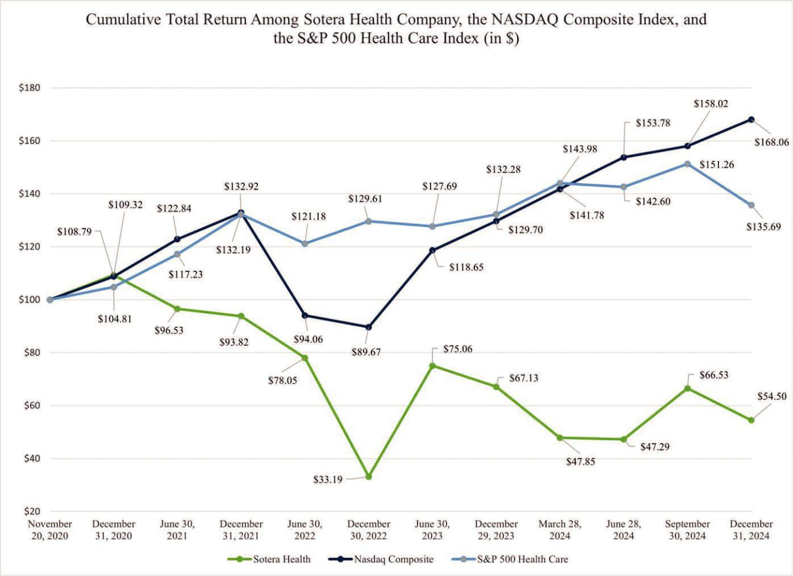

The performance graph and other information furnished under this Part II Item 5 of this Annual Report on Form 10-K shall not be deemed to be “soliciting material” or to be “filed” with the SEC or subject to Regulation 14A or 14C under, or to the liabilities of Section 18 of, the Exchange Act.

Item 6. [Reserved]

Item 7. Management’s Discussion and Analysis of Financial Condition and Results of Operations

You should read this Management’s Discussion and Analysis (“MD&A”) in conjunction with our consolidated financial statements and related notes included elsewhere in this Annual Report on Form 10-K. This MD&A contains forward-looking statements that are based on management’s current expectations, estimates and projections about our business and operations. Our actual results may differ materially from those currently anticipated and expressed in such forward-looking statements as

a result of various factors, including the factors we describe in Item 1A, “Risk Factors” and elsewhere in this Annual Report on Form 10-K.

OVERVIEW

We are a leading global provider of mission-critical end-to-end sterilization solutions, lab testing and advisory services for the healthcare industry. We are driven by our mission: Safeguarding Global Health®. We provide end-to-end sterilization as well as microbiological and analytical lab testing and advisory services to help ensure that medical, pharmaceutical and food products are safe for healthcare practitioners, patients and consumers in the United States and around the world. In 2024, our customers included over 40 of the top 50 medical device companies and nine of the top ten global pharmaceutical companies (based on revenue). Our services are an essential aspect of our customers’ manufacturing processes and supply chains, helping to ensure sterilized medical products reach healthcare practitioners and patients. Most of these services are necessary for our customers to satisfy applicable government requirements.

49

We are a trusted partner to approximately 5,000 customers in over 50 countries. We strive to give our customers confidence that their products meet regulatory, safety and effectiveness requirements. With our industry-recognized scientific and technological expertise, we help to promote the safety of millions of patients and healthcare practitioners around the world every year. Across our 62 facilities worldwide, we have over 3,000 employees who are dedicated to safety and quality.

We serve our customers throughout their product lifecycles, from product design to manufacturing and delivery, helping to promote the sterility, effectiveness and safety of their products for the end user. We operate across two core businesses: sterilization services and lab services. Each of our businesses has a longstanding record and is a leader in its respective market, supported and connected by our core capabilities including deep end market, regulatory, technical and logistics expertise. The combination of Sterigenics, our terminal sterilization business, and Nordion, our Co-60 supply business, makes us the only vertically integrated global gamma sterilization provider in the sterilization industry. This provides us with additional insights and allows us to better serve our customers. For financial reporting purposes, our sterilization services business breaks out into two reportable segments, Sterigenics and Nordion, and our lab services business constitutes a third reportable segment, Nelson Labs.

For the year ended December 31, 2024, we recorded net revenues of $1,100.4 million, net income of $44.4 million, Adjusted Net Income of $198.5 million and Adjusted EBITDA of $548.6 million. Adjusted Net Income and Adjusted EBITDA are financial measures not based on any standardized methodology prescribed by U.S. Generally Accepted Accounting Principles (“GAAP”). For the definition of Adjusted Net Income and Adjusted EBITDA and the reconciliation of these non-GAAP measures from net income (loss), please see “Non-GAAP Financial Measures.”

TRENDS AND KEY FACTORS AFFECTING OUR RESULTS OF OPERATIONS

We expect that our performance and financial condition will continue to be driven by the key trends impacting our industries, customers and their end markets as outlined in Item 1, “Business.” In addition, we believe the following trends and key factors have underpinned our recent operating results and may continue to affect our performance and financial condition in future periods.

- Business and market conditions. Consolidated net revenues and Adjusted EBITDA for the year ended December 31, 2024 increased from the year ended December 31, 2023, which was primarily a result of favorable pricing and improvements in volume and mix across all three reportable segments, partially offset by unfavorable changes in foreign currency exchanges rates.

As discussed in Item 1A, “Risk Factors”, a portion of our supply of Co-60 is generated by Russian nuclear reactors. We continue to monitor the potential for disruption in the supply of Co-60 from Russian nuclear reactors. There was no impact to our supply or revenue in the year ended December 31, 2024.

- Investment initiatives. We continue to advance our growth-related investments, including our two active capacity expansion projects within the Sterigenics segment, Co-60 development projects in the Nordion segment and lab expansion efforts to support pharma testing services in the Nelson Labs segment.

- Disciplined and strategic M&A activity. We remain committed to our highly disciplined acquisition strategy and continue to seek suitable acquisition targets.

- Litigation costs. We are currently the subject of tort lawsuits alleging injury by purported exposure to EO used, emitted or released by current facilities in Atlanta, Georgia and Vernon, California and our former facility in Willowbrook, Illinois. Additional EO lawsuits have been threatened relating to Sterigenics’ former facility in Willowbrook and existing facilities in Atlanta, Georgia; Charlotte, North Carolina; Grand Prairie, Texas; and Vernon, California and may be filed in the future relating to these or Sterigenics’ other EO facilities; these threats of additional EO lawsuits are comparable to threats that have similarly been made against other companies within our industry. In addition, we are defendants in a lawsuit brought by the State of New Mexico Attorney General alleging that emissions of EO from our Santa Teresa facility negatively impacted Santa Teresa and surrounding communities. We maintain that these facilities did not pose and do not pose any safety risk to their surrounding communities. We deny the allegations in these lawsuits and are vigorously defending against these claims. See Item 3, “Legal Proceedings” and Note 19, “Commitments and Contingencies,” to our consolidated financial statements.

For the years ended December 31, 2024, 2023 and 2022, we recorded costs of $32.7 million, $45.3 million and $72.6 million, respectively, representing professional fees and other expenses related to litigation associated with our EO sterilization facilities.

50

- Borrowings, financing costs and financial leverage. On May 30, 2024, the Company and SHH entered into Amendment No. 4 to the Senior Secured Credit Facilities, which provided for the issuance of term loans to the Company in an aggregate principal amount of $1,509.4 million maturing on May 30, 2031. On the same date, the Company issued Secured Notes in an aggregate principal amount of $750.0 million, which bear interest at an annual rate of 7.375% and mature on June 1, 2031. The proceeds from the Refinancing Term Loans and the issuance of the Secured Notes, along with cash on the balance sheet, were used to refinance all of the Company’s previously outstanding term loans due December 2026.

COMPONENTS OF OUR RESULTS OF OPERATIONS

Net Revenues

Service revenues primarily consist of revenue generated from contract sterilization and lab testing and advisory services within our Sterigenics and Nelson Labs segments, respectively. Service revenues also primarily consist of Co-60 installation and disposal revenues and gamma irradiation system refurbishments and installation services within our Nordion segment. Product revenues primarily consist of revenues generated from sales of Co-60 radiation sources and gamma irradiation systems. Provisions for discounts, rebates to customers, and other adjustments may be provided for as reductions in net revenues. Refunds, returns, warranties and other related obligations are not material to any of our business units, nor do we intend to incur material incremental costs to secure customer contracts.

Cost of Revenues

Our cost of revenues consists primarily of direct materials, utilities, labor and related benefit costs, and depreciation and amortization. Although the cost of utilities and direct materials can fluctuate, the remaining components of cost of revenues are generally more stable. Direct material costs relating to service revenues primarily includes EO gas, nitrogen gas and Co-60. The physical decay of Co-60 assets is included within depreciation expense as a cost of revenue. Direct material costs relating to product revenues also include the costs associated with acquiring Co-60 in finished or semi-finished form, acquiring Co-59 in a form ready for insertion into reactors for conversion into Co-60, the reactor time and associated services to convert Co-59 into Co-60, and parts and equipment associated with maintaining gamma irradiation systems.

Operating Expenses

SG&A Expenses

Selling, general and administrative expenses (“SG&A”) primarily consists of compensation and benefits costs and general operating and administrative expenses, including professional service fees (which include finance and legal costs), travel and entertainment expenses, and other general and administrative expenses. Share-based compensation expense is also included in SG&A.

Amortization of Intangible Assets

Amortization of intangible assets primarily consists of expense associated with customer relationship intangible assets, the majority of which relate to the fair values attributed to these assets upon the recapitalization of the Company in connection with the acquisition by the Sponsors in 2015. These customer relationship intangible assets were initially assigned a weighted average useful life of ten years and have a remaining useful life of approximately one year. These customer relationship intangible assets accounted for approximately $48.4 million of our current annual amortization expense and are expected to be fully amortized in 2025. Amortization expense fluctuates when we have an acquisition, disposition, impairment charge, or as their useful lives expire.

Operating Income

Operating income represents gross profit, less SG&A and amortization of intangible assets.

Interest Expense, Net

Interest expense, net, represents interest paid or accruing on our outstanding indebtedness and the amortization of debt discount and debt issuance costs. Interest expense, net is primarily affected by changes in average outstanding indebtedness (including finance lease obligations) and variable interest rates. We present interest expense net of interest income, which primarily consists of interest earned on cash on hand.

51

Loss on Refinancing of Debt

Loss on refinancing of debt for the year ended December 31, 2024 occurred in connection with the refinancing of our capital structure in May 2024 and Amendment No. 3 (as defined below) to Revolving Credit Facility. The refinancing activity primarily resulted in the write off of certain unamortized debt issuance costs and discounts on the Term Loans due 2026. In addition, certain new debt issuance costs and discounts were expensed upon the issuance of the Refinancing Term Loans and Secured Notes.

Georgia EO litigation settlement

On October 16, 2023, the Company reached an agreement to resolve 79 EO claims in the State of Georgia. Under the terms of the agreements, the Company paid $35.0 million to settle the claims.

Illinois EO litigation settlement

On January 9, 2023, the Company reached agreements to settle approximately 880 pending and threatened EO claims in Illinois. Under the terms of the agreements, the Company paid $407.7 million to settle the claims.

Impairment of investment in unconsolidated affiliate

During the year ended December 31, 2022, we recorded an impairment charge of $9.6 million related to a joint venture investment, which was acquired as part of the 2020 acquisition of Iotron Industries Canada, Inc.. Due to a shift in business strategy, the joint venture did not proceed. Based on these facts and circumstances, we concluded that the investment was impaired as of June 30, 2022.

Other Income, Net

Other income, net primarily consists of changes in the fair value of the embedded derivatives in Nordion’s contracts, the net impact of pension related benefits and the income related to deferred income on a lease associated with the 2018 divestiture of the Medical Isotopes business.

Provision (Benefit) for Income Taxes

Provision for income taxes primarily consists of income taxes in foreign jurisdictions and U.S. federal and state income taxes.

Constant Currency Sales Growth (Non-GAAP)

“Constant currency” is a non-GAAP financial measure we use to assess performance excluding the impact of foreign currency exchange rate changes. Constant currency sales growth is calculated by translating prior year sales in local currency at the average exchange rates applicable for the current period. The translated results are then used to determine year-over-year percentage increases or decreases. We generally refer to such amounts calculated on a constant currency basis as excluding the impact of foreign currency exchange rates. These results should be considered in addition to, not as a substitute for, results reported in accordance with GAAP. Results on a constant currency basis, as we present them, may not be comparable to similarly titled measures used by other companies and are not measures of performance presented in accordance with U.S. GAAP.

Adjusted Net Income and Adjusted EBITDA (Non-GAAP)

We use Adjusted Net Income and Adjusted EBITDA, non-GAAP financial measures, as the principal measures of our operating performance. Management believes Adjusted Net Income and Adjusted EBITDA are useful because they allow management to more effectively evaluate our operating performance and compare the results of our operations from period to period without the impact of certain non-cash items and non-routine items that we do not expect to continue at the same level in the future and other items that are not core to our operations. We believe that these measures are useful to our investors because they provide a more complete understanding of the factors and trends affecting our business than could be obtained absent this disclosure. In addition, we believe Adjusted Net Income and Adjusted EBITDA will assist investors in making comparisons to our historical operating results and analyzing the underlying performance of our operations for the periods presented. Our management also uses Adjusted Net Income and Adjusted EBITDA in their financial analysis and operational decision-making and Adjusted EBITDA serves as the metric for attainment of our primary annual incentive program. Adjusted Net Income and Adjusted EBITDA may be calculated differently from, and therefore may not be comparable to, a similarly titled measure used by other companies.

52

For more information regarding our definition and calculation of Adjusted Net Income and Adjusted EBITDA, including information about its limitations as a tool for analysis and reconciliation to the most directly comparable financial measures calculated in accordance with GAAP, please see “Non-GAAP Financial Measures” within this Item 7.

Segment Income

Segment income is the primary earnings measure we use to evaluate the performance of our reportable segments, as disclosed in Note 21, “Segment and Geographic Information” to our consolidated financial statements. Costs associated with support functions that are not directly associated with one of the three reportable segments, such as corporate operating expenses for executive management, accounting, information technology, legal, human resources, treasury, investor relations, corporate development, tax, purchasing, and marketing, are allocated to the segments based on net revenue. Corporate operating expenses that are directly incurred by a segment are reflected in each segment’s income. Segment income excludes certain items which are included in “Income (loss) before taxes” as determined in our Consolidated Statements of Operations and Comprehensive Income (Loss).

CONSOLIDATED RESULTS OF OPERATIONS

The following section summarizes the consolidated results of operations for the years ended December 31, 2024 and 2023. The discussion of the consolidated results of operation for the years ended December 31, 2023 and 2022 are presented within our Annual Report on Form 10-K for the year ended December 31, 2023 under “Item 7. Management’s Discussion and Analysis of Financial Condition and Results of Operations - Consolidated Results of Operations.”

Year Ended December 31, 2024 as compared to Year Ended December 31, 2023

The following table sets forth the components of our results of operations for the years ended December 31, 2024 and 2023.

(thousands of U.S. dollars) |  | 2024 |  |  | 2023 |  |  | $ Change |  | % Change
Total net revenues |  | $ 1,100,441 | $ |  | 1,049,288 | $ |  | 51,153 | 4.9 %
Total cost of revenues |  | 498,146 |  |  | 472,130 |  |  | 26,016 | 5.5 %
Total operating expenses |  | 304,669 |  |  | 300,466 |  |  | 4,203 | 1.4%
Operating income |  | 297,626 |  |  | 276,692 |  |  | 20,934 | 7.6 %
Net income |  | 44,398 |  |  | 51,376 |  |  | (6,978) | (13.6%)
Adjusted Net Income(1) |  | 198,500 |  |  | 204,326 |  |  | (5,826) | (2.9)%
Adjusted EBITDA(1) |  | 548,574 |  |  | 528,029 |  |  | 20,545 |  | 3.9 %
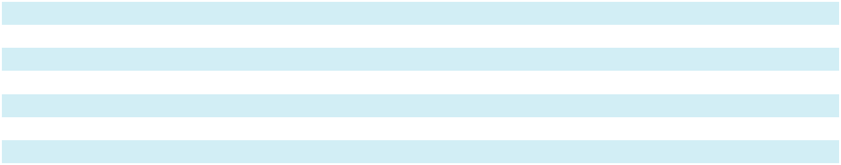

- Adjusted Net Income and Adjusted EBITDA are non-GAAP financial measures. For more information regarding our calculation of Adjusted Net Income and Adjusted EBITDA, including information about their limitations as tools for analysis and a reconciliation of net income, the most directly comparable financial measure calculated and presented in accordance with GAAP, to Adjusted Net Income and Adjusted EBITDA, please see the reconciliation included below in “Non-GAAP Financial Measures.”

Total Net Revenues

The following table compares our revenues by type for the year ended December 31, 2024 to the year ended December 31, 2023.

(thousands of U.S. dollars)
Net revenues for the year ended December 31, |  |  | 2024 |  |  | 2023 |  |  | $ Change |  | % Change
Service |  | $ | 941,822 | $ |  | 905,598 | $ |  | 36,224 | 4.0 %
Product |  |  | 158,619 |  |  | 143,690 |  |  | 14,929 |  | 10.4 %
Total net revenues |  | $ | 1,100,441 | $ |  | 1,049,288 | $ |  | 51,153 | 4.9 %

Net revenues were $1,100.4 million in the year ended December 31, 2024, an increase of $51.2 million, or 4.9%, as compared with the prior year. Net revenues in the year ended December 31, 2024 increased approximately 5.4% compared with the same period in 2023 on a constant currency basis.

53

Service revenues

Service revenues increased $36.2 million, or 4.0%, to $941.8 million in 2024 as compared to $905.6 million in 2023. Favorable pricing of $30.6 million and $6.7 million in the Sterigenics and Nelson Labs segments, respectively, coupled with an increase in service revenue volume and mix of $2.2 million and $1.0 million in the Sterigenics and Nelson Labs segments, respectively, were the primary drivers of service revenue growth. Partially offsetting these growth factors was a $2.2 million unfavorable impact from changes in foreign currency exchange rates across all segments as well as a decline in service revenue of $2.1 million in the Nordion segment.

Product revenues

Product revenues increased $14.9 million, or 10.4%, to $158.6 million in the year ended December 31, 2024 as compared to $143.7 million in the year ended December 31, 2023. Volume and mix growth of $10.3 million coupled with favorable pricing of $7.3 million were the primary drivers of the increase in product revenues. Partially offsetting these growth factors was an unfavorable change in foreign currency exchange rates of $2.7 million.

Total Cost of Revenues

The following table compares our cost of revenues by type for the year ended December 31, 2024 to the year ended December 31, 2023.

(thousands of U.S. dollars)
Cost of revenues for the year ended December 31, |  |  | 2024 |  |  | 2023 |  |  | $ Change |  | % Change
Service |  | $ | 439,543 | $ |  | 418,611 | $ |  | 20,932 | 5.0 %
Product |  |  | 58,603 |  |  | 53,519 |  |  | 5,084 |  | 9.5 %
Total cost of revenues |  | $ | 498,146 | $ |  | 472,130 | $ |  | 26,016 | 5.5 %

Total cost of revenues accounted for approximately 45.3% and 45.0% of our consolidated net revenues for the years ended December 31, 2024 and 2023, respectively.

Cost of service revenues

Cost of service revenues increased $20.9 million for the year ended December 31, 2024 as compared to the prior year. The primary drivers of the increase in cost of service revenues were higher employee compensation costs of $10.1 million, a $5.1 million increase in depreciation related to capital assets recently placed in service and an increase in certain facility repairs and maintenance costs of $3.3 million. The remaining difference was primarily driven by other inflationary pressures. This was partially offset by favorable changes in foreign currency exchange rates of $1.2 million.

Cost of product revenues

Cost of product revenues increased $5.1 million, or 9.5%, for the year ended December 31, 2024 as compared to the prior year. The increase was primarily a result of higher volumes of Co-60 shipments and supplier mix, which resulted in increases in direct material and material transportation costs of $4.8 million. Changes in foreign currency exchange rates resulted in a $0.8 million favorable impact to cost of product revenues.

Operating Expenses

The following table compares our operating expenses for the year ended December 31, 2024 to the year ended December 31, 2023:

(thousands of U.S. dollars)
Operating expenses for the year ended December 31, |  |  | 2024 |  |  | 2023 |  |  | $ Change |  | % Change
Selling, general and administrative expenses |  | $ | 242,630 | $ |  | 236,667 | $ |  | 5,963 | 2.5 %
Amortization of intangible assets |  |  | 62,039 |  |  | 63,799 |  |  | (1,760) |  | (2.8) %
Total operating expenses |  | $ | 304,669 |  | $ | 300,466 |  | $ | 4,203 |  | 1.4 %

54

Operating expenses accounted for approximately 27.7% and 28.6% of our consolidated net revenues for the years ended December 31, 2024 and 2023, respectively.

SG&A

SG&A increased $6.0 million, or 2.5%, for the year ended December 31, 2024 as compared to the prior year. The increase was driven primarily by $9.9 million of incremental SG&A compensation related costs and a $4.5 million increase in share-based compensation expense, partially offset by a $9.5 million decrease in legal and other professional services expenses.

Amortization of intangible assets

Amortization of intangible assets decreased $1.8 million, or 2.8%, for the year ended December 31, 2024, compared to the prior year, due primarily to changes in foreign currency exchange rates.

Interest Expense, Net

Interest expense, net increased $21.8 million, or 15.3%, for the year ended December 31, 2024 as compared to the prior year. Lower favorability from interest rate derivative activity of $15.0 million coupled with an $8.4 million decline in interest income on cash and cash equivalents on deposit at financial institutions were the primary drivers of the increase in interest expense, net.

Loss on Refinancing of Debt

Loss on refinancing of debt for the year ended December 31, 2024 was $24.2 million and primarily occurred in connection with the refinancing of our capital structure in May 2024 and Amendment No. 3 to Revolving Credit Facility. The refinancing activity resulted in the write off of certain unamortized debt issuance costs and discounts on the Term Loans due 2026. In addition, certain new debt issuance costs and discounts were expensed upon the issuance of the Refinancing Term Loans and Secured Notes.

Georgia EO litigation settlement

On October 16, 2023, the Company reached an agreement to resolve 79 pending EO claims in the State of Georgia. Under the terms of the agreement, the Company paid $35.0 million in January 2024 to settle the claims.

Foreign Exchange Loss

Foreign exchange loss was $0.2 million for the year ended December 31, 2024 and 2023. Foreign exchange gains and losses in our Consolidated Statements of Operations and Comprehensive Income (Loss) mainly relates to short-term gains and losses on transactions denominated in currencies other than the functional currency of our operating entities. As described in Note 20, “Financial Instruments and Financial Risk”, we enter into monthly U.S. dollar-denominated foreign currency forward contracts to manage foreign currency exchange rate risk related to our international subsidiaries.

Other Income, Net

Other income, net was $5.3 million for the year ended December 31, 2024, a decrease of $2.1 million, or 28.0%, as compared to the prior year. The fluctuation was primarily driven by a $3.9 million unfavorable change in the fair value of embedded derivatives in Nordion’s purchase and sales contracts, partially offset by $1.1 million of other income related to a tax credit incentive.

Provision for Income Taxes

Provision for income taxes was $69.5 million for the year ended December 31, 2024 as compared to $54.7 million in the prior year. The change was primarily attributable to higher pre-tax income of $113.9 million in the year ended December 31, 2024 compared to $106.0 million for the year ended December 31, 2023, and an incremental increase in the valuation allowance attributable to the limitation on the deductibility of interest expense, partially offset by a decrease in Global Intangible Low Taxed Income (“GILTI”).

Provision for income taxes for the year ended December 31, 2024 differed from the statutory rate of 21% primarily due to a net increase in the valuation allowance attributable to the limitation on the deductibility of interest expense and the foreign rate

55

differential, partially offset by a benefit for state income taxes. The provision for income taxes for the year ended December 31, 2023 differed from the statutory rate of 21% primarily due to an increase in the the valuation allowance attributable to the limitation on the deductibility of interest expense as well as federal and state net operating loss carryforward balances, the impact of the foreign rate differential and GILTI, partially offset by a benefit for state income taxes.

Net Income, Adjusted Net Income and Adjusted EBITDA

Net income for the year ended December 31, 2024 was $44.4 million, as compared to net income of $51.4 million for the year ended December 31, 2023, primarily due to the factors described above. Adjusted Net Income was $198.5 million for the year ended December 31, 2024, as compared to $204.3 million for the year ended December 31, 2023, primarily due to the factors described above. Adjusted EBITDA was $548.6 million for the year ended December 31, 2024, as compared to $528.0 million for the year ended December 31, 2023, primarily due to the factors described above. Please see “Non-GAAP Financial Measures” below for a reconciliation of Adjusted Net Income and Adjusted EBITDA to their most directly comparable financial measure calculated and presented in accordance with GAAP.

NON-GAAP FINANCIAL MEASURES

To supplement our consolidated financial statements presented in accordance with GAAP, we consider Adjusted Net Income and Adjusted EBITDA, financial measures that are not based on any standardized methodology prescribed by GAAP.

We define Adjusted Net Income as net income (loss) before amortization and certain other adjustments that we do not consider in our evaluation of our ongoing operating performance from period to period as discussed further below. We define Adjusted EBITDA as Adjusted Net Income before interest expense, depreciation (including depreciation of Co-60 used in our operations) and income tax provision applicable to Adjusted Net Income.

We use Adjusted Net Income and Adjusted EBITDA, non-GAAP financial measures, as the principal measures of our operating performance. Management believes Adjusted Net Income and Adjusted EBITDA are useful because they allow management to more effectively evaluate our operating performance and compare the results of our operations from period to period without the impact of certain non-cash items and non-routine items that we do not expect to continue at the same level in the future and other items that are not core to our operations. We believe that these measures are useful to our investors because they provide a more complete understanding of the factors and trends affecting our business than could be obtained absent this disclosure. In addition, we believe Adjusted Net Income and Adjusted EBITDA will assist investors in making comparisons to our historical operating results and analyzing the underlying performance of our operations for the periods presented. Our management also uses Adjusted Net Income and Adjusted EBITDA in their financial analysis and operational decision-making, and Adjusted EBITDA serves as the basis for the metric we utilize to determine attainment of our primary annual incentive program. Adjusted Net Income and Adjusted EBITDA may be calculated differently from, and therefore may not be comparable to, a similarly titled measure used by other companies.

Adjusted Net Income and Adjusted EBITDA should not be considered in isolation from, or as a substitute for, financial information prepared in accordance with GAAP. There are a number of limitations related to the use of Adjusted Net Income and Adjusted EBITDA rather than net income (loss), the nearest GAAP equivalent. For example, Adjusted Net Income and Adjusted EBITDA primarily exclude:

- certain recurring non-cash charges such as depreciation of fixed assets, although these assets may have to be replaced in the future, as well as amortization of acquired intangible assets and asset retirement obligations (“ARO”);

- costs of acquiring and integrating businesses, which will continue to be a part of our growth strategy;

- non-cash gains or losses from fluctuations in foreign currency exchange rates, and the mark-to-fair value of derivatives not designated as hedging instruments, which includes the embedded derivatives relating to certain customer and supply contracts at Nordion;

- impairment charges on long-lived assets, intangible assets and investments accounted for under the equity method;

- loss on refinancing of debt incurred in connection with refinancing or early extinguishment of long-term debt;

- expenses incurred in connection with the secondary offering of our common stock and other shareholder activities;

- expenses and charges related to the litigation, settlement agreements, and other activities associated with our EO sterilization facilities, including those related to Willowbrook, Illinois, Atlanta, Georgia, Santa Teresa, New Mexico and Vernon, California;

56

- in the case of Adjusted EBITDA, interest expense or the cash requirements necessary to service interest or principal payments on our indebtedness; and

- share-based compensation expense, which has been, and will continue to be for the foreseeable future, a significant recurring expense and an important part of our compensation strategy.

In evaluating Adjusted Net Income and Adjusted EBITDA, you should be aware that, in the future, we will incur expenses similar to the adjustments in this presentation. Our presentations of Adjusted Net Income and Adjusted EBITDA should not be construed as suggesting that our future results will be unaffected by these expenses or any unusual or non-recurring items. When evaluating our performance, you should consider Adjusted Net Income and Adjusted EBITDA alongside other financial performance measures, including our net income and other GAAP measures.

The following table presents a reconciliation of net income (loss), the most directly comparable financial measure calculated and presented in accordance with GAAP to Adjusted Net Income and Adjusted EBITDA, for each of the periods indicated:

Year Ended December 31,

(in thousands) |  | 2024 |  |  | 2023
Net income | $ | 44,398 |  | $ | 51,376
Amortization of intangible assets |  | 79,377 |  |  | 81,348
Share-based compensation^{(a)} |  | 36,896 |  |  | 32,364
Loss on refinancing of debt^{(b)} |  | 24,168 |  |  | —
Loss (gain) on foreign currency and derivatives not designated as hedging instruments, net^{(c)} |  | 2,448 |  |  | (1,552)
Business optimization expenses^{(d)} |  | 7,504 |  |  | 7,662
Professional services relating to EO sterilization facilities^{(e)} |  | 32,694 |  |  | 45,312
Georgia EO litigation settlement^{(f)} |  | — |  |  | 35,000
Secondary offering and other shareholder activities^{(g)} |  | 1,864 |  |  | —
Accretion of asset retirement obligations^{(h)} |  | 2,638 |  |  | 2,413
Income tax benefit associated with pre-tax adjustments^{(i)} |  | (33,487) |  |  | (49,597)
Adjusted Net Income |  | 198,500 |  |  | 204,326
Interest expense, net^{(j)} |  | 164,691 |  |  | 142,878
Depreciation^{(k)} |  | 82,420 |  |  | 76,577
Income tax provision applicable to Adjusted Net Income^{(l)} |  | 102,963 |  |  | 104,248
Adjusted EBITDA^{(m)} | $ | 548,574 |  | $ | 528,029
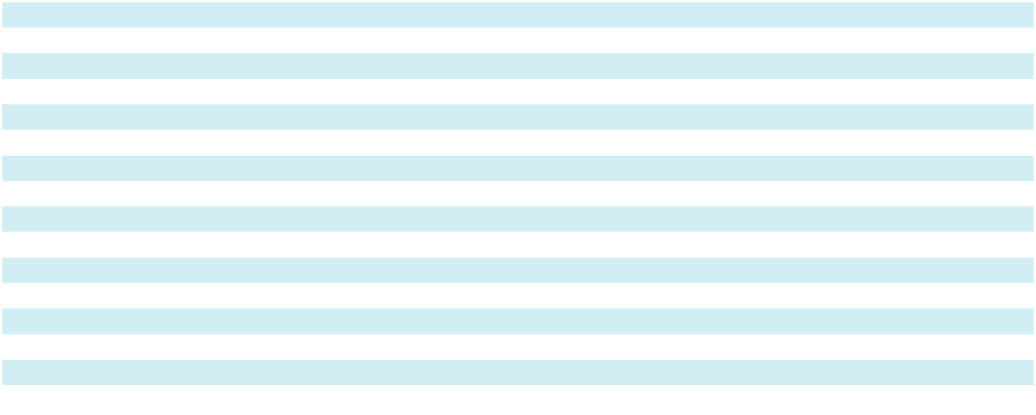

- Represents share-based compensation expense to employees and Non-Employee Directors. See Note 15, “Share-Based Compensation” for further information.

- Represents the write-off of unamortized debt issuance costs and discounts, as well as certain other costs incurred related to the Refinancing Term Loans and the Secured Notes. The year ended December 31, 2024 also includes $0.7 million of debt refinancing costs related to Amendment No. 3 to the Senior Secured Credit Facilities.

- Represents the effects of (i) fluctuations in foreign currency exchange rates and (ii) non-cash mark-to-fair value of embedded derivatives relating to certain customer and supply contracts at Nordion.

- Represents (i) certain costs related to acquisitions and the integration of recent acquisitions, (ii) the earnings impact of fair value adjustments (excluding those recognized within amortization expense) resulting from the businesses acquired, (iii) transition services income and non-cash deferred lease income associated with the terms of the divestiture of the Medical Isotopes business in 2018, (iv) professional fees and other costs associated with business optimization, cost saving and other process enhancement projects, and (v) professional fees, payroll costs, and other costs, including ongoing lease and utility expenses associated with the closure of the Willowbrook, Illinois facility. The year ended December 31, 2023 includes a $1.0 million cancellation fee received from a tenant in connection with the termination of an office space lease at the Nordion facility.

- Represents litigation and other professional fees associated with our EO sterilization facilities. Amounts presented for the year ended December 31, 2023 have been adjusted to exclude interest expense, net associated with Term Loan B due 2026 attributable to the loan proceeds that were used to fund the $408.0 million Illinois EO litigation settlement.

- Represents the cost to settle 79 pending EO claims in Georgia under a settlement entered into on December 21, 2023. See Note 19, “Commitments and Contingencies.”

- Represents expenses incurred in connection with secondary offerings of our common stock that closed on March 4, 2024 and September 6, 2024 and legal, consulting, and other fees associated with shareholder engagement.

57

- Represents non-cash accretion of ARO related to Co-60 gamma and EO processing facilities, which are based on estimated site remediation costs for any future decommissioning of these facilities and are accreted over the life of the asset.

- Represents the income tax impact of adjustments calculated based on the tax rate applicable to each item. We eliminate the effect of tax rate changes as applied to tax assets and liabilities and unusual items from our presentation of adjusted net income.

- Interest expense, net presented in this reconciliation for the year ended December 31, 2023 has been adjusted to conform to the current year presentation to include interest expense, net on Term Loan B due 2026 attributable to the loan proceeds that were used to fund the $408.0 million Illinois EO litigation settlement.

- Includes depreciation of Co-60 held at gamma irradiation sites. The year ended December 31, 2024 excludes accelerated depreciation associated with business optimization activities.

- Represents the difference between the income tax provision/benefit as determined under U.S. GAAP and the income tax benefit associated with pre-tax adjustments described in footnote (i).

- $97.1 million and $94.1 million of the adjustments for the year ended December 31, 2024 and 2023, respectively, are included in cost of revenues, primarily consisting of amortization of intangible assets, depreciation, and accretion of ARO.

SEGMENT RESULTS OF OPERATIONS

We have three reportable segments: Sterigenics, Nordion and Nelson Labs. Our chief operating decision maker evaluates performance and allocates resources within our business based on segment income, which excludes certain items which are included in income (loss) before tax as determined in our Consolidated Statements of Operations and Comprehensive Income (Loss). The accounting policies for our reportable segments are the same as those for the consolidated Company.

Our Segments

Sterigenics

Our Sterigenics business provides outsourced terminal sterilization and irradiation services for the medical device, pharmaceutical, food safety and advanced applications markets using three major technologies: gamma irradiation, EO processing and E-beam irradiation.

Nordion

Our Nordion business is a leading global provider of Co-60 used in the sterilization and irradiation processes for the medical device, pharmaceutical, food safety, and high-performance materials industries, as well as in the treatment of cancer. In addition, Nordion is a leading global provider of gamma irradiation systems.

As a result of the time required to meet regulatory and logistics requirements for delivery of radioactive products, combined with accommodations that we make to our customers to minimize disruptions to their operations during the installation of Co-60, Nordion sales patterns can often vary significantly from one quarter to the next. In most cases, however, timing-related impacts on our sales performance tend to be resolved within several quarters, resulting in more consistent performance over longer periods of time. In addition, sales of gamma irradiation systems occur infrequently and tend to be for larger amounts.

Nelson Labs

Our Nelson Labs business provides outsourced microbiological and analytical chemistry testing and advisory services for the medical device and pharmaceutical industries.

For more information regarding our reportable segments please refer to Item 1. “Business” and Note 21, “Segment and Geographic Information” to our consolidated financial statements.

58

Segment Results for the Years Ended December 31, 2024 and 2023

The following section summarizes the segment results for the years ended December 31, 2024 and 2023. The discussion of the segment results for the years ended December 31, 2023 and 2022 are presented within our Annual Report on Form 10-K for the year ended December 31, 2023 under “Item 7. Management’s Discussion and Analysis of Financial Condition and Results of Operations - Segment Results for the years ended December 31, 2023 and 2022.”

The following tables compare segment net revenue and segment income for the year ended December 31, 2024 to the year ended December 31, 2023:

Year Ended

December 31,

(in thousands) |  | 2024 |  |  | 2023 |  |  | $ Change |  | % Change
Net Revenues
Sterigenics | $ | 697,853 | $ |  | 667,130 | $ |  | 30,723 | 4.6%
Nordion |  | 173,355 |  |  | 160,459 |  |  | 12,896 | 8.0%
Nelson Labs |  | 229,233 |  |  | 221,699 |  |  | 7,534 | 3.4%
Segment Income
Sterigenics | $ | 378,171 | $ |  | 362,212 | $ |  | 15,959 | 4.4%
Nordion |  | 101,220 |  |  | 96,678 |  |  | 4,542 | 4.7%
Nelson Labs |  | 69,183 |  |  | 69,139 |  |  | 44 |  | 0.1%
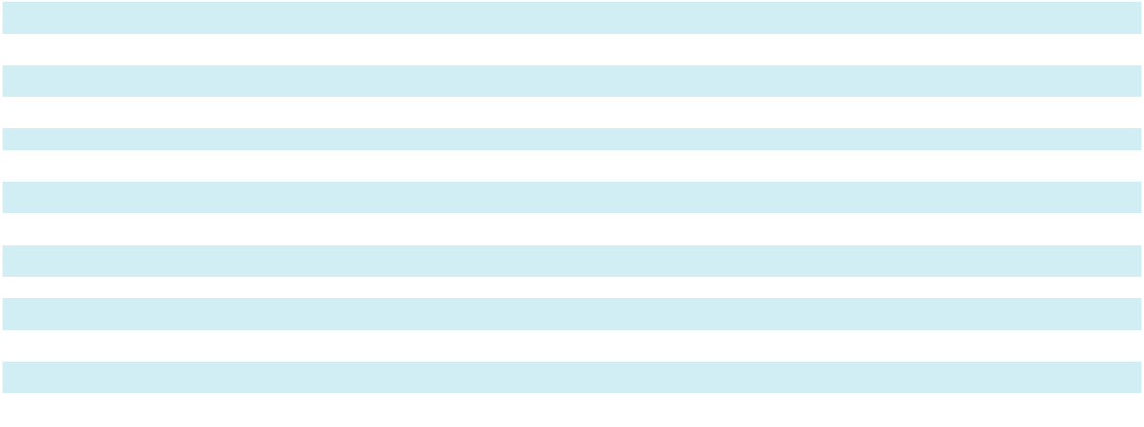

Segment Income Margin
Sterigenics | 54.2 % | 54.3 %
Nordion | 58.4 % | 60.3 %
Nelson Labs | 30.2 % |  | 31.2 %

Net Revenues

Sterigenics net revenues were $697.9 million for the year ended December 31, 2024, an increase of $30.7 million, or 4.6%, as compared to the prior year. The increase was attributable to a favorable impact from pricing of 4.6% and changes in volume and mix of 0.3%, partially offset by unfavorable changes in foreign currency exchange rates of 0.3%.

Nordion net revenues were $173.4 million for the year ended December 31, 2024, an increase of $12.9 million, or 8.0%, as compared to the prior year. The increase was driven by growth from volume and mix and pricing of 4.9% and 5.2%, respectively, partially offset by unfavorable changes in foreign currency exchange rates of 2.1%.

Nelson Labs net revenues were $229.2 million for the year ended December 31, 2024, an increase of $7.5 million, or 3.4%, as compared to the prior year. The increase was attributable to a 3.0% favorable impact from pricing and 0.4% from changes in volume and mix.

Segment Income

Sterigenics segment income was $378.2 million for the year ended December 31, 2024, an increase of $16.0 million, or 4.4%, as compared to the prior year. The increase in segment income was driven mainly by favorable pricing, partially offset by inflation and certain facility repairs and maintenance costs.

Nordion segment income was $101.2 million for the year ended December 31, 2024, an increase of $4.5 million, or 4.7%, as compared to the prior year. The increase in segment income was driven primarily by favorable pricing and higher volumes and mix, partially offset by supplier mix. The decrease in segment income margin was driven by higher employee compensation costs and unfavorable mix.

Nelson Labs segment income was $69.2 million for the year ended December 31, 2024, an increase of 0.1%, as compared to the prior year. Pricing and labor productivity improvements resulted in a favorable impact to segment income during the year ended December 31, 2024 compared to the prior year. Partially offsetting this and negatively impacting segment income margin were increases in employee compensation costs and unfavorable mix.

59

LIQUIDITY AND CAPITAL RESOURCES

Sources of Cash

The primary sources of liquidity for our business are cash flows from operations and borrowings under our credit facilities. As of December 31, 2024, we had $278.9 million of cash and cash equivalents. This is a decrease of $22.8 million from the balance at December 31, 2023. The decrease in cash and cash equivalents was attributable to $179.0 million of purchases of property, plant and equipment, $50.6 million of cash used in financing activities and a $17.4 million decline due to changes in foreign currency exchange rates, partially offset by $224.2 million of cash provided by operating activities. Our foreign subsidiaries held cash of approximately $259.8 million at December 31, 2024 and $224.1 million at December 31, 2023. No material restrictions exist to accessing cash held by our foreign subsidiaries notwithstanding any potential tax consequences.

Refer to “Debt Facilities” below within this Item, Note 9, “Long-Term Debt”, and Item 1A, “Risk Factors” - “Risks Related to Our Indebtedness and Liquidity” for additional information.

As described in more detail below, on March 1, 2024, the Company and SHH entered into Amendment No. 3 to the Revolving Credit Facility. Amendment No. 3 did not materially change the terms and conditions of the Credit Agreement, including with respect to the amount of commitments under the Revolving Credit Facility, which remain $423.8 million.

As discussed below, on May 30, 2024 the Company and SHH closed on the Refinancing Term Loans in an aggregate principal amount of $1,509.4 million as well as an issuance of Secured Notes in an aggregate principal amount of $750.0 million, both of which mature in 2031. The Company used the net proceeds from the Refinancing Term Loans and Secured Notes, along with cash on hand, to refinance its previously outstanding $1,763.1 million and $496.3 million Term Loans due 2026.

Uses of Cash

We expect that cash on hand, operating cash flows and amounts available under our credit facilities will provide sufficient working capital to operate our business, meet foreseeable liquidity requirements (inclusive of debt service on our long-term debt), make expected capital expenditures including investments in fixed assets to build and/or expand existing facilities, and meet litigation costs that we expect to continue to incur for at least the next twelve months. Our primary long-term liquidity requirements beyond the next twelve months will be to service our debt, make capital expenditures, and fund suitable business acquisitions. As of December 31, 2024, there were no outstanding borrowings on the Revolving Credit Facility. We expect any excess cash provided by operations will be allocated to fund capital expenditures, potential acquisitions, or for other general corporate purposes. Our ability to meet future working capital, capital expenditures and debt service requirements will depend on our future financial performance, which will be affected by a range of macroeconomic, competitive and business factors, including interest rate changes and changes in our industry, many of which are outside of our control. As of December 31, 2024, our interest rate derivatives limit our cash flow exposure of our variable rate borrowings under the Term Loans. Refer to Note 20, “Financial Instruments and Financial Risk”, “Derivative Instruments” for additional information regarding the interest rate limits used to manage economic risks associated with our variable rate borrowings. Refer to Item 7A., “Quantitative and

Qualitative Disclosures About Market Risk” for additional information about changes in interest rate risk.

Capital Expenditures

Our capital expenditure program is a component of our long-term strategy. This program includes, among other things, investments in new and existing facilities, business expansion projects, Co-60 used by Sterigenics at its gamma irradiation facilities, cobalt development projects and information technology enhancements. During the year ended December 31, 2024, our capital expenditures amounted to $179.1 million, compared to $215.0 million in the year ended December 31, 2023. Our capital expenditures for the year ended December 31, 2024 included approximately $32 million related to environmental facility enhancements.

In 2024, we expect to continue to invest in facility expansions, ongoing routine maintenance for existing facilities, and acquisition of Co-60 for use by our Sterigenics segment in its gamma irradiation facilities. In addition, we expect to invest in special projects related to development of new Co-60 supply sources and facility enhancements at our EO sterilization facilities. For 2025, it is estimated that approximately $46 million of capital expenditures will relate to environmental facility enhancements.

60

Debt Facilities

Senior Secured Credit Facilities

On December 13, 2019, SHH, our wholly owned subsidiary, entered into senior secured first lien credit facilities (the “Senior Secured Credit Facilities”), consisting of both a prepayable senior secured first lien term loan (the “Term Loan”) and a senior secured first lien revolving credit facility (the “Revolving Credit Facility”) pursuant to a first lien credit agreement (as amended through Amendment No. 4, the “Credit Agreement”). The total borrowing capacity under the Revolving Credit Facility is $423.8 million. The Senior Secured Credit Facilities also provide SHH the right at any time and under certain conditions to request incremental term loans or incremental revolving credit commitments based on a formula defined in the Senior Secured Credit Facilities.

On May 30, 2024, the Company and SHH entered into Amendment No. 4 (“Amendment No. 4”) to the Senior Secured Credit Facilities. Among other changes, Amendment No. 4 provides for Refinancing Term Loans to SHH in an aggregate principal amount of $1,509.4 million. Pursuant to Amendment No. 4, the Refinancing Term Loans shall have an applicable interest rate margin per annum equal to (i) ABR plus 2.25% for ABR Loans (as defined in the Credit Agreement), (ii) daily simple Secured Overnight Financing Rate (“SOFR”) plus 3.25% for RFR Loans (as defined in the Credit Agreement) and (iii) Term SOFR plus 3.25% for Term Benchmark Loans (as defined in the Credit Agreement), in each case with a 0% applicable floor and the applicable interest rate margin shall be subject to a pricing step-down of 0.25% when the Senior Secured Leverage Ratio (as defined in the Credit Agreement) is less than or equal to 3.30:1.00. The Refinancing Term Loans amortize at a rate of 1.00% per annum and mature on May 30, 2031. The weighted average interest rate on borrowings under the Refinancing Term Loans for the year ended December 31, 2024 was 8.29%.

On May 30, 2024, SHH, the Company, certain subsidiaries of the Company (the “Guarantors”), and Wilmington Trust, National Association, as trustee, paying agent, registrar, transfer agent and notes collateral agent, entered into an Indenture (the “Indenture”) governing SHH’s $750.0 million aggregate principal amount of 7.375% senior secured notes due 2031 (the “Secured Notes”) issued in May 2024. The Secured Notes will pay interest semiannually in arrears on June 1 and December 1 of each year, beginning on December 1, 2024, at a rate of 7.375% per year, and will mature on June 1, 2031. The Secured Notes may be redeemed, at any time or from time to time, in whole or in part, on or after June 1, 2027 at the redemption prices specified in the Indenture, together with accrued and unpaid interest, if any, thereon to, but excluding, the redemption date. At any time or from time to time, prior to June 1, 2027, the Secured Notes may be redeemed, in whole or in part, at a redemption price equal to 100% of the aggregate principal amount thereof plus a make-whole premium, together with accrued and unpaid interest, if any, thereon to, but excluding, the redemption date. In addition, at any time or from time to time, prior to June 1, 2027, SHH may redeem up to 40% of the aggregate principal amount of the Secured Notes (including any additional Secured Notes issued under the Indenture) with an amount not to exceed the net cash proceeds from certain equity offerings at a redemption price equal to 107.375% of the aggregate principal amount thereof plus accrued and unpaid interest, if any, thereon to, but excluding, the redemption date. Further, at any time or from time to time, on or before June 1, 2027, SHH may redeem up to 10% of the then outstanding aggregate principal amount of Secured Notes (including any additional Secured Notes issued under the Indenture) during each of the twelve-month periods ending after the issue date, at a redemption price equal to 103% of the aggregate principal amount thereof, plus accrued and unpaid interest, if any, thereon to, but excluding, the redemption date.

The obligations under the Indenture are secured on a first-lien basis by security interests in substantially all of the assets of SHH, the Company and the Guarantors (other than any excluded assets) that secure the Credit Agreement on a pari passu basis, subject to certain limitations, exceptions and permitted liens. These obligations are secured pursuant to a security agreement, dated as of May 30, 2024, by and among SHH, the Company, the other grantors party thereto, and Wilmington Trust, National Association (the “Security Agreement”), as may be amended from time to time, and related financing statements.

The Company used the combined net proceeds from the Refinancing Terms Loans and Secured Notes, along with cash on hand, to refinance its previously outstanding $1,763.1 million Term Loan due 2026 and $496.3 million Term Loan B due 2026.

On March 1, 2024, the Company and SHH entered into Amendment No. 3 (“Amendment No. 3”) to the Revolving Credit Facility. Among other changes, Amendment No. 3 provides (i) for new commitments under the existing Revolving Credit Facility to replace the existing revolving commitments in an aggregate principal amount of $83.0 million, (ii) that certain of the lenders providing revolving credit commitments shall also provide additional commitments for the issuance of letters of credit under the Revolving Credit Facility in an aggregate principal amount of $37.5 million and (iii) for the extension of the maturity date of the Revolving Credit Facility to March 1, 2029.

61

The Senior Secured Credit Facilities and the Indenture contain additional covenants that, among other things, restrict, subject to certain exceptions, limitations and qualifications, our ability and the ability of our restricted subsidiaries to engage in certain activities, such as incur additional indebtedness or permit to exist any lien on any property or asset now owned or hereafter acquired, as specified in the Senior Secured Credit Facilities and the Indenture. The Senior Secured Credit Facilities and the Indenture also contain certain customary affirmative covenants and events of default, including upon a change of control. In addition, an event of default under the Senior Secured Credit Facilities and the Indenture would occur if the Company or certain of its subsidiaries received one or more enforceable judgments for payment in an aggregate amount in excess of the greater of

- $162.6 million or (ii) 30.0% of consolidated EBITDA or LTM EBITDA (as defined in the Credit Agreement and the Indenture, respectively) and the judgments were not stayed or remained undischarged for a period of 60 consecutive days. As of December 31, 2024, we were in compliance with all of the covenants under the Senior Secured Credit Facilities and the Indenture.

All of SHH’s obligations under the Senior Secured Credit Facilities and the Indenture are unconditionally guaranteed by the Company and each existing and subsequently acquired or organized direct or indirect wholly-owned domestic restricted subsidiary of the Company, with customary exceptions including, among other things, where providing such guarantees is not permitted by law, regulation or contract or would result in material adverse tax consequences. All obligations under the Senior Secured Credit Facilities and the Indenture, and the guarantees of such obligations, are secured by substantially all assets of SHH and the guarantors, subject to permitted liens and other exceptions and exclusions, as outlined in the Senior Secured Credit Facilities, the Indenture and the Security Agreement.

Outstanding letters of credit are collateralized by encumbrances against the Revolving Credit Facility and the collateral pledged thereunder, or by cash placed on deposit with the issuing bank. As of December 31, 2024, the Company had $14.0 of letters of credit issued against the Revolving Credit Facility, resulting in total availability under the Revolving Credit Facility of $409.8 million.

Term Loan Interest Rate Risk Management

The Company utilizes interest rate derivatives to reduce the variability of cash flows in the interest payments associated with our variable rate debt due to changes in SOFR. For additional information on the derivative instruments described above, refer to Note 20, “Financial Instruments and Financial Risk”, “Derivative Instruments.”

Cash Flow Information

The following section summarizes cash flow information for the years ended December 31, 2024 and 2023. Cash flow information for the years ended December 31, 2023 and 2022 are presented within our Annual Report on Form 10-K for the year ended December 31, 2023 under Item 7, “Management’s Discussion and Analysis of Financial Condition and Results of Operations - Liquidity and Capital Resources.”

Year Ended December 31, 2024 compared to the Year Ended December 31, 2023

(thousands of U.S. dollars) |  |  | 2024 |  |  | 2023
Net Cash Provided by (Used in):
Operating activities |  | $ | 224,164 | $ |  | (147,732)
Investing activities |  |  | (178,996) |  |  | (214,906)
Financing activities |  |  | (50,564) |  |  | 265,959
Effect of foreign currency exchange rate changes on cash and cash equivalents |  |  | (17,393) |  |  | 2,039
Net (decrease) increase in cash and cash equivalents, including restricted cash, during the period |  | $ | (22,789) | $ |  | (94,640)
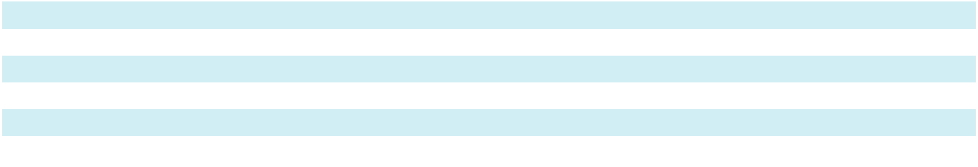

Operating activities

Net cash provided by operating activities increased $371.9 million to net cash provided of $224.2 million for the year ended December 31, 2024 as compared to net cash used in operating activities of $147.7 million for the prior year. The increase in net cash provided by operating activities in 2024 compared to the prior year was due mainly to the timing of cash outflows for the Illinois and Georgia EO litigation settlements. Approximately $407.7 million was paid in June 2023 for the settlements of the Illinois EO claims, whereas $35.0 million was paid in January 2024 for settlement of the Georgia EO claims.

62

Investing activities

Net cash used in investing activities decreased $35.9 million to net cash used of $179.0 million in the year ended December 31, 2024 as compared to $214.9 million for the prior year. The variance was mainly driven by a decrease in capital expenditures of $35.9 million in the year ended December 31, 2024 compared to the prior year.

Financing activities

For the year ended December 31, 2024, net cash used in financing activities was $50.6 million compared to net cash provided by financing activities of $266.0 million for the year ended December 31, 2023 resulting in a net change of $316.5 million. The difference was mainly attributable to $5.0 million of debt repayments (net of debt proceeds) in the year ended December 31, 2024 as compared to $297.5 million of debt proceeds (net of repayments) in the year ended December 31, 2023 resulting in a $302.5 million net change in cash outflow. Cash outflows for debt issuance costs also increased $6.4 million during the year ended December 31, 2024 as compared to the prior year. In addition, a purchase option for a leased facility was exercised in the first quarter of 2024 resulting in a $6.7 million cash outflow.

CONTRACTUAL OBLIGATIONS AND COMMERCIAL COMMITMENTS

The following table describes our significant contractual and other cash obligations as of December 31, 2024:

 |  |  |  |  |  |  | Payments due by period
 |  |  |  |  |  | Less than |  |  |  |  |  |  |  |  |  | More than 5
(thousands of U.S. dollars) |  |  | Total |  |  | 1 Year |  |  |  | 2-3 Years |  |  | 4-5 Years |  |  | Years
Long-term debt ^{(a)}
 |  | $ | 3,299,746 | $ |  | 183,748 | $ |  |  | 348,172 | $ |  | 362,490 | $ |  | 2,405,336
Lease obligations:
Finance ^{(b)} |  |  | 165,197 |  |  | 9,245 |  |  |  | 19,012 |  |  | 19,573 |  |  | 117,367
Operating ^{(c)} |  |  | 39,130 |  |  | 6,937 |  |  |  | 12,112 |  |  | 7,792 |  |  | 12,289
Supply and service obligations ^{(d)} |  |  | 2,219,136 |  |  | 60,291 |  |  |  | 113,279 |  |  | 106,600 |  |  | 1,938,966
Direct material costs ^{(e)} |  |  | 161,796 |  |  | 21,440 |  |  |  | 49,217 |  |  | 58,410 |  |  | 32,729
Total |  | $ | 5,885,005 |  | $ | 281,661 |  |  | $ | 541,792 |  | $ | 554,865 |  | $ | 4,506,687
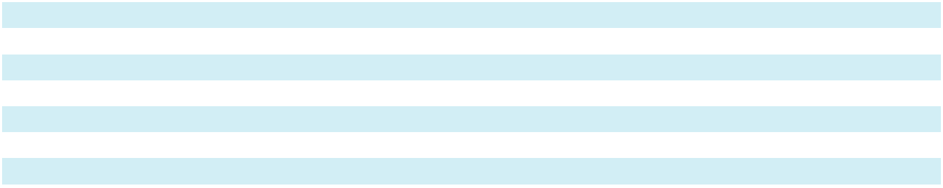

- Represents principal and interest payments on the Senior Secured Credit Facilities and Secured Notes. We have calculated the interest payments on the Senior Secured Credit Facilities using an assumed range of 6.91% to 7.84% based on anticipated forward movements in SOFR and the fixed rate of 7.375% for the Secured Notes. In addition, interest payments include the impact of existing interest rate swaps described in Note 20, “Financial Instruments and Financial Risk” in the notes to consolidated financial statements.

- Consists of payments under our finance leases for various facilities and equipment.

- Represents minimum lease payments under our operating leases for several of our facilities and other property and equipment.
- Consists of our best estimate of our obligations under various supply and service agreements, primarily Co-60, that are enforceable and legally binding on us.
- Consists of our best estimate of our obligations to purchase EO gas under commitments that are enforceable and legally binding on us. We have excluded contracts to purchase energy and other supplies, which generally have terms of one year or less. Our contract to purchase EO gas in the U.S. requires us to purchase all our requirements from our supplier, and our contracts to purchase EO gas outside the U.S. generally require that we purchase a specified percentage of our requirements for our operations in the countries covered by those contracts. Although our EO gas contracts generally do not contain fixed minimum purchase volumes, we have calculated the amounts set forth in the table above based on the percentage of our requirements specified in the contracts and our budgeted purchase volumes for those periods.

At December 31, 2024 and 2023, we had $58.5 million and $67.3 million, respectively, of standby letters of credit, surety bonds and other bank guarantees outstanding, primarily in favor of local and state licensing authorities for future decommissioning costs, and to support the unfunded portion of our pension obligation. We are obligated to provide financial assurance to local and state licensing authorities for possible future decommissioning costs associated with the various facilities that hold Co-60. At December 31, 2024 and 2023, $49.1 million and $48.2 million, respectively, of the standby letters of credit and surety bonds referenced above were outstanding in favor of the various local and state licensing authorities in the event we defaulted on our decommissioning obligation.

63

CRITICAL ACCOUNTING POLICIES AND ESTIMATES

The following subsections describe our most critical accounting policies, estimates, and assumptions. Our discussion of critical accounting policies and estimates is intended to supplement, not duplicate, our summary of significant accounting policies so that readers will have greater insight into the uncertainties involved in these areas. Our accounting policies are more fully described in Note 1, “Significant Accounting Policies” to our consolidated financial statements.

The preparation of consolidated financial statements and related disclosures in conformity with GAAP requires management to make judgments, estimates and assumptions at a specific point in time and in certain circumstances that affect amounts reported in the accompanying consolidated financial statements. In preparing these consolidated financial statements, management has made its best estimates and judgments of certain amounts, giving due consideration to materiality. The application of accounting policies involves the exercise of judgment and use of assumptions as to future uncertainties and, as a result, actual results could differ from these estimates.

Revenue Recognition. The majority of our sales agreements contain performance obligations satisfied at a point in time when control of promised goods or services have transferred to our customers. Revenues recognized over time are generally accounted for using an input measure to determine progress completed as of the end of the period.

Refunds, returns, warranties and other related obligations are not material to any of our business units and we do not incur material incremental costs to secure customer contracts.

The Sterigenics segment provides outsourced terminal sterilization and irradiation services for the medical device, pharmaceutical, food safety and advanced applications markets. We typically have multi-year service contracts with our significant customers, and these sales contracts are primarily based on customers’ purchase orders. Given the relatively short turnaround times, performance obligations are generally satisfied at a point-in-time upon the completion of sterilization or irradiation processing and the approval of our quality assurance process, at which time the service is complete.

The Nordion segment is a provider of Co-60 and gamma irradiation systems, which are key components to the gamma sterilization process. Revenue from the sale of Co-60 radiation sources is recognized at a point-in-time upon satisfaction of our performance obligations for delivery/installation and disposal of existing sources. Revenue from the sale of gamma irradiation systems in our Nordion segment is recognized over time using an input measure of costs incurred and is immaterial to the overall business.

The Nelson Labs segment provides outsourced microbiological and analytical chemistry testing and advisory services for the medical device and pharmaceutical industries. We provide our customers mission-critical lab testing services, which assess the product quality, effectiveness, patient safety and end-to-end sterility of products. These services are necessary for our customers’ regulatory approvals, product releases and ongoing product performance evaluations. Nelson Labs services are generally provided on a fee-for-service or project basis, and we recognize revenues over time generally using an input measure of time incurred to determine progress completed at the end of the period. Revenue recognized over time in excess of the amount billed to the customer is recorded as a customer contract asset. When we receive consideration from a customer prior to transferring goods or services under the terms of a sales contract, we record deferred revenue, which represents a contract liability. We utilize our customer relationship management system to assess time incurred and the extent of project completion at the end of the period.

We do not capitalize sales commissions because substantially all of our sales commission programs have an amortization period of one year or less. Furthermore, costs to fulfill a contract are not material.

Provisions for discounts, rebates to customers, and other adjustments are provided for as reductions in net revenues in the period the related sale was recorded. Shipping and handling charges billed to customers are included in net revenues, and the related shipping and handling costs are included in cost of net revenues on the Consolidated Statements of Operations and Comprehensive Income (Loss). Taxes assessed by a governmental authority that are both imposed on and concurrent with a specific revenue-producing transaction, that are collected by us from a customer, are excluded from net revenue.

Payment terms vary by the type and location of the customer and the products or services offered. Generally, the time between when revenue is recognized and when payment is due is not significant. We do not evaluate whether the selling price contains a financing component for contracts that have a duration of less than one year.

64

Goodwill and Other Indefinite-Lived Intangibles. Assets and liabilities of a business acquired are accounted for at their estimated fair values as of the acquisition date. Any excess of the cost of the acquisition over the fair value of the net tangible and intangible assets acquired is recorded as goodwill. We generally supplement management expertise with valuation specialists in performing appraisals to assist us in determining the fair values of assets acquired and liabilities assumed. These valuations require us to make estimates and assumptions, especially with respect to intangible assets. We generally amortize our intangible assets over their useful lives with the exception of indefinite lived intangible assets. We do not amortize goodwill, but we evaluate it annually for impairment. Therefore, the allocation of the purchase price to intangible assets and goodwill has a significant impact on future operating results.

Goodwill and other indefinite-lived intangible assets, primarily certain regulatory licenses and trade names, are tested for impairment annually as of October 1. If circumstances change during interim periods between annual tests that indicate that the carrying amount of such assets may not be recoverable, the Company tests such assets at an interim date for impairment. Factors which would necessitate an interim impairment assessment include prolonged negative industry or economic trends and significant underperformance relative to historical or projected future operating results.

At December 31, 2024, goodwill and intangible assets totaled $1,398.7 million, or 45.5% of our total assets. We consider the impairment analyses of these assets critical because of their quantitative significance to the Company and our segments.

Goodwill is assigned to our segments at December 31, 2024 as follows:

(thousands of U.S. dollars) |  |  | Sterigenics |  |  | Nordion |  |  | Nelson Labs |  | Total
Goodwill at December 31, 2024
 |  | $ | 653,222 |  | $ | 255,485 |  | $ | 172,366 |  | $ 1,081,073

We performed a quantitative assessment of all reporting units (Sterigenics, Nordion and Nelson Labs) as of October 1, 2024. The fair value of each reporting unit was calculated using a discounted cash flow analysis which was dependent on subjective market participant assumptions determined by management. Assumptions used in the analyses included discount rates, revenue growth rates and projected operating cash flows. Estimates of future cash flows are based upon relevant data at a point-in-time, are subject to change, and could vary from actual results. Cash flows are based on recent historical results and are consistent with the Company’s near-term financial forecasts and long-term strategic plans. The estimated fair value of Sterigenics, Nordion and Nelson Labs each exceeded its carrying amount (including goodwill) by an adequate margin to support a positive assertion that goodwill is not impaired as of October 1, 2024. No factors were identified that would result in the potential impairment to the indefinite-lived intangible assets. There have been no other significant events or circumstances that occurred since the annual assessment date of October 1 that would change the conclusions reached above. We provide additional information about our goodwill and other indefinite-lived intangible assets in Note 7, “Goodwill and Other Intangible Assets” to our consolidated financial statements.

Income Taxes. We use the liability method of accounting for income taxes whereby we recognize deferred tax assets and liabilities for the future tax consequences of temporary differences between the tax bases of assets and liabilities and their reported amounts in the consolidated financial statements. Measurements of deferred taxes requires the use of judgment with respect to the realization of tax basis. We periodically review our deferred tax assets for recoverability and establish a valuation allowance based on historical taxable income, projected future taxable income, expected timing of reversals of existing temporary timing differences and the implementation of tax planning strategies. Deferred tax assets will be reduced by a valuation allowance if, based on management’s estimate, it is more likely than not that a portion of the deferred tax assets will not be realized in a future period. The estimates used in the recognition of deferred tax assets are subject to revision in future periods based on new facts and circumstances. At December 31, 2024 and 2023, we maintained a valuation allowance of $160.6 million and $125.4 million, respectively, against our deferred tax assets, primarily attributable to the excess interest expense on our long-term debt in the United States, as well as state and foreign net operating loss carryforwards. If we are unable to generate sufficient future taxable income in certain tax jurisdictions, or if there is a material change in the effective income tax rates or time period within which the underlying temporary differences become taxable or deductible, we could be required to increase our valuation allowance, which would increase our effective income tax rate and could result in an adverse impact on our consolidated financial position or results of operations. Changes in our judgment related to the measurement of deferred tax assets and liabilities could materially impact our results of operations.

We determine whether it is more likely than not that a tax position will be sustained upon examination, including resolution of related appeals or litigation processes, based on the technical merits of the position. In evaluating whether a tax position meets the more likely-than-not recognition threshold, we presume that the position will be examined by the appropriate taxing authority and that the taxing authority will have full knowledge of all relevant information. A tax position that meets the more likely-than-not recognition threshold is measured at the largest amount of benefit that is greater than 50% likely of being

65

realized upon ultimate settlement. Determining what constitutes an individual tax position and whether the more likely-than-not recognition threshold is met for a tax position are matters of judgment based on the individual facts and circumstances of that position evaluated in light of all available evidence. We review and adjust tax estimates periodically because of ongoing examinations by, and settlements with, the various taxing authorities, as well as changes in tax laws, regulations, and precedent. Changes in our judgment related to the assessment of uncertain tax positions could materially impact our results of operations.

We are subject to taxation from federal, state, local, and foreign jurisdictions. Tax positions are settled primarily through the completion of audits within each individual tax jurisdiction or the closing of a statute of limitation. Changes in applicable tax law or other events may also require us to revise past estimates. The United States Internal Revenue Service routinely conducts audits of our federal income tax returns. Additional information regarding income taxes is included in Note 10, “Income Taxes” to our consolidated financial statements.

Commitments and Contingencies. We are, and will likely continue to be, involved in a number of legal proceedings, government investigations and claims, which we believe generally arise in the course of our business, given our size, history, complexity and the nature of our business, products, customers, regulatory environment and industries in which we participate. These legal proceedings, investigations and claims generally involve a variety of legal theories and allegations, including, without limitation, personal injury (e.g., slip and falls, burns, vehicle accidents, mass tort), regulation (e.g., failure to meet specification or failure to comply with regulatory requirements), commercial claims (e.g., breach of contract, economic loss, misrepresentation), financial (e.g., taxes, reporting), employment (e.g., wrongful termination, discrimination, benefits matters) and other claims for damage and relief.

We record a liability for such contingencies to the extent we conclude that their occurrence is both probable and estimable. If a potentially material loss contingency is not probable, but is reasonably possible, or is probable but cannot be estimated, then the nature of the contingent liability is disclosed within our consolidated financial statements, together with an estimate of the range of possible loss if the range is determinable and material. We consider many factors in making these assessments, including the professional judgment of experienced members of management and our legal counsel. For legal proceedings and claims described within our consolidated financial statements, we have made estimates as to the likelihood of unfavorable outcomes and the amounts of such potential losses, if a range is determinable. While it is not possible to determine the ultimate disposition of each of these matters, the ultimate resolution of pending regulatory and legal matters in future periods may have a material adverse effect on our financial condition, results of operations and/or liquidity. The Company may also incur material defense and settlement costs, diversion of management resources and other adverse effects on our business, financial condition, and/or results of operations. We record gain contingencies when realized and expected recoveries under applicable insurance contracts when we are assured of recovery. Refer to Note 19, “Commitments and Contingencies,” to our consolidated financial statements.

The Company reached agreements to settle approximately 880 pending and threatened EO claims in the State of Illinois on January 9, 2023. Under the binding Settlement Agreements, the Company paid $407.7 million to settle the claims.

On October 16, 2023, the Company reached an agreement to resolve 79 EO claims in the State of Georgia. Under the terms of the agreements, the Company paid $35.0 million to settle the claims.

NEW ACCOUNTING PRONOUNCEMENTS

For a description of recent accounting pronouncements applicable to our business, see Note 2, “Recent Accounting Standards” to our consolidated financial statements.

Item 7A. Quantitative and Qualitative Disclosures About Market Risk

We are exposed to market risks in the ordinary course of business, primarily changes in commodity prices, interest rates and foreign currency exchange rates and regulatory risk.

Commodity Price Risk

We purchase our supply of EO gas from various suppliers around the world, but in the United States there is a sole supplier for EO gas used for applications relevant to our business. We are exposed to market risk based on fluctuations in the price of EO gas.

66

We actively seek to manage the risk of fluctuating prices through long-term supply and service contracts. Most of our Sterigenics customer contracts contain provisions that permit us to pass through all or a portion of our supply price increases to our customers, though some of our contracts do not contain these provisions. Even for contracts that do contain these provisions, there is often at least a brief lag between when we incur increased costs for supplies and when we can pass through these costs to our customers. In addition, even when we are contractually permitted to pass on price increases, we may decide not to do so to preserve our sales volumes or for other reasons.

Interest Rate Risk

We are subject to interest rate risk on borrowings that bear interest at floating rates. From time to time, the Company utilizes interest rate derivatives to reduce the variability of cash flows in the interest payments associated with our variable rate borrowings.

In March 2023, we entered into an interest rate swap agreement with a notional amount of $400.0 million. The interest rate swap’s effective date began on August 23, 2023 and expires on August 23, 2025. We designated the interest rate swap as a cash flow hedge designed to hedge the variability of cash flows attributable to changes in the SOFR benchmark interest rate of our Term Loan. We receive interest at the one-month Term SOFR rate and pay a fixed interest rate under the terms of the swap agreement.

In May 2022, we entered into two interest rate cap agreements with a combined notional amount of $1,000.0 million for a total option premium of $4.1 million. The interest rate caps became effective as of July 31, 2023 and expired on July 31, 2024. We designated these interest rate caps as cash flow hedges that were designed to hedge the variability of cash flows attributable to changes in the benchmark interest rate of our Term Loan. Under the current terms of the loan agreement, the benchmark interest rate index transitioned from LIBOR to Term SOFR on June 30, 2023. Accordingly, the interest rate cap agreements hedged the variability of cash flows attributable to changes in SOFR by limiting our cash flow exposure related to Term SOFR under a portion of our variable rate borrowings to 3.5%.

In October 2021, we entered into two interest rate cap agreements with a combined notional amount of $1,000.0 million for a total option premium of $1.8 million. Both interest rate caps were effective on December 31, 2022 and expired on July 31, 2023. These interest rate caps were designated as cash flow hedges and were designed to hedge the variability of cash flows attributable to changes in LIBOR (or its successor), the benchmark interest rate being hedged, by limiting our cash flow exposure related to the LIBOR base rate under a portion of our variable rate borrowings to 1.0%.

Based on our indebtedness outstanding as of December 31, 2024, the interest rate under our Term Loans that was in effect on December 31, 2024, and after applying the effects of interest rate caps and the swap referenced above, a 1.0% increase in the interest rate under our outstanding debt obligations as of December 31, 2024, would increase interest expense by approximately $11.1 million per year.

See Note 20, “Financial Instruments and Financial Risk” to our consolidated financial statements for a summary of the activity of the interest rate caps for the periods presented.

Foreign Currency Exchange Rate Risk

We are exposed to market risk from fluctuations in foreign currencies. We present our consolidated financial statements in U.S. dollars. Consequently, increases or decreases in the value of the U.S. dollar relative to the non-U.S. dollar functional currencies of the countries in which we operate may affect the value of assets, liabilities, revenues, expenses and other figures presented in our consolidated financial statements, even if their value has not changed in their local currencies. We translate the financial statements of subsidiaries whose local currency is their functional currency to their U.S. dollar equivalents at end-of-period exchange rates for assets and liabilities and at average exchange rates for revenues and expenses. These translations could significantly affect the comparability of our results between financial periods and/or result in significant changes to the carrying value of our assets and liabilities. Translation adjustments are recorded as a component of accumulated other comprehensive income (loss) within equity.

Our results of operations are impacted by currency exchange rate fluctuations to the extent that we are unable to match net revenues received in foreign currencies with expenses incurred in the same currency. Transaction gains and losses arising from fluctuations in currency exchange rates on transactions denominated in currencies other than the functional currency are recognized in the Consolidated Statements of Operations and Comprehensive Income (Loss) as foreign exchange loss (gain).

67

The Company also routinely enters into foreign currency forward contracts to manage foreign currency exchange rate risk of our intercompany loans in certain of our international subsidiaries and non-functional currency assets and liabilities. The foreign currency forward contracts expire on a monthly basis. The net fair value of the outstanding foreign currency forward contracts was $0.1 million as of each of the years ended December 31, 2024 and 2023.

Approximately 44.0% of our revenues and 47.3% of our consolidated total assets as of December 31, 2024 were derived from operations outside the United States. Holding other variables constant (such as interest rates and debt levels), if the U.S. dollar had appreciated by 10% against the foreign currencies used by our operations in the year ended December 31, 2024, revenues would have been reduced by approximately $48.4 million and gross profit by approximately $26.1 million.

Regulatory Risk

We are subject to extensive regulatory requirements and routine regulatory audits, and we must receive permits, licenses, and/or regulatory clearance or approval for numerous aspects of our operations. Regulatory agencies may refuse to grant approval or clearance or may require the provision of additional data, and regulatory processes may be time consuming and costly, and their outcome may be uncertain in certain of the countries in which we operate. Regulatory agencies may also change policies, adopt additional regulations or revise existing regulations, any of which could impact our ability to provide our services. Our failure to comply with the regulatory requirements of these agencies may subject us to administratively or judicially imposed sanctions. These sanctions could include, among others, warning letters, fines, civil penalties, criminal penalties, injunctions, debarment, product seizure or detention and total or partial suspension of operations. The failure to receive or maintain, or delays in the receipt of, relevant U.S. or international regulatory qualifications could have a material adverse effect on our business, prospects, financial condition or results of operations.

68

Item 8. Financial Statements and Supplementary Data
INDEX TO CONSOLIDATED FINANCIAL STATEMENTS
Consolidated Financial Statements of Sotera Health Company
 | Report of Independent Registered Public Accounting Firm (PCAOB ID: 42) |  |  |  |  |  |  |  | 70
 | Consolidated Balance Sheets |  |  |  |  |  |  |  | 72
 | Consolidated Statements of Operations and Comprehensive Income (Loss) |  |  |  |  |  |  |  | 73
 | Consolidated Statements of Cash Flows |  |  |  |  |  |  |  | 74
 | Consolidated Statements of Equity |  |  |  |  |  |  |  | 75
 | Notes to Consolidated Financial Statements |  |  |  |  |  |  |  | 76
Supplementary Data
 | Schedule II – Valuation and Qualifying Accounts |  |  |  |  |  |  |  | 115
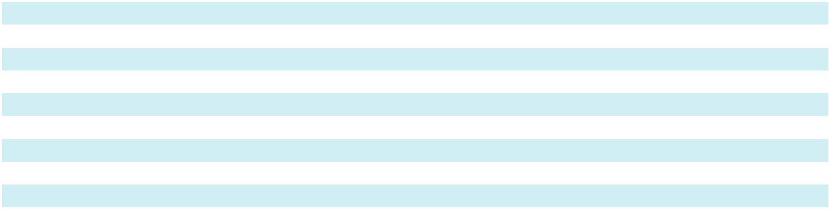

69

REPORT OF INDEPENDENT REGISTERED PUBLIC ACCOUNTING FIRM To the Stockholders and the Board of Directors of Sotera Health Company

Opinion on the Financial Statements

We have audited the accompanying consolidated balance sheets of Sotera Health Company (the Company) as of December 31, 2024 and 2023, the related consolidated statements of operations and comprehensive income (loss), equity and cash flows for each of the three years in the period ended December 31, 2024, and the related notes and financial statement schedule listed in the Index at Item 15(a)(2) (collectively referred to as the “consolidated financial statements”). In our opinion, the consolidated financial statements present fairly, in all material respects, the financial position of the Company at December 31, 2024 and 2023, and the results of its operations and its cash flows for each of the three years in the period ended December 31, 2024, in conformity with U.S. generally accepted accounting principles.

We also have audited, in accordance with the standards of the Public Company Accounting Oversight Board (United States) (PCAOB), the Company's internal control over financial reporting as of December 31, 2024, based on criteria established in Internal Control—Integrated Framework issued by the Committee of Sponsoring Organizations of the Treadway Commission (2013 framework), and our report dated February 27, 2025 expressed an unqualified opinion thereon.

Basis for Opinion

These financial statements are the responsibility of the Company’s management. Our responsibility is to express an opinion on the Company’s financial statements based on our audits. We are a public accounting firm registered with the PCAOB and are required to be independent with respect to the Company in accordance with the U.S. federal securities laws and the applicable rules and regulations of the Securities and Exchange Commission and the PCAOB.

We conducted our audits in accordance with the standards of the PCAOB. Those standards require that we plan and perform the audit to obtain reasonable assurance about whether the financial statements are free of material misstatement, whether due to error or fraud. Our audits included performing procedures to assess the risks of material misstatement of the financial statements, whether due to error or fraud, and performing procedures that respond to those risks. Such procedures included examining, on a test basis, evidence regarding the amounts and disclosures in the financial statements. Our audits also included evaluating the accounting principles used and significant estimates made by management, as well as evaluating the overall presentation of the financial statements. We believe that our audits provide a reasonable basis for our opinion.

Critical Audit Matter

The critical audit matter communicated below is a matter arising from the current period audit of the financial statements that was communicated or required to be communicated to the audit committee and that: (1) relates to accounts or disclosures that are material to the financial statements and (2) involved our especially challenging, subjective or complex judgments. The communication of the critical audit matter does not alter in any way our opinion on the consolidated financial statements, taken as a whole, and we are not, by communicating the critical audit matter below, providing a separate opinion on the critical audit matter or on the account or disclosure to which it relates.

Valuation of Nelson Labs Reporting Unit Goodwill

Description of the Matter As disclosed in Note 7 to the consolidated financial statements, at December 31, 2024, the Company reported $1.1 billion of goodwill; of that, $172.4 million related to the Nelson Labs reporting unit. As explained in Note 1 to the consolidated financial statements, goodwill is tested for impairment annually as of October 1. Management performed a quantitative impairment assessment for its annual evaluation of the Nelson Labs reporting unit in 2024. As part of the quantitative impairment test, management estimated the fair value of the Nelson Labs reporting unit using the discounted cash flow method, a form of the income approach.

70

Auditing the Company’s goodwill impairment assessment for the Nelson Labs reporting unit was complex due to the significant estimation required to determine the fair value of the reporting unit. In particular, this fair value measurement was sensitive to revenue growth rates and projected EBITDA margins. Elements of these assumptions are forward-looking and could be affected by future market or economic conditions.

How We Addressed the Matter We obtained an understanding, evaluated the design and tested the operating effectiveness of

in Our Audit controls over the Company’s goodwill impairment assessment process. This included controls over management's review of the significant assumptions described above.

To test the estimated fair value of the Nelson Labs reporting unit, we performed audit procedures that included, among others, assessing the valuation methodology, testing the significant assumptions described above, and testing the completeness and accuracy of the underlying data used by the Company in its analysis. As it pertains to the revenue growth rates and projected EBITDA margins, we compared the significant assumptions used by management to current industry data and historical performance. We performed sensitivity analyses of assumptions to evaluate the changes in the fair value of the reporting unit that would result from changes in the assumptions. We evaluated the reconciliation of the fair value of the reporting units to the market capitalization of the Company. We also assessed the appropriateness of the disclosures in the consolidated financial statements. In addition, we involved our valuation specialists to assist with our evaluation of the methodology and significant assumptions used by the Company.

/s/ Ernst & Young LLP

We have served as the Company’s auditor since 2019.

Cleveland, Ohio

February 27, 2025

71

Sotera Health Company

Consolidated Balance Sheets

(in thousands, except per share amounts)

 |  | As of December 31,
 |  | 2024 |  |  | 2023
Assets
Current assets:
Cash and cash equivalents | $ | 277,242 | $ |  | 296,407
Restricted cash short-term |  | 1,623 |  |  | 5,247
Accounts receivable, net of allowance for uncollectible accounts of $2,532 and $4,689 as of December 31, 2024 |  | 140,327 |  |  | 147,696
and 2023, respectively |  | 140,327 |  |  | 147,696
Inventories, net |  | 49,158 |  |  | 48,316
Prepaid expenses and other current assets |  | 51,031 |  |  | 53,846
Income taxes receivable |  | 6,656 |  |  | 5,732
Total current assets |  | 526,037 |  |  | 557,244
Property, plant, and equipment, net |  | 1,036,892 |  |  | 946,914
Operating lease assets |  | 27,551 |  |  | 24,037
Deferred income taxes |  | 2,865 |  |  | 4,993
Post-retirement assets |  | 42,524 |  |  | 28,482
Other assets |  | 37,053 |  |  | 41,242
Other intangible assets, net |  | 317,653 |  |  | 416,318
Goodwill |  | 1,081,073 |  |  | 1,111,190
Total assets | $ | 3,071,648 | $ |  | 3,130,420
Liabilities and equity
Current liabilities:
Accounts payable | $ | 55,098 | $ |  | 71,039
Accrued liabilities |  | 90,463 |  |  | 122,471
Deferred revenue |  | 15,100 |  |  | 13,492
Current portion of long-term debt |  | 14,803 |  |  | 4,797
Current portion of finance lease obligations |  | 2,923 |  |  | 8,771
Current portion of operating lease obligations |  | 5,056 |  |  | 5,934
Income taxes payable |  | 7,559 |  |  | 4,150
Total current liabilities |  | 191,002 |  |  | 230,654
Long-term debt |  | 2,208,100 |  |  | 2,223,674
Finance lease obligations, less current portion |  | 95,286 |  |  | 63,793
Operating lease obligations, less current portion |  | 24,465 |  |  | 20,087
Noncurrent asset retirement obligations |  | 49,319 |  |  | 47,944
Deferred lease income |  | 16,784 |  |  | 18,762
Post-retirement obligations |  | 7,863 |  |  | 8,439
Noncurrent liabilities |  | 4,418 |  |  | 8,879
Deferred income taxes |  | 69,500 |  |  | 64,454
Total liabilities |  | 2,666,737 |  |  | 2,686,686
See Commitments and contingencies note
Equity:
Common stock, with $0.01 par value, 1,200,000 shares authorized; 286,037 shares issued at December 31, 2024 |  | 2,860 |  |  | 2,860
and 2023 |  | 2,860 |  |  | 2,860
Preferred stock, with $0.01 par value, 120,000 shares authorized; no shares issued at December 31, 2024 and |  | — |  |  | —
2023 |  | — |  |  | —
Treasury stock, at cost (2,571 and 3,207 shares at December 31, 2024 and 2023, respectively) |  | (23,434) |  |  | (27,182)
Additional paid-in capital |  | 1,243,778 |  |  | 1,215,178
Retained deficit |  | (610,042) |  |  | (654,440)
Accumulated other comprehensive loss |  | (208,251) |  |  | (92,682)
Total equity |  | 404,911 |  |  | 443,734
Total liabilities and equity | $ | 3,071,648 | $ |  | 3,130,420


See notes to consolidated financial statements.

72

Sotera Health Company

Consolidated Statements of Operations and Comprehensive Income (Loss)

(in thousands, except per share amounts)

 |  | Year Ended December 31,
 |  | 2024 |  |  | 2023 |  |  | 2022
Revenues: | $ | 941,822
Service | $ | 941,822 | $ |  | 905,598 | $ |  | 864,828
Product |  | 158,619 |  |  | 143,690 |  |  | 138,859
Total net revenues |  | 1,100,441 |  |  | 1,049,288 |  |  | 1,003,687
Cost of revenues:
Service |  | 439,543 |  |  | 418,611 |  |  | 390,860
Product |  | 58,603 |  |  | 53,519 |  |  | 55,823
Total cost of revenues |  | 498,146 |  |  | 472,130 |  |  | 446,683
Gross profit |  | 602,295 |  |  | 577,158 |  |  | 557,004
Operating expenses:
Selling, general and administrative expenses |  | 242,630 |  |  | 236,667 |  |  | 245,714
Amortization of intangible assets |  | 62,039 |  |  | 63,799 |  |  | 62,940
Total operating expenses |  | 304,669 |  |  | 300,466 |  |  | 308,654
Operating income |  | 297,626 |  |  | 276,692 |  |  | 248,350
Interest expense, net |  | 164,691 |  |  | 142,878 |  |  | 80,144
Loss on refinancing of debt |  | 24,168 |  |  | — |  |  | —
Georgia EO litigation settlement |  | — |  |  | 35,000 |  |  | —
Illinois EO litigation settlement |  | — |  |  | — |  |  | 408,000
Impairment of investment in unconsolidated affiliate |  | — |  |  | — |  |  | 9,613
Foreign exchange loss |  | 199 |  |  | 159 |  |  | 145
Other income, net |  | (5,306) |  |  | (7,372) |  |  | (6,441)
Income (loss) before income taxes |  | 113,874 |  |  | 106,027 |  |  | (243,111)
Provision (benefit) for income taxes |  | 69,476 |  |  | 54,651 |  |  | (9,541)
Net income (loss) | $ | 44,398 |  | $ | 51,376 |  | $ | (233,570)
Other comprehensive income (loss), net of tax:
Pension and post-retirement benefits (net of taxes of $2,804, $(3,420) and $7,022, | $ | 8,462 | $ |  | (10,506) | $ |  | 20,790
respectively)
Interest rate derivatives (net of taxes of $(1,856), $(5,467) and $7,387, respectively) |  | (5,396) |  |  | (15,697) |  |  | 20,939
Foreign currency translation |  | (118,635) |  |  | 40,174 |  |  | (64,816)
Comprehensive income (loss) | $ | (71,171) |  | $ | 65,347 |  | $ | (256,657)
Earnings (Loss) per share:
Basic | $ | 0.16 | $ |  | 0.18 | $ |  | (0.83)
Diluted |  | 0.16 |  |  | 0.18 |  |  | (0.83)
Weighted average number of shares outstanding:
Basic |  | 282,784 |  |  | 281,008 |  |  | 280,096
Diluted |  | 284,906 |  |  | 283,222 |  |  | 280,096


See notes to consolidated financial statements.

73

Sotera Health Company

Consolidated Statements of Cash Flows

(in thousands)

 |  | Year Ended December 31,
 |  | 2024 |  |  | 2023 |  |  | 2022
Operating activities:
Net income (loss) | $ | 44,398 | $ |  | 51,376 | $ |  | (233,570)
Adjustments to reconcile net income (loss) to net cash provided by (used in) operating activities:
Depreciation |  | 84,260 |  |  | 76,577 |  |  | 64,000
Amortization of intangible assets |  | 79,377 |  |  | 81,348 |  |  | 81,554
Loss on refinancing of debt |  | 24,168 |  |  | — |  |  | —
Impairment of investment in unconsolidated affiliate |  | — |  |  | — |  |  | 9,613
Deferred income taxes |  | 9,433 |  |  | 3,449 |  |  | (73,960)
Share-based compensation expense |  | 36,777 |  |  | 32,238 |  |  | 21,211
Accretion of asset retirement obligations |  | 2,638 |  |  | 2,413 |  |  | 2,194
Unrealized foreign exchange (gain) loss |  | (18,337) |  |  | 6,057 |  |  | (3,984)
Unrealized loss (gain) on derivatives not designated as hedging instruments |  | 2,213 |  |  | (1,637) |  |  | 2,977
Amortization of debt issuance costs |  | 7,238 |  |  | 9,051 |  |  | 5,681
Other |  | (5,367) |  |  | (5,319) |  |  | (6,989)
Changes in operating assets and liabilities:
Accounts receivable |  | 2,216 |  |  | (21,724) |  |  | (12,555)
Inventories |  | (4,753) |  |  | (9,972) |  |  | 14,441
Other current assets |  | 3,598 |  |  | 4,003 |  |  | (5,816)
Accounts payable |  | (6,644) |  |  | (5,333) |  |  | 1,107
Accrued liabilities |  | 7,114 |  |  | 3,500 |  |  | 20,595
Illinois EO litigation settlement |  | — |  |  | (407,712) |  |  | 408,000
Georgia EO litigation settlement |  | (35,000) |  |  | 35,000 |  |  | —
Income taxes payable / receivable, net |  | 1,470 |  |  | 924 |  |  | (12,332)
Other liabilities |  | (3,793) |  |  | (1,733) |  |  | 383
Other long-term assets |  | (6,842) |  |  | (238) |  |  | (4,589)
Net cash provided by (used in) operating activities |  | 224,164 |  |  | (147,732) |  |  | 277,961
Investing activities:
Purchases of property, plant and equipment |  | (179,070) |  |  | (214,975) |  |  | (182,378)
Purchase of Regulatory Compliance Associates Inc., net of cash acquired |  | — |  |  | — |  |  | 450
Other investing activities |  | 74 |  |  | 69 |  |  | 32
Net cash used in investing activities |  | (178,996) |  |  | (214,906) |  |  | (181,896)
Financing activities:
Proceeds from revolving credit facility and long-term borrowings |  | 2,259,350 |  |  | 500,000 |  |  | 200,000
Payment of revolving credit facility |  | — |  |  | (200,000) |  |  | —
Payments of debt issuance costs and debt discount |  | (32,071) |  |  | (25,645) |  |  | (31)
Payments of long-term borrowings |  | (2,264,373) |  |  | (2,500) |  |  | —
Buyout of leased facility |  | (6,736) |  |  | — |  |  | —
Shares withheld for employee taxes on equity awards |  | (4,428) |  |  | (4,089) |  |  | (393)
Other financing activities |  | (2,306) |  |  | (1,807) |  |  | (1,815)
Net cash (used in) provided by financing activities |  | (50,564) |  |  | 265,959 |  |  | 197,761
Effect of exchange rate changes on cash and cash equivalents |  | (17,393) |  |  | 2,039 |  |  | (4,456)
Net (decrease) increase in cash and cash equivalents, including restricted cash |  | (22,789) |  |  | (94,640) |  |  | 289,370
Cash and cash equivalents, including restricted cash, at beginning of period |  | 301,654 |  |  | 396,294 |  |  | 106,924
Cash and cash equivalents, including restricted cash, at end of period | $ | 278,865 | $ |  | 301,654 | $ |  | 396,294
Supplemental disclosures of cash flow information:
Supplemental disclosures of cash flow information: | $ | 179,924
Cash paid during the period for interest | $ | 179,924 | $ |  | 173,842 | $ |  | 75,849
Cash paid during the period for income taxes, net of tax refunds received |  | 65,829 |  |  | 50,210 |  |  | 75,496
Purchases of property, plant and equipment included in accounts payable |  | 10,180 |  |  | 16,720 |  |  | 16,413


See notes to consolidated financial statements.

74

Sotera Health Company

Consolidated Statements of Equity

(in thousands)

 | Shares |  | Amount |  |  | Amount |  |  |  |  |  |  |  |  | Accumulated
 | Shares |  |  |  |  | Amount |  |  | Additional |  |  |  |  |  | Other
 | Common |  | Common |  |  | Treasury |  |  | Paid-In |  |  | Retained |  | Comprehensive |  |  | Total
 | Stock |  |  | Stock |  | Stock |  |  | Capital |  |  | Deficit |  |  | (Loss) Income |  | Equity
Balance at January 1, 2022 | 282,985 | $ |  | 2,860 | $ (33,545) |  | $ |  | 1,172,593 | $ |  | (472,246) | $ |  | (83,566) | $ 586,096
Share-based compensation plans | (564) |  |  | — | 3,770 |  |  |  | 17,029 |  |  | — |  |  | — | 20,799
Comprehensive income (loss):
Pension and post-retirement plan | — |  |  | — |  | — |  |  | — |  |  | — |  |  | 20,790 | 20,790
adjustments, net of tax | — |  |  | — |  | — |  |  | — |  |  | — |  |  | 20,790
Foreign currency translation | — |  |  | — |  | — |  |  | — |  |  | — |  |  | (64,816) | (64,816)
Interest rate derivatives, net of tax | — |  |  | — |  | — |  |  | — |  |  | — |  |  | 20,939 | 20,939
Net loss | — |  |  | — |  | — |  |  | — |  |  | (233,570) |  |  | — |  | (233,570)
Balance at December 31, 2022 | 282,421 |  |  | 2,860 | (29,775) |  |  |  | 1,189,622 |  |  | (705,816) |  |  | (106,653) | 350,238
Share-based compensation plans | 409 |  |  | — | 2,593 |  |  |  | 25,556 |  |  | — |  |  | — | 28,149
Comprehensive income (loss):
Pension and post-retirement plan | — |  |  | — |  | — |  |  | — |  |  | — |  |  | (10,506) | (10,506)
adjustments, net of tax | — |  |  | — |  | — |  |  | — |  |  | — |  |  | (10,506)
Foreign currency translation | — |  |  | — |  | — |  |  | — |  |  | — |  |  | 40,174 | 40,174
Interest rate derivatives, net of tax | — |  |  | — |  | — |  |  | — |  |  | — |  |  | (15,697) | (15,697)
Net income | — |  |  | — |  | — |  |  | — |  |  | 51,376 |  |  | — |  | 51,376
Balance at December 31, 2023 | 282,830 |  |  | 2,860 | (27,182) |  |  |  | 1,215,178 |  |  | (654,440) |  |  | (92,682) | 443,734
Share-based compensation plans | 636 |  |  | — | 3,748 |  |  |  | 28,600 |  |  | — |  |  | — | 32,348
Comprehensive income (loss):
Pension and post-retirement plan | — |  |  | — |  | — |  |  | — |  |  | — |  |  | 8,462 | 8,462
adjustments, net of tax | — |  |  | — |  | — |  |  | — |  |  | — |  |  | 8,462
Foreign currency translation | — |  |  | — |  | — |  |  | — |  |  | — |  |  | (118,635) | (118,635)
Interest rate derivatives, net of tax | — |  |  | — |  | — |  |  | — |  |  | — |  |  | (5,396) | (5,396)
Net income | — |  |  | — |  | — |  |  | — |  |  | 44,398 |  |  | — |  | 44,398
Balance at December 31, 2024 | 283,466 | $ |  | 2,860 | $ (23,434) |  | $ |  | 1,243,778 | $ |  | (610,042) | $ |  | (208,251) | $ 404,911
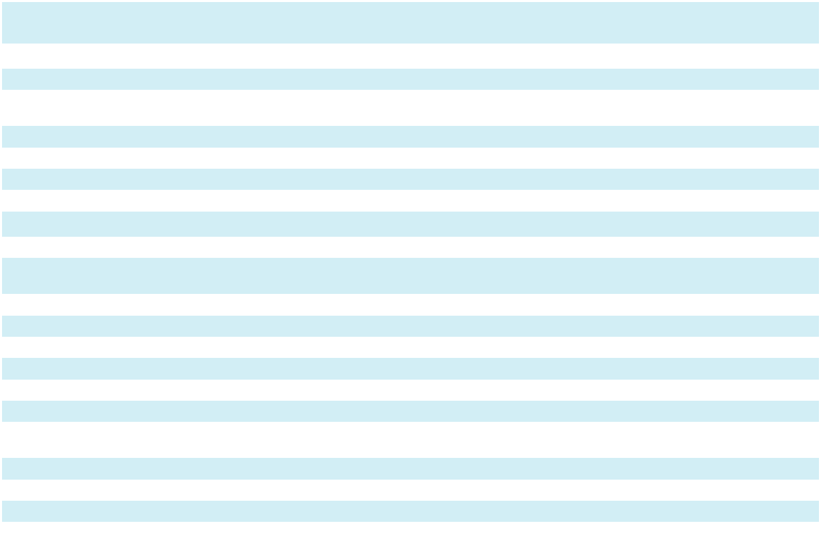

See notes to consolidated financial statements.

75

Sotera Health Company

Notes to Consolidated Financial Statements

- Significant Accounting Policies

Principles of Consolidation – Sotera Health Company (also referred to herein as the “Company,” “we,” “our,” “us” or “its”), is a leading global provider of mission-critical end-to-end sterilization solutions, lab testing and advisory services for the healthcare industry with operations primarily in the Americas, Europe and Asia.

The accompanying consolidated financial statements include the assets, liabilities, operating results, and cash flows of the Company and its wholly owned subsidiaries prepared in accordance with U.S. generally accepted accounting principles (“GAAP”).

We operate and report in three segments, Sterigenics, Nordion and Nelson Labs. We describe our reportable segments in Note 21, “Segment and Geographic Information.” All intercompany balances and transactions have been eliminated in consolidation.

Use of Estimates – In preparing our consolidated financial statements in conformity with GAAP, we make estimates and assumptions that affect the amounts reported and the accompanying notes. We regularly evaluate the estimates and assumptions used and revise them as new information becomes available. Actual results may vary from those estimates.

Cash and Cash Equivalents – We consider all highly liquid investments purchased with an original maturity of three months or less from the date of purchase to be cash equivalents. Cash and cash equivalents may include various deposit accounts and money market funds.

Accounts Receivable - Accounts receivable consists of amounts billed and currently due from customers. The amounts due are stated net of the allowance for uncollectible accounts. The Company maintains an allowance for uncollectible receivables to provide for the estimated amount of receivables that will not be collected.

Allowance for Uncollectible Accounts Receivable – We maintain an allowance for uncollectible accounts receivable for estimated losses in the collection of amounts owed to us by customers. We estimate the allowance based on analyzing a number of factors, including amounts written off historically, customer payment practices, customer financial information and credit ratings, current market conditions as well as the expected future economic conditions that may impact the collection of accounts receivable. We also analyze significant customer accounts on a regular basis and record a specific allowance when we become aware of a specific customer’s inability to pay. We generally do not charge interest on accounts receivable or require collateral from our customers.

We record write-offs against the allowance for uncollectible accounts receivable when all reasonable efforts for collection have been exhausted. As a result, the related accounts receivable are reduced to an amount that we reasonably believe is collectible. These analyses require judgment. If the financial condition of our customers worsens, or economic conditions change, we may be required to make changes to our allowance for uncollectible accounts receivable.

Inventories – Inventories as of December 31, 2024 and 2023 are held at Nordion. Inventories are stated at the lower of cost or net realizable value. Cost of material, labor, and manufacturing overhead are determined using standard cost, which approximates average cost. We review inventory on an ongoing basis, considering factors such as deterioration and obsolescence. We record a reserve for excess and obsolete inventory, which was immaterial at December 31, 2024 and 2023, when the facts and circumstances indicate that particular inventories will not be usable. If future market conditions vary from those projected, and our estimates prove to be inaccurate, we may be required to write-down inventory values and record an adjustment to cost of revenues.

Property, Plant, and Equipment – Property, plant, and equipment is carried at cost, or initially at fair value if acquired in an acquisition, less accumulated depreciation and amortization. Except for Co-60, a radioactive isotope used in gamma radiation sterilization, all property, plant, and equipment depreciation is computed using the straight-line method over estimated useful lives. Leasehold improvements are amortized over their estimated useful lives or the term of the related lease, whichever is shorter. Co-60 is amortized using an accelerated method, which relates to the natural radioactive decay of the isotope over its estimated useful life which is approximately twenty years. Amortization of Co-60 is included within depreciation expense as a cost of revenue. Expenditures for major software purchases and software developed for internal use are capitalized and depreciated using the straight-line method over the estimated useful lives of the related assets, which are generally one to five

76

Sotera Health Company

Notes to Consolidated Financial Statements

years. For software obtained or developed for internal use, all external direct costs for materials and services and certain personnel costs incurred to develop the software during the application development stage are capitalized. At December 31, 2024 and 2023, we had undepreciated software costs of $11.4 million and $7.9 million, respectively, included in property, plant, and equipment, net. We recognized $4.2 million, $3.3 million and $2.2 million, of depreciation expense related to software costs for the years ending December 31, 2024, 2023 and 2022, respectively.

Depreciation is computed using the assets’ estimated useful lives as presented below:
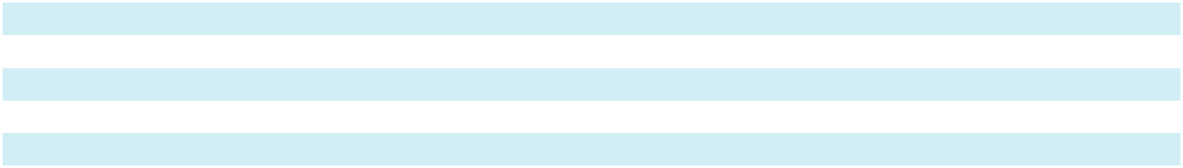

Buildings and building improvements

Machinery and equipment

Leasehold improvements

Furniture and fixtures

Computer hardware and software

15–44 years

3–30 years

2–20 years

3–10 years

1–7 years

From time to time, we build or expand facilities. The cost of construction of these facilities is reflected as construction-in-progress until the asset is ready for its intended use, at which time the costs are reclassified to the appropriate depreciable category of property, plant, and equipment and depreciation commences. Fixed asset projects requiring one or more years to complete construction qualify for capitalization of interest costs in accordance with our policy. Interest related to property, plant and equipment projects with a construction period of less than one year are not capitalized and are immaterial. Repairs and maintenance costs that do not extend the useful life of an asset are expensed as incurred.

Upon sale or retirement of assets, the cost and related accumulated depreciation is removed from the Consolidated Balance Sheets, and the resulting gain or loss is reflected as a component of operating income.

Leases – We determine if an agreement contains a lease and classify our leases as operating or finance at the lease commencement date. Leases with an initial term of twelve months or less are recognized as lease expense on a straight-line basis over the lease term and are not recorded on the Consolidated Balance Sheets. Non-lease components are accounted for separately from the lease components for all asset classes.

Finance leases are those in which we will pay substantially all the underlying asset’s fair value or will use the asset for all or a major part of its economic life, including circumstances in which we will ultimately own the asset. Lease assets arising from finance leases are included in “Property, plant and equipment, net” and the liabilities are included in “Finance lease obligations” on the Consolidated Balance Sheets. For finance leases, we recognize interest expense using the effective interest method and we recognize amortization expense on the lease asset over the shorter of the lease term or the useful life of asset. Finance leases are accounted for as if the assets were owned and financed, with associated expense recognized in “Interest expense, net” and “Cost of revenues” or “Selling, general and administrative expenses” within the Consolidated Statements of Operations and Comprehensive Income (Loss) depending on the nature of the underlying asset.

Operating lease assets and liabilities are recognized at the commencement date of the lease based on the present value of lease payments over the lease term. Lease assets represent the right to use an underlying asset for the lease term and lease liabilities represent the obligation to make lease payments arising from the lease. As most leases do not provide an implicit interest rate, we estimate an incremental borrowing rate to determine the present value of lease payments. Our estimated incremental borrowing rate reflects a secured rate based on recent debt issuances, our estimated credit rating, and lease term. We recognize operating lease costs on a straight-line basis over the term of the lease in “Cost of revenues” or “Selling, general and administrative expenses” on the Consolidated Statements of Operations and Comprehensive Income (Loss) depending on the nature of the underlying asset.

Goodwill and Other Indefinite-Lived Intangibles – Goodwill and other indefinite-lived intangible assets, primarily certain regulatory licenses and tradenames, are tested for impairment annually as of October 1. If circumstances change during interim periods between annual tests that would indicate that the carrying amount of such assets may not be recoverable, the Company tests such assets at an interim date for impairment. Factors that necessitate an interim impairment assessment include prolonged negative industry or economic trends and significant underperformance relative to historical or projected future operating results.

77

Sotera Health Company

Notes to Consolidated Financial Statements

We performed a quantitative assessment of all reporting units (Sterigenics, Nordion and Nelson Labs) as of October 1, 2024. The fair value of each reporting unit was calculated using a discounted cash flow analysis which was dependent on subjective market participant assumptions determined by management. We further corroborated these discounted cash flow analyses utilizing a market approach to determine the estimated enterprise fair value. Assumptions used in the analyses included discount rates, revenue growth rates and projected operating cash flows. Estimates of future cash flows are based upon relevant data at a point-in-time, are subject to change, and could vary from actual results. The estimated fair value of each reporting unit exceeded its carrying amount by a sufficient margin to support a positive assertion that goodwill is not impaired. We performed a qualitative impairment assessment to evaluate any potential impairment to the indefinite-lived intangible assets. We considered significant events and circumstances that could affect the significant inputs used to determine the estimated fair value of the indefinite-lived intangible assets, and determined, after considering the totality of evidence that it is not more likely than not that the indefinite-lived intangible assets are impaired. There have been no other significant events or circumstances that occurred since the annual assessment date of October 1 that would change the conclusions reached above.

Derivative Instruments – We may enter into derivative instruments and hedging activities to manage, where possible and economically efficient, commodity price risk, foreign currency exchange rate risk and interest rate risk related to borrowings. We also have identified embedded derivatives in certain supply and customer contracts. Certain interest rate derivatives are designated as cash flow hedges allowing for changes in fair value to be recorded through “Other comprehensive income (loss).” Amounts in accumulated other comprehensive income (loss) will be reclassified into earnings in the same periods during which the hedged transaction affects earnings and are presented in “Interest expense, net” within the Consolidated Statements of Operations and Comprehensive Income (Loss). Derivatives not designated as hedges are recorded at fair value on the Consolidated Balance Sheets, with any changes in the value being recorded in the Consolidated Statements of Operations and Comprehensive Income (Loss) in the same line item as the corresponding hedged item. We classify cash flows from derivative instruments and hedging activities as cash flows from operating activities in the Consolidated Statements of Cash Flows. To the extent derivative arrangements are with the same counterparty and contractual right of offset exists under applicable master agreements, we offset assets and liabilities for reporting on the Consolidated Balance Sheets.

Pension, Post-Retirement and Other Post-Employment Benefit Plans – We sponsor a defined-contribution retirement plan that covers substantially all U.S. employees. We also sponsor various post-employment benefit plans at our Nordion business in Canada, including defined benefit and defined contribution pension plans, retirement compensation arrangements and plans that provide extended health care coverage to retired employees. In addition, we provide other benefit plans at our foreign subsidiaries, including a supplemental retirement arrangement, a retirement and termination allowance and post-retirement benefit plans, which include contributory healthcare benefits and contributory life insurance coverage. All non-pension post-employment benefit plans are unfunded.

These costs and obligations are affected by assumptions including the discount rate, the expected long-term rate of return on plan assets, the annual rate of change in compensation for eligible employees, estimated changes in costs of healthcare benefits, and other demographic and economic factors. We review the assumptions used on an annual basis.

We recognize the over/under funded status of defined benefit pension and post-retirement benefits plans in our Consolidated Balance Sheets. This amount is measured as the difference between the fair value of plan assets and the projected benefit obligation (“PBO”). Changes in the funded status of the plans are recorded in other comprehensive income (loss) in the year they occur. We measure plan assets and obligations as of the balance sheet date. We provide additional information about our pension and other post-retirement benefits plans in Note 11, “Employee Benefits.”

Amortization of net gain or loss included in accumulated other comprehensive income (loss) is reclassified to net periodic pension cost if, as of the beginning of the year, that gain or loss exceeds 10% of the greater of the PBO or the market related value of the plan assets (the ‘corridor’). As most of the plan’s participants are no longer actively accruing benefits, the average remaining life expectancy is used.

Asset Retirement Obligations (“ARO”) – ARO are legal obligations associated with the retirement of long-lived assets or the exit of a leased facility. We recognize a liability for an ARO in the period in which it is incurred if a reasonable estimate of fair value can be made, and the associated asset retirement costs are then capitalized as part of the carrying amount of the long-lived asset. We lease various facilities where sterilization and ionization services are performed. Under the lease agreements, we are required to return the facilities to their original condition and to perform decommissioning activities. In addition, certain of our

78

Sotera Health Company

Notes to Consolidated Financial Statements

owned facilities are required to be decommissioned when we vacate the facility. Accretion expense is recognized in cost of revenues in the Consolidated Statements of Operations and Comprehensive Income (Loss) over time as the discounted liability is accreted to its expected settlement value.

Debt Issuance Costs, Premiums and Discounts – We have incurred costs in connection with obtaining financing as well as premiums and discounts associated with our long-term debt. The portion of these fees that are capitalized are recorded as a reduction of debt on the Consolidated Balance Sheets and amortized into interest expense over the term of the debt agreement. Debt issuance costs associated with the Company’s revolving credit facilities are classified as assets unless there are outstanding borrowings under such arrangements.

Concentration of Credit Risk, Other Risks and Uncertainties – We maintain cash and cash equivalents in the form of demand deposits in accounts with major financial institutions in the U.S. and in countries where our subsidiaries operate. Deposits in these institutions may exceed amounts of insurance provided on such accounts. We have not experienced any losses on our deposits of cash and cash equivalents.

Our net revenues and accounts receivable are derived from customers located primarily in North America and Europe.

No customer accounted for 10% or more of accounts receivable at December 31, 2024 and 2023, or 10% or more of net revenues for the years ended December 31, 2024, 2023 and 2022.

Income Taxes –We use the liability method of accounting for income taxes whereby we recognize deferred tax assets and liabilities for the future tax consequences of temporary differences between the tax bases of assets and liabilities and their reported amounts in the consolidated financial statements. Deferred tax assets will be reduced by a valuation allowance if, based on management’s estimate, it is more likely than not that a portion of the deferred tax assets will not be realized in a future period. The estimates used in the recognition of deferred tax assets are subject to revision in future periods based on new facts and circumstances.

We determine whether it is more likely than not that a tax position will be sustained upon examination, including resolution of related appeals or litigation processes, based on the technical merits of the position. In evaluating whether a tax position has met the more-likely-than-not recognition threshold, we presume that the position will be examined by the appropriate taxing authority and that the taxing authority will have full knowledge of all relevant information. A tax position that meets the more-likely-than-not recognition threshold is measured at the largest amount of benefit that is greater than 50% likely of being realized upon ultimate settlement. Determining what constitutes an individual tax position and whether the more-likely-than-not recognition threshold is met for a tax position are matters of judgment based on the individual facts and circumstances of that position evaluated in light of all available evidence. We review and adjust tax estimates periodically because of ongoing examinations by, and settlements with, the various taxing authorities, as well as changes in tax laws, regulations, and precedent. We are subject to a tax on Global Intangible Low Taxed Income (“GILTI”) which we record as a period cost.

Our policy is to recognize interest and penalties related to income tax matters as a component of the provision for income taxes in our Consolidated Statements of Operations and Comprehensive Income (Loss).

Foreign Currency Translation – The functional currency of our foreign subsidiaries is generally the local currency. Accordingly, assets and liabilities are generally translated into U.S. dollars at the current rates of exchange as of the balance sheet date, and revenues and expenses are translated using weighted-average rates prevailing during the period. Adjustments from foreign currency translation are included as a separate component of accumulated other comprehensive income (loss).

Gains or losses arising from foreign currency transactions are recognized in the Consolidated Statements of Operations and Comprehensive Income (Loss) as foreign exchange loss (gain). The Company routinely enters into foreign currency forward contracts to manage foreign currency exchange rate risk of our intercompany loans in certain of our international subsidiaries and non-functional currency assets and liabilities. The foreign currency forward contracts expire on a monthly basis. For the years ended December 31, 2024, 2023 and 2022, foreign exchange loss related primarily to short-term losses (offset by short-term gains) on sales denominated in currencies other than the functional currency of our operating entities.

79

Sotera Health Company

Notes to Consolidated Financial Statements

Revenue Recognition – Revenue is recognized when control of promised goods or services is transferred to customers in an amount that reflects the consideration to which the Company expects to be entitled in exchange for those goods or services. The majority of our sales agreements contain performance obligations satisfied at a point-in-time when control of promised goods or services have transferred to our customers. Sales recognized over time are generally accounted for using an input measure to determine progress completed as of the end of the period.

Refunds, returns, warranties and other related obligations are not material to any of our segments and we do not incur material incremental costs to secure customer contracts.

Our Sterigenics segment provides outsourced terminal sterilization and irradiation services for the medical device, pharmaceutical, food safety and advanced applications markets. We typically have multiyear service contracts with our significant customers, and these sales contracts are primarily based on customers’ purchase orders. Given the relatively short turnaround times, performance obligations are generally satisfied at a point-in-time upon the completion of sterilization or irradiation processing and approval by our quality assurance process. Sterigenics segment revenues are included in service revenues in our Consolidated Statements of Operations and Comprehensive Income (Loss).

Our Nordion segment is a global provider of Co-60 and gamma irradiation systems, which are key components to the gamma sterilization process. Revenue from the sale of Co-60 sources is recognized as product revenue at a point-in-time upon satisfaction of our performance obligations for delivery of existing sources. Revenue from the sale of gamma irradiation systems is recognized as product revenue over time using an input measure of costs incurred and is immaterial to the overall business. Revenues from Co-60 installation and disposal and gamma irradiation systems refurbishments and installations are recognized as service revenue.

Our Nelson Labs segment provides outsourced microbiological and analytical chemistry testing and advisory services for the medical device and pharmaceutical industries. We provide our customers mission-critical lab testing services, which assess the product quality, effectiveness, patient safety and end-to-end sterility of products. These services are necessary for our customers’ regulatory approvals, product releases and ongoing product performance evaluations. Nelson Labs services are generally provided on a fee-for-service or project basis, and we recognize revenues over time using an input measure of time incurred to determine progress completed at the end of the period. Nelson Labs segment revenues are included in service revenues in our Consolidated Statements of Operations and Comprehensive Income (Loss).

We do not capitalize sales commissions because substantially all of our sales commission programs have an amortization period of one year or less. Furthermore, costs to fulfill a contract are not material.

Provisions for discounts, rebates to customers, and other adjustments are provided for as reductions in net revenues in the period the related sale is recorded. Shipping and handling charges billed to customers are included in net revenues, and the related shipping and handling costs are included in cost of net revenues on the Consolidated Statements of Operations and Comprehensive Income (Loss). Taxes assessed by a governmental authority that are both imposed on and concurrent with a specific revenue-producing transaction, that are collected by us from a customer, are excluded from net revenue.

Payment terms vary by the type and location of the customer and the products or services offered. Generally, the time between when revenue is recognized and when payment is due is not significant. We do not evaluate whether the selling price contains a financing component for contracts that have a duration of less than one year.

Share-Based Compensation – Equity-based awards issued to employees under the Sotera Health Company 2020 Omnibus Incentive Plan (“2020 Plan”) include restricted stock units (“RSUs”) and stock options that vest over time. Prior to our initial public offering (the “IPO” as described in Note 14, “Stockholders' Equity”), equity-based awards were issued to employees and non-employee directors in the form of partnership interests in our predecessor, Sotera Health Topco Parent, L.P. (“Topco Parent”), which vested based on either time (“time vesting awards”) or the achievement of certain performance and market conditions (“performance awards” and, together with the time vesting awards, the “pre-IPO awards”). In connection with the IPO, Topco Parent made in-kind distributions of restricted shares of our common stock to holders of pre-IPO awards as described in Note 14, “Stockholders' Equity.” The restricted shares of our common stock distributed in respect of pre-IPO time vesting awards vest through June 2025; expense related to these unvested awards will be recognized over the remaining vesting period. Expense attributable to the performance awards was recognized in its entirety in the year ended December 31, 2020 as

80

Sotera Health Company

Notes to Consolidated Financial Statements

the related performance conditions were considered probable of achievement and the implied service condition was met. Share-based compensation expense is recognized in the Consolidated Statements of Operations and Comprehensive Income (Loss), primarily within “Selling, general and administrative expenses” at the grant date fair value over the requisite service period (one to four years for awards granted under the 2020 Plan and five years for time vesting pre-IPO awards on a straight-line basis). Fair value of the pre-IPO awards was estimated on the date of grant using a simulation-based option valuation model incorporating multiple and variable assumptions over time, including assumptions such as employee forfeitures, unit price volatility and dividend assumptions. We use the Black-Scholes option pricing model to measure the grant date fair value of stock options awarded under the 2020 Plan using certain valuation assumptions. Share-based compensation expense for all awards recognizes forfeitures as they occur.

Earnings (Loss) Per Share – In periods in which the Company has net income, earnings per share information is determined using the two-class method, which includes the weighted-average number of common shares outstanding during the period and securities that participate in dividends (“participating securities”). Our unvested restricted common stock distributed in respect of partnership interests in Topco Parent (“pre-IPO Class B-1 restricted stock awards”) has the right to receive non-forfeitable dividends or dividend equivalents if the Company declares dividends on its common stock. Under the two-class method, earnings are allocated to both common stock shares and participating securities based on their respective weighted-average shares outstanding for the period. Diluted earnings (loss) per common share incorporates the dilutive effect of common stock equivalents on an average basis during the period, if dilutive, in which case the dilutive effect of such securities is calculated using the more dilutive of (a) the two-class method, or (b) treasury stock method, as applicable, to the potentially dilutive instruments. Unvested restricted common stock is not included in the weighted average common shares outstanding figure within earnings per share until the period in which the vesting condition is satisfied. In periods in which the Company has a net loss, the two-class method is not applicable because the pre-IPO Class B-1 restricted stock awards do not participate in losses. Refer to Note 16, “Earnings (Loss) Per Share” for additional information.

Treasury Stock – The Company records repurchases of its own common stock at cost. Repurchased common stock is presented as a reduction of equity in the Consolidated Balance Sheets. The difference between the repurchase and reissue price of the Company’s own stock is added to or deducted from additional paid-in capital. The cost of Treasury Stock reissued is calculated using a weighted average cost method.

Commitments and Contingencies – Certain conditions may exist as of the date of the consolidated financial statements which may result in a loss to the Company but will only be resolved when one or more future events occur or fail to occur. Such liabilities for loss contingencies arising from claims, assessments, litigation, fines, penalties, settlement agreements, and other sources, are recorded when management assesses that it is probable that a future liability has been incurred and the amount can be reasonably estimated. Recoveries of costs from third parties, which management assesses as being probable of realization, are recorded to the extent related contingent liabilities are accrued. Legal costs incurred in connection with matters relating to contingencies are expensed in the period incurred. We record gain contingencies when realized.

- Recent Accounting Standards

Adoption of Accounting Standard Updates

In the year ended December 31, 2024, we adopted Accounting Standards Update (“ASU”) 2023-07-Segment Reporting (Topic 280): Improvements to Reportable Segment Disclosures. The amendments in ASU 2023-07 require an entity to provide enhanced disclosures about significant segment expenses. The adoption of this standard did not have a material impact on our consolidated financial statements and disclosures.

ASUs Issued But Not Yet Adopted

In December 2023, the FASB issued ASU 2023-09-Income Taxes (Topic 740): Improvements to Income Tax Disclosures. The amendments in this ASU require entities to disclose, on an annual basis, specific categories in the reconciliation of the provision (benefit) for income taxes to the statutory rate and provide additional information for reconciling items that meet a quantitative threshold. Additionally, the update requires entities to disclose a disaggregation of taxes paid by category (federal, state and foreign taxes) as well as individual jurisdictions. For public business entities, the amendments in this ASU are effective for annual periods beginning after December 15, 2024. The Company is in the process of evaluating the impact of this standard on our consolidated financial statements and disclosures.

81

Sotera Health Company

Notes to Consolidated Financial Statements

In November 2024, the FASB issued ASU 2024-03-Income Statement-Reporting Comprehensive Income-Expense Disaggregation Disclosures (Subtopic 220-40): Disaggregation of Income Statement Expenses. The amendments in this ASU requires entities to disaggregate certain expense captions into specified categories in disclosures within the footnotes to the financial statements. The Company is in the process of evaluating the impact of this standard on our consolidated financial statements and disclosures. In January 2025, the FASB issued ASU 2025-01, which revises the effective date of ASU 2024-03 and clarifies that entities are required to adopt the guidance in annual reporting periods beginning after December 15, 2026, and interim periods within annual reporting periods beginning after December 15, 2027. The Company is in the process of evaluating the impact of this standard on our consolidated financial statements and disclosures.

- Revenue Recognition

The following table shows disaggregated net revenues from contracts with external customers by timing of revenue and by segment for the years ended December 31, 2024, 2023 and 2022:

 |  |  |  |  | Year Ended December 31, 2024
 |  | Sterigenics |  |  | Nordion |  |  | Nelson Labs |  |  | Consolidated
Point in time | $ | 697,853 | $ |  | 171,285 | $ |  | — | $ |  | 869,138
Over time |  | — |  |  | 2,070 |  |  | 229,233 |  |  | 231,303
Total | $ | 697,853 |  | $ | 173,355 |  | $ | 229,233 |  | $ | 1,100,441
 |  |  |  |  | Year Ended December 31, 2023
 |  | Sterigenics |  |  | Nordion |  |  | Nelson Labs |  |  | Consolidated
Point in time | $ | 667,130 | $ |  | 153,747 | $ |  | — | $ |  | 820,877
Over time |  | — |  |  | 6,712 |  |  | 221,699 |  |  | 228,411
Total | $ | 667,130 |  | $ | 160,459 |  | $ | 221,699 |  | $ | 1,049,288
 |  |  |  |  | Year Ended December 31, 2022
 |  | Sterigenics |  |  | Nordion |  |  | Nelson Labs |  |  | Consolidated
Point in time | $ | 626,646 | $ |  | 147,499 | $ |  | — | $ |  | 774,145
Over time |  | — |  |  | 6,140 |  |  | 223,402 |  |  | 229,542
Total | $ | 626,646 |  | $ | 153,639 |  | $ | 223,402 |  | $ | 1,003,687

When we receive consideration from a customer prior to transferring goods or services under the terms of a sales contract, we record deferred revenue, which represents a contract liability. Deferred revenue totaled $15.1 million and $13.5 million at December 31, 2024 and 2023, respectively. We recognize deferred revenue after we have transferred control of the goods or services to the customer and all revenue recognition criteria are met.

- Inventories

Inventories consisted of the following:

(thousands of U.S. dollars)
As of December 31, |  |  |  | 2024 |  |  | 2023
Raw materials and supplies
 |  |  | $ | 42,408 | $ |  | 43,411
Work-in-process |  |  |  | 929 |  |  | 471
Finished goods |  |  |  | 6,039 |  |  | 4,670
 |  |  |  | 49,376 |  |  | 48,552
Reserve for excess and obsolete inventory |  |  |  | (218) |  |  | (236)
Inventories, net |  |  | $ | 49,158 | $ |  | 48,316

82

Sotera Health Company

Notes to Consolidated Financial Statements

- Prepaid Expenses and Other Current Assets

Prepaid expenses and other current assets consisted of the following:

 | (thousands of U.S. dollars)
 | As of December 31, |  |  |  | 2024 |  |  | 2023
 | Prepaid taxes
 | Prepaid taxes |  |  | $ | 4,993 | $ |  | 4,129
 | Prepaid business insurance |  |  |  | 6,993 |  |  | 7,174
 | Prepaid rent |  |  |  | 1,223 |  |  | 1,150
 | Customer contract assets |  |  |  | 15,213 |  |  | 17,785
 | Current deposits |  |  |  | 807 |  |  | 715
 | Prepaid maintenance contracts |  |  |  | 638 |  |  | 422
 | Value added tax receivable |  |  |  | 3,614 |  |  | 4,306
 | Prepaid software licensing |  |  |  | 2,590 |  |  | 2,503
 | Stock supplies |  |  |  | 4,025 |  |  | 3,669
 | Embedded derivatives |  |  |  | 2,689 |  |  | 1,225
 | Other |  |  |  | 8,246 |  |  | 10,768
 | Prepaid expenses and other current assets |  |  | $ | 51,031 | $ |  | 53,846
6. Property, Plant and Equipment
Property, plant, and equipment, net, consisted of the following:
 | (thousands of U.S. dollars)
 | As of December 31, |  |  |  | 2024 |  |  | 2023
 | Land and buildings
 |  |  |  | $ | 418,038 | $ |  | 345,309
 | Leasehold improvements |  |  |  | 98,028 |  |  | 82,582
 | Machinery, equipment, including Co-60 |  |  |  | 757,568 |  |  | 710,000
 | Furniture and fixtures |  |  |  | 9,118 |  |  | 8,754
 | Computer hardware and software |  |  |  | 58,767 |  |  | 51,437
 | Asset retirement costs |  |  |  | 7,368 |  |  | 6,590
 | Construction-in-progress |  |  |  | 250,418 |  |  | 247,019
 |  |  |  |  | 1,599,305 |  |  | 1,451,691
 | Less accumulated depreciation |  |  |  | (562,413) |  |  | (504,777)
 | Property, plant and equipment, net |  |  | $ | 1,036,892 | $ |  | 946,914
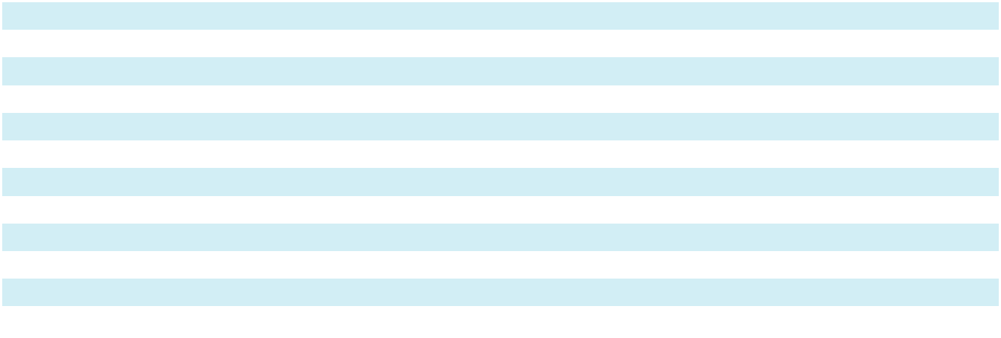
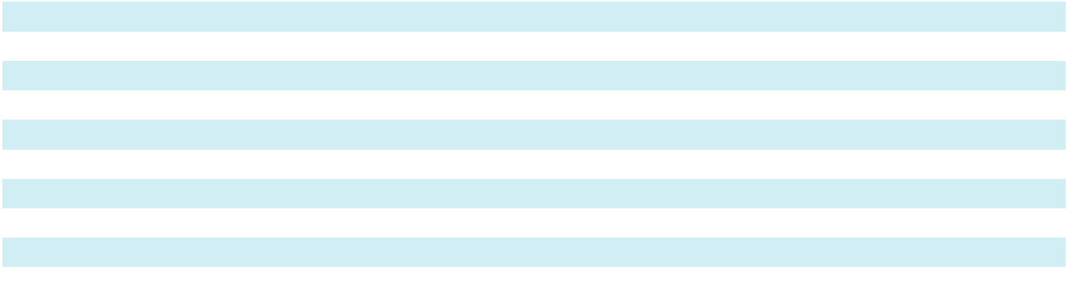

Depreciation and amortization expense for property, plant, and equipment, including property under finance leases, was $84.3 million, $76.6 million and $64.3 million for the years ended December 31, 2024, 2023 and 2022, respectively. Capitalized interest totaled $16.2 million, $12.2 million and $3.7 million for the years ended December 31, 2024, 2023 and 2022, respectively, and was recorded as a reduction in “Interest expense, net” in the Consolidated Statements of Operations and Comprehensive Income (Loss).

83

Sotera Health Company

Notes to Consolidated Financial Statements

- Goodwill and Other Intangible Assets

Changes to goodwill during the years ended December 31, 2024 and 2023 were as follows:

 | (thousands of U.S. dollars) |  |  |  | Sterigenics |  |  | Nordion |  |  | Nelson Labs |  |  | Total
 | Goodwill at January 1, 2023
 |  |  |  | $ | 657,458 | $ |  | 270,966 | $ |  | 173,344 | $ |  | 1,101,768
 | Changes due to foreign currency exchange rates |  |  |  | 2,430 |  |  | 5,963 |  |  | 1,029 |  |  | 9,422
 | Goodwill at December 31, 2023 |  |  |  | 659,888 |  |  | 276,929 |  |  | 174,373 |  |  | 1,111,190
 | Changes due to foreign currency exchange rates |  |  |  | (6,666) |  |  | (21,444) |  |  | (2,007) |  |  | (30,117)
 | Goodwill at December 31, 2024 |  |  | $ | 653,222 |  | $ | 255,485 |  | $ | 172,366 |  | $ | 1,081,073
Other intangible assets consisted of the following:
 | (thousands of U.S. dollars) |  |  |  |  |  |  |  |  | Gross Carrying |  |  | Accumulated
 | As of December 31, 2024
 | As of December 31, 2024 |  |  |  |  |  |  |  |  |  | Amount |  | Amortization
 | Finite-lived intangible assets
 |  |  |  |  |  |  |  |  | $ |  | 646,965 | $ |  | 537,871
 | Customer relationships
 | Proprietary technology |  |  |  |  |  |  |  |  |  | 73,464 |  |  | 52,976
 | Trade names |  |  |  |  |  |  |  |  |  | 2,531 |  |  | 1,651
 | Land-use rights |  |  |  |  |  |  |  |  |  | 8,493 |  |  | 2,008
 | Sealed source and supply agreements |  |  |  |  |  |  |  |  |  | 192,630 |  |  | 110,668
 | Other |  |  |  |  |  |  |  |  |  | 4,344 |  |  | 3,655
 | Total finite-lived intangible assets |  |  |  |  |  |  |  |  |  | 928,427 |  |  | 708,829
 | Indefinite-lived intangible assets
 | Regulatory licenses and other^{(a)} |  |  |  |  |  |  |  |  |  | 72,550 |  |  | —
 | Trade names / trademarks |  |  |  |  |  |  |  |  |  | 25,505 |  |  | —
 | Total indefinite-lived intangible assets |  |  |  |  |  |  |  |  |  | 98,055 |  |  | —
 | Total |  |  |  |  |  |  |  |  | $ | 1,026,482 |  | $ | 708,829
 | As of December 31, 2023 |  |  |  |  |  |  |  |  | Gross Carrying |  |  | Accumulated
 | As of December 31, 2023 |  |  |  |  |  |  |  |  |  | Amount |  | Amortization
 | Finite-lived intangible assets
 | Customer relationships |  |  |  |  |  |  |  | $ |  | 657,673 | $ |  | 485,188
 | Proprietary technology |  |  |  |  |  |  |  |  |  | 84,918 |  |  | 56,846
 | Trade names |  |  |  |  |  |  |  |  |  | 2,567 |  |  | 1,207
 | Land-use rights |  |  |  |  |  |  |  |  |  | 8,756 |  |  | 1,855
 | Sealed source and supply agreements |  |  |  |  |  |  |  |  |  | 208,919 |  |  | 107,561
 | Other |  |  |  |  |  |  |  |  |  | 4,517 |  |  | 2,905
 | Total finite-lived intangible assets |  |  |  |  |  |  |  |  |  | 967,350 |  |  | 655,562
 | Indefinite-lived intangible assets
 | Regulatory licenses and other^{(a)} |  |  |  |  |  |  |  |  |  | 78,684 |  |  | —
 | Trade names / trademarks |  |  |  |  |  |  |  |  |  | 25,846 |  |  | —
 | Total indefinite-lived intangible assets |  |  |  |  |  |  |  |  |  | 104,530 |  |  | —
 | Total |  |  |  |  |  |  |  | $ |  | 1,071,880 | $ |  | 655,562
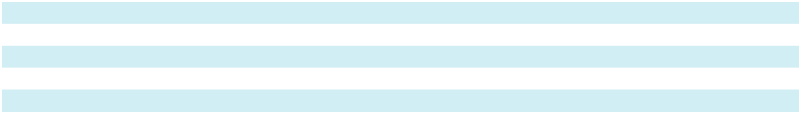
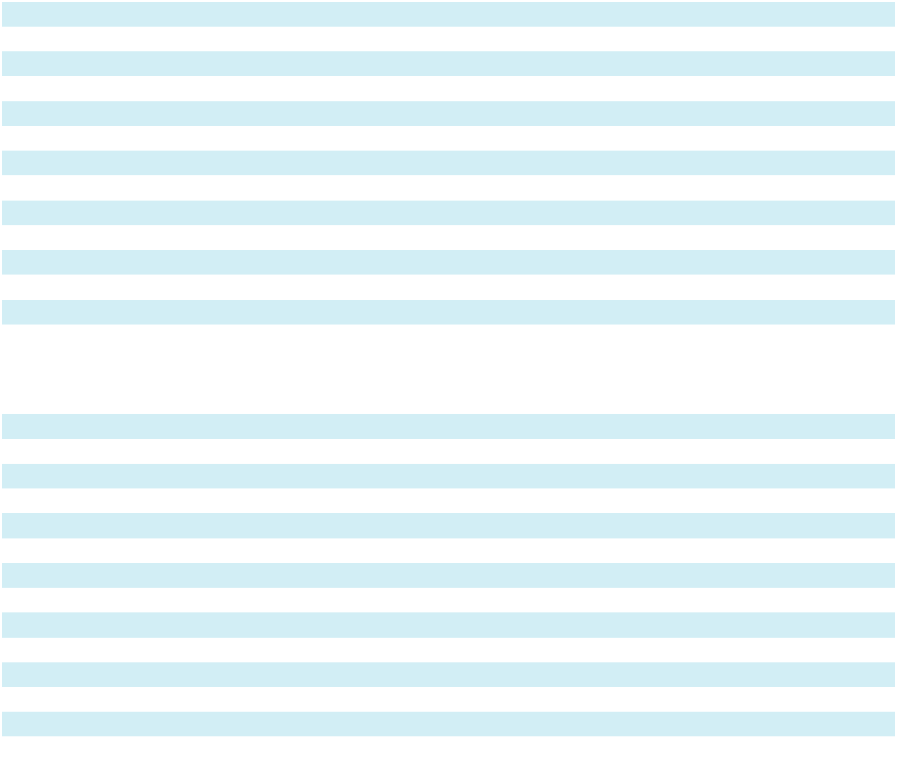

84

Sotera Health Company

Notes to Consolidated Financial Statements

- Includes certain transportation certifications, a class 1B nuclear license and other intangibles related to obtaining such licensure. These assets are considered indefinite-lived as the decision for renewal by the Canadian Nuclear Safety Commission is highly based on a licensee’s previous assessments, reported incidents, and annual compliance and inspection results. New applications for license can take a significant amount of time and cost; whereas an existing licensee with a historical record of compliance and current operating conditions more than likely ensures renewal for another 10 year license period as Nordion has demonstrated over its 75 years of history.

Amounts include the impact of foreign currency translation. Fully amortized amounts are written off.

Amortization expense for finite-lived intangible assets was $79.4 million, $81.3 million, and $81.6 million for the years ended December 31, 2024, 2023 and 2022, respectively. $62.0 million, $63.8 million, and $62.9 million was included in “Amortization of intangible assets” in the Consolidated Statements of Operations and Comprehensive Income (Loss) for the years ended December 31, 2024, 2023 and 2022, whereas the remainder was included in “Cost of revenues.”

The estimated aggregate amortization expense for finite-lived intangible assets for each of the next five years and thereafter is as follows:

(thousands of U.S. dollars)
2025 |  | $ | 41,338
2026 |  |  | 21,379
2027 |  |  | 20,303
2028 |  |  | 19,755
2029 |  |  | 19,645
Thereafter |  |  | 97,178
Total |  | $ | 219,598

The weighted-average remaining amortization periods of the finite-lived intangible assets by major intangible asset class as of

December 31, 2024 were as follows:

 |  |  | Weighted average
 |  |  | remaining
 | (in years) |  | amortization period
 | Customer relationships |  | 8.4
 | Proprietary technology |  | 10.0
 | Trade names |  | 1.8
 | Land-use rights |  | 31.7
 | Sealed source and supply agreements |  | 10.0
 | Other |  | 1.0
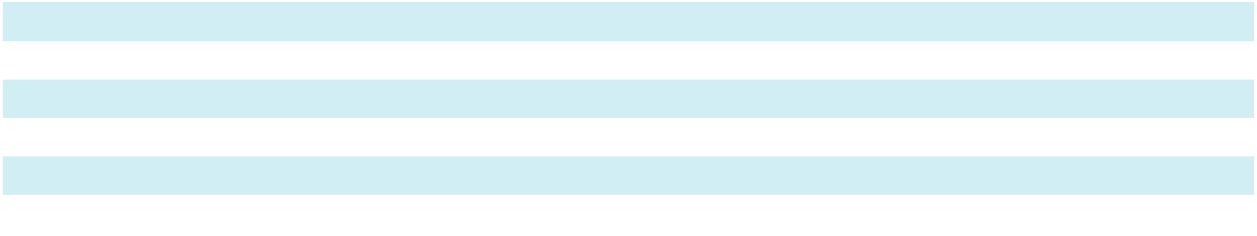

85

Sotera Health Company

Notes to Consolidated Financial Statements

- Accrued Liabilities

Accrued liabilities consisted of the following:

 | (thousands of U.S. dollars)
 | As of December 31, |  |  |  |  |  |  |  |  |  |  |  |  | 2024 |  |  |  |  | 2023
 | Accrued employee compensation
 |  |  |  |  |  |  |  |  |  |  |  |  | $ | 37,018 |  |  |  | $ | 35,037
 | Georgia EO litigation settlement reserve |  |  |  |  |  |  |  |  |  |  |  |  | — |  |  |  |  | 35,000
 | Illinois EO litigation settlement reserve |  |  |  |  |  |  |  |  |  |  |  |  | — |  |  |  |  | 288
 | Other legal reserves |  |  |  |  |  |  |  |  |  |  |  |  | — |  |  |  |  | 1,480
 | Accrued interest expense |  |  |  |  |  |  |  |  |  |  |  |  | 25,321 |  |  |  |  | 26,681
 | Embedded derivatives |  |  |  |  |  |  |  |  |  |  |  |  | 4,098 |  |  |  |  | 414
 | Professional fees |  |  |  |  |  |  |  |  |  |  |  |  | 12,572 |  |  |  |  | 12,691
 | Accrued utilities |  |  |  |  |  |  |  |  |  |  |  |  | 1,651 |  |  |  |  | 2,056
 | Insurance accrual |  |  |  |  |  |  |  |  |  |  |  |  | 2,326 |  |  |  |  | 2,922
 | Accrued taxes |  |  |  |  |  |  |  |  |  |  |  |  | 3,923 |  |  |  |  | 2,407
 | Other |  |  |  |  |  |  |  |  |  |  |  |  | 3,554 |  |  |  |  | 3,495
 | Accrued liabilities |  |  |  |  |  |  |  |  |  |  |  | $ | 90,463 |  |  |  | $ | 122,471
9. Long-Term Debt
Long-term debt consisted of the following:
 | (thousands of U.S. dollars)
 | As of December 31, 2024 |  |  |  |  |  | Gross Amount |  | Unamortized Debt |  |  | Unamortized Debt |  |  |  |  |  | Net Amount
 |  |  |  |  |  |  | Gross Amount |  |  | Issuance Costs |  |  | Discount
 | Secured notes due 2031
 |  |  |  |  |  | $ | 750,000 |  | $ | (3,707) |  | $ |  | — |  | $ |  |  | 746,293
 | Term loan due 2031 |  |  |  |  |  | 1,505,577 |  |  | (6,508) |  |  |  | (22,459) |  |  |  |  | 1,476,610
 |  |  |  |  |  |  | 2,255,577 |  |  | (10,215) |  |  |  | (22,459) |  |  |  |  | 2,222,903
 | Less current portion |  |  |  |  |  | 15,094 |  |  | (65) |  |  |  | (226) |  |  |  |  | 14,803
 | Long-term debt |  |  |  |  | $ | 2,240,483 |  | $ | (10,150) |  | $ |  | (22,233) |  | $ |  |  | 2,208,100
 | (thousands of U.S. dollars)
 | As of December 31, 2023 |  |  |  |  |  | Gross Amount |  | Unamortized Debt |  |  | Unamortized Debt |  |  |  |  |  | Net Amount
 |  |  |  |  |  |  | Gross Amount |  |  | Issuance Costs |  |  | Discount
 | Term loan, due 2026
 |  |  |  |  |  | $ | 1,763,100 | $ |  | (1,606) | $ |  |  | (10,298) |  | $ |  |  | 1,751,196
 | Term loan B, due 2026 |  |  |  |  |  | 497,500 |  |  | (7,616) |  |  |  | (12,609) |  |  |  |  | 477,275
 |  |  |  |  |  |  | 2,260,600 |  |  | (9,222) |  |  |  | (22,907) |  |  |  |  | 2,228,471
 | Less current portion |  |  |  |  |  | 5,000 |  |  | (76) |  |  |  | (127) |  |  |  |  | 4,797
 | Long-term debt |  |  |  |  | $ | 2,255,600 | $ |  | (9,146) | $ |  |  | (22,780) |  | $ |  |  | 2,223,674

Debt Facilities

Senior Secured Credit Facilities

On December 13, 2019, SHH, our wholly owned subsidiary, entered into senior secured first lien credit facilities (the “Senior Secured Credit Facilities”), consisting of both a prepayable senior secured first lien term loan (the “Term Loan”) and a senior secured first lien revolving credit facility (the “Revolving Credit Facility”) pursuant to a first lien credit agreement (as amended through Amendment No. 4, the “Credit Agreement”). The total borrowing capacity under the Revolving Credit Facility is $423.8 million. The Senior Secured Credit Facilities also provide SHH the right at any time and under certain conditions to

86

Sotera Health Company

Notes to Consolidated Financial Statements

request incremental term loans or incremental revolving credit commitments based on a formula defined in the Senior Secured Credit Facilities.

On May 30, 2024, the Company and SHH entered into Amendment No. 4 (“Amendment No. 4”) to the Senior Secured Credit Facilities. Among other changes, Amendment No. 4 provides for Refinancing Term Loans to SHH in an aggregate principal amount of $1,509.4 million. Pursuant to Amendment No. 4, the Refinancing Term Loans shall have an applicable interest rate margin per annum equal to (i) ABR plus 2.25% for ABR Loans (as defined in the Credit Agreement), (ii) daily simple Secured Overnight Financing Rate (“SOFR”) plus 3.25% for RFR Loans (as defined in the Credit Agreement) and (iii) Term SOFR plus 3.25% for Term Benchmark Loans (as defined in the Credit Agreement), in each case with a 0.00% applicable floor and the applicable interest rate margin shall be subject to a pricing step-down of 0.25% when the Senior Secured Leverage Ratio (as defined in the Credit Agreement) is less than or equal to 3.30:1.00. The Refinancing Term Loans amortize at a rate of 1.00% per annum and mature on May 30, 2031. The weighted average interest rate on borrowings under the Refinancing Term Loans for the year ended December 31, 2024 was 8.29%.

On May 30, 2024, SHH, the Company, certain subsidiaries of the Company (the “Guarantors”), and Wilmington Trust, National Association, as trustee, paying agent, registrar, transfer agent and notes collateral agent, entered into an Indenture (the “Indenture”) governing SHH’s $750.0 million aggregate principal amount of 7.375% senior secured notes due 2031 (the “Secured Notes”) issued in May 2024. The Secured Notes will pay interest semiannually in arrears on June 1 and December 1 of each year, beginning on December 1, 2024, at a rate of 7.375% per year, and will mature on June 1, 2031. The Secured Notes may be redeemed, at any time or from time to time, in whole or in part, on or after June 1, 2027 at the redemption prices specified in the Indenture, together with accrued and unpaid interest, if any, thereon to, but excluding, the redemption date. At any time or from time to time, prior to June 1, 2027, the Secured Notes may be redeemed, in whole or in part, at a redemption price equal to 100% of the aggregate principal amount thereof plus a make-whole premium, together with accrued and unpaid interest, if any, thereon to, but excluding, the redemption date. In addition, at any time or from time to time, prior to June 1, 2027, SHH may redeem up to 40% of the aggregate principal amount of the Secured Notes (including any additional Secured Notes issued under the Indenture) with an amount not to exceed the net cash proceeds from certain equity offerings at a redemption price equal to 107.375% of the aggregate principal amount thereof plus accrued and unpaid interest, if any, thereon to, but excluding, the redemption date. Further, at any time or from time to time, on or before June 1, 2027, SHH may redeem up to 10% of the then outstanding aggregate principal amount of Secured Notes (including any additional Secured Notes issued under the Indenture) during each of the twelve-month periods ending after the issue date, at a redemption price equal to 103% of the aggregate principal amount thereof, plus accrued and unpaid interest, if any, thereon to, but excluding, the redemption date.

The obligations under the Indenture are secured on a first-lien basis by security interests in substantially all of the assets of SHH, the Company and the Guarantors (other than any excluded assets) that secure the Credit Agreement on a pari passu basis, subject to certain limitations, exceptions and permitted liens. These obligations are secured pursuant to a security agreement, dated as of May 30, 2024, by and among SHH, the Company, the other grantors party thereto, and Wilmington Trust, National Association (the “Security Agreement”), as may be amended from time to time, and related financing statements.

The Company used the combined net proceeds from the Refinancing Terms Loans and Secured Notes, along with cash on hand, to refinance its previously outstanding $1,763.1 million Term Loan due 2026 and $496.3 million Term Loan B due 2026.

On March 1, 2024, the Company and SHH entered into Amendment No. 3 (“Amendment No. 3”) to the Revolving Credit Facility. Among other changes, Amendment No. 3 provides (i) for new commitments under the existing Revolving Credit Facility to replace the existing revolving commitments in an aggregate principal amount of $83.0 million, (ii) that certain of the lenders providing revolving credit commitments shall also provide additional commitments for the issuance of letters of credit under the Revolving Credit Facility in an aggregate principal amount of $37.5 million and (iii) for the extension of the maturity date of the Revolving Credit Facility to March 1, 2029.

87

Sotera Health Company

Notes to Consolidated Financial Statements

The Senior Secured Credit Facilities and the Indenture contain additional covenants that, among other things, restrict, subject to certain exceptions, limitations and qualifications, our ability and the ability of our restricted subsidiaries to engage in certain activities, such as incur additional indebtedness or permit to exist any lien on any property or asset now owned or hereafter acquired, as specified in the Senior Secured Credit Facilities and the Indenture. The Senior Secured Credit Facilities and the Indenture also contain certain customary affirmative covenants and events of default, including upon a change of control. In addition, an event of default under the Senior Secured Credit Facilities and the Indenture would occur if the Company or certain of its subsidiaries received one or more enforceable judgments for payment in an aggregate amount in excess of the greater of

- $162.6 million or (ii) 30.0% of consolidated EBITDA or LTM EBITDA (as defined in the Credit Agreement and the Indenture, respectively) and the judgments were not stayed or remained undischarged for a period of 60 consecutive days. As of December 31, 2024, we were in compliance with all of the covenants under the Senior Secured Credit Facilities and the Indenture.

All of SHH’s obligations under the Senior Secured Credit Facilities and the Indenture are unconditionally guaranteed by the Company and each existing and subsequently acquired or organized direct or indirect wholly-owned domestic restricted subsidiary of the Company, with customary exceptions including, among other things, where providing such guarantees is not permitted by law, regulation or contract or would result in material adverse tax consequences. All obligations under the Senior Secured Credit Facilities and the Indenture, and the guarantees of such obligations, are secured by substantially all assets of SHH and the guarantors, subject to permitted liens and other exceptions and exclusions, as outlined in the Senior Secured Credit Facilities, the Indenture and the Security Agreement.

Outstanding letters of credit are collateralized by encumbrances against the Revolving Credit Facility and the collateral pledged thereunder, or by cash placed on deposit with the issuing bank. As of December 31, 2024, the Company had $14.0 million of letters of credit issued against the Revolving Credit Facility, resulting in total availability under the Revolving Credit Facility of $409.8 million.

Term Loan Interest Rate Risk Management

The Company utilizes interest rate derivatives to reduce the variability of cash flows in the interest payments associated with our variable rate debt due to changes in SOFR. For additional information on the derivative instruments described above, refer to Note 20, “Financial Instruments and Financial Risk”, “Derivative Instruments.”

Aggregate Maturities

Aggregate maturities of the Company’s long-term debt, excluding debt issuance costs and discounts, as of December 31, 2024, are as follows:

(thousands of U.S. dollars)
2025 |  | $ | 15,094
2026 |  |  | 15,094
2027 |  |  | 15,094
2028 |  |  | 15,094
Thereafter |  |  | 2,195,201
Total |  | $ | 2,255,577

88

Sotera Health Company

Notes to Consolidated Financial Statements

10. Income Taxes

The geographic sources of income (loss) before income taxes were as follows:

 | (thousands of U.S. dollars)
 | Year ended December 31, |  |  |  | 2024 |  |  | 2023 |  |  | 2022
 | U.S.
 |  |  |  | $ | (116,049) | $ |  | (100,635) | $ |  | (418,308)
 | Foreign |  |  |  | 229,923 |  |  | 206,662 |  |  | 175,197
 | Income (loss) before income taxes |  |  | $ | 113,874 | $ |  | 106,027 | $ |  | (243,111)
Provision (benefit) for income taxes consisted of the following:
 | (thousands of U.S. dollars)
 | Year ended December 31, |  |  |  | 2024 |  |  | 2023 |  |  | 2022
 | Current
 |  |  |  | $ | 708
 | Federal U.S. |  |  | $ | 708 | $ |  | (3,809) | $ |  | 12,841
 | State U.S. |  |  |  | 1,100 |  |  | 924 |  |  | 5,082
 | Foreign |  |  |  | 58,235 |  |  | 54,087 |  |  | 46,496
 | Total current provision |  |  |  | 60,043 |  |  | 51,202 |  |  | 64,419
 | Deferred |  |  |  | 13,645
 | Federal U.S. |  |  |  | 13,645 |  |  | 6,933 |  |  | (52,382)
 | State U.S. |  |  |  | (837) |  |  | (619) |  |  | (17,919)
 | Foreign |  |  |  | (3,375) |  |  | (2,865) |  |  | (3,659)
 | Total deferred provision (benefit) |  |  |  | 9,433 |  |  | 3,449 |  |  | (73,960)
 | Total provision (benefit) for income taxes |  |  | $ | 69,476 | $ |  | 54,651 | $ |  | (9,541)
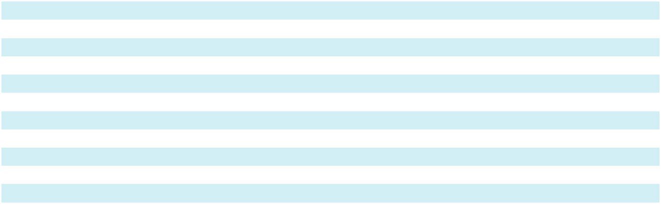

The provision (benefit) for income taxes is reconciled with the U.S. federal statutory rate as follows:

(thousands of U.S. dollars)
Year ended December 31, |  |  |  | 2024 |  |  | 2023 |  |  | 2022
Provision (benefit) computed at federal statutory rate
 |  |  | $ | 23,914 | $ |  | 22,265 | $ |  | (51,053)
Increase (decrease) in taxes as a result of:
State taxes, net of federal benefit |  |  |  | (2,840) |  |  | (2,889) |  |  | (20,359)
Valuation allowance |  |  |  | 35,660 |  |  | 19,494 |  |  | 53,860
Global intangible low-tax income (“GILTI”) |  |  |  | 1,691 |  |  | 4,861 |  |  | 1,427
Nondeductible share-based compensation |  |  |  | 3,859 |  |  | 3,192 |  |  | 2,510
Foreign tax rate differential |  |  |  | 11,893 |  |  | 10,595 |  |  | 8,335
Impact of rate changes on deferred tax balances |  |  |  | (914) |  |  | (92) |  |  | (1,184)
Tax holiday |  |  |  | (1,335) |  |  | (1,082) |  |  | (605)
Audit settlement |  |  |  | 17 |  |  | 739 |  |  | 276
Tax credits |  |  |  | (259) |  |  | — |  |  | (172)
Other |  |  |  | (2,210) |  |  | (2,432) |  |  | (2,576)
Total provision (benefit) for income taxes |  |  | $ | 69,476 | $ |  | 54,651 | $ |  | (9,541)
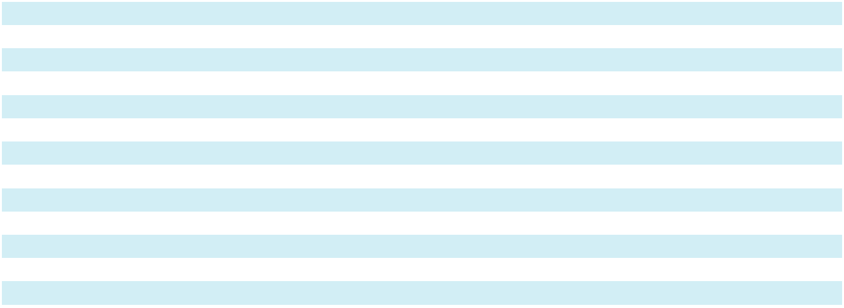

89

Sotera Health Company

Notes to Consolidated Financial Statements

The components of the tax effects of temporary differences and carryforwards that gave rise to significant portions of the deferred tax assets and liabilities are as follows:

(thousands of U.S. dollars)
As of December 31, |  |  |  | 2024 |  |  | 2023
Net operating loss carryforwards
 |  |  | $ | 56,097 | $ |  | 71,552
Net capital loss carryforwards |  |  |  | 2,890 |  |  | 4,686
Reserves and accruals |  |  |  | 14,785 |  |  | 26,591
Employee benefits and compensation |  |  |  | 10,481 |  |  | 8,519
Asset retirement obligations |  |  |  | 11,506 |  |  | 11,140
Lease liability |  |  |  | 7,783 |  |  | 8,733
Disallowed interest carryforward |  |  |  | 167,369 |  |  | 129,320
Other |  |  |  | 8,804 |  |  | 10,806
Deferred tax assets before valuation allowance |  |  |  | 279,715 |  |  | 271,347
Valuation allowance |  |  |  | (160,595) |  |  | (125,435)
Net deferred tax assets |  |  |  | 119,120 |  |  | 145,912
Depreciation and amortization |  |  |  | (170,646) |  |  | (195,450)
Reserves and accruals |  |  |  | (11,240) |  |  | (7,931)
Other |  |  |  | (3,869) |  |  | (1,992)
Total deferred tax liabilities |  |  |  | (185,755) |  |  | (205,373)
Net deferred tax liabilities |  |  | $ | (66,635) |  | $ | (59,461)
Noncurrent net deferred tax assets |  |  | $ | 2,865 | $ |  | 4,993
Noncurrent net deferred tax liabilities |  |  |  | (69,500) |  |  | (64,454)
Noncurrent net deferred tax liabilities |  |  | $ | (66,635) | $ |  | (59,461)
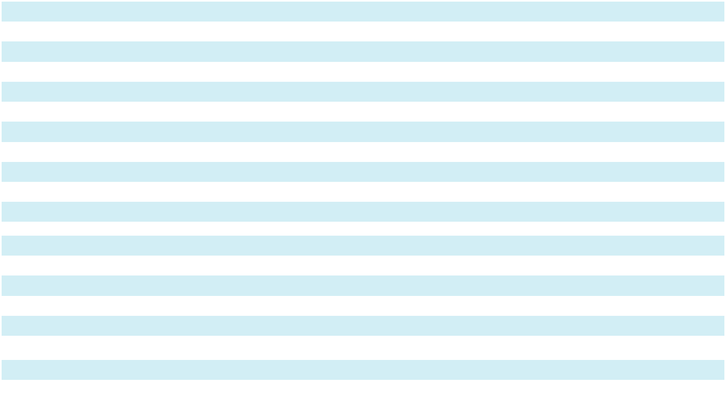

At December 31, 2024 and 2023, the Company had available U.S. federal net operating loss carryforwards of $164.1 million and $235.0 million, respectively, which have no expiration date. At December 31, 2024 and 2023, the Company had available state net operating loss carryforwards of $293.8 million and $298.8 million, respectively, of which $89.6 million and $103.6

million have no expiration date, and foreign net operating loss carryforwards of approximately $21.4 million and $23.4 million, respectively, the majority of which have no expiration date. At December 31, 2024 and 2023, a valuation allowance was established against foreign net operating loss carryforwards for $3.6 million and $4.4 million, respectively. At December 31, 2024 there is no valuation allowance against U.S. federal net operating loss carryforwards as we expect these deferred tax assets will be realized. At December 31, 2023 we established a valuation allowance against U.S. federal net operating loss carryforwards of $6.8 million. At December 31, 2024 and 2023, we also established a valuation allowance against U.S. state net operating loss carryforwards for $12.5 million and $11.3 million, respectively. Based on management’s assessment, it is not more likely than not that these deferred tax assets will be realized through future taxable income.

At December 31, 2024, a deferred tax liability of $3.8 million was recorded for repatriation of earnings for purposes of the Company’s consolidated financial statements as these earnings are not deemed to be indefinitely reinvested. Determining the amount of unrecognized deferred tax liability related to any remaining undistributed foreign earnings not subject to the transition tax and additional outside basis difference in these entities (i.e., basis difference in excess of that subject to the one-time transition tax) is not practicable.

As of December 31, 2024 and 2023, the gross reserve for uncertain tax positions, excluding accrued interest and penalties, was $0.

The Company recognizes interest and penalties as part of the provision for income taxes. For the years ended December 31, 2024, 2023 and 2022, interest and penalties related to uncertain income tax positions that were recognized in the Consolidated Statements of Operations and Comprehensive Income (Loss) were not material.

90

Sotera Health Company

Notes to Consolidated Financial Statements

The Company, which represents all of its subsidiaries, files income tax returns in the U.S. federal jurisdiction and various states and foreign jurisdictions. The Company is no longer subject to U.S. federal, state, and local tax examinations before 2016, and non-U.S. income tax examinations by tax authorities for years before 2012. Tax years through December 31, 2018 have been audited by the Internal Revenue Service and are effectively closed for U.S. federal income tax purposes and no other fiscal years are currently under audit. For Nordion’s Canadian tax, all tax years through October 31, 2018 have been closed through audit or statute, and no other fiscal years are currently under audit.

A portion of the Company’s foreign operations benefit from a tax holiday, which is set to expire in 2030. This tax holiday may be terminated early if certain conditions are not met. The tax benefit attributable to this holiday was $1.3 million and $1.1 million for the fiscal years ended December 31, 2024 and 2023, respectively.

11. Employee Benefits

Employee Retirement Benefits in the U.S.

We have a defined-contribution retirement plan that covers all U.S. employees upon date of hire. Contributions are directed by each participant into various investment options. Under this plan, we match participants’ contributions based on plan provisions. The Company’s contributions, which are expensed as incurred, were $6.0 million, $5.7 million, and $5.0 million for the years ended December 31, 2024, 2023 and 2022, respectively, and are recorded in the same line as the respective employee’s wages. Administrative expenses related to the plan are paid by the Company and are not material.

Employee Retirement Benefits Outside the U.S.

The Company participates in qualified supplemental retirement and savings plans in various countries outside the U.S. where we operate. Under these defined-contribution plans, funding and costs are generally based upon a predetermined percentage of employee compensation. The Company’s contributions, which are expensed as incurred and recorded in the same line as the respective employee’s wages, were $1.7 million, $1.7 million and $1.2 million for the years ended December 31, 2024, 2023 and 2022, respectively.

Defined Benefit Pension Plans

The Company also sponsors various post-employment benefit plans including, in certain countries outside the U.S., defined benefit and defined contribution plans, retirement compensation arrangements, and plans that provide extended health care coverage to retired employees, the majority of which relate to Nordion.

Defined benefit pension plan

The following defined benefit pension plan disclosure relates to Nordion. Certain immaterial foreign defined benefit pension plans have been excluded from the table below. The interest cost, expected return on plan assets and amortization of net actuarial loss are recorded in “Other (income) expense, net” and the service cost component is included in the same financial statement line item as the applicable employee’s wages in the Consolidated Statements of Operations and Comprehensive Income (Loss). The components of net periodic pension benefit for the defined benefit plans were as follows:

Year ended December 31,
(thousands of U.S. dollars) |  |  |  | 2024 |  |  | 2023 |  |  | 2022
Service cost
 |  |  | $ | 570 | $ |  | 525 | $ |  | 969
Interest cost |  |  |  | 10,435 |  |  | 10,917 |  |  | 7,411
Expected return on plan assets |  |  |  | (15,823) |  |  | (16,108) |  |  | (14,421)
Net periodic benefit |  |  | $ | (4,818) | $ |  | (4,666) | $ |  | (6,041)
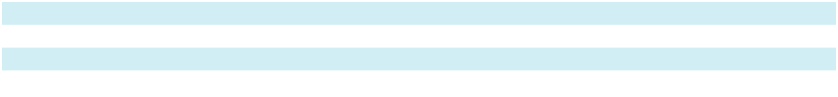

91

Sotera Health Company

Notes to Consolidated Financial Statements

The following weighted average assumptions were used in the determination of the PBO and the net periodic benefit:

Year ended December 31, |  | 2024 | 2023
Projected benefit obligation
 |  | 4.65 %
Discount rate |  | 4.65 % | 4.65 %
Rate of compensation increase |  | 3.00 % | 3.00 %
Periodic benefit
Discount rate |  | 4.65 % | 5.19 %
Expected return on plan assets |  | 6.25 % | 6.50 %
Rate of compensation increase |  | 3.00 % | 3.00 %

The changes in the PBO, fair value of plan assets, and the funded status of the plans are as follows:

(thousands of U.S. dollars)
As of December 31, |  |  |  | 2024 |  |  | 2023
Change in projected benefit obligation:
 |  |  | $ | 239,947
Projected benefit obligation, as of beginning of the year |  |  | $ | 239,947 | $ |  | 217,582
Service cost |  |  |  | 732 |  |  | 681
Interest cost |  |  |  | 10,435 |  |  | 10,917
Benefits paid |  |  |  | (12,737) |  |  | (12,305)
Actuarial loss |  |  |  | 935 |  |  | 17,934
Foreign currency exchange rate changes |  |  |  | (18,679) |  |  | 5,138
Projected benefit obligation, end of year |  |  | $ | 220,633 | $ |  | 239,947
Change in fair value of plan assets:
Fair value of plan assets as of the beginning of the year |  |  | $ | 268,424 | $ |  | 253,130
Actual return on plan assets |  |  |  | 27,925 |  |  | 21,163
Benefits paid |  |  |  | (12,737) |  |  | (12,305)
Employer contributions |  |  |  | 604 |  |  | 496
Employee contributions |  |  |  | 162 |  |  | 156
Foreign currency exchange rate changes |  |  |  | (21,675) |  |  | 5,784
Fair value of plan assets, end of year |  |  | $ | 262,703 |  | $ | 268,424
Funded status at end of year |  |  | $ | 42,070 |  | $ | 28,477
Accumulated benefit obligation, end of year |  |  | $ | 218,122 | $ |  | 237,016
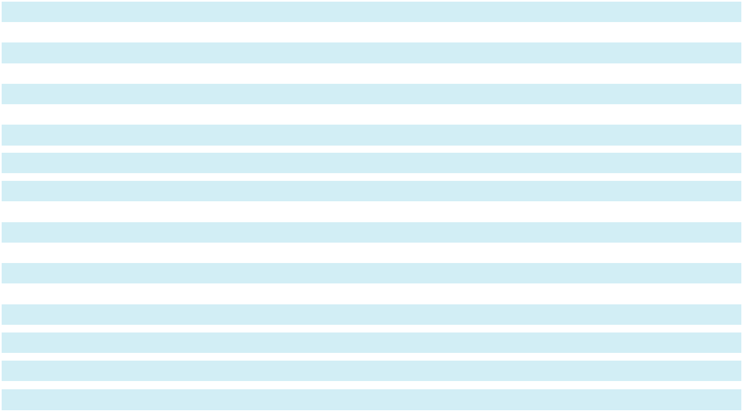

All defined benefit pension plans are overfunded as of December 31, 2024 and December 31, 2023.

The funded status, measured as the difference between the fair value of the plan assets and the PBO, are included in “Post-retirement assets” for overfunded plans and “Post-retirement obligations” for underfunded plans in the Consolidated Balance Sheets.

92

Sotera Health Company

Notes to Consolidated Financial Statements

A reconciliation of the funded status to amounts recognized in the Consolidated Balance Sheets is as follows:

(thousands of U.S. dollars)
As of December 31, |  |  |  | 2024 |  |  | 2023
Projected benefit obligation
 |  |  | $ | 220,633 | $ |  | 239,947
Fair value of plan assets |  |  |  | 262,703 |  |  | 268,424
Plan assets greater than projected benefit obligation (noncurrent assets) |  |  |  | 42,070 |  |  | 28,477
Unrecognized net actuarial (gain) loss |  |  |  | (107) |  |  | 11,429
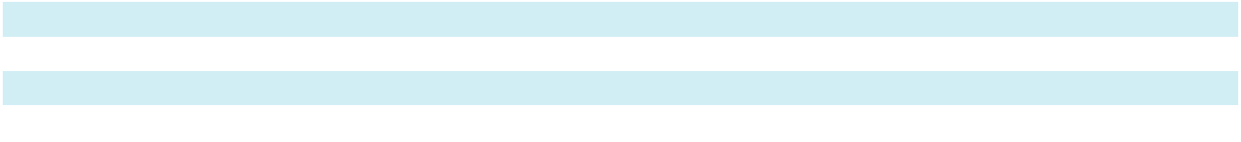

The following table illustrates the amounts in accumulated other comprehensive (income) loss that have not yet been recognized as components of pension expense:

(thousands of U.S. dollars)
As of December 31, |  |  |  | 2024 |  |  | 2023
Net actuarial (gain) loss
 |  |  | $ | (107) | $ |  | 11,429
Deferred income taxes |  |  |  | 27 |  |  | (2,919)
Accumulated other comprehensive (income) loss – net of tax |  |  | $ | (80) | $ |  | 8,510

We do not expect to reclassify any of the net actuarial gain in accumulated other comprehensive income to net periodic pension income in the next twelve months.

The weighted average asset allocation of the Company’s pension plans was as follows:

Asset Category |  | Target | 2024 |  | 2023
Cash
 |  | 0.0 % |  | 0.6 % | 0.7 %
Fixed income |  | 54.0 % | 52.3 % |  | 43.7 %
Equities |  | 27.0 % | 25.9 % |  | 34.0 %
Hedge funds |  | 19.0 % |  | 21.2 % |  | 21.6 %
Total |  | 100.0 % |  | 100.0 % | 100.0 %

The Company maintains target allocation percentages among various asset classes based on investment policies established for the pension plans, which are designed to maximize the total rate of return (income and appreciation) after inflation, within the limits of prudent risk taking, while providing for adequate near-term liquidity for benefit payments. Such investment strategies have adopted an equity-based philosophy to achieve their long-term investment goals by investing in assets that often have uncertain returns, such as Canadian and other foreign equities, and non-government bonds, although the Company also attempts to reduce the overall level of risk by diversifying the asset classes and further diversifying within each individual asset class.

The Company’s expected return on asset assumptions are derived from studies conducted by actuaries and investment advisors. The studies include a review of anticipated future long-term performance of individual asset classes and consideration of the appropriate asset allocation strategy given the anticipated requirements of the plans to determine the average rate of earnings expected on the funds invested to provide for the pension plans benefits. While the study considers recent fund performance and historical returns, the assumption is primarily a long-term, prospective rate.

Valuation Methodologies

Below is a description of the composition and valuation methodologies for pension plan assets. Refer to the discussion of fair value hierarchy in Note 20, “Financial Instruments and Financial Risk.”

Cash and cash equivalents – Consists of deposits with financial institutions and other short-term highly liquid investments with an original maturity of three months or less. Cash and cash equivalents are categorized as Level 1 instruments in the fair value hierarchy.

93

Sotera Health Company

Notes to Consolidated Financial Statements

Fixed income securities, equity securities and hedge fund assets - These assets are invested in managed funds that are measured at fair value using the net asset value per share practical expedient and, therefore, are not categorized in the fair value hierarchy.

Expected future benefit payments from plan assets are as follows:

(thousands of U.S. dollars)
Year Ended December 31,
2025 |  |  | $ | 12,969
2026 |  |  |  | 13,260
2027 |  |  |  | 13,571
2028 |  |  |  | 13,708
2029 |  |  |  | 13,839
2030 - 2034 |  |  |  | 70,473
 |  |  | $ | 137,820

Other benefit plans

Other benefit plans disclosed below relate to Nordion and include a supplemental retirement arrangement, a retirement and termination allowance, and post-retirement benefit plans, which include contributory health and dental care benefits and contributory life insurance coverage. Certain immaterial other foreign benefit plans have been excluded from the table below. All non-pension post-employment benefit plans are unfunded. All other non-pension post-employment benefit plans are immaterial.

The interest cost and amortization of net actuarial (gain) loss are recorded in “Other income, net” and the service cost component is included in the same financial statement line item as the applicable employee’s wages in the Consolidated Statements of Operations and Comprehensive Income (Loss). The components of net periodic benefit cost for the other benefit plans were as follows:

(thousands of U.S. dollars)
Year Ended December 31, |  |  |  | 2024 |  |  | 2023 |  |  | 2022
Service cost
 |  |  | $ | 10 | $ |  | 9 | $ |  | 16
Interest cost |  |  |  | 371 |  |  | 398 |  |  | 284
Amortization of net actuarial gain |  |  |  | (170) |  |  | (197) |  |  | (171)
Net periodic benefit cost |  |  | $ | 211 | $ |  | 210 | $ |  | 129

The weighted average assumptions used to determine the PBO and net periodic pension cost for these plans were as follows:

Year Ended December 31,
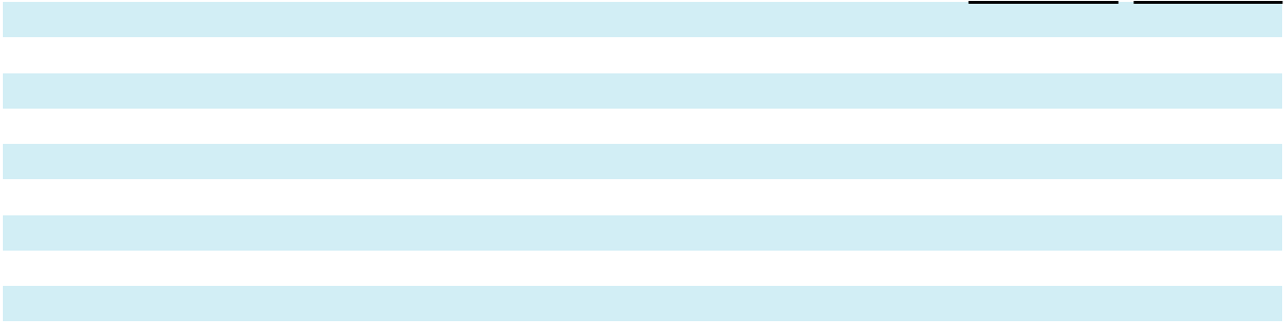

Projected benefit obligation:

Discount rate

Rate of compensation increase

Initial health care cost trend rate

Ultimate health care cost trend rate

Years until ultimate trend rate is reached

Benefit cost:

Discount rate

Rate of compensation increase

2024 2023

4.65 % 4.65 %

3.00 % 3.00 %

7.00 % 7.00 %

4.00 % 4.00 %

- 16

4.65 % 5.19 %

3.00 % 3.00 %

94

Sotera Health Company

Notes to Consolidated Financial Statements

Assumed health care cost trend rates have a significant effect on the amounts reported for the health care plans. A one-percentage point change in assumed health care cost trend rates would have had the following impact on our consolidated financial statements in 2024:

(thousands of U.S. dollars) |  |  | 1% Increase |  |  | 1% Decrease
Change in net periodic benefit cost
 |  | $ | 22 |  | $ | (19)
Change in projected benefit obligation |  |  | 490 |  |  | (417)

The changes in the projected benefit obligation and the funded status of the other post-retirement plans were as follows:

(thousands of U.S. dollars)
As of December 31, |  |  |  | 2024 |  |  | 2023
Change in projected benefit obligation:
Projected benefit obligation |  |  | $ | 8,964 | $ |  | 8,391
Service cost |  |  |  | 10 |  |  | 9
Interest cost |  |  |  | 371 |  |  | 398
Benefits paid |  |  |  | (609) |  |  | (665)
Actuarial loss |  |  |  | 211 |  |  | 509
Plan participant contributions |  |  |  | 132 |  |  | 129
Foreign currency exchange rate changes |  |  |  | (704) |  |  | 193
Projected benefit obligation, end of year |  |  | $ | 8,375 | $ |  | 8,964
Change in fair value of plan assets:
Fair value of plan assets as of the beginning of the year |  |  | $ | 525 | $ |  | 481
Benefits paid |  |  |  | (187) |  |  | (183)
Employer contributions |  |  |  | 216 |  |  | 216
Foreign currency exchange rate changes |  |  |  | (42) |  |  | 11
Fair value of plan assets, end of year |  |  | $ | 512 |  | $ | 525
Underfunded status at end of year |  |  | $ | (7,863) |  | $ | (8,439)
Accumulated benefit obligation, end of year |  |  | $ | 8,364 | $ |  | 8,943
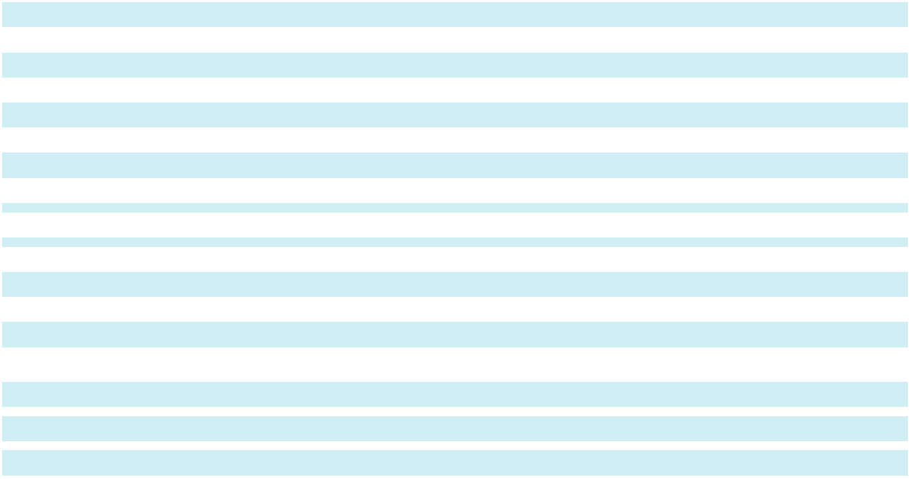

All other post-retirement benefit pension plans are underfunded as of December 31, 2024 and 2023.

A reconciliation of the funded status to the net plan liabilities recognized in the Consolidated Balance Sheets is as follows:

(thousands of U.S. dollars)
As of December 31, |  |  |  | 2024 |  |  | 2023
Projected benefit obligation
 |  |  | $ | 8,375 | $ |  | 8,964
Fair value of plan assets |  |  |  | 512 |  |  | 525
Plan assets less than projected benefit obligation (noncurrent liabilities) |  |  |  | (7,863) |  |  | (8,439)
Unrecognized actuarial gains |  |  |  | (1,549) |  |  | (2,074)

The other benefit plan liabilities are presented on the Consolidated Balance Sheets as “Post retirement obligations.”

95

Sotera Health Company

Notes to Consolidated Financial Statements

The following table illustrates the amounts in accumulated other comprehensive income (loss) that have not yet been recognized as components of other benefit plan expense:

(thousands of U.S. dollars)
As of December 31, |  |  |  | 2024 |  |  | 2023
Net actuarial gain
 |  |  | $ | (1,549) | $ |  | (2,074)
Deferred income taxes |  |  |  | 444 |  |  | 585
Accumulated other comprehensive income – net of tax |  |  | $ | (1,105) | $ |  | (1,489)

Based on the actuarial assumptions used to develop the Company’s benefit obligations as of December 31, 2024, the following benefit payments are expected to be made to plan participants:

(thousands of U.S. dollars)
Years ended December 31
2025 |  |  | $ | 613
2026 |  |  |  | 536
2027 |  |  |  | 558
2028 |  |  |  | 487
2029 |  |  |  | 488
2030 - 2034 |  |  |  | 2,490
Total |  |  | $ | 5,172

The Company currently has no funding requirements as the Nordion pension plan had a going concern surplus as of January 1, 2024, as defined by Canadian federal regulations, which require solvency testing on defined benefit pension plans on an annual basis.

The Company may obtain a qualifying letter of credit for solvency payments, up to 15% of the market value of solvency liabilities as determined on the valuation date, instead of cash payment into the pension fund. As of December 31, 2024 and 2023, we had letters of credit outstanding relating to the defined benefit plans totaling $6.4 million and $16.0 million, respectively. The actual funding requirements over the five-year period will be dependent on subsequent annual actuarial valuations. These amounts are estimates, which may change with actual investment performance, changes in interest rates, any pertinent changes in Canadian government regulations, and any voluntary contributions.

12. Related Parties

For the years ended December 31, 2024, 2023 and 2022, the Company did not engage in any material related party transactions.

13. Other Comprehensive Income (Loss)

Amounts in accumulated other comprehensive income (loss) are presented net of the related tax. Foreign currency translation is not adjusted for income taxes.

96

Sotera Health Company

Notes to Consolidated Financial Statements

Changes in our accumulated other comprehensive income (loss) balances, net of applicable tax, were as follows:

 |  |  | Defined |  |  | Foreign |  |  | Interest
 |  |  | Benefit |  |  | Currency |  |  | Rate
(thousands of U.S. dollars) |  |  | Plans |  | Translation |  |  |  | Derivatives |  |  | Total
Beginning balance – January 1, 2022
 |  | $ | (17,581) |  | $ | (66,389) | $ |  | 404 |  | $ | (83,566)
Other comprehensive income (loss) before reclassifications |  |  | 20,803 |  |  | (64,816) |  |  | 20,939 |  |  | (23,074)
Amounts reclassified from accumulated other comprehensive
income (loss) |  |  | (13) _{(a)} |  |  | — |  |  | — (b) |  |  | (13)
Net current-period other comprehensive income (loss) |  |  | 20,790 |  |  | (64,816) |  |  | 20,939 |  |  | (23,087)
Ending balance – December 31, 2022 |  | $ | 3,209 |  | $ | (131,205) |  | $ | 21,343 |  | $ | (106,653)
Beginning balance – January 1, 2023
 |  | $ | 3,209 |  | $ | (131,205) | $ |  | 21,343 |  | $ | (106,653)
Other comprehensive income (loss) before reclassifications |  |  | (10,308) |  |  | 40,174 |  |  | 6,441 |  |  | 36,307
Amounts reclassified from accumulated other comprehensive
income (loss) |  |  | (198) _{(a)} |  |  | — |  |  | (22,138) _{(b)} |  |  | (22,336)
Net current-period other comprehensive income (loss) |  |  | (10,506) |  |  | 40,174 |  |  | (15,697) |  |  | 13,971
Ending balance – December 31, 2023 |  | $ | (7,297) |  | $ | (91,031) |  | $ | 5,646 |  | $ | (92,682)
Beginning balance – January 1, 2024
 |  | $ | (7,297) |  | $ | (91,031) | $ |  | 5,646 |  | $ | (92,682)
Other comprehensive income (loss) before reclassifications |  |  | 8,632 |  |  | (118,635) |  |  | 4,449 |  |  | (105,554)
Amounts reclassified from accumulated other comprehensive |  |  | (170) _{(a)} |  |  | — |  |  | (9,845) _{(b)} |  |  | (10,015)
income (loss) |  |  |  |  |  | — |  |  |  |  |  | (10,015)
Net current-period other comprehensive income (loss) |  |  | 8,462 |  |  | (118,635) |  |  | (5,396) |  |  | (115,569)
Ending balance – December 31, 2024 |  | $ | 1,165 |  | $ | (209,666) |  | $ | 250 |  | $ | (208,251)
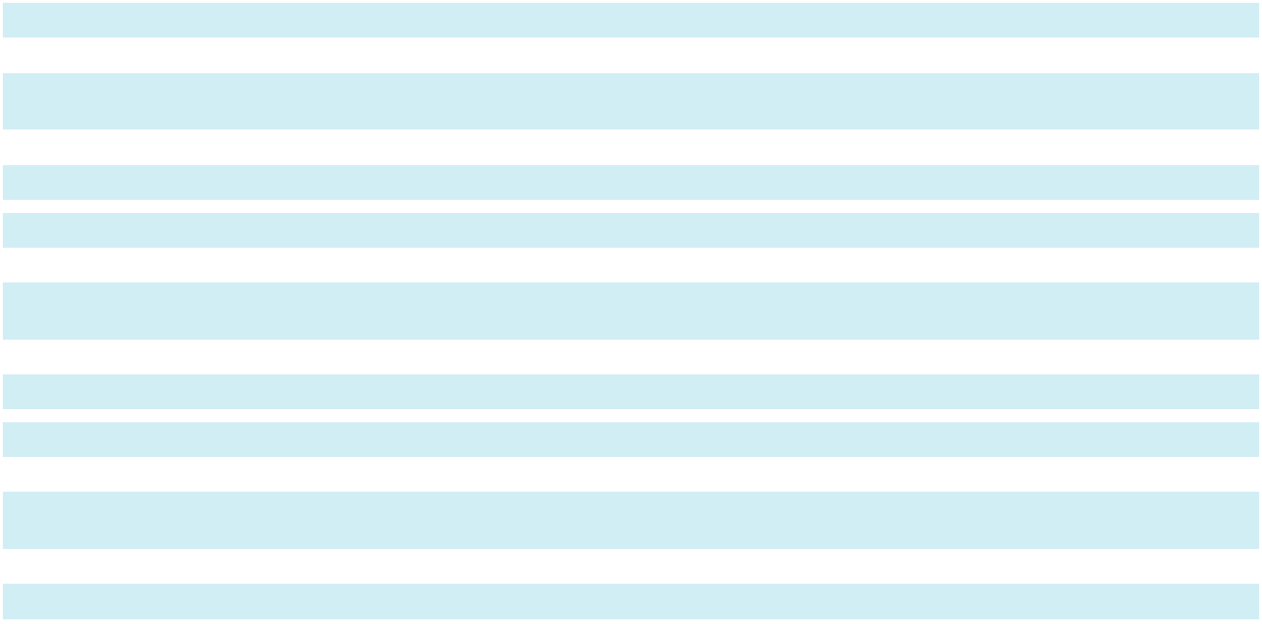

- For defined benefit pension and other post-retirement plans, amounts reclassified from accumulated other comprehensive income (loss) are recorded to “Other income, net” within the Consolidated Statements of Operations and Comprehensive Income (Loss).
- For interest rate derivatives, amounts reclassified from accumulated other comprehensive income (loss) are recorded to “Interest expense, net” within the Consolidated Statements of Operations and Comprehensive Income (Loss).

- Stockholders’ Equity Common Stock

The Company completed its IPO in the fourth quarter of 2020 and shares began trading on Nasdaq on November 20, 2020. Prior to the completion of the IPO, the Company amended and restated its certificate of incorporation to authorize 1,200,000,000 shares of common stock, par value $0.01 per share, and reclassify all 3,000 shares of its common stock then outstanding as 232,400,200 shares. Upon completion of the IPO, 284,421,755 shares of common stock were outstanding.

Voting Rights. Holders of common stock are entitled to one vote for each share held on all matters submitted to a vote of stockholders, subject to certain restrictions described in the certificate of incorporation.

Dividends. Subject to preferences that may be applicable to any then outstanding preferred stock, holders of our common stock are entitled to receive ratably those dividends, if any, as may be declared by the board of directors out of legally available funds.

Liquidation, Dissolution, and Winding Up. In the event of liquidation, dissolution or winding up, the holders of the Company’s common stock will be entitled to share equally and ratably in the net assets legally available for distribution to stockholders after the payment of all of debts and other liabilities, subject to the prior rights of any preferred stock then outstanding.

97

Sotera Health Company

Notes to Consolidated Financial Statements

Preferred Stock

In addition, prior to the completion of the IPO, the Company’s amended and restated certificate of incorporation authorized 120,000,000 shares of preferred stock, par value $0.01 per share. The board of directors may issue preferred stock, without stockholder approval, in such series and with such designations, preferences, conversion or other rights, voting powers and qualifications, limitations or restrictions thereof, as the board of directors deems appropriate.

15. Share-Based Compensation

Pre-IPO Awards

Prior to our IPO, the Company’s equity-based awards issued to service providers (including directors and employees) included partnership interests in Topco Parent (Class B-1 or B-2 Units) which vested based on either time or the achievement of certain performance and market conditions (the “pre-IPO awards”). These equity-based awards represented an interest in our former parent and were granted in respect of services provided to the Company and its subsidiaries. In connection with the IPO, our former parent made in-kind distributions of shares of our common stock to its limited partners. At the time of the IPO, there were fewer than 60 individuals who received shares in the in-kind distribution; while this distribution represented a modification to the existing awards, there was no associated change in compensation expense because the fair value of the distributed shares immediately before and after the distribution was the same.

Restricted stock distributed in respect of pre-IPO Class B-1 time vesting units vests on a daily basis pro rata over a five-year vesting period (20% per year) beginning on the original vesting commencement date of the corresponding Class B-1 time vesting units, subject to the grantee’s continued services through each vesting date. Upon the occurrence of a change in control of the Company, all then outstanding unvested shares of our common stock distributed in respect of Class B-1 Units will vest as of the date of consummation of such change in control, subject to the grantee’s continued services through the consummation of the change in control.

Restricted stock distributed in respect of pre-IPO Class B-2 Units were considered performance vesting units. The required performance threshold for the vesting of B-2 restricted stock was the first date on which (i) our Sponsors received actual cash proceeds in an amount equal to or in excess of at least two and one-half times their invested capital in Topco Parent (of which the Company was a direct wholly-owned subsidiary prior to the IPO) and (ii) the Sponsors’ internal rate of return exceeded 20%, subject to such grantee’s continued services through such date. Both performance thresholds were satisfied on March 4, 2024 and, as a result, all outstanding B-2 Units were fully vested as of that date. Share-based compensation expense attributed to the pre-IPO Class B-2 awards was recorded in the fourth quarter of 2020 as the related performance conditions were considered probable of achievement and the implied service conditions were met.

We recognized $1.6 million, $2.0 million and $2.1 million of share-based compensation expense related to the pre-IPO Class B-1 awards for the years ended December 31, 2024, 2023, and 2022, respectively.

98

Sotera Health Company

Notes to Consolidated Financial Statements

A summary of the activity for the years ended December 31, 2024, 2023 and 2022 related to the restricted stock distributed to the Company service providers in respect of the pre-IPO awards (Class B-1 and B-2) is presented below:

 | Restricted |  | Restricted
 | Stock - Pre-IPO |  | Stock - Pre-IPO
 | B-1 |  | B-2
At January 1, 2022 | 1,206,089 |  | 2,023,959
Forfeited | (54,333) | (925,544)
Vested | (435,665) |  | —
At December 31, 2022 | 716,091 | 1,098,415
Forfeited | (16,243) | (111,304)
Vested | (347,401) |  | —
At December 31, 2023 | 352,447 |  | 987,111
Forfeited | (2,651) |  | —
Vested | (278,345) | (987,111)
At December 31, 2024 | 71,451 |  | —

The following table provides a summary of the weighted average unit grant date fair value, weighted average remaining contractual term, total compensation cost and unrecognized compensation cost for the pre-IPO awards:

December 31, 2024 |  |  | Restricted Stock -
(dollars in millions, except per award values) |  |  | Pre-IPO B-1
Weighted average grant date fair value per unit of unvested units^{(a)}
 |  | $ | 6.32
Weighted average remaining contractual term |  |  | 0.4 years
Total compensation cost recognized during 2024 |  | $ | 1.6
Unrecognized compensation expense at December 31, 2024 |  | $ | 0.5

- Due to the in-kind distribution of shares of our common stock in connection with our IPO described above, the weighted average grant date fair value per unit is not comparable to the IPO share price.

2020 Omnibus Incentive Plan

We maintain the 2020 Plan that allows for grants of incentive stock options to employees (including employees of any of our subsidiaries), nonstatutory stock options, restricted stock awards (“RSAs”), RSUs and other cash-based, equity-based or equity-related awards to employees, directors, and consultants, including employees or consultants of our subsidiaries. A maximum of 27.9 million shares of common stock may be issued under the 2020 Plan. At December 31, 2024, 15.6 million shares were available for future issuance. The Company plans to issue shares available under the 2020 Plan or shares from treasury to satisfy requirements of awards paid with shares.

We recognize share-based compensation expense at grant date fair value over the requisite service period on a straight-line basis in our Consolidated Statements of Operations and Comprehensive Income (Loss), in “Selling, general and administrative expenses.” We recognized $35.2 million ($16.4 million for stock options and $18.8 million for RSAs and RSUs), $30.4 million ($14.4 million for stock options and $16.0 million for RSUs) and $19.1 million ($7.8 million for stock options and $11.3 million for RSUs) of share-based compensation expense for these awards for the years ending December 31, 2024, 2023 and 2022, respectively.

99

Sotera Health Company

Notes to Consolidated Financial Statements

Stock Options

We use a Black-Scholes option pricing model to estimate the fair value of stock options. Since we are a newly public company, the expected volatility is based on the volatility of similar publicly traded businesses within the same or similar industry as the Company in combination with our own volatility. We used the simplified method to estimate the expected term. The risk-free rate is based on the U.S. Treasury yield in effect at the time of the grant.

Weighted-average grant-date fair values of stock options and the assumptions used in estimating the fair values are as follows:

For the year ended December 31, |  | 2024 |  | 2023 |  | 2022
Weighted average grant date fair value per option | $ | 7.35 | $ | 7.13 | $ | 4.86
Expected term (years) |  | 6 years |  | 6 years |  | 5.8 years
Risk-free interest rate |  | 4.2 | % | 4.2 | % | 3.4 %
Expected volatility |  | 46.8 % |  | 50.0 % |  | 45.7 %
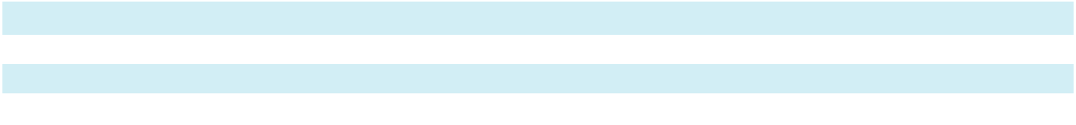

Stock options generally vest ratably over a period of two to four years. They have an exercise price equal to the fair market value of a share of common stock on the date of grant, and a contractual term of 10 years. The following table summarizes our stock option activity for the year ended December 31, 2024:

Outstanding at the beginning of the year Granted

Forfeited

Outstanding at the end of the year

Exercisable at the end of the year

Unvested at the end of the year

 |  |  |  |  |  |  |  | Aggregate
 |  |  |  |  |  |  |  | Intrinsic
 |  |  | Weighted- |  | Remaining |  |  | Value
Number of |  |  | average |  | Contractual |  |  | (millions of
Shares |  | Exercise Price |  |  | Life |  |  | U.S. dollars)
6,972,661 | $ |  | 15.17
1,615,721 |  |  | 14.57
(260,331) |  |  | 18.76
8,328,051 |  | $ | 14.94 |  | 7.6 years |  | $ | 19.9
5,730,231 |  | $ | 14.41 |  | 7.1 years |  | $ | —
2,597,820 |  | $ | 16.12 |  | 8.6 years |  | $ | —
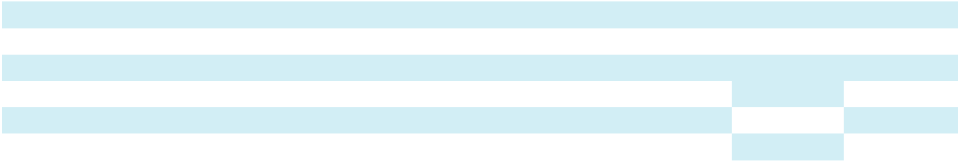

At December 31, 2024, the total unrecognized compensation expense related to stock options expected to be recognized over the weighted-average period of approximately 1.8 years is $12.5 million. The total fair value of stock options vested during the years ended December 31, 2024, 2023 and 2022 was $16.3 million, $10.6 million and $4.4 million, respectively.

RSUs

RSUs generally vest ratably over a period of one to four years and are valued based on the market price on the date of grant.

The following table summarizes our unvested RSUs activity for the year ended December 31, 2024:

 |  |  | Weighted-average Grant
 | Number of Shares |  |  | Date Fair Value
Unvested at the beginning of the year | 2,298,836 | $ |  | 13.81
Granted | 1,233,596 |  |  | 14.05
Forfeited | (190,297) |  |  | 12.27
Vested | (1,063,598) |  |  | 14.52
Unvested at the end of the year | 2,278,537 |  | $ | 13.73

As of December 31, 2024, total unrecognized compensation expense related to RSUs expected to be recognized over the weighted-average period of approximately 1.7 years is $18.7 million. The total fair value of RSUs vested during the years ended December 31, 2024, 2023 and 2022 was $15.4 million, $14.1 million and $5.7 million, respectively.

100

Sotera Health Company

Notes to Consolidated Financial Statements

16. Earnings (Loss) Per Share

Basic earnings per share represents the amount of income attributable to each common share outstanding. Diluted earnings per share represents the amount of income attributable to each common share outstanding adjusted for the effects of potentially dilutive common shares. Potentially dilutive common shares include stock options and other stock-based awards. In the periods where the effect would be antidilutive, potentially dilutive common shares are excluded from the calculation of diluted earnings per share.

In periods in which the Company has net income, earnings per share is calculated using the two-class method. This method is required as unvested restricted stock distributed in respect of pre-IPO Class B-1 and B-2 awards have the right to receive non-forfeitable dividends or dividend equivalents if the Company were to declare dividends on its common stock. Pursuant to the two-class method, earnings for each period are allocated on a pro-rata basis to common stockholders and unvested pre-IPO Class B-1 and B-2 restricted stock awards. As of March 4, 2024, the performance threshold applicable to all Class B-2 restricted stock awards were fully satisfied, thereby releasing the vesting and forfeiture restrictions on these common shares. Beginning on that date, B-2 restricted stock was not included in the earnings allocation. Diluted earnings per share is computed using the more dilutive of (a) the two-class method, or (b) treasury stock method, as applicable, to the potentially dilutive instruments.

Our basic and diluted earnings (loss) per common share are calculated as follows:

 |  |  | Year Ended December 31,
in thousands of U.S. dollars and share amounts (except per share amounts) |  |  | 2024 |  |  | 2023 |  |  | 2022
Earnings (loss):
Net income (loss) |  | $ | 44,398 | $ |  | 51,376 | $ |  | (233,570)
Less: Allocation to participating securities |  |  | 59 |  |  | 287 |  |  | —
Net income (loss) attributable to Sotera Health Company common |  | $ | 44,339 | $ |  | 51,089 | $ |  | (233,570)
stockholders
Weighted Average Common Shares:
Weighted-average common shares outstanding - basic |  |  | 282,784 |  |  | 281,008 |  |  | 280,096
Dilutive effect of potential common shares^{(a)} |  |  | 2,122 |  |  | 2,213 |  |  | —
Weighted-average common shares outstanding - diluted |  |  | 284,906 |  |  | 283,222 |  |  | 280,096
Earnings (loss) per Common Share:
Net income (loss) per common share attributable to Sotera Health |  | $ | 0.16 | $ |  | 0.18 | $ |  | (0.83)
Company common stockholders - basic
Net income (loss) per common share attributable to Sotera Health |  |  | 0.16 |  |  | 0.18 |  |  | (0.83)
Company common stockholders - diluted |  |  | 0.16 |  |  | 0.18 |  |  | (0.83)
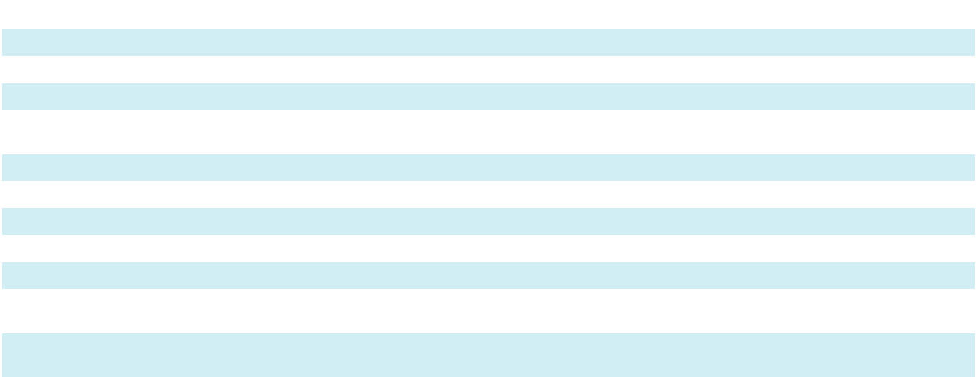

- As the Company reported a net loss for the year ended December 31, 2022, the calculation of diluted weighted average common shares outstanding is not applicable for the year ended December 31, 2022 because the effect of including the potential common shares would be anti-dilutive.

Diluted earnings per shares does not consider the following potential common shares as the effect would be anti-dilutive:

Year Ended December 31,

in thousands of share amounts |  | 2024 | 2023 |  | 2022
RSUs
RSUs |  | 34 | 291 |  | 2,467
Stock options |  | 5,469 | 4,108 |  | 5,990
Total anti-dilutive securities |  | 5,503 |  | 4,399 |  | 8,457

101

Sotera Health Company

Notes to Consolidated Financial Statements

17. Leases

We lease certain facilities and equipment under various non-cancelable leases. Most of our real property leases provide for renewal periods and rent escalations and stipulate that we pay taxes, maintenance, and certain other operating expenses applicable to the leased premises.

The components of lease expense were as follows:

 |  |  | Year Ended December 31,
(thousands of U.S. dollars) |  |  | 2024 |  |  | 2023 |  |  | 2022
Operating lease costs (a)
 |  | $ | 13,267 | $ |  | 13,920 | $ |  | 15,122
Finance lease costs:
Amortization of right of use assets |  |  | 8,438 |  |  | 8,152 |  |  | 6,368
Interest on lease liabilities |  |  | 6,064 |  |  | 4,394 |  |  | 3,454
Total finance lease costs |  |  | 14,502 |  |  | 12,546 |  |  | 9,822
Total lease costs |  | $ | 27,769 | $ |  | 26,466 | $ |  | 24,944
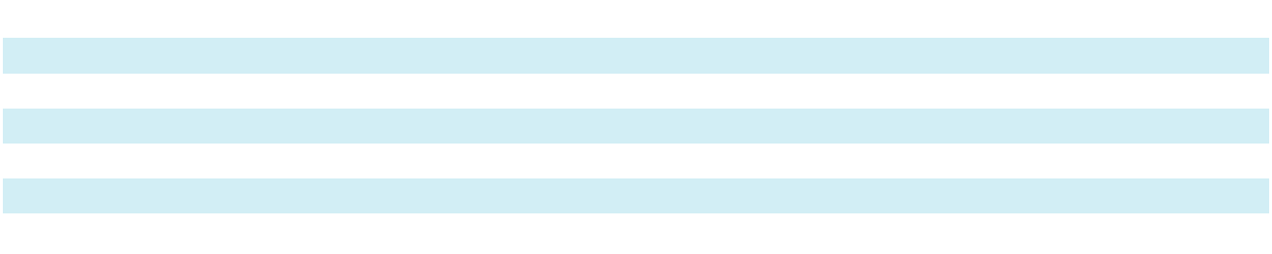

- Includes $1.5 million, $1.4 million, and $1.3 million of short-term lease costs in the years ended December 31, 2024, 2023, and 2022, respectively.

Lease terms and discount rates were as follows:

 |  |  |  |  |  |  | Year Ended December 31,
 | Weighted average remaining lease term: |  |  |  |  | 2024 |  |  |  |  |  |  | 2023
 | Operating leases |  |  |  |  |  |  | 7.3 years |  |  |  |  | 5.7 years
 | Finance leases |  |  |  |  |  | 15.2 years |  |  |  |  |  | 14.0 years
 | Weighted average discount rate:
 | Operating leases |  |  |  |  |  |  | 6.57 % |  |  |  |  | 5.92 %
 | Finance leases |  |  |  |  |  |  | 6.55 % |  |  |  |  | 5.76 %
Supplemental cash flow information related to leases was as follows:
 |  |  |  |  | Year Ended December 31,
 | (thousands of U.S. dollars) |  |  | 2024 |  |  |  | 2023 |  |  |  |  | 2022
 | Cash paid for amounts included in the measurement of lease liabilities:
 | Operating cash flows for operating leases |  | $ | 7,382 |  | $ |  | 10,067 |  |  | $ |  | 11,112
 | Operating cash flows for finance leases |  |  | 6,277 |  |  |  | 3,988 |  |  |  |  | 2,932
 | Finance cash flows for finance leases |  |  | 8,088 |  |  |  | 1,823 |  |  |  |  | 1,066
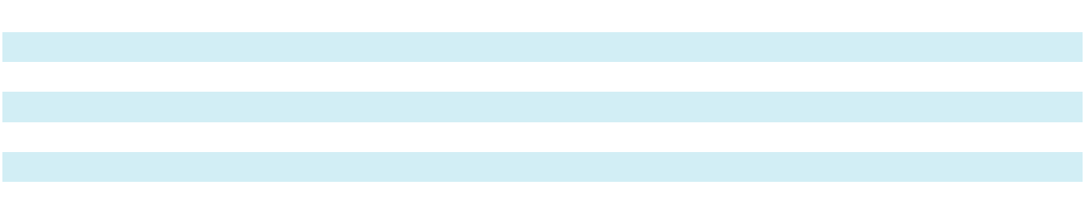
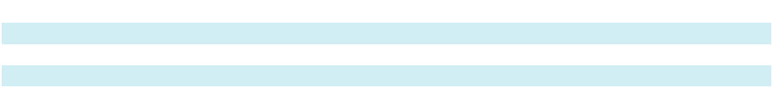

Supplemental non-cash information was as follows:

Year Ended December 31,
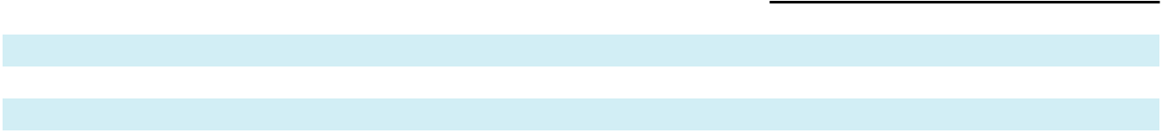

(thousands of U.S. dollars) |  |  | 2024 |  |  | 2023 |  |  | 2022
Lease liabilities arising from obtaining right-of-use assets:
Operating leases |  | $ | 10,550 | $ |  | 4,559 | $ |  | 1,338
Finance leases |  |  | 36,016 |  |  | 14,770 |  |  | 18,286

102

Sotera Health Company

Notes to Consolidated Financial Statements

Maturities of lease liabilities as of December 31, 2024 are as follows:

 |  |  | Operating |  |  | Finance
(thousands of U.S. dollars) |  |  | Leases |  |  | Leases |  |  | Total
2025
2025 |  | $ | 6,937 |  | $ | 9,245 |  | $ | 16,182
2026 |  |  | 6,572 |  |  | 9,365 |  |  | 15,937
2027 |  |  | 5,540 |  |  | 9,647 |  |  | 15,187
2028 |  |  | 4,293 |  |  | 9,947 |  |  | 14,240
2029 |  |  | 3,499 |  |  | 9,626 |  |  | 13,125
2030 and Thereafter |  |  | 12,289 |  |  | 117,367 |  |  | 129,656
Total lease payments |  |  | 39,130 |  |  | 165,197 |  |  | 204,327
Less imputed interest |  |  | (9,609) |  |  | (66,988) |  |  | (76,597)
Total lease liabilities |  | $ | 29,521 |  | $ | 98,209 |  | $ | 127,730
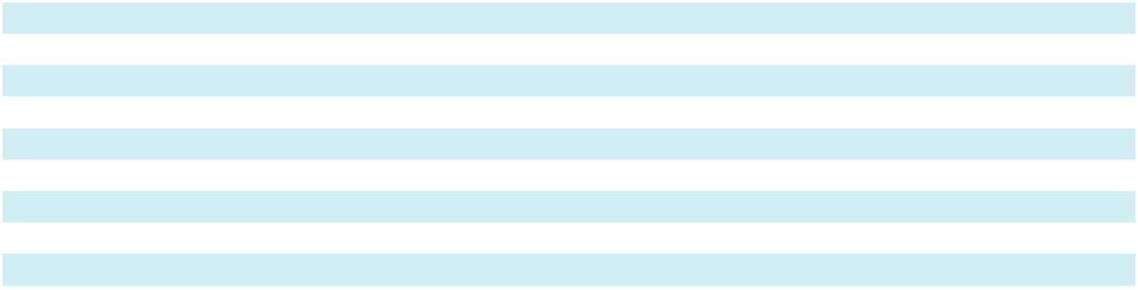

18. Asset Retirement Obligations (“ARO”)

Our ARO represent the present value of future remediation costs and an increase in the carrying amounts of the related assets in property, plant and equipment in the Consolidated Balance Sheets. The capitalized future site remediation costs are depreciated and the ARO are accreted over the life of the related assets which is included in depreciation and amortization expense within cost of revenues, respectively.

The fair value of the ARO is determined based on estimates requiring management judgment. Key assumptions include the timing and estimated decommissioning costs of the remediation activities and credit adjusted risk free interest rates. Changes in the assumptions based on future information may result in adjustments to the estimated obligations over time. No market risk premium has been included in the calculation for the ARO since no reliable estimate can be made by the Company. Any difference between costs incurred upon settlement of an ARO and the liability recognized for the estimated cost of asset retirements will be recognized as a gain or loss in our current period operating results.

Each year, we review decommissioning costs and consider changes in marketplace rates. The following table describes changes to our ARO liability during the years presented:

(thousands of U.S. dollars)
For the years ended December 31, |  |  |  | 2024 |  |  | 2023
ARO – beginning of period
 |  |  | $ | 47,944 | $ |  | 45,482
Liabilities settled |  |  |  | — |  |  | (2,896)
Changes in estimates |  |  |  | 1,240 |  |  | 2,133
Accretion expense |  |  |  | 2,638 |  |  | 2,413
Foreign currency exchange and other |  |  |  | (2,503) |  |  | 812
ARO – end of period |  |  | $ | 49,319 |  | $ | 47,944
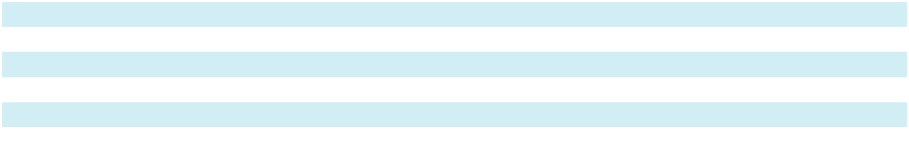

We recorded depreciation expense on the ARO of $0.4 million, $0.4 million and $0.3 million, for the years ended December 31, 2024, 2023, and 2022 respectively.

We are obligated to provide financial assurance to local and state licensing authorities for possible future decommissioning costs associated with the various facilities that hold Co-60. At December 31, 2024 and 2023, $49.1 million and $48.2 million, respectively, of the standby letters of credit referenced above and surety bonds were outstanding in favor of the various local and state licensing authorities in the event we defaulted on our decommissioning obligation.

103

Sotera Health Company

Notes to Consolidated Financial Statements

19. Commitments and Contingencies

We depend on a limited number of suppliers and our agreements with these suppliers account for material portions of our supply and direct material costs. These costs include obligations under various supply agreements in our Nordion segment for Co-60 that are enforceable and legally binding on us. As of December 31, 2024, we had minimum purchase commitments primarily with domestic and international suppliers of raw materials for the Nordion business totaling $2,219.1 million. The terms of these long-term supply or service arrangements range from 1 to 39 years. In addition, our Sterigenics segment has obligations to purchase ethylene oxide (“EO”). Our contract to purchase EO in the U.S. requires us to purchase all of our requirements from one supplier, and our contracts to purchase EO outside the U.S. generally require that we purchase a specified percentage of our requirements for our operations in the countries covered by those contracts. We expect to utilize the Co-60 and EO encompassed by these agreements in the normal course of our business and therefore our commitments under these agreements are not recognized on the consolidated balance sheets as a liability.

From time to time, we may be or are subject to various lawsuits and other claims, as well as gain contingencies, in the ordinary course of our business. In addition, from time to time, we receive communications from government or regulatory agencies concerning investigations or allegations of noncompliance with laws or regulations in jurisdictions in which we operate. We assess these regulatory and legal actions to determine if a contingent liability should be recorded. In making these determinations, we may, depending on the nature of the matter, consult with internal and external legal counsel and technical experts.

We establish reserves for specific liabilities in connection with regulatory and legal actions that we determine to be both probable and reasonably estimable. The outcomes of regulatory and legal actions can be difficult to predict and are often resolved over long periods of time, making our probability and estimability determinations highly judgmental. Probability determinations require the analysis of various possible outcomes, assessments of potential damages and the impact of multiple factors beyond our control, including potential actions by others, interpretations of the law, and changes and developments in relevant facts, circumstances, regulations and other laws. If a potentially material loss contingency is not probable, but is reasonably possible, or is probable but cannot be estimated, then the nature of the contingent liability is disclosed, together with an estimate of the range of possible loss if the range is determinable and material. In certain of the matters described below, we are not able to estimate potential liability because of the uncertainties related to the outcome(s) and/or the amount(s) or range(s) of loss. The ultimate resolution of pending regulatory and legal matters in future periods, including the matters described below, may have a material adverse effect on our financial condition, results of operations and/or liquidity. The Company may also incur material defense and settlement costs, diversion of management resources and other adverse effects on our business, financial condition, and/or results of operations.

Ethylene Oxide Tort Litigation

Sterigenics U.S., LLC (“Sterigenics”) and other medical supply sterilization companies have been subjected to tort lawsuits alleging various injuries caused by low-level environmental exposure to EO used at or emitted from sterilization facilities. Those lawsuits, as detailed further below, are individual claims, as opposed to class actions.

California

As of December 31, 2024, subsidiaries of the Company and other parties were defendants in four lawsuits in Los Angeles County Superior Court in which the plaintiffs are asserting 33 claims for personal injuries and wrongful death allegedly resulting from emissions and releases of EO from Sterigenics’ Vernon facilities (the “Vernon Cases”). The Vernon Cases have been assigned to one judge and discovery is underway.

We are vigorously defending the Vernon Cases.

Georgia

Subsidiaries of the Company and other parties are defendants in lawsuits in Georgia in which plaintiffs allege personal injuries, wrongful death and property devaluation resulting from use, emissions and releases of EO from or at Sterigenics’ Atlanta facility (the “Atlanta Cases”).

104

Sotera Health Company

Notes to Consolidated Financial Statements

As of December 31, 2024, subsidiaries of the Company and other parties were defendants in 313 personal injury and wrongful death claims in the State Court of Cobb County (the “Georgia Trial Court”) and 312 of the claims have been consolidated for pretrial purposes (the “Consolidated Personal Injury Cases”). The Consolidated Personal Injury Cases are governed by a case management order pursuant to which general causation issues in a pool of eight cases are to be adjudicated in Phase 1 and specific causation issues in the pool cases are to be adjudicated in Phase 2; the remaining Consolidated Personal Injury Cases (including ten cases that include both personal injury and property claims) are stayed. On November 22, 2024, the Georgia Trial Court issued a Phase 1 ruling on general causation issues granting in part and denying in part defendants’ motions to exclude certain Phase 1 expert testimony and defendants’ motions for summary judgment on Phase 1 issues (the “Phase 1 Ruling”). Both plaintiffs and defendants appealed the Phase 1 Ruling and these appeals are pending before the Georgia Court of Appeals. Phase 2 discovery in the pool cases is scheduled to take place through May 2025. One lawsuit has not been consolidated and the parties have jointly requested the Georgia Trial Court to stay the case along with the stayed cases in the Consolidated Personal Injury Cases.

As of December 31, 2024, subsidiaries of the Company and other parties were also defendants in a lawsuit pending in the Georgia Trial Court in which employees of a sterilization customer of Sterigenics allege they were injured while working at the customer’s distribution facility by exposure to residual EO allegedly emanating from products of the customer that had been sterilized by Sterigenics. Pursuant to the customer’s contract with Sterigenics, the customer is indemnifying Sterigenics against this lawsuit and discovery is underway.

As of December 31, 2024, subsidiaries of the Company were also defendants in 345 property devaluation lawsuits pending in the Georgia Trial Court that have been consolidated for pretrial purposes (the “Consolidated Property Cases”). A pool of nine of the Consolidated Property Cases are proceeding under case management orders and the remaining cases are stayed.

We are vigorously defending the Atlanta Cases.

Illinois

As of December 31, 2024, subsidiaries of the Company and other parties were defendants in 96 lawsuits in Illinois in which plaintiffs allege personal injuries or wrongful deaths resulting from purported emissions and releases of EO from Sterigenics’ former Willowbrook facility (the “Willowbrook Cases”). The Willowbrook Cases are pending in the Circuit Court of Cook County and have been assigned to a single judge for coordinated discovery and pretrial proceedings. Two of the Willowbrook Cases are set for trial in April 2025 and five of the Willowbrook Cases are set for trial in June 2025.

We are vigorously defending the Willowbrook Cases.

New Mexico

The Company and certain subsidiaries are defendants in a lawsuit in the Third Judicial District Court, Doña Ana County, New Mexico in which the New Mexico Attorney General (“NMAG”) alleges that emissions and releases of EO from Sterigenics’ facility in Santa Teresa have deteriorated the air quality in surrounding communities and materially contributed to increased health risks for residents of those communities. In April 2024, the Court of Appeals of the State of New Mexico denied the NMAG’s petition for leave to file an interlocutory appeal of an August 2023 order granting Sterigenics’ motion for summary judgment on strict liability, the Unfair Practices Act claim, and the claims for decreased property values, increased healthcare costs and medical monitoring costs. The case has been remanded to the District Court of Doña Ana County for further proceedings on the remaining claims. The case is set for trial in July 2026.

We are vigorously defending the NMAG’s remaining claims.

* * *

Additional EO lawsuits have been threatened relating to Sterigenics’ former facility in Willowbrook and existing facilities in Atlanta, Georgia; Charlotte, North Carolina; Grand Prairie, Texas; and Vernon, California and may be filed in the future relating to these or Sterigenics’ other EO facilities; these threats of additional EO lawsuits are comparable to threats that have

105

Sotera Health Company

Notes to Consolidated Financial Statements

similarly been made against other companies within our industry. Based on our view of the strength of the science and related evidence that emissions of EO from Sterigenics’ operations have not caused and could not have caused the harms alleged in such lawsuits, we believe that losses in the remaining or future EO cases through trials and any appeals that may prove necessary are not probable. Although the Company is vigorously defending against the EO tort claims, future settlements of EO tort claims are reasonably possible. The previously disclosed settlements of certain cases related to our facilities in Willowbrook and Atlanta Settlements and the resolution of the tort lawsuit pending in the United States District Court for the District of New Mexico (as previously disclosed in Note 14, Commitments and Contingencies of our Quarterly Report on Form 10-Q for the quarterly period ended September 30, 2024) were driven by dynamics unique to the claims that were settled and thus should not give rise to presumptions that the Company will settle additional EO tort claims and/or that any such settlements will be for comparable amounts.

Potential trial and settlement outcomes can vary widely based on a host of factors. EO tort lawsuits will be presided over by different judges, tried by different counsel presenting different evidence and decided by different juries. The substantive and procedural laws of jurisdictions vary and can meaningfully impact the litigation process and outcome of a case. Each plaintiff’s claim involves unique facts and evidence including the circumstances of the plaintiff’s alleged exposure, the type and severity of the plaintiff’s disease, the plaintiff’s medical history and course of treatment, the location of and other factors related to the plaintiff’s real property, and other circumstances. The outcomes of trials before juries are rarely certain and a judgment rendered or settlement reached in one case is not necessarily representative of potential outcomes of other seemingly comparable cases. As a result, it is not possible to estimate a reasonably possible loss or range of loss with respect to any future EO tort lawsuit, trial or settlement.

Insurance Coverage for Environmental Liabilities

An environmental liability insurance policy under which we have received coverage for the EO tort lawsuits in Georgia, Illinois and New Mexico described above had limits of $10.0 million per occurrence and $20.0 million in the aggregate. Those per occurrence and aggregate limits were fully utilized in the defense of the Georgia, Illinois and New Mexico litigation. Our insurance for future alleged environmental liabilities excludes coverage for EO claims.

We are pursuing additional insurance coverage for our legal expenses related to EO tort lawsuits. In 2021, Sterigenics filed an insurance coverage lawsuit in the U.S. District Court for the Northern District of Illinois (the “Illinois District Court”) relating to two commercial general liability policies issued in the 1980s (the “Northern District of Illinois Coverage Lawsuit”). The Illinois District Court issued an order declaring that the defendant insurer owes a duty to Sterigenics and another insured party to defend the Willowbrook Cases (the “Duty to Defend Order”) and entered judgment for Sterigenics in January 2024 in the amount of $110.2 million for certain defense costs incurred in the Willowbrook Cases as of August 2022 (the “Defense Costs Judgment”). The defendant insurer has appealed the Duty to Defend Order and Defense Costs Judgment; briefing is complete, and oral argument was held before the United States Court of Appeals for the Seventh Circuit on September 25, 2024.

Sterigenics is also a party in insurance coverage lawsuits pending in the Circuit Court of Cook County, the Delaware Superior Court and the Los Angeles County Superior Court relating to insurance coverage from various historical commercial general liability policies for certain EO litigation settlement amounts and defense costs that the insurer against which a judgment has been secured in the Northern District of Illinois Coverage Lawsuit may fail to fund. The Delaware Superior Court case is stayed pending resolution of the coverage lawsuit in the Circuit Court of Cook County and the Los Angeles County Superior Court case remains in preliminary stages. It is not possible to predict how much, if any, of the insurance proceeds sought will ultimately be recovered.

Sotera Health Company Securities Litigation and Related Matters

In January 2023, a stockholder class action was filed in the U.S. District Court for the Northern District of Ohio (the “Ohio District Court”) against the Company, certain past and present directors and senior executives, the Company’s private equity stockholders and the underwriters of the Company’s initial public offering (“IPO”) in November 2020 and the Company’s secondary public offering (“SPO”) in March 2021 (the “Michigan Funds Litigation”). In April 2023, the Ohio District Court appointed the Oakland County Employees’ Retirement System, Oakland County Voluntary Employees’ Beneficiary Association, and Wayne County Employees’ Retirement System (the “Michigan Funds”) to serve as lead plaintiff to prosecute claims on behalf of a proposed class of stockholders who acquired shares of the Company in connection with our IPO or SPO between November 20, 2020 and September 19, 2022 (the “Proposed Class”). The Michigan Funds allege that certain

106

Sotera Health Company

Notes to Consolidated Financial Statements

statements made regarding the safety of the Company’s use of EO and/or the EO tort lawsuits and other risks of its EO operations violated Sections 11, 12(a)(2) and 15 of the Securities Act of 1933 (when made in the registration statements for the IPO and SPO) and Sections 10(b), Section 20(a) and Rule 10b-5 of the Securities Exchange Act of 1934 (when made in subsequent securities filings and other contexts). Defendants have moved to dismiss the Amended Complaint, and that motion remains pending.

In May 2024, a stockholder derivative lawsuit was filed in the Court of Chancery of the State of Delaware (the “Delaware Chancery Court”) for the benefit of the Company as the nominal defendant (the “May 2024 Derivative Litigation”). The plaintiffs allege breaches of fiduciary duties, insider trading, unjust enrichment and other violations by certain past and present directors and senior executives of the Company and the Company’s private equity stockholders. On June 25, 2024, the Delaware Chancery Court stayed the May 2024 Derivative Litigation pending a ruling on the merits on the motion to dismiss the Amended Complaint in the Michigan Funds Litigation.

The Company is vigorously defending the Michigan Funds Litigation and, if necessary, plans to vigorously defend the May 2024 Derivative Litigation.

The Company has also received demands pursuant to 8 Del. C. §220 for inspections of its books and records (“220 Demands”) from shareholders purporting to investigate potential wrongdoing by Company fiduciaries and other issues relating to the Company’s statements regarding the safety of its use of EO and/or the EO tort lawsuits and other risks of its EO operations. The Company has produced documents in response to the 220 Demands and may produce additional documents.

20. Financial Instruments and Financial Risk

Derivative Instruments

We do not use derivatives for trading or speculative purposes and are not a party to leveraged derivatives.

Derivatives Designated in Hedge Relationships

From time to time, the Company utilizes interest rate derivatives designated in hedge relationships to manage interest rate risk associated with our variable rate borrowings. These instruments are measured at fair value with changes in fair value recorded as a component of “Accumulated other comprehensive income (loss)” on our Consolidated Balance Sheets.

In March 2023, we entered into an interest rate swap agreement with a notional amount of $400.0 million. The interest rate swap was effective on August 23, 2023 and expires on August 23, 2025. We have designated the interest rate swap as a cash flow hedge designed to hedge the variability of cash flows attributable to changes in the SOFR benchmark interest rate of our Term Loan (or any successor thereto). We receive interest at the one-month Term SOFR rate and pay a fixed interest rate under the terms of the swap agreement.

In May 2022, we entered into two interest rate cap agreements with a combined notional amount of $1,000.0 million for a total option premium of $4.1 million. The interest rate caps were effective on July 31, 2023 and expired on July 31, 2024. We designated these interest rate caps as cash flow hedges designed to hedge the variability of cash flows attributable to changes in the benchmark interest rate of our Term Loan (or any successor thereto). Under the current terms of the loan agreement, the benchmark interest rate index transitioned from LIBOR to the Term SOFR on June 30, 2023. Accordingly, the interest rate cap agreements hedged the variability of cash flows attributable to changes in SOFR by limiting our cash flow exposure related to Term SOFR under a portion of our variable rate borrowings to 3.5%.

In October 2021, we entered into two interest rate cap agreements with a combined notional amount of $1,000.0 million for a total option premium of $1.8 million. Both interest rate caps were effective on December 31, 2022 and expired on July 31, 2023. These interest rate caps were designated as cash flow hedges and were designed to hedge the variability of cash flows attributable to changes in LIBOR (or its successor), the benchmark interest rate being hedged, by limiting our cash flow exposure related to the LIBOR base rate under a portion of our variable rate borrowings to 1.0%.

107

Sotera Health Company

Notes to Consolidated Financial Statements

Derivatives Not Designated in Hedge Relationships

Additionally, from time to time, the Company enters into interest rate derivatives to manage economic risks associated with our variable rate borrowings that are not designated in hedge relationships. These instruments are recorded at fair value on the Consolidated Balance Sheets, with any changes in the value being recorded in “Interest expense, net” in the Consolidated Statements of Operations and Comprehensive Income (Loss).

The Company also routinely enters into foreign currency forward contracts to manage foreign currency exchange rate risk of our intercompany loans in certain of our international subsidiaries and non-functional currency assets and liabilities. The foreign currency forward contracts expire on a monthly basis.

Embedded Derivatives

We have embedded derivatives in certain of our customer and supply contracts as a result of the currency of the contract being different from the functional currency of the parties involved. Changes in the fair value of the embedded derivatives are recognized in “Other income, net” in the Consolidated Statements of Operations and Comprehensive Income (Loss).

The following table provides a summary of the notional and fair values of our derivative instruments:

 |  |  |  | December 31, 2024 |  |  |  |  |  |  | December 31, 2023
 | (in U.S. dollars; notional in millions, fair value in thousands) |  |  |  |  |  | Fair Value |  |  |  |  |  |  | Fair Value
 |  |  | Notional |  |  | Derivative |  | Derivative |  |  | Notional |  | Derivative |  | Derivative
 |  |  | Amount |  |  |  | Assets | Liabilities |  |  | Amount |  |  | Assets | Liabilities
 | Derivatives designated as hedging instruments
 | Interest rate caps |  | $ | — |  | $ | — $ |  | — | $ 1,000.0 |  |  | $ | 8,763 | $ | —
 | Interest rate swaps |  |  | 400.0 |  |  | 459 |  | — | 400.0 |  |  |  | 1,487 |  | —
 | Derivatives not designated as hedging instruments
 | Foreign currency forward contracts |  |  | 263.7 |  |  | 88 |  | 198 | 171.0 |  |  |  | 149 |  | 9
 | Embedded derivatives |  |  | 230.8 | (a) |  | 2,689 |  | 4,098 |  | 150.1 | (a) |  | 1,225 |  | 405
 | Total |  | $ | 894.5 |  | $ | 3,236 | $ | 4,296 | $ 1,721.1 |  |  | $ | 11,624 | $ | 414
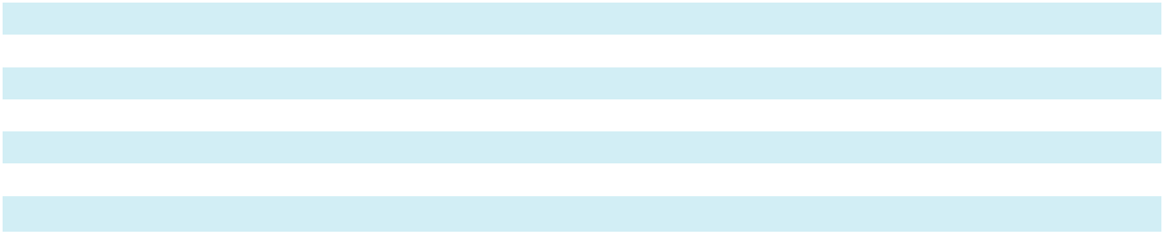
- Represents the total notional amounts for certain of the Company’s supply and sales contracts accounted for as embedded derivatives.

Embedded derivatives assets and foreign currency forward contracts are included in “Prepaid expenses and other current assets” and “Accrued Liabilities” on our Consolidated Balance Sheets depending upon their position at period end. Interest rate swaps and interest rate caps are included in “Other assets” and “Noncurrent liabilities” on the Consolidated Balance Sheets depending upon their position at period end.

The following tables summarize the activities of our derivative instruments for the periods presented, and the line item they are recorded in the Consolidated Statements of Operations and Comprehensive Income (Loss):

(thousands of U.S. dollars)
Year Ended December 31, |  |  | 2024 |  |  | 2023 |  |  | 2022
Realized gain on interest rate derivatives recorded in interest expense, net^{(a)}
 |  |  | $ (13,233) | $ |  | (33,094) | $ |  | (12,226)
Unrealized loss (gain) on embedded derivatives recorded in other income, net |  |  | 2,213 |  |  | (1,637) |  |  | 1,324
Realized loss (gain) on foreign currency forward contracts recorded in foreign |  |  | 18,055 |  |  | (2,025) |  |  | 3,931
exchange loss |  |  | 18,055 |  |  | (2,025) |  |  | 3,931
Unrealized loss (gain) on foreign currency forward contracts recorded in foreign |  |  | 249 |  |  | (412) |  |  | 272
exchange loss |  |  | 249 |  |  | (412) |  |  | 272
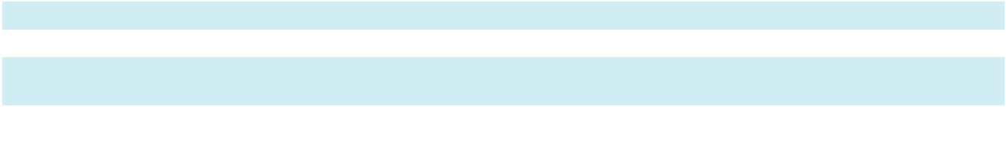

- Amounts represent periodic settlement of interest rate caps and swaps.

108

Sotera Health Company

Notes to Consolidated Financial Statements

We expect to reclassify approximately $0.5 million of after-tax net gains on derivative instruments from accumulated other comprehensive income (loss) to income during the next 12 months associated with our cash flow hedges. Refer to Note 13, “Other Comprehensive Income (Loss)” for unrealized gains on interest rate derivatives, net of applicable tax, recorded in other comprehensive income (loss) and amounts reclassified from accumulated other comprehensive income to interest expense, net of applicable tax, during the years ended December 31, 2024 and December 31, 2023.

Credit Risk

Certain of our financial assets, including cash and cash equivalents, are exposed to credit risk.

We are also exposed, in our normal course of business, to credit risk from our customers. As of December 31, 2024 and 2023, accounts receivable was net of an allowance for uncollectible accounts of $2.5 million and $4.7 million, respectively.

Credit risk on financial instruments arises from the potential for counterparties to default on their contractual obligations to us. We are exposed to credit risk in the event of non-performance, but do not anticipate non-performance by any of the counterparties to our financial instruments. We limit our credit risk by dealing with counterparties that are considered to be of high credit quality. In the event of non-performance by counterparties, the carrying value of our financial instruments represents the maximum amount of loss that would be incurred.

Our credit team evaluates and regularly monitors changes in the credit risk of our customers. We routinely assess the collectability of accounts receivable and maintain an adequate allowance for uncollectible accounts to address potential credit losses. The process includes a review of customer financial information and credit ratings, current market conditions as well as the expected future economic conditions that may impact the collection of trade receivables. We regularly review our customers’ past due amounts through an analysis of aged accounts receivables, specific customer past due aging amounts, and the history of trade receivables written off. Upon concluding that a receivable balance is not collectible, the balance is written off against the allowance for uncollectible accounts.

Fair Value Hierarchy

The fair value of our financial instruments is the price that would be received to sell an asset or paid to transfer a liability in an orderly transaction between market participants at the measurement date. The valuation techniques we would use to determine such fair values are described as follows: Level 1—fair values determined by inputs utilizing quoted prices in active markets for identical assets or liabilities; Level 2—fair values based on observable inputs other than quoted prices included in Level 1, such as quoted prices for similar assets and liabilities in active markets, quoted prices for identical or similar assets and liabilities in markets that are not active, or other inputs that are observable; Level 3—fair values determined by unobservable inputs reflecting our own assumptions, consistent with reasonably available assumptions made by other market participants.

109

Sotera Health Company

Notes to Consolidated Financial Statements

The following table discloses the fair value our financial assets and liabilities:

As of December 31, 2024 |  |  |  |  |  |  |  |  |  | Fair Value
 |  |  |  | Carrying
(thousands of U.S. dollars) |  |  |  | Amount |  |  | Level 1 |  |  | Level 2 |  |  | Level 3
Derivatives designated as hedging instruments^{(a)}
Interest rate swap |  |  | $ | 459 |  | $ | — $ |  |  | 459 | $ |  | —
Derivatives not designated as hedging instruments^{(b)}
Foreign currency forward contract assets |  |  |  | 88 |  |  | — |  |  | 88 |  |  | —
Foreign currency forward contract liabilities |  |  |  | 198 |  |  | — |  |  | 198 |  |  | —
Embedded derivative assets |  |  |  | 2,689 |  |  | — |  |  | 2,689 |  |  | —
Embedded derivative liabilities |  |  |  | 4,098 |  |  | — |  |  | 4,098 |  |  | —
Current portion of long-term debt^{(c)}
Term Loan, due 2031 |  |  |  | 14,803 |  |  | — |  |  | 15,123 |  |  | —
Long-Term Debt^{(c)}
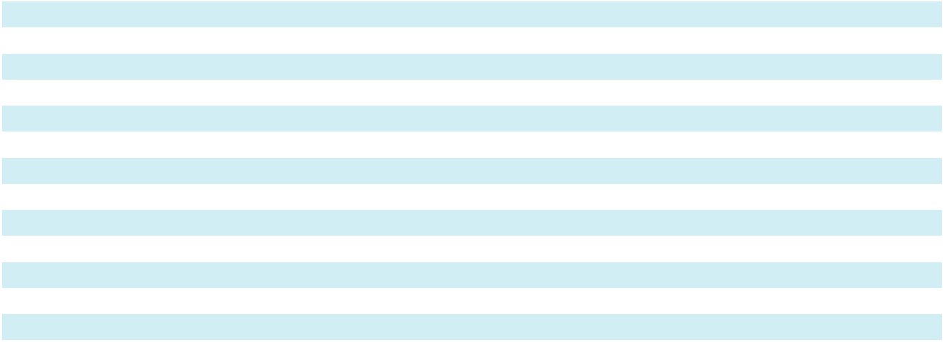

Secured Notes, due 2031

Term loan, due 2031

Finance Lease Obligations (with current portion)^{(d)}

As of December 31, 2023

(thousands of U.S. dollars)

Derivatives designated as hedging instruments^{(a)}

Interest rate caps

Interest rate swap

Derivatives not designated as hedging instruments^{(b)}

 | 746,293 |  |  | — |  |  | 759,375 |  |  | —
 | 1,461,807 |  |  | — |  |  | 1,493,314 |  |  | —
 | 98,209 |  |  | — |  |  | 98,209 |  |  | —
 |  |  |  |  |  |  | Fair Value
 | Carrying
 | Amount |  |  | Level 1 |  |  | Level 2 |  |  | Level 3
$ | 8,763 |  | $ | — | $ |  | 8,763 | $ |  | —
 | 1,487 |  |  | — |  |  | 1,487 |  |  | —
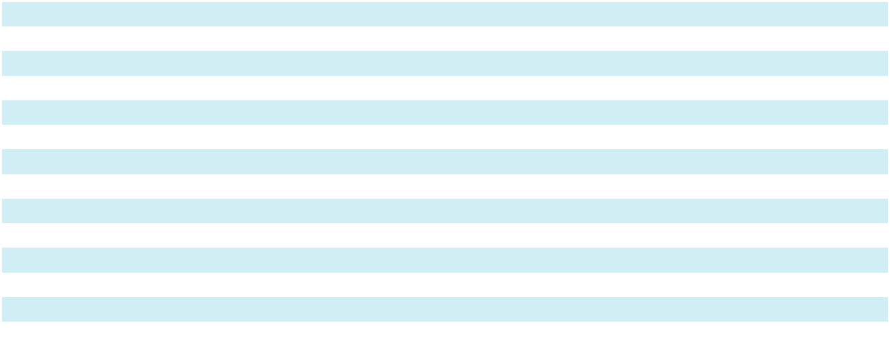

Foreign currency forward contracts assets | 149 |  | — | 149 |  | —
Foreign currency forward contracts liabilities | 9 | $ | — $ | 9 | $ | —
Embedded derivative assets | 1,225 |  | — | 1,225 |  | —
Embedded derivative liabilities | 405 |  | — | 405 |  | —
Current portion of long-term debt^{(c)}
Term Loan B, due 2026 | 4,797 |  | — | 5,000 |  | —
Long-Term Debt^{(c)}
Term Loan, due 2026 | 1,751,197 |  | — | 1,758,163 |  | —
Term Loan B, due 2026 | 472,477 |  | — | 492,500 |  | —
Finance Lease Obligations (with current portion)^{(d)} | 72,564 |  | — | 72,564 |  | —

- Derivatives designated as hedging instruments are measured at fair value with changes in fair value recorded as a component of accumulated other comprehensive income (loss). Interest rate caps and swaps are valued using pricing models that incorporate observable market inputs including interest rate curves and yield curves. Additional information is provided in Note 1, “Significant Accounting Policies.”

- Derivatives that are not designated as hedging instruments are measured at fair value with gains or losses recognized immediately in the Consolidated Statements of Operations and Comprehensive Income (Loss). Refer also to Note 1, “Significant Accounting Policies.” Embedded derivatives are valued using internally developed models that rely on observable market inputs, including foreign currency forward curves. Foreign currency forward contracts are valued by reference to changes in foreign currency exchange rate over the life of the contract.
- Carrying amounts of current portion of long-term debt and long-term debt instruments are reported net of discounts and debt issuance costs. The estimated fair value of these instruments are based upon quoted prices for each Term Loan and the Secured Notes in inactive markets as provided by an independent fixed income security pricing service.

- Refer to Note 17, “Leases.” Fair value approximates carrying value.

110

Sotera Health Company

Notes to Consolidated Financial Statements

21. Segment and Geographic Information

We identify our operating segments based on the way we manage, evaluate and internally report our business activities for purposes of allocating resources and assessing performance. We have three reportable segments: Sterigenics, Nordion and Nelson Labs. We have determined our reportable segments based upon an assessment of organizational structure, service types, and internally prepared financial statements. Our chief operating decision maker, the Chairman and Chief Executive Officer of Sotera Health Company (“CODM”), evaluates performance and allocates resources based on segment income after the elimination of intercompany activities. The CODM uses these performance measures to inform decisions about the operations of the business and dedication of resources to selling and general administrative matters pertinent to the Company. The accounting policies of our reportable segments are the same as those described in Note 1, “Significant Accounting Policies.”

Sterigenics

Sterigenics provides outsourced terminal sterilization and irradiation services for the medical device, pharmaceutical, food safety and advanced applications markets using three major technologies: gamma irradiation, EO processing and E-beam irradiation.

Nordion

Nordion is a leading global provider of Co-60 used in the sterilization and irradiation processes for the medical device, pharmaceutical, food safety, and high-performance materials industries, as well as in the treatment of cancer. In addition, Nordion is a leading global provider of gamma irradiation systems.

Nelson Labs

Nelson Labs provides outsourced microbiological and analytical chemistry testing and advisory services for the medical device and pharmaceutical industries.

Segment Revenue Concentrations

For the year ended December 31, 2024, two customers reported within the Nordion segment individually represented 10% or more of the segment’s total net revenues. These customers represented 21.3% and 13.0% of the total segment’s external net revenues for the year ended December 31, 2024. For the year ended December 31, 2023, three customers reported within the Nordion segment individually represented 10% or more of the segment’s total net revenues. These customers represented

20.1%, 14.8%, and 13.9% of the total segment’s external net revenues for the year ended December 31, 2023. For the year ended December 31, 2022, five customers reported within the Nordion segment individually represented 10% or more of the

segment’s total net revenues. These customers represented 17.7%, 13.6%, 11.2%, 10.7% and 10.2% of the total segment’s external net revenues for the year ended December 31, 2022.

Financial information for each of our segments is presented in the following table:

 |  |  |  |  | Year Ended December 31, 2024
(thousands of U.S. dollars) |  |  | Sterigenics |  | Nordion |  | Nelson Labs |  |  | Total
Net revenues^{(a)}
 |  | $ | 697,853 | $ | 173,355 | $ | 229,233 | $ |  | 1,100,441
Segment expenses^{(b)} |  |  | 286,434 |  | 67,087 |  | 155,088 |  |  | 508,609
Corporate expense allocation^{(c)} |  |  | 33,248 |  | 5,048 |  | 4,962 |  |  | 43,258
Segment income |  | $ | 378,171 | $ | 101,220 | $ | 69,183 | $ |  | 548,574
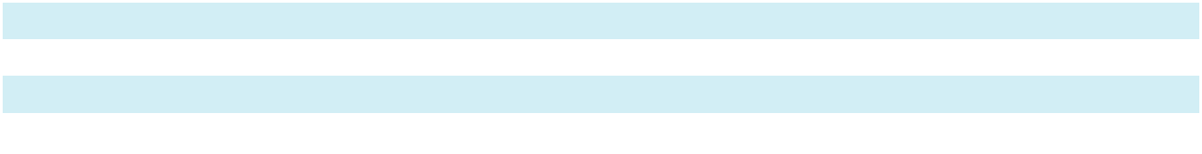

111

Sotera Health Company

Notes to Consolidated Financial Statements

 |  |  |  |  | Year Ended December 31, 2023
(thousands of U.S. dollars) |  |  | Sterigenics |  | Nordion |  | Nelson Labs |  |  | Total
Net revenues^{(a)}
 |  | $ | 667,130 | $ | 160,459 | $ | 221,699 | $ |  | 1,049,288
Segment expenses^{(b)} |  |  | 275,424 |  | 59,399 |  | 148,209 |  |  | 483,032
Corporate expense allocation^{(c)} |  |  | 29,494 |  | 4,382 |  | 4,351 |  |  | 38,227
Segment income |  | $ | 362,212 | $ | 96,678 | $ | 69,139 | $ |  | 528,029
 |  |  |  |  | Year Ended December 31, 2022
(thousands of U.S. dollars) |  |  | Sterigenics |  | Nordion |  | Nelson Labs |  |  | Total
Net revenues^{(a)}
 |  | $ | 626,646 | $ | 153,639 | $ | 223,402 | $ |  | 1,003,687
Segment expenses^{(b)} |  |  | 260,295 |  | 60,119 |  | 141,761 |  |  | 462,175
Corporate expense allocation^{(c)} |  |  | 27,207 |  | 4,043 |  | 4,013 |  |  | 35,263
Segment income |  | $ | 339,144 | $ | 89,477 | $ | 77,628 | $ |  | 506,249

- Revenues are reported net of intersegment sales. Our Nordion segment recognized $58.7 million, $43.9 million and $52.4 million in revenues from sales to our Sterigenics segment for the years ended December 31, 2024, 2023 and 2022, respectively, that is not reflected in net revenues in the table above. Intersegment sales for Sterigenics and Nelson Labs are immaterial for all periods presented.

- Segment expenses are comprised of direct materials, labor, utilities, other costs of revenues, SG&A, and other non-operating expense (income) attributable to each segment.
- Corporate operating expenses that are directly incurred by a segment are reflected in each segment’s income. The remaining Corporate operating expenses for executive management, accounting, information technology, legal, human resources, treasury, investor relations, corporate development, tax, purchasing, and marketing not directly incurred by a segment are allocated to the segments primarily based on total net revenue.

Capital expenditures by segment for the years ended December 31, 2024, 2023 and 2022 were as follows:

 |  |  | Year Ended December 31,
(thousands of U.S. dollars) |  |  | 2024 |  |  | 2023 |  |  | 2022
Sterigenics
 |  | $ | 131,258 | $ |  | 163,043 | $ |  | 144,027
Nordion |  |  | 34,928 |  |  | 38,351 |  |  | 26,575
Nelson Labs |  |  | 12,884 |  |  | 13,581 |  |  | 11,776
Total capital expenditures |  | $ | 179,070 | $ |  | 214,975 | $ |  | 182,378

Total assets and depreciation and amortization expense by segment are not readily available and are not reported separately to the CODM.

112

Sotera Health Company

Notes to Consolidated Financial Statements

A reconciliation of segment income to consolidated income (loss) before taxes is as follows:

(thousands of U.S. dollars)
Year Ended December 31, |  |  |  | 2024 |  |  | 2023 |  |  | 2022
Segment income
 |  |  | $ | 548,574 | $ |  | 528,029 | $ |  | 506,249
Less adjustments:
Interest expense, net(a) |  |  |  | 164,691 |  |  | 142,878 |  |  | 78,490
Depreciation and amortization(b) |  |  |  | 161,797 |  |  | 157,925 |  |  | 145,554
Share-based compensation(c) |  |  |  | 36,896 |  |  | 32,364 |  |  | 21,211
Loss on refinancing of debt(d) |  |  |  | 24,168 |  |  | — |  |  | —
(Gain) loss on foreign currency and derivatives not designated as hedging
instruments, net(e) |  |  |  | 2,448 |  |  | (1,552) |  |  | 3,150
Business optimization expenses(f) |  |  |  | 7,504 |  |  | 7,662 |  |  | 8,509
Impairment of investment in unconsolidated affiliate(g) |  |  |  | — |  |  | — |  |  | 9,613
Professional services relating to EO sterilization facilities(h) |  |  |  | 32,694 |  |  | 45,312 |  |  | 72,639
Illinois EO litigation settlement(i) |  |  |  | — |  |  | — |  |  | 408,000
Georgia EO litigation settlement(j) |  |  |  | — |  |  | 35,000 |  |  | —
Secondary offering and other shareholder activities(k) |  |  |  | 1,864 |  |  | — |  |  | —
Accretion of asset retirement obligation(l) |  |  |  | 2,638 |  |  | 2,413 |  |  | 2,194
Consolidated income (loss) before taxes |  |  | $ | 113,874 | $ |  | 106,027 | $ |  | (243,111)
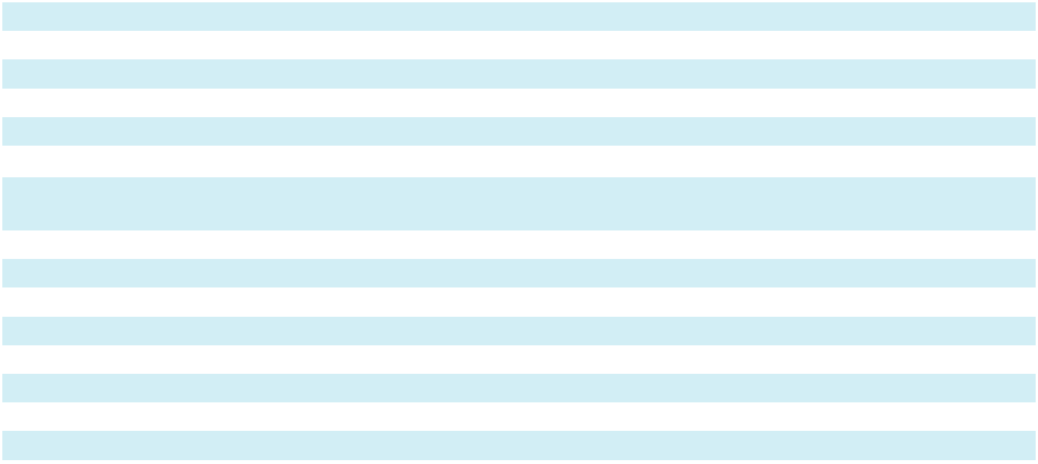

- Interest expense, net presented in this reconciliation for the year ended December 31, 2023 has been adjusted to conform to the current year presentation to include interest expense, net on Term Loan B due 2026 attributable to the loan proceeds that were used to fund the $408.0 million Illinois EO litigation settlement. The year ended December 31, 2022 excludes a $1.7 million unrealized loss on interest rate derivatives not designated as hedging instruments.

- Includes depreciation of Co-60 held at gamma irradiation sites. The year ended December 31, 2024 excludes accelerated depreciation associated with business optimization activities.

- Represents share-based compensation expense to employees and Non-Employee Directors. See Note 15, “Share-Based Compensation” for further information.

- Represents the write-off of unamortized debt issuance costs and discounts, as well as certain other costs incurred related to the Refinancing Term Loans and the Secured Notes. The year ended December 31, 2024 also includes $0.7 million of debt refinancing costs related to Amendment No. 3 to the Senior Secured Credit Facilities.

- Represents the effects of (i) fluctuations in foreign currency exchange rates and (ii) non-cash mark-to-fair value of embedded derivatives relating to certain customer and supply contracts at Nordion.

- Represents (i) certain costs related to acquisitions and the integration of recent acquisitions, (ii) the earnings impact of fair value adjustments (excluding those recognized within amortization expense) resulting from the businesses acquired, (iii) transition services income and non-cash deferred lease income associated with the terms of the divestiture of the Medical Isotopes business in 2018, (iv) professional fees and other costs associated with business optimization, cost saving and other process enhancement projects, and (v) professional fees, payroll costs, and other costs, including ongoing lease and utility expenses associated with the closure of the Willowbrook, Illinois facility. The year ended December 31, 2023 includes a $1.0 million cancellation fee received from a tenant in connection with the termination of an office space lease at the Nordion facility.

- Represents an impairment charge on an equity method investment in a joint venture.

- Represents litigation and other professional fees associated with our EO sterilization facilities. Amounts presented for the year ended December 31, 2023 have been adjusted to exclude interest expense, net associated with Term Loan B due 2026 attributable to the loan proceeds that were used to fund the $408.0 million Illinois EO litigation settlement.

- Represents the cost to settle 880 pending and threatened EO claims in Illinois pursuant to settlement agreements entered into on March 28, 2023. See Note 19, “Commitments and Contingencies.”

- Represents the cost to settle 79 pending EO claims in Georgia under a settlement entered into on December 21, 2023. See Note 19, “Commitments and Contingencies.”

113

Sotera Health Company

Notes to Consolidated Financial Statements

- Represents expenses incurred in connection with secondary offerings of our common stock that closed on March 4, 2024 and September 6, 2024 and legal, consulting, and other fees associated with shareholder engagement.

- Represents non-cash accretion of ARO related to Co-60 gamma and EO processing facilities, which are based on estimated site remediation costs for any future decommissioning of these facilities and are accreted over the life of the asset.

Geographic Information

Net revenues for geographic area are reported by the country’s origin of the revenues.

(thousands of U.S. dollars)
Year Ended December 31, |  |  |  | 2024 |  |  | 2023 |  |  | 2022
United States
 |  |  | $ | 616,684 | $ |  | 590,967 | $ |  | 579,018
Canada |  |  |  | 208,886 |  |  | 192,050 |  |  | 188,741
Europe |  |  |  | 196,011 |  |  | 187,542 |  |  | 166,025
Other |  |  |  | 78,860 |  |  | 78,729 |  |  | 69,903
Total |  |  | $ | 1,100,441 | $ |  | 1,049,288 | $ |  | 1,003,687
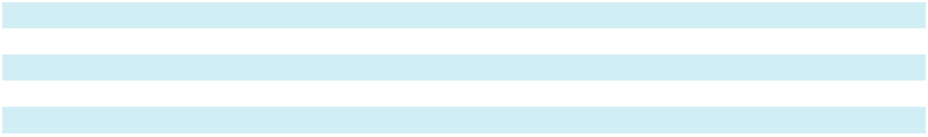

The ‘Other’ category above is primarily comprised of net revenues from Asian and Latin American countries that individually represent 3% or less of our total net revenues.

Long-lived assets are based on physical locations and are comprised of the net book value of property, plant, and equipment.

(thousands of U.S. dollars)
As of December 31, |  |  |  | 2024 |  |  | 2023
United States
United States |  |  | $ | 587,707 | $ |  | 494,793
Canada |  |  |  | 188,498 |  |  | 181,628
Europe |  |  |  | 174,227 |  |  | 170,669
Other |  |  |  | 86,460 |  |  | 99,824
Total |  |  | $ | 1,036,892 | $ |  | 946,914
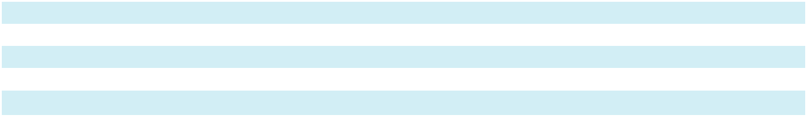

The ‘Other’ category above is primarily comprised of long-lived assets in Asian and Latin American countries that individually represent 5% or less of our total long-lived assets.

114

Sotera Health Company

Schedule II – Valuation and Qualifying Accounts

(in thousands)

 |  |  | Balance at |  |  | Charges
 |  |  | Balance at |  |  | (credits) to |  |  |  |  |  | Translation |  | Balance at End
Description |  |  | Beginning of |  |  | costs and |  |  | Deductions⁽¹⁾ |  |  | Translation
Description |  |  | Period |  |  | expense |  |  | Deductions⁽¹⁾ |  | Adjustments⁽²⁾ |  |  |  | of Period
Year Ended December 31, 2024
Deducted from asset accounts:
 | Allowance for uncollectible | $ | 4,689 | $ |  | (435) | $ |  | (1,580) | $ |  | (142) | $ |  | 2,532
 | accounts receivable
 | Deferred tax asset valuation |  | 125,435 |  |  | 35,660 |  |  | — |  |  | (500) |  |  | 160,595
 | allowance |  | 125,435 |  |  | 35,660 |  |  | — |  |  | (500) |  |  | 160,595
Year Ended December 31, 2023
Deducted from asset accounts:
 | Allowance for uncollectible | $ | 1,871 | $ |  | 4,313 | $ |  | (1,502) | $ |  | 7 | $ |  | 4,689
 | accounts receivable
 | Deferred tax asset valuation |  | 105,600 |  |  | 19,682 |  |  | — |  |  | 153 |  |  | 125,435
 | allowance |  | 105,600 |  |  | 19,682 |  |  | — |  |  | 153 |  |  | 125,435
Year Ended December 31, 2022
Deducted from asset accounts:
 | Allowance for uncollectible | $ | 1,287 | $ |  | 1,009 | $ |  | (419) | $ |  | (6) | $ |  | 1,871
 | accounts receivable
 | Deferred tax asset valuation |  | 52,080 |  |  | 53,945 |  |  | — |  |  | (425) |  |  | 105,600
 | allowance |  | 52,080 |  |  | 53,945 |  |  | — |  |  | (425) |  |  | 105,600
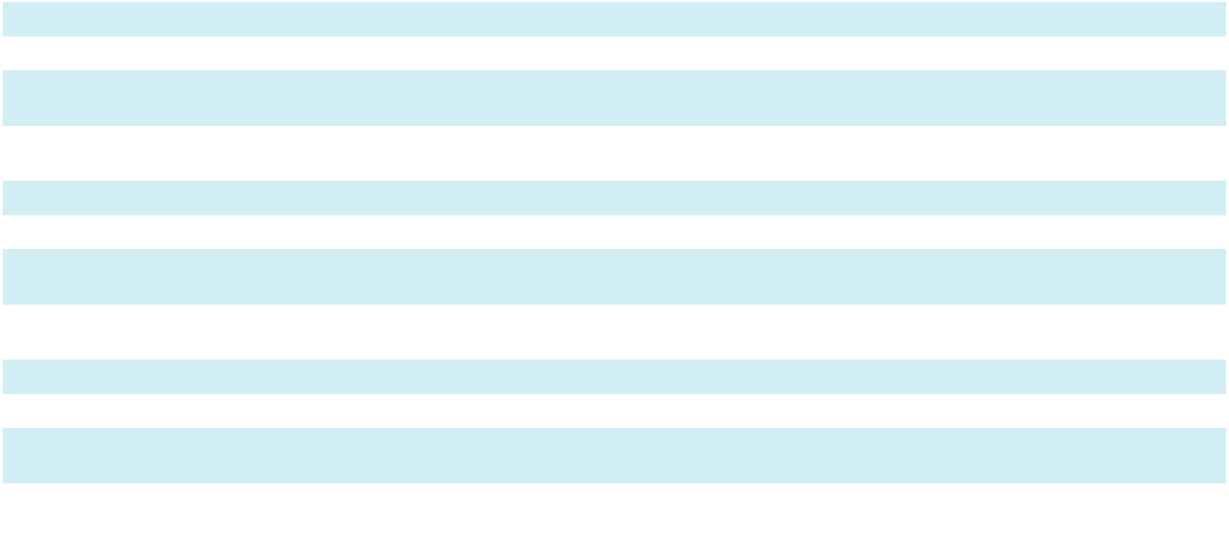

- Uncollectible accounts written off, net of recoveries.

- Change in foreign currency exchange rates.

115

Item 9. Changes in and Disagreements With Accountants on Accounting and Financial Disclosure

None.

Item 9A. Controls and Procedures

Evaluation of Disclosure Controls and Procedures

Our management, with the participation of our Chief Executive Officer and Chief Financial Officer, has evaluated the effectiveness of the Company’s “disclosure controls and procedures” (as defined in Rules 13a-15(e) and 15d-15(e) under the Exchange Act). Based upon their evaluation, the Chief Executive Officer and Chief Financial Officer concluded that, as of the end of the period covered by this Annual Report on Form 10-K, our disclosure controls and procedures were effective to provide reasonable assurance that information we are required to disclose in reports that we file or submit under the Exchange Act is recorded, processed, summarized, and reported within the time periods specified in the rules and forms of the SEC, and that such information is accumulated and communicated to our management, including our Chief Executive Officer and Chief Financial Officer, as appropriate, to allow timely decisions regarding required disclosure.

Management’s Annual Report on Internal Control Over Financial Reporting

The management of the Company is responsible for establishing and maintaining adequate internal control over financial reporting as defined in Exchange Act Rule 13a-15(f). Using criteria set forth by the Committee of Sponsoring Organizations of the Treadway Commission (2013 framework) in Internal Control-Integrated Framework, the Company’s management assessed the effectiveness of the Company’s internal control over financial reporting as of December 31, 2024. Based on this assessment, management concluded that the Company’s internal control over financial reporting was effective as of December 31, 2024.

The effectiveness of the Company’s internal control over financial reporting as of December 31, 2024 has been audited by Ernst

- Young LLP, an independent registered public accounting firm, as stated in their report, which is included in this Annual Report on Form 10-K and is included in this Item 9A below.

Changes in Internal Control Over Financial Reporting

During the fourth quarter of 2024, there were no changes in our internal control over financial reporting that materially affected, or are reasonably likely to materially affect, our internal control over financial reporting.

116

REPORT OF INDEPENDENT REGISTERED PUBLIC ACCOUNTING FIRM To the Stockholders and the Board of Directors of Sotera Health Company Opinion on Internal Control Over Financial Reporting

We have audited Sotera Health Company’s internal control over financial reporting as of December 31, 2024, based on criteria established in Internal Control—Integrated Framework issued by the Committee of Sponsoring Organizations of the Treadway Commission (2013 framework) (the COSO criteria). In our opinion, Sotera Health Company (the Company) maintained, in all material respects, effective internal control over financial reporting as of December 31, 2024, based on the COSO criteria.

We also have audited, in accordance with the standards of the Public Company Accounting Oversight Board (United States) (PCAOB), the 2024 consolidated financial statements of the Company and our report dated February 27, 2025 expressed an unqualified opinion thereon.

Basis for Opinion

The Company’s management is responsible for maintaining effective internal control over financial reporting and for its assessment of the effectiveness of internal control over financial reporting included in the accompanying Management’s Annual Report on Internal Control over Financial Reporting. Our responsibility is to express an opinion on the Company’s internal control over financial reporting based on our audit. We are a public accounting firm registered with the PCAOB and are required to be independent with respect to the Company in accordance with the U.S. federal securities laws and the applicable rules and regulations of the Securities and Exchange Commission and the PCAOB.

We conducted our audit in accordance with the standards of the PCAOB. Those standards require that we plan and perform the audit to obtain reasonable assurance about whether effective internal control over financial reporting was maintained in all material respects.

Our audit included obtaining an understanding of internal control over financial reporting, assessing the risk that a material weakness exists, testing and evaluating the design and operating effectiveness of internal control based on the assessed risk, and performing such other procedures as we considered necessary in the circumstances. We believe that our audit provides a reasonable basis for our opinion.

Definition and Limitations of Internal Control Over Financial Reporting

A company’s internal control over financial reporting is a process designed to provide reasonable assurance regarding the reliability of financial reporting and the preparation of financial statements for external purposes in accordance with generally accepted accounting principles. A company’s internal control over financial reporting includes those policies and procedures that (1) pertain to the maintenance of records that, in reasonable detail, accurately and fairly reflect the transactions and dispositions of the assets of the company; (2) provide reasonable assurance that transactions are recorded as necessary to permit preparation of financial statements in accordance with generally accepted accounting principles, and that receipts and expenditures of the company are being made only in accordance with authorizations of management and directors of the company; and (3) provide reasonable assurance regarding prevention or timely detection of unauthorized acquisition, use, or disposition of the company’s assets that could have a material effect on the financial statements.

Because of its inherent limitations, internal control over financial reporting may not prevent or detect misstatements. Also, projections of any evaluation of effectiveness to future periods are subject to the risk that controls may become inadequate because of changes in conditions, or that the degree of compliance with the policies or procedures may deteriorate.

/s/ Ernst & Young LLP

Cleveland, Ohio

February 27, 2025

117

Item 9B. Other Information

Rule 10b5-1 Trading Plans

During the three months ended December 31, 2024, none of the Company’s directors or officers (as defined in Rule 16a-1(f) under the Exchange Act) adopted or terminated any contract, instruction or written plan for the purchase or sale of Company securities that was intended to satisfy the affirmative defense conditions of Rule 10b5-1(c) or any “non-Rule 10b5-1 trading arrangement” (as that term is defined in Regulation S-K, Item 408).

Offer Letter Revision and Retention Awards

The Company is currently a party to an offer letter, dated February 26, 2024, with Mr. Jonathan Lyons, the Company’s Chief Financial Officer, which offer letter generally provides for certain of his initial and ongoing compensation and benefits arrangements with the Company. On February 26, 2025, the Company entered into an amendment and restatement of the offer letter, primarily to revise the terms of Mr. Lyons’ entitlement to cash severance benefits under the offer letter. Under the amendment and restatement, the Company increased the amount of such cash severance benefits from one times his annual base salary rate to one times the sum of his annual base salary rate plus his target short-term annual incentive. Further, on March 3, 2025, the Company intends to provide to Mr. Lyons (1) a $500,000 cash-based retention award that will vest as to 10% of the award on the 6-month anniversary of the grant date, 20% of the award on the 12-month anniversary of the grant date, 30% of the award on the 18-month anniversary of the grant date and the remaining amount of the award on the 24-month anniversary of the grant date, in each case generally subject to Mr. Lyons’ continued service with the Company through the applicable vesting date, as well as (2) a retention grant of $500,000 in time-based restricted stock units, which award will, in general, vest as to 50% of the award on the first anniversary of the grant date and the remaining amount of the award on the second anniversary of the grant date, in each case subject to Mr. Lyons’ continued service with the Company through the applicable vesting date. The vesting of the time-based restricted stock units award will accelerate if Mr. Lyons’ service ceases due to his death or disability, or under certain conditions regarding a change in control of the Company (as described in the applicable award agreement).

Item 9C. Disclosure Regarding Foreign Jurisdictions that Prevent Inspections

Not Applicable.

118

Part III

Item 10. Directors, Executive Officers and Corporate Governance

Certain information required by this Item is incorporated by reference to the sections titled “Board Composition, Nominations Process and Director Qualifications,” “Corporate Governance” and “Insider Trading Policy” to be included in our Definitive Proxy Statement for the 2025 Annual Meeting of Stockholders, which will be filed with the SEC within 120 days after the fiscal year ended December 31, 2024.

The following table sets forth information about our executive officers as of February 20, 2025:

Name |  | Age |  | Position
Michael B. Petras, Jr. |  | 57 | Chairman and Chief Executive Officer
Jonathan (Jon) Lyons |  | 47 | Senior Vice President and Chief Financial Officer
Michael (Mike) P. Rutz |  | 53 | President of Sterigenics
Alexander (Alex) Dimitrief |  | 66 | Senior Vice President and General Counsel
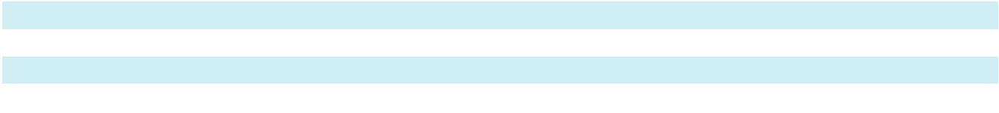

Set forth below is a brief description of the business experience of our executive officers.

Michael B. Petras, Jr. has served as our Chief Executive Officer since June 2016 and as the Chairman of our board of directors since October 2020 and served as the Chairman of the board of managers of Sotera Health Topco, L.P. (“Topco Parent”) from January 2019 and as a member of Topco Parent’s board of managers from June 2016 until the completion of the IPO. Prior to joining the Company, Mr. Petras served as chief executive officer of Post-Acute Solutions at Cardinal Health, Inc., a multinational healthcare services company, from 2015 to 2016 and chief executive officer of Cardinal Health at-Home at Cardinal Health, Inc. from 2013 to 2015. From 2011 to 2013, he was the chief executive officer for AssuraMed Holdings, Inc., a medical products supplier owned by the Clayton, Dubilier & Rice and Goldman Sachs private equity firms, which was sold to Cardinal Health, Inc. in 2013. From 2008 to 2011, Mr. Petras was president and chief executive officer at GE Lighting, a General Electric Company (“GE”) business unit. During his over 20 year career at GE, he held several management positions in multiple disciplines. Mr. Petras holds a B.S.B.A. in finance from John Carroll University and an M.B.A. in marketing from Case Western Reserve University.

Jonathan (Jon) M. Lyons has served as our Senior Vice President and Chief Financial Officer since June 2023. Prior to joining the Company, Mr. Lyons served as vice president, corporate FP&A of Owens Corning, a global leader specializing in building and construction materials, from June 2021 to June 2023 and vice president, finance of the insulation segment from October 2018 to May 2021. Mr. Lyons joined Owens Corning in 2010 as assistant treasurer and also served as treasurer from 2011 to 2014. Mr. Lyons also spent eight years with Cardinal Health, Inc., holding several senior leadership roles in treasury, FP&A, investor relations and tax after beginning his career in public accounting. Mr. Lyons holds an M.B.A. from The Ohio State University and a B.S. in Accounting from Kent State University.

Michael (Mike) P. Rutz has served as President of Sterigenics since October 2020. Prior to that, Mr. Rutz was Chief Operating Officer of Sterigenics from May 2020 to October 2020. Prior to joining the Company, he was senior vice president and general manager of the Semiconductor Business Unit at Littelfuse, Inc., a multinational electronic manufacturing company, where he was responsible for leading sales, marketing, product development, operations and business development for power and protection based semiconductor products. Mr. Rutz joined Littelfuse, Inc. in 2014 as senior vice president of global operations, overseeing the company’s manufacturing, procurement, planning, quality, and operational excellence initiatives. Prior to joining Littelfuse, Inc., Mr. Rutz served as senior vice president global supply chain at WMS Gaming, a Chicago-based manufacturer of equipment and software for the gaming industry. Mr. Rutz also spent 16 years with Motorola Solutions, Inc., a telecommunications company, in the paging, cellular and networking groups, and previously as vice president, networks supply chain. Mr. Rutz holds a Bachelor’s degree in mechanical engineering from the University of Michigan and Master’s degrees in mechanical engineering and management from the Massachusetts Institute of Technology.

119

Alexander (Alex) Dimitrief has served as our Senior Vice President and General Counsel since November 2022 and he served as Secretary from November 2022 to December 2024. Prior to joining the Company, from February 2020 to October 2022, he was a partner at Zeughauser Group, a legal management consulting firm, where he remains as an advisor. Mr. Dimitrief was a senior fellow and distinguished adjunct professor at New York Law School from August 2020 to December 2022 and a lecturer on law at Harvard Law School from September 2019 to December 2022. Mr. Dimitrief previously served in a variety of leadership roles at GE. Mr. Dimitrief was president and chief executive officer of GE’s Global Growth Organization from 2018 until his retirement from GE in January 2019. He previously served as GE’s senior vice president and general counsel from 2015 to

2018 and held other senior legal roles at GE beginning in 2007. Mr. Dimitrief came to GE from Kirkland & Ellis LLP, where he practiced law for twenty years. Mr. Dimitrief holds a B.A. in economics and political science from Yale College and a J.D. from Harvard Law School. He also serves as an independent director of Eos Energy Enterprises and on the Advisory Board of Cresset.

Item 11. Executive Compensation

The information required by this Item is incorporated by reference to the sections titled “Non-Employee Director Compensation,” “Compensation Discussion and Analysis,” “Compensation Tables,” “Potential Termination Payments” and “CEO Pay Ratio” to be included in our Definitive Proxy Statement for the 2025 Annual Meeting of Stockholders, which will be filed with the SEC within 120 days after the fiscal year ended December 31, 2024.

Item 12. Security Ownership of Certain Beneficial Owners and Management and Related Stockholder Matters

The information required by this Item is incorporated by reference to the sections titled “Security Ownership of Certain Beneficial Owners and Management” and “Equity Compensation Plan Information” to be included in our Definitive Proxy Statement for the 2025 Annual Meeting of Stockholders, which will be filed with the SEC within 120 days after the fiscal year ended December 31, 2024.

Item 13. Certain Relationships and Related Transactions, and Director Independence

The information required by this Item is incorporated by reference to the sections titled “Director Independence” and “Certain Relationships and Related Party Transactions” to be included in our Definitive Proxy Statement for the 2025 Annual Meeting of Stockholders, which will be filed with the SEC within 120 days after the fiscal year ended December 31, 2024.

Item 14. Principal Accountant Fees and Services

The information required by this Item is incorporated by reference to the sections titled “Independent Registered Public Accounting Firm Fees” and “Policy on Audit Committee’s Pre-Approval of Audit and Permissible Non-Audit Services of Independent Registered Public Accounting Firm” to be included in our Definitive Proxy Statement for the 2025 Annual Meeting of Stockholders, which will be filed with the SEC within 120 days after the fiscal year ended December 31, 2024.

120

Part IV

Item 15. Exhibits and Financial Statement Schedules

- Documents Filed with Report

  - Consolidated Financial Statements

The consolidated financial statements are filed as part of this Annual Report on Form 10-K under Item 8, “Financial Statements and Supplementary Data”

  - Financial Statement Schedules

Schedule II - Valuation and Qualifying Accounts for the years ended December 31, 2024, 2023 and 2022

All other schedules for which provision is made in the applicable accounting regulation of the Securities and Exchange Commission are not required under the related instructions or are inapplicable, and therefore, have been omitted.

  - Exhibits

The exhibits listed in the following Exhibit Index are filed, furnished, or incorporated by reference, as applicable, as part of this Annual Report on Form 10-K.

 |  |  |  |  |  |  |  |  |  |  |  |  |  | Incorporated by Reference
 |  |  |  |  |  |  |  |  |  |  | Filed/
Exhibit No |  |  | Description of Exhibits |  |  |  |  |  |  |  | Furnished |  | Form | File No. | Exhibit | Filing Date
 |  |  |  |  |  |  |  |  |  |  | Herewith
3.1 |  |  | Amended and Restated Certificate of |  |  |  |  |  |  |  |  |  | 10-K | 001-39729 | 3.1 | 2021-03-09
 |  |  | Incorporation of the Registrant
3.2 |  |  | Certificate of Amendment to the Amended
 |  |  | and Restated Certificate of Incorporate of |  |  |  |  |  |  |  |  |  | 8-K | 001-39729 | 3.1 | 2024-05-24
 |  |  | Sotera Health Company, dated May 23,
 |  |  | 2024

3.3

4.1

4.2

4.3

Amended and Restated Bylaws of Sotera Health Company

Description of our Common Stock

Amended and Restated Registration Rights Agreement

Indenture dated as of May 30, 2024, among Sotera Health Holdings, LLC, as Issuer of the Notes, Sotera Health Company, as Holdings, and the Guarantors party hereto and Wilmington Trust, National Association

10-Q 001-39729 3.1 2024-11-05

10-K 001-39729 4.1 2021-03-09

10-K 001-39729 4.2 2021-03-09

10-Q 001-39729 4.1 2024-08-05

4.4

4.5

10.1+

10.2+

Form of 7.375% Senior Secured Notes due 2031

Notes Security Agreement, dated as of May 30, 2024, among Sotera Health Holdings, LLC, Sotera Health Company, the other Grantors party thereto, and Wilmington Trust, National Association

Employment Agreement by and between Sotera Health Company and Michael B. Petras, Jr., dated as of November 10, 2020

Executed Employment Offer by Sotera Health Company and Michael F. Biehl dated as of July 18, 2022

10-Q 001-39729 4.2 2024-08-05

10-Q 001-39729 4.3 2024-08-05

S-1/A 333-249648 10.1 2020-11-12

10-K 001-39729 10.5 2023-02-28

121

 |  |  |  |  |  |  |  |  |  |  |  | Incorporated by Reference
 |  |  |  |  |  |  |  |  | Filed/
Exhibit No |  |  | Description of Exhibits |  |  |  |  |  | Furnished |  | Form | File No. | Exhibit | Filing Date
 |  |  |  |  |  |  |  |  | Herewith
10.3+ |  |  | Executed Restrictive Covenants Agreement
 |  |  | by and between Sotera Health Company |  |  |  |  |  |  |  | 10-K | 001-39729 | 10.6 | 2023-02-28
 |  |  | and Michael F. Biehl dated as of July 20,
 |  |  | 2022

10.4+ | Executed Employment Offer by Sotera
 | Health Company and Alex Dimitrief dated
 | as of October 28, 2022
10.5+ | Executed Restrictive Covenants Agreement
 | by and between Sotera Health Company
 | and Alex Dimitrief, dated as of November
 | 1, 2022
10.6+ | Cash Retention Bonus Agreement by and
 | between Michael Rutz and Sotera Health
 | Company dated as of November 7, 2022
10.7+ | Executed Amended and Restated
 | Employment Offer by Sotera Health
 | Company and Jonathan M. Lyons dated as
 | of February 26, 2024
10.8+ | Executed Restrictive Covenants Agreement
 | by and between Sotera Health Company
 | and Jonathan M. Lyons dated as of June |  |  |  |  |  |  |  |  | 26,
 | 2023

10-K 001-39729 10.7 2023-02-28

10-K 001-39729 10.8 2023-02-28

10-K 001-39729 10.9 2023-02-28

10-K 001-39729 10.7 2024-02-27

10-Q 001-39729 10.3 2023-08-03

10.9+ | Sotera Health Company Supplemental
 | Retirement Benefit Plan, effective as of
 | January 1, 2018
10.10+ | Sotera Health Company 2020 Omnibus
 | Incentive Plan
10.11+ | Form of Sotera Health Company 2020
 | Omnibus Incentive Plan Restricted Stock
 | Unit Grant Notice and Agreement
10.12+ | Form of Sotera Health Company 2020
 | Omnibus Incentive Plan Stock Option
 | Grant Notice and Agreement
10.13 | Form of Indemnification Agreement
 | entered into between the Registrant and
 | each director and executive officer
10.14 | Stockholders Agreement
10.15 | 2019 Credit Agreement, dated as of
 | December 13, 2019, among the Registrant,
 | Sotera Health Holdings, LLC, the lenders
 | and issuing banks party thereto and
Jefferies Finance LLC, as first lien administrative agent and first lien collateral agent

S-1/A 333-249648 10.4 2020-11-12

S-1/A 333-249648 10.5 2020-11-12

S-1/A 333-249648 10.6 2020-11-12

S-1/A 333-249648 10.7 2020-11-12

S-1/A 333-249648 10.8 2020-11-02

10-K 001-39729 10.9 2021-03-09

S-1 333-249648 10.10 2020-10-23

10.16 | Guarantee Agreement, dated as of
 | December 13, 2019, among the | Registrant, |  |  |  | S-1 | 333-249648 10.11 2020-10-23
 | Sotera Health Holdings, LLC, the other |  |  |  |  | S-1 | 333-249648 10.11 2020-10-23
 | guarantors party thereto and Jefferies
 | Finance LLC, as first lien collateral agent

122

Exhibit No

 |  |  |  |  | Incorporated by Reference
 |  | Filed/
Description of Exhibits |  | Furnished |  | Form | File No. | Exhibit Filing Date
Description of Exhibits |  | Herewith |  | Form | File No. | Exhibit Filing Date

10.17

10.18

10.19

10.20

10.21

10.22

10.23

Collateral Agreement, dated as of December 13, 2019, among the Registrant, Sotera Health Holdings, LLC, the other guarantors party thereto and Jefferies Finance LLC, as first lien collateral agent

Patent Security Agreement, dated as of December 13, 2019, between Sterigenics U.S., LLC and Jefferies Finance LLC, as collateral agent

Trademark Security Agreement, dated as of December 13, 2019, between Sterigenics U.S., LLC and Jefferies Finance LLC, as collateral agent

Trademark Security Agreement, dated as of December 13, 2019, between Nelson Laboratories, LLC and Jefferies Finance LLC, as collateral agent

Trademark Security Agreement, dated as of December 13, 2019, between Sotera Health LLC and Jefferies Finance LLC, as collateral agent

Copyright Security Agreement, dated as of December 13, 2019, among Jefferies Finance LLC and Nelson Laboratories, LLC, as collateral agent

First Lien Pari Passu Intercreditor Agreement, dated as of July 31, 2020, among Sotera Health Holdings, LLC, the Registrant, Jefferies Finance LLC as Collateral Agent and Authorized Representative, and Wilmington Trust, National Association as Additional First Lien Collateral Agent and Initial Authorized Representative

S-1 | 333-249648 | 10.12 | 2020-10-23
S-1 | 333-249648 | 10.13 | 2020-10-23
S-1 | 333-249648 | 10.14 | 2020-10-23
S-1 | 333-249648 | 10.15 | 2020-10-23
S-1 | 333-249648 | 10.16 | 2020-10-23
S-1 | 333-249648 | 10.17 | 2020-10-23
S-1 | 333-249648 | 10.25 | 2020-10-23

10.24 | First Lien Collateral Agreement, dated as of
 | July 31, 2020, among the Registrant, Sotera
 | Health Holdings, LLC, the other grantors
 | party thereto and Wilmington Trust,
 | National Association, as first lien notes
 | collateral agent
10.25 | Patent Security Agreement, dated as of July
 | 31, 2020, between Sterigenics U.S., LLC
 | and Wilmington Trust, National
 | Association, as first lien notes |  |  | collateral
 | agent
10.26 | Trademark Security Agreement, dated as of
 | July 31, 2020, between Sotera Health
Holdings LLC and Wilmington Trust,
National Association, as first lien notes
collateral agent

S-1 333-249648 10.26 2020-10-23

S-1 333-249648 10.27 2020-10-23

S-1 333-249648 10.28 2020-10-23

123

Incorporated by Reference

Filed/
Furnished

Exhibit No Description of Exhibits Herewith Form File No. Exhibit Filing Date 10.27

Copyright Security Agreement, dated as of
^{July 31, 2020, between Nelson} S-1 333-249648 10.29 2020-10-23 Laboratories, LLC and Wilmington Trust,

National Association, as first lien notes
collateral agent

10.28†
Restated Supply Agreement, dated as of
October 6, 2020, between Balchem
Corporation and Sterigenics U.S., LLC, S-1/A 333-249648 10.30 2020-11-18 Sterigenics S. De R.L. De C.V., Sterigenics
Costa Rica S.R.L. and Sterigenics EO

Canada, Inc.

10.29+ | Form of Restricted Stock Agreement and
 | Acknowledgement
10.30+ | Non-Employee Director Compensation
 | Policy
10.31+ | Employment Agreement by and between
 | Sotera Health LLC and Michael P. Rutz,
 | dated as of May 21, 2020
10.32
10.32 | Incremental Facility Amendment to the
 | 2019 Credit Agreement, dated as of
 | December 17, 2020, among Sotera |  |  |  |  |  |  | Health
 | Company, Sotera Health Holdings, LLC,
 | the Incremental Amendment Revolving
 | Lends party thereto, Jefferies Finance LLC,
 | as First Lien Administrative Agent, each
 | Issuing Bank and the Other Loan Parties
10.33 | Refinancing Amendment to the First Lien
 | 2019 Credit Agreement, dated as of January
 | 20, 2021, among Sotera Health Company,
 | Sotera Health Holdings, LLC, the
 | Refinancing Lenders Party thereto, |  |  |  |  |  | the
 | Revolving Lenders party to the First Lien
 | Credit Agreement and Jefferies Finance
 | LLC, as First Lien Administrative Agent
 | and First Lien Collateral Agent
10.34 | Revolving Facilities Amendment to the
 | 2019 Credit Agreement, dated as of March
 | 26, 2021, among Sotera Health Company,
 | Sotera Health Holdings, LLC, the
 | Refinancing Lenders Party thereto, |  |  |  |  |  | the
 | Revolving Lenders party to the First Lien
 | Credit Agreement and Jefferies Finance
 | LLC, as First Lien Administrative Agent
 | and First Lien Collateral Agent
10.35
10.35 | Amendment to First Lien 2019 Credit
 | Agreement, dated as of December 23, |  |  |  |  |  |  |  | 2021
 | by and among Sotera Health Company,
Sotera Health Holdings, LLC, and JPMorgan Chase Bank, N.A. as First Lien Administrative Agent and First Lien Collateral Agent

S-1/A 333-249648 10.31 2020-11-12

S-1/A 333-249648 10.32 2020-11-12

10-K 001-39729 10.26 2021-03-09

10-K 001-39729 10.27 2021-03-09

10-K 001-39729 10.28 2021-03-09

10-Q 001-39729 10.2 2021-05-13

10-K 001-39729 10.31 2022-03-01

124

 |  |  |  |  |  |  |  |  |  |  | Incorporated by Reference
 |  |  |  |  |  |  |  | Filed/
Exhibit No |  |  | Description of Exhibits |  |  |  |  | Furnished |  | Form | File No. | Exhibit | Filing Date
 |  |  |  |  |  |  |  | Herewith
10.36 |  |  | Amendment to First Lien 2019 Credit
 |  |  | Agreement, dated as of March 24, 2022, by
 |  |  | and among Sotera Health Company, Sotera |  |  |  |  |  |  | 10-K | 001-39729 | 10.37 | 2023-02-28
Health Holdings, LLC, and JPMorgan
Chase Bank, N.A. as First Lien
Administrative Agent

10.37 | 2023 Credit Agreement dated as of
 | February 23, 2023 among the Registrant,
 | Sotera Health Holdings, LLC, the Lenders
 | party thereto and JPMorgan Chase Bank,
 | N.A., as First Lien Administrative Agent
 | and First Lien Collateral Agent
10.38
10.38 | First Lien Guarantee Agreement dated as of
 | February 23, 2023, among the Registrant,
 | Sotera Health Holdings, LLC, the other
 | guarantors party thereto and JPMorgan
 | Chase Bank, N.A., as First Lien Collateral
 | Agent
10.39 | First Lien Collateral Agreement dated as of
 | February 23, 2023, among the Registrant,
 | Sotera Health Holdings, LLC, the other
 | grantors party thereto and JPMorgan Chase
 | Bank, N.A., as First Lien Collateral Agent
10.40 | First Lien Pari Passu Intercreditor
 | Agreement dated as of February 23, 2023,
 | among Sotera Health Holdings, LLC, the
 | Registrant, the other grantors party thereto
 | and JPMorgan Chase Bank, N.A.
10.41
10.41 | Copyright Security Agreement, dated as of
 | February 23, 2023, among Nelson
 | Laboratories, LLC and JPMorgan |  |  |  |  |  | Chase
 | Bank, N.A., as collateral agent
10.42
10.42 | Trademark Security Agreement, dated as of
 | February 23, 2023, among Nelson
 | Laboratories Bozeman, LLC and |  |  |  |  |  | JPMorgan
 | Chase Bank, N.A., as collateral agent
10.43
10.43 | Trademark Security Agreement, dated as of
 | February 23, 2023, among Regulatory
 | Compliance Associates Inc. and JPMorgan
 | Chase Bank, N.A., as collateral agent
10.44
10.44 | Trademark Security Agreement, dated as of
 | February 23, 2023, among Sotera Health
 | Holdings, LLC and JPMorgan Chase Bank,
 | N.A., as collateral agent
10.45
10.45 | Incremental Facility Amendment No. 2,
 | dated as of March 21, 2023, to the First
 | Lien Credit Agreement dated as of
 | December 13, 2019 by and among |  |  |  |  |  |  | Sotera
 | Health Company, Sotera Health Holdings,
LLC, certain subsidiaries of Sotera Health Company, JPMorgan Chase Bank, N.A., as First Lien Administrative Agent and the lenders and issuing banks party thereto

10-K 001-39729 10.38 2023-02-28

10-K 001-39729 10.39 2023-02-28

10-K 001-39729 10.40 2023-02-28

10-K 001-39729 10.41 2023-02-28

10-K 001-39729 10.42 2023-02-28

10-K 001-39729 10.43 2023-02-28

10-K 001-39729 10.44 2023-02-28

10-K 001-39729 10.45 2023-02-28

8-K 001-39729 10.1 2023-03-22

125

Exhibit No |  |  | Description of Exhibits
10.46 |  |  | Amendment, dated as of June 22, 2023, to
 |  |  | the First Lien Credit Agreement dated as of
 |  |  | December 13, 2019 by and among Sotera
 |  |  | Health Company, Sotera Health Holdings,
 |  |  | LLC, certain subsidiaries of Sotera Health
 |  |  | Company, JPMorgan Chase Bank, N.A., as
 |  |  | First Lien Administrative Agent and the
 |  |  | lenders and issuing banks party thereto
10.47 |  |  | Amendment No. 3 to the First Lien Credit
 |  |  | Agreement, dated March 1, 2024, by and
 |  |  | among Sotera Health Company, Sotera
 |  |  | Health Holdings, the Refinancing
 |  |  | Revolving Lenders, and JPMorgan |  |  |  |  |  |  |  |  |  |  | Chase
 |  |  | Bank, N.A., as First Lien Administrative
 |  |  | Agent
10.48 |  |  | Amendment No. 4 to First Lien Credit
 |  |  | Agreement, dated as of May 30, 2024,
 |  |  | among Sotera Health Company, Sotera
 |  |  | Health Holdings, LLC, each Term and
 |  |  | Revolving Lender party and JPMorgan
 |  |  | Chase Bank, N.A., as First Lien
 |  |  | Administrative Agent
10.49‡ |  |  | Willowbrook Group Settlement Term Sheet
10.50‡ |  |  | Willowbrook Trial Plaintiffs Settlement
 |  |  | Term Sheet
10.51‡
 |  |  | Settlement Agreement dated as of March
 |  |  | 28, 2023 by and among Sotera Health LLC,
 |  |  | Sterigenics U.S., LLC and Plaintiffs’
 |  |  | Counsel (Illinois Ethylene Oxide Tort
 |  |  | Litigation)
10.52‡ |  |  | Willowbrook Group Settlement Agreement
 |  |  | dated as of March 28, 2023 by and among
 |  |  | Sotera Health LLC, Sterigenics U.S., LLC
 |  |  | and Plaintiff's Executive Committee
 |  |  | (Illinois Ethylene Oxide Tort Litigation)
10.53+ |  |  | Form of Sotera Health Company 2020
 |  |  | Omnibus Incentive Plan Restricted Stock
 |  |  | Unit Grant Notice (As Amended) and
 |  |  | Agreement
10.54+
10.54+ |  |  | Form of Sotera Health Company 2020
 |  |  | Omnibus Incentive Plan Stock Option
 |  |  | Grant Notice (As Amended) and
 |  |  | Agreement
19.1
19.1 |  |  | Insider Trading Policy of Sotera Health
 |  |  | Company
21.1 |  |  | List of Subsidiaries
23.1
23.1 |  |  | Consent of Ernst & Young LLP,
 |  |  | Independent Registered Public |  |  |  |  |  |  |  |  | Accounting
 |  |  | Firm

 |  |  | Incorporated by Reference
Filed/
Furnished |  | Form | File No. | Exhibit | Filing Date
Herewith
 |  | 8-K | 001-39729 | 10.1 | 2023-06-22

8-K 001-39729 10.1 2024-03-04

10-Q 001-39729 10.1 2024-08-05

10-K 001-39729 10.46 2023-02-28

10-K 001-39729 10.47 2023-02-28

10-Q 001-39729 10.2 2023-05-08

10-Q 001-39729 10.3 2023-05-08

10-K 001-39729 10.48 2023-02-28

10-K 001-39729 10.49 2023-02-28

*

*

*

126

 |  |  |  |  |  |  |  |  |  |  |  |  |  |  |  |  |  |  | Incorporated by Reference
 |  |  |  |  |  |  |  |  |  |  |  |  |  |  |  | Filed/
Exhibit No |  |  | Description of Exhibits |  |  |  |  |  |  |  |  |  |  |  |  | Furnished |  | Form | File No. | Exhibit Filing Date
 |  |  |  |  |  |  |  |  |  |  |  |  |  |  |  | Herewith |  | Form | File No. | Exhibit Filing Date
31.1 |  |  | Certification of Principal Executive Officer
 |  |  | pursuant to Exchange Act Rules 13a-14(a) |  |  |  |  |  |  |  |  |  |  | *
 |  |  | and 15d-14(a), as adopted pursuant to
 |  |  | Section 302 of the Sarbanes-Oxley Act |  |  |  |  |  |  | of
 |  |  | 2002
31.2 |  |  | Certification of Principal Financial Officer
 |  |  | pursuant to Exchange Act Rules 13a-14(a) |  |  |  |  |  |  |  |  |  |  | *
 |  |  | and 15d-14(a), as adopted pursuant to
 |  |  | Section 302 of the Sarbanes-Oxley Act |  |  |  |  |  |  | of
 |  |  | 2002
32.1 |  |  | Certifications of Principal Executive
 |  |  | Officer and Principal Financial Officer |  |  |  |  |  |  |  |  |  |  | **
 |  |  | pursuant to 18 U.S.C. Section 1350, as
 |  |  | adopted pursuant to Section 906 of the
 |  |  | Sarbanes-Oxley Act of 2002

97.1

101.INS

101.SCH

101.CAL

101.DEF

101.LAB

101.PRE

104

Sotera Health Company Policy for the Recovery of Erroneously Awarded Compensation

Inline XBRL Instance Document - The XBRL Instance Document does not appear in the Interactive Data File because its XBRL tags are embedded within the Inline XBRL document

Inline XBRL Taxonomy Extension Schema Document

Inline XBRL Taxonomy Extension Calculation Linkbase Document

Inline XBRL Taxonomy Extension Definition Linkbase Document

Inline XBRL Taxonomy Label Linkbase Document

Inline XBRL Taxonomy Extension Presentation Linkbase Document

Cover Page Interactive Data File (formatted as Inline XBRL and contained in Exhibit 101)

10-K 001-39729 97.1 2024-02-27

*

*

*

*

*

*

*

- Filed Herewith

** Furnished Herewith

- Denotes management contract or compensatory plan or arrangement.

- Certain confidential portions of this exhibit have been redacted pursuant to Item 601(b)(10)(iv) of Regulation S-K. The omitted information is (i) not material, and (ii) would likely cause us competitive harm if publicly disclosed. We agree to furnish supplementally an unredacted copy of the exhibit to the Securities and Exchange Commission on its request.

- Certain confidential portions of this exhibit have been redacted pursuant to Item 601(b)(10)(iv) of Regulation S-K. The omitted information is (i) not material, and (ii) the type of information that the registrant treats as private and confidential. We agree to furnish supplementally an unredacted copy of the exhibit to the Securities and Exchange Commission on its request.

Item 16. Form 10-K Summary

None.

127

SIGNATURES

Pursuant to the requirements of the Securities Exchange Act of 1934, the Registrant has duly caused this report to be signed on its behalf by the undersigned thereunto duly authorized.

SOTERA HEALTH COMPANY

By: /s/ Michael B. Petras, Jr.

Name: Michael B. Petras, Jr.

Title: Chairman and Chief Executive Officer

Date: February 27, 2025

Pursuant to the requirements of the Securities Exchange Act of 1934, this report has been signed below by the following persons on behalf of the Registrant and in the capacities and on the dates indicated.

Name |  | Title |  | Date
/s/ Michael B. Petras, Jr. |  | Chairman and Chief Executive Officer |  | February 27,
/s/ Michael B. Petras, Jr. |  | (Principal Executive Officer) | 2025
Michael B. Petras, Jr.
/s/ Jonathan M. Lyons |  | Senior Vice President and Chief Financial Officer |  | February 27,
/s/ Jonathan M. Lyons |  | (Principal Financial and Accounting Officer) | 2025
Jonathan M. Lyons
/s/ Ruoxi Chen |  | Director |  | February 27,
/s/ Ruoxi Chen |  | Director | 2025
Ruoxi Chen
/s/ Sean L. Cunningham |  | Director |  | February 27,
/s/ Sean L. Cunningham |  | Director | 2025
Sean L. Cunningham
/s/ Karen A. Flynn |  | Director |  | February 27,
/s/ Karen A. Flynn |  | Director | 2025
Karen A. Flynn
/s/ Ann R. Klee |  | Director |  | February 27,
/s/ Ann R. Klee |  | Director | 2025
Ann R. Klee
/s/ Robert B. Knauss |  | Director |  | February 27,
/s/ Robert B. Knauss |  | Director | 2025
Robert B. Knauss
/s/ Constantine S. Mihas |  | Director |  | February 27,
/s/ Constantine S. Mihas |  | Director | 2025
Constantine S. Mihas
/s/ James C. Neary |  | Director |  | February 27,
/s/ James C. Neary |  | Director | 2025
James C. Neary
/s/ Vincent K. Petrella |  | Director |  | February 27,
/s/ Vincent K. Petrella |  | Director | 2025
Vincent K. Petrella
/s/ Christopher A. Simon |  | Director |  | February 27,
/s/ Christopher A. Simon |  | Director | 2025
Christopher A. Simon
/s/ David E. Wheadon |  | Director |  | February 27,
/s/ David E. Wheadon |  | Director | 2025
David E. Wheadon

128


Shareholder Information

Principal Office

9100 South Hills Boulevard, Suite 300

Broadview Heights, Ohio 44147

2025 Annual Meeting of Stockholders

Wednesday, May 21, 2025

9:00 a.m. Eastern Time

Meeting will be held virtually at:

www.virtualshareholdermeeting.com/SHC2025

All shareholders as of March 28, 2025, and their duly appointed proxies are invited to attend.

2024 Annual Report on Form 10-K

Sotera Health Company’s Annual Report on Form 10-K for the fiscal year ended December 31, 2024, is included in this Annual Report in its entirety, with the exception of certain exhibits.

The Form 10-K, complete with all of its exhibits, is available on our website at: https://investors.soterahealth.com/sec-filings.com

Communicate with the Board

Shareholders and other interested parties can communicate with our Board of Directors by email at: board@soterahealth.com.

The Secretary reviews all communications sent to the Board. Inquiries that relate to the functions of the Board or a Board Committee will be relayed to the Board, Board Committee or to individual directors, as appropriate.

Stock Listing

Listed on Nasdaq Global Select Market Stock Symbol: SHC

Investor Relations Contact

Email: IR@soterahealth.com

Phone: 833.561.1310

Investor Relations website:

www.investors.soterahealth.com

Transfer Agent

Computershare Trust Company, N.A.

118 Fernwood Avenue

Edison, New Jersey 08837

Independent Registered Public

Accounting Firm

Ernst & Young LLP

This Annual Report contains forward-looking statements. The reader is cautioned not to rely on these statements, which are based on current expectations of future events. For important information about these statements, including the risks, uncertainties and other factors that could cause actual results to vary materially from the assumptions, expectations and projections expressed in any forward-looking statements, the reader should review the enclosed Annual Report on Form 10-K for the fiscal year ended December 31, 2024, including in the sections captioned “Cautionary Note Regarding Forward-Looking Statements” and “Item

1A. Risk Factors.” Sotera Health Company does not undertake to update any forward-looking statement as a result of new information or future events or developments.

The Sotera Health trade name, logo and other trademarks included in this Annual Report are the property of Sotera Health Company or its respective affiliates. © 2025 Sotera Health Company. All Rights Reserved.




Sotera Health Company • 9100 South Hills Blvd, Suite 300 • Broadview Heights, OH 44147 • 440.262.1410 • Nasdaq: SHC

soterahealth.com

