UNITED STATES

SECURITIES AND EXCHANGE COMMISSION

Washington, D.C. 20549

SCHEDULE 14A INFORMATION

Proxy Statement Pursuant to Section 14(a)

of the Securities Exchange Act of 1934

Filed by the Registrant ☒

Filed by a Party other than the Registrant ☐

Check the appropriate box:

- Preliminary Proxy Statement

- Confidential, for Use of the Commission Only (as permitted by Rule 14a-6(e)(2))

- Definitive Proxy Statement

- Definitive Additional Materials

- Soliciting Material Pursuant to § 240.14a-12

SOTERA HEALTH COMPANY

(Name of Registrant as Specified In Its Charter)

Payment of Filing Fee (Check the appropriate box):

- No fee required.

- Fee computed on table below per Exchange Act Rules 14a-6(i)(1) and 0-11.

  - Title of each class of securities to which transaction applies:

  - Aggregate number of securities to which transaction applies:

  - Per unit price or other underlying value of transaction computed pursuant to Exchange Act Rule 0-11 (set forth the amount on which the filing fee is calculated and state how it was determined):

  - Proposed maximum aggregate value of transaction:

  - Total fee paid:

- Fee paid previously with preliminary materials.

- Check box if any part of the fee is offset as provided by Exchange Act Rule 0-11(a)(2) and identify the filing for which the offsetting fee was paid previously. Identify the previous filing by registration statement number, or the Form or Schedule and the date of its filing.

  - Amount Previously Paid:

  - Form, Schedule or Registration Statement No.:

  - Filing Party:

  - Date Filed:

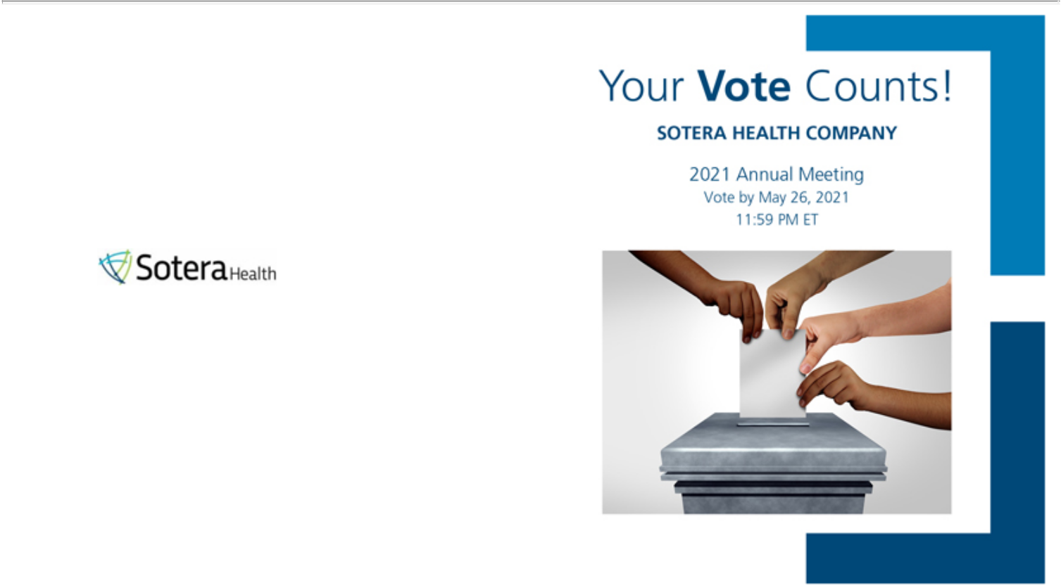

SOTERA HEALTH COMPANY
9100 SOUTH HILLS BLVD, SUITE 300
BROADVIEW HEIGHTS, OH 44147

D50824-P52913

You invested in SOTERA HEALTH COMPANY and it’s time to vote!

You have the right to vote on proposals being presented at the Annual Meeting. This is an important notice regarding the availability of proxy material for the stockholder meeting to be held on May 27, 2021.

Get informed before you vote

View the Notice and Proxy Statement, Annual Report and Form 10-K online OR you can receive a free paper or email copy of the material(s) by requesting prior to May 13, 2021. If you would like to request a copy of the material(s) for this and/or future stockholder meetings, you may (1) visit www.ProxyVote.com, (2) call 1-800-579-1639 or (3) send an email to sendmaterial@proxyvote.com. If sending an email, please include your control number (indicated below) in the subject line. Unless requested, you will not otherwise receive a paper or email copy.


Smartphone users |  | Vote Virtually at the Meeting*
Point your camera here and |  | May 27, 2021
Point your camera here and |  | 9:00 a.m., Eastern Time
vote without entering a |  | 9:00 a.m., Eastern Time
control number |  | Virtually at:
 |  | www.virtualshareholdermeeting.com/SHC2021



*Please check the meeting materials for any special requirements for meeting attendance.
V1

Vote at www.ProxyVote.com

THIS IS NOT A VOTABLE BALLOT

This is an overview of the proposals being presented at the
upcoming stockholder meeting. Please follow the instructions on

the reverse side to vote these important matters.

Board

Voting Items Recommends

- Elect the following Class I nominees for director to hold office until the 2024 Annual Meeting and until their successors have been duly elected and qualified:

Nominees:
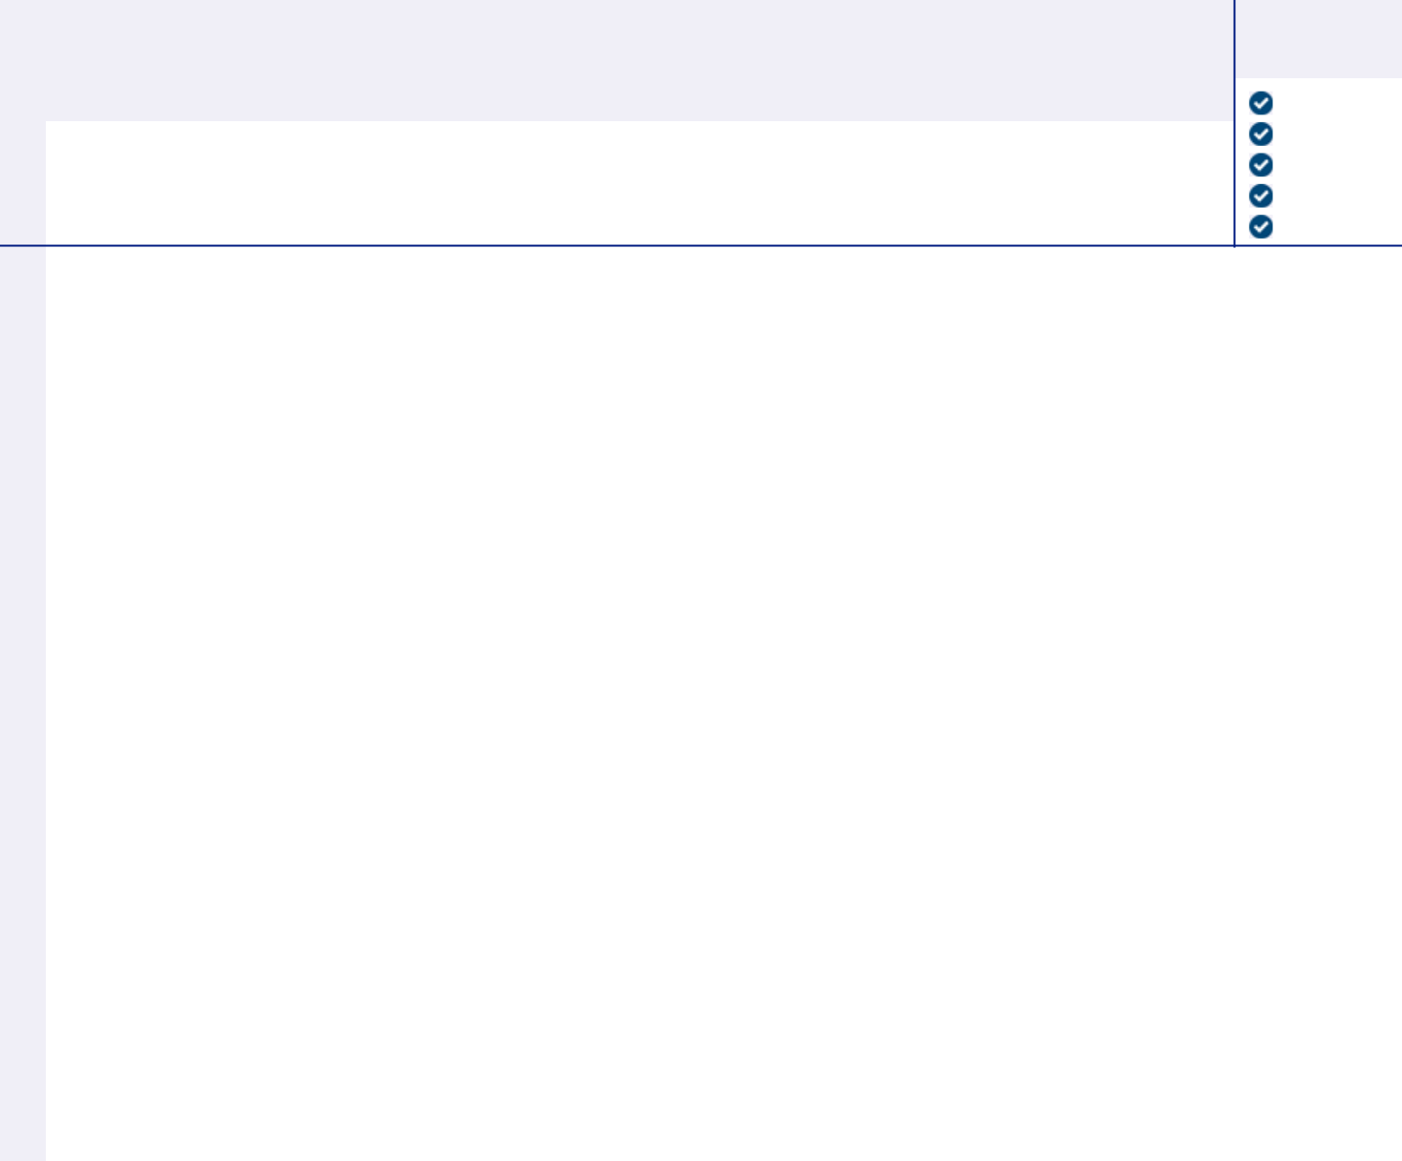

1a. |  |  | For
1a. | Constantine S. Mihas |  | For
1b. | James C. Neary |  | For
1c. | Michael B. Petras, Jr. |  | For
1d. | David E. Wheadon |  | For
2. | Ratification of the appointment of Ernst & Young LLP as our independent auditors for 2021. |  | For

Prefer to receive an email instead? While voting on www.ProxyVote.com, be sure to click “Sign up for E-delivery”.

D50825-P52913

